Promoted for and on behalf of Cycling Time Trials under their rules and regulations

The start sheet for the

Team VeloVelocity 25m TT
Including BBAR Qualification event

COURSE E2/25 – Saturday September 7th 2019 - STARTS AT 14:00

.
IN THE INTEREST OF YOUR OWN SAFETY, CYCLING TIME TRIALS AND THE EVENT PROMOTERS STRONGLY ADVISE YOU TO WEAR A HARD SHELL SAFETY HELMET THAT MEETS AN INTERNATIONALLY ACCEPTED

NOTES TO RIDERS - The following local regulations must be adhered to: -

- No riding with your head down, any rider observed riding dangerously will be disqualified from the event and reported to the CTT District Committee for further disciplinary action. Have a fast, but safe ride.
- NO 'U' TURNS are allowed within sight of either the start or finish area. Riders carrying out this dangerous maneuver are liable for disqualification from the event and further disciplinary action by the CTT District Committee.
- Numbers will be situated in the HQ; Please sign these numbers back and you wil be given a raffle ticket, which can be exchanged for a hot or cold drink after the event at the leisure centre café, Cake will be available in the Studio 2.
- NO cars to stop or park at the start or finish areas, the finish is a clearway.
- No warming-up by competitors is allowed along any part of the designated course, after the event has started. NOTE: NO Riders allowed in the start area more than 5 minutes before starting.
- ANY RIDER NOT STAYING IN THE LEFT HAND LANE AT THE A11/A14 GOING WEST BOUND WILL BE DQ’d AND REPORTED TO LONDON EAST CTT DISTRICT COMMITTEE FOR DISCIPLINARY ACTION
- ON FINISHING RIDERS MUST STAY TO THE LEFT HAND SIDE OF THE SLIP ROAD, ANY RIDER MOVING OVER TO THE RIGHT WILL BE DQ’D, THIS IS FOR YOUR OWN SAFETY

- AT THE TOP OF THE SLIP ROAD GO LEFT, THEN TAKE NEXT LEFT, WINDMILL HILL FOLLOW TO EXNING, AT T JUNCTION GO LEFT INTO EXNING ROAD, THE LEISURE CENTRE IS APPROX. 2.5 MILES

Timekeepers: Mike Bannister Chronos RT & Michael Beasant Ciclos Uno
Event Secretary: Debbie Knott –TVV – 83 Elm Park Close, Houghton Regis, Beds, LU5 5PW 07950 193977

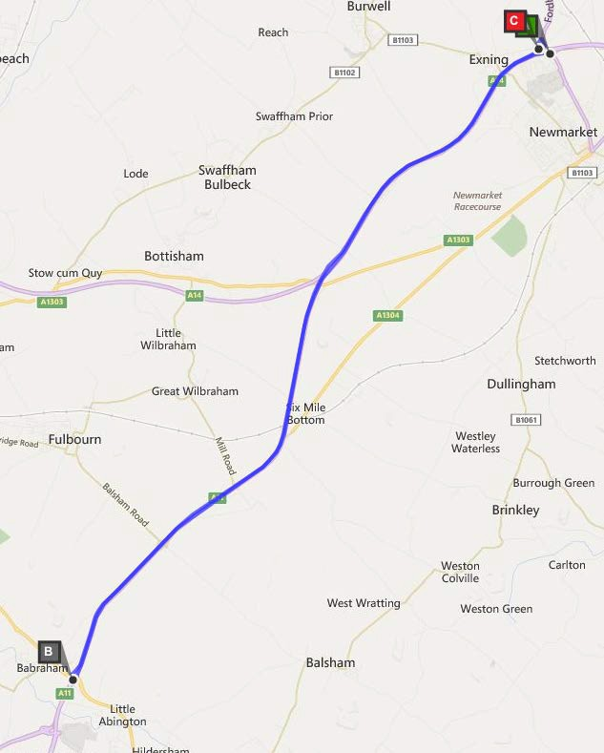
Course details E2/25 - START at paint mark on A142 just before slip road to A14 westbound. Take slip road and continue onto A14 westbound, and stay in left lane onto A11 where A14 diverges. Continue to Four Went Ways (12.77m), where take slip road to elevated roundabout and circle to rejoin A11 northbound. Retrace via A11 and A14 to FINISH at last drain cover before 'Give way in 100 yards' sign on slip road to A142

Start List

bib | start_Time | firstname | lastname | club | gender | category
1 | 14:01 | Murat | Ozdenya | Team Vision Racing - Silverhook | Male | Veteran
2 | 14:02 | Mathilda | Dyson | Islington Cycling Club | Female | Senior
3 | 14:03 | Becky | Taylor | Wisbech Whs | Female | Veteran
4 | 14:04 | Virginia | Mcgee | ...a3crg | Female | Veteran
5 | 14:05 | David | Procter | Team Velovelocity | Male | Veteran
6 | 14:06 | Robert | Watson | Cambridge CC | Male | Veteran
7 | 14:07 | Martin | Bullen | Peterborough CC | Male | Veteran
8 | 14:08 | Denise | Hurren | Team Velovelocity | Female | Veteran
9 | 14:09 | Jeremy | Parker | Metropolitan Police Cycle Club | Male | Veteran
10 | 14:10 | Matt | O'brien | Plomesgate CC | Male | Veteran
11 | 14:11 | Rory | Havis | Ely & District CC/B&T Motor Repairs | Male | Senior
12 | 14:12 | Lee | Kennedy | Army Cycling | Male | Senior
13 | 14:13 | James | Moss | North Road CC | Male | Veteran
14 | 14:14 | Helen | Gravatt | CC Ashwell | Female | Veteran
15 | 14:15 | Mark | Newton | Elite Cycling | Male | Veteran
16 | 14:16 | Tim | Kingston | GS Invicta - Eye Level Optical- Herbert Cycles | Male | Veteran
17 | 14:17 | Tony | May | TMG Horizon Cycling Team | Male | Veteran
18 | 14:18 | Jim | Reed | Colchester Rovers CC | Male | Veteran
19 | 14:19 | Sharon | Bennett | Ely & District CC/B&T Motor Repairs | Female | Veteran
20 | 14:20 | Adam | Bidwell | Kingston Wheelers CC | Male | Veteran
21 | 14:21 | Matt J | Smith | Cycling Club Hackney | Male | Veteran
22 | 14:22 | Steve | Kaye | Fenland Clarion CC | Male | Veteran
23 | 14:23 | Nick | Hickman | Team Salesengine.co.uk | Male | Veteran
24 | 14:24 | Jennifer | Smart | Team Velovelocity | Female | Veteran
25 | 14:25 | Alice | Lethbridge | DRAG2ZERO | Female | Senior
26 | 14:26 | Michael | Martin | CC Ashwell | Male | Veteran
27 | 14:27 | Phil | Lee | Wisbech Whs | Male | Veteran
28 | 14:28 | Claire | Emons | Newbury RC | Female | Veteran
29 | 14:29 | Abi | Vyner | Rapha Cycling Club | Female | Veteran
30 | 14:30 | James | Rix | Team Bottrill | Male | Veteran
31 | 14:31 | Iain | Boardman | Dulwich Paragon CC | Male | Veteran
32 | 14:32 | Ken | Platts | Cambridge CC | Male | Veteran
33 | 14:33 | John | Manlow | Ely & District CC/B&T Motor Repairs | Male | Veteran
34 | 14:34 | Andrew | Bright | Chronos RT | Male | Veteran
35 | 14:35 | Dave | Green | CC Breckland | Male | Veteran
36 | 14:36 | Tim | Phillips | St Ives CC | Male | Veteran
37 | 14:37 | Jennifer | Millmore | Islington Cycling Club | Female | Senior
38 | 14:38 | Susan | Triplow | CC Sudbury | Female | Veteran
39 | 14:39 | Stephanie | Cousins | Team Milton Keynes | Female | Veteran
40 | 14:40 | Richard | Harrison | DRAG2ZERO | Male | Veteran
41 | 14:41 | Michael | Schofield | Bishop's Stortford CC | Male | Veteran
42 | 14:42 | Adrian | Blacker | C and N Cycles RT | Male | Veteran
43 | 14:43 | Simon | Geraci | Team Swift | Male | Veteran
44 | 14:44 | Marek | Sasura | GS Avanti | Male | Veteran
45 | 14:45 | Peter | Harding | Chelmer CC | Male | Senior
46 | 14:46 | Matthew | Mcclure | Wisbech Whs | Male | Senior
47 | 14:47 | Steve | Clarke | TMG Horizon Cycling Team | Male | Veteran
48 | 14:48 | Stuart | Weatherley | TPH Racing | Male | Senior
49 | 14:49 | Chris | Shaw | Fenland Clarion CC | Male | Veteran
50 | 14:50 | John | Wingfield | Team Signum | Male | Senior
51 | 14:51 | Matthew | Reader | Verulam CC | Male | Veteran
52 | 14:52 | Neil | Empson | Wisbech Whs | Male | Senior
53 | 14:53 | Paul | Sexton | CC Breckland | Male | Veteran
54 | 14:54 | Paul | Looke | Shaftesbury CC | Male | Veteran
55 | 14:55 | Andrew | Grant | Cambridge CC | Male | Veteran
56 | 14:56 | Paul | Schofield | St Ives CC | Male | Senior
57 | 14:57 | Lee | Garrod | Sole Bay Cycle Sport | Male | Veteran
58 | 14:58 | Ian | Braybrook | Basildon CC | Male | Veteran
59 | 14:59 | Nigel | Fitzroy | Chelmer CC | Male | Veteran
60 | 15:00 | Simon | Norman | Bedfordshire Road RT | Male | Veteran
61 | 15:01 | Alex | Leek | Velo Club St Raphael | Male | Senior
62 | 15:02 | Richard | Tully | Elite Cycling | Male | Veteran
63 | 15:03 | Chris | Nudds | CC Breckland | Male | Veteran
64 | 15:04 | Philip | Waring | Cambridge CC | Male | Veteran
65 | 15:05 | Keith | Dorling | Team Bottrill | Male | Veteran
66 | 15:06 | Tom | Hilder | trainSharp | Male | Senior
67 | 15:07 | Stephen | Wilkinson | Folkestone Velo Club | Male | Veteran
68 | 15:08 | Peter | Tibbitts | Ford CC | Male | Veteran
69 | 15:09 | Peter | Aldred | Great Yarmouth C C | Male | Veteran
70 | 15:10 | David | Harding | Chelmer CC | Male | Senior
71 | 15:11 | Tim | Beaven | Bicester Millennium CC | Male | Veteran
72 | 15:12 | Kevin | Plummer | South Downs Bikes / Casco Pet | Male | Veteran
73 | 15:13 | James | Scarth | Bishop's Stortford CC | Male | Veteran
74 | 15:14 | John | Iszatt | Team Vision Racing - Silverhook | Male | Veteran
75 | 15:15 | Paul David | Fleming | Preston Whs | Male | Veteran
76 | 15:16 | Paul | Smith | VeloRefined.com Aerosmiths | Male | Veteran
77 | 15:17 | Chris | Tye | Plomesgate CC | Male | Veteran
78 | 15:18 | Simon | Keen | Crest CC | Male | Veteran
79 | 15:19 | Andy | Clark | Rutland Cycling Club | Male | Veteran
80 | 15:20 | Julian | Elliott | Finsbury Park CC | Male | Veteran
81 | 15:21 | Terry | Garlinge | Easterley Road Club | Male | Veteran
82 | 15:22 | Adam | Hardy | Crest CC | Male | Senior
83 | 15:23 | Roger | Sewell | Wisbech Whs | Male | Veteran
84 | 15:24 | Chris | Womack | VC Baracchi | Male | Veteran
85 | 15:25 | Chris | Jones | Bynea Cycling Club | Male | Veteran
86 | 15:26 | Nick | Morgan | Hitchin Nomads CC | Male | Senior
87 | 15:27 | Alister | Campbell | Eagle Road Club | Male | Veteran
88 | 15:28 | Julia | Freeman | Easterley Road Club | Female | Veteran
89 | 15:29 | Sam | Straw | Albarosa CC | Male | Senior
90 | 15:30 | Ben | Stancombe | Team Velovelocity | Male | Senior
91 | 15:31 | Glenn | Taylor | Shorter Rochford RT | Male | Veteran
92 | 15:32 | Matt | Meek | Aspire Velo Racing Team | Male | Senior
93 | 15:33 | Philip | Watkins | North Norfolk Whs | Male | Veteran
94 | 15:34 | Damian | Monaghan | ABCpure | Male | Senior
95 | 15:35 | William | Wallace | CC London | Male | Veteran
96 | 15:36 | Tim | Davies | CC Luton | Male | Veteran
97 | 15:37 | Mark | Hamer | Stratford Cycling Club | Male | Veteran
98 | 15:38 | Warren | Jackson | Congleton CC | Male | Veteran
99 | 15:39 | Karen | Dennett | Bishop's Stortford CC | Female | Veteran
100 | 15:40 | Peter | Lawrence | High Wycombe CC | Male | Veteran
101 | 15:41 | Richard | O'rourke | Team Vision Racing - Silverhook | Male | Veteran
102 | 15:42 | Nic | Stevenson | Westerley Cycling Club | Male | Senior
103 | 15:43 | Duncan | Emery | Twickenham CC | Male | Veteran
104 | 15:44 | Adam | Bishop | Lea Valley CC | Male | Veteran
105 | 15:45 | Mark | Ellis | Team Milton Keynes | Male | Veteran
106 | 15:46 | Darran | Bennett | Ely & District CC/B&T Motor Repairs | Male | Veteran
107 | 15:47 | Henry | Moss | Cambridge CC | Male | Senior
108 | 15:48 | John | Golder | Chelmer CC | Male | Veteran
109 | 15:49 | Grazyna | Monaghan | ABCpure | Female | Senior
110 | 15:50 | Matthew | Senter | Peterborough CC | Male | Senior
111 | 15:51 | Adam | Fisher | Cambridge CC | Male | Senior
112 | 15:52 | Daniel | Homer | London Phoenix CC | Male | Veteran
113 | 15:53 | Amy | Pritchard | Team Bottrill | Female | Veteran
114 | 15:54 | Michael | Cope | Kettering CC | Male | Veteran
115 | 15:55 | Paul | Atkins | Kenilworth Whs | Male | Veteran
116 | 15:56 | Vicky | Gill | DRAG2ZERO | Female | Senior
117 | 15:57 | Colin | Lizieri | Cambridge CC | Male | Veteran
118 | 15:58 | David | Giffin | West Suffolk Wheelers | Male | Veteran
119 | 15:59 | Andrew | Merchant | Southend Wheelers | Male | Veteran
120 | 16:00 | David | Veitch | Lea Valley CC | Male | Senior
121 | 16:01 | Karl | Willis | Herts Rouleurs Racing Club | Male | Senior
122 | 16:02 | Antony | Brown | Kettering CC | Male | Veteran
123 | 16:03 | Jackie | Field | CC Ashwell | Female | Veteran
124 | 16:04 | Jeremy | Saynor | PMR | Male | Veteran
125 | 16:05 | Leon | West | CC Sudbury | Male | Veteran
126 | 16:06 | David | Crisp | 3T-RACING | Male | Veteran
127 | 16:07 | Paul | Hayward | VC Baracchi | Male | Veteran
128 | 16:08 | Mike | Padfield | North Norfolk Whs | Male | Veteran
129 | 16:09 | Michelle | Morley | Team Swift | Female | Veteran
130 | 16:10 | Brett | Harwood | Team Bottrill | Male | Veteran
131 | 16:11 | Martin | Reynolds | Cambridge CC | Male | Veteran
132 | 16:12 | Steve | Smith | Redbridge CC | Male | Veteran
133 | 16:13 | Christopher | Wedge | Whitewebbs CC | Male | Veteran
134 | 16:14 | Katja | Rietdorf | Born to Bike - Bridgtown Cycles | Female | Veteran
135 | 16:15 | Richard | Gifford | trainSharp | Male | Veteran
136 | 16:16 | Steven | Bass | Maldon & District CC | Male | Veteran
137 | 16:17 | Wolfgang | Emmerich | London Phoenix CC | Male | Veteran
138 | 16:18 | John | Martin | Elmsall Road Club | Male | Veteran
139 | 16:19 | Louise | Robinson | Essex Roads CC | Female | Veteran
140 | 16:20 | Paul | Jay | Team Velovelocity | Male | Veteran
141 | 16:21 | Sam | Wightman | Chelmer CC | Male | Veteran
142 | 16:22 | Kevin | Baumber | Shaftesbury CC | Male | Veteran
143 | 16:23 | Alan | Crane | Chronos RT | Male | Veteran
144 | 16:24 | Glen | Knight | Newbury RC | Male | Veteran
145 | 16:25 | Jon | Surtees | CES Sport | Male | Veteran
146 | 16:26 | Sam | Brown | Lea Valley CC | Male | Senior
147 | 16:27 | Lee | Turner | Sigma Sports | Male | Veteran
148 | 16:28 | Ian | Markham | Chronos RT | Male | Veteran
149 | 16:29 | Paul | Wright | Hitchin Nomads CC | Male | Veteran
150 | 16:30 | Mark | Arnold | VTTA (East Anglia Group) | Male | Veteran

Tandems

151 |  | 16:32 | Wayne | Crombie | East London Velo | Male | Veteran
 |  |  | Warren | Crombie | Musselburgh RCC | Male | Veteran
152 |  | 16:34 | Rachael | Elliott | Newbury RC | Female | Tan
 |  |  | Ian | Greenstreet | AeroCoach | Male | Veteran

Reserve Rider

R1 |  |  | Ritchie | Parkins | Diss & District CC | Male | Veteran
R2 |  |  | David | Cook | Bedfordshire Road RT | Male | Veteran
R3 |  |  | Tony | Summers | Rapha Cycling Club | Male | Veteran
R4 |  |  | Johnathan | Lincoln | Great Yarmouth C C | Male | Veteran
R5 |  |  | James | Lonergan | Essex Roads CC | Male | Senior
R6 |  |  | Patrick | Charlton | Wolsey RC | Male | Veteran
R7 |  |  | Tony | Baxter | Withington Wheelers | Male | Veteran
R8 |  |  | Nigel | Hodge | Tri-Anglia Triathlon Club | Male | Veteran
R9 |  |  | Tony | Capon | Becontree Wheelers CC | Male | Veteran
R10 |  |  | Gary | Boyd | Hub Velo | Male | Veteran
R11 |  |  | Rich | Crook | Fenland Clarion CC | Male | Senior

Due to the amount of entries being rejected, if you are planning on not starting, please inform Debbie Knott 07950 193977 as early as possible to allow for a reserve to be allocated a start time.

Team VeloVelocity awards Actual fastest
Club team of three on standard 1st Tandem Prize TBC
Men | Ladies
1- £50 | 1- £50
2- £40 | 2 - £40
3- £30 | 3 - £30
4- £20
5- £15

Team of 3 riders £15 each Sponsored by

EVENT HQ – Newmarket Leisure Centre, Studio 2, Exning Road, Newmarket, Suffolk, CB8 0EB.

To get to the HQ, turn off the A14 and turn left. Turn next left into Windmill Hill. At T junction turn left into Exning Road, the leisure centre is on your right approx 1.5 miles along Exning Road, there is adequate parking, but please be considerate and park sensibly.

Note: the start is approximately 2.65 miles from the HQ, please allow enough time to get to the start on time, there is adequate areas near the start to also park & warm up.
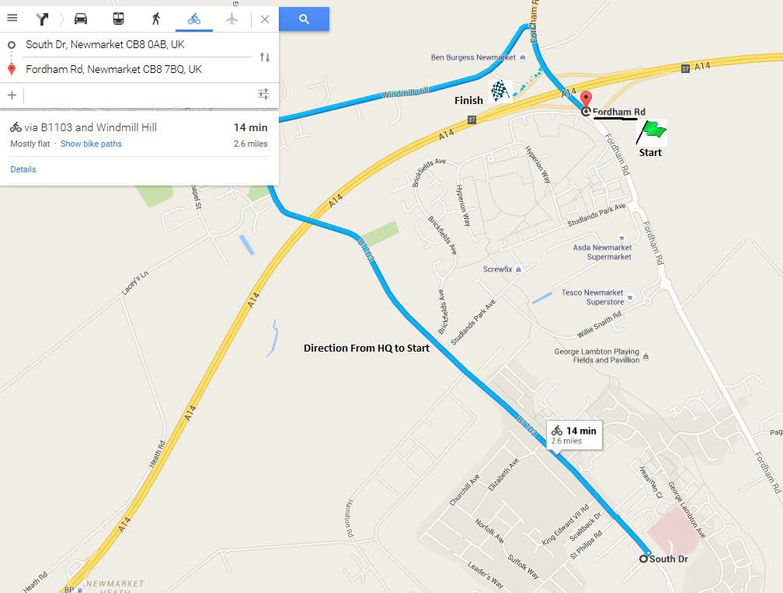
Changing facilities and showers are available in the Leisure Centre, please do not change in the car park.
Please sign your number back and collect a raffle ticket for a hot drink at the Café.
Cakes will be available in studio 2

Directions to the START

  - Turn Left out of the Leisure Centre onto Exning Road
  - Continue along Exning road into Exning
  - At the crossroads in Exning turn right unto Windmill Hill
  - Follow windmill Hill until you meet the A142 Fordham road
  - Turn Right onto Fordham Road – CARE this is a busy road!
  - Follow the A142 over the A14 and the start is on the right

Aerial view of Start and Finish Area
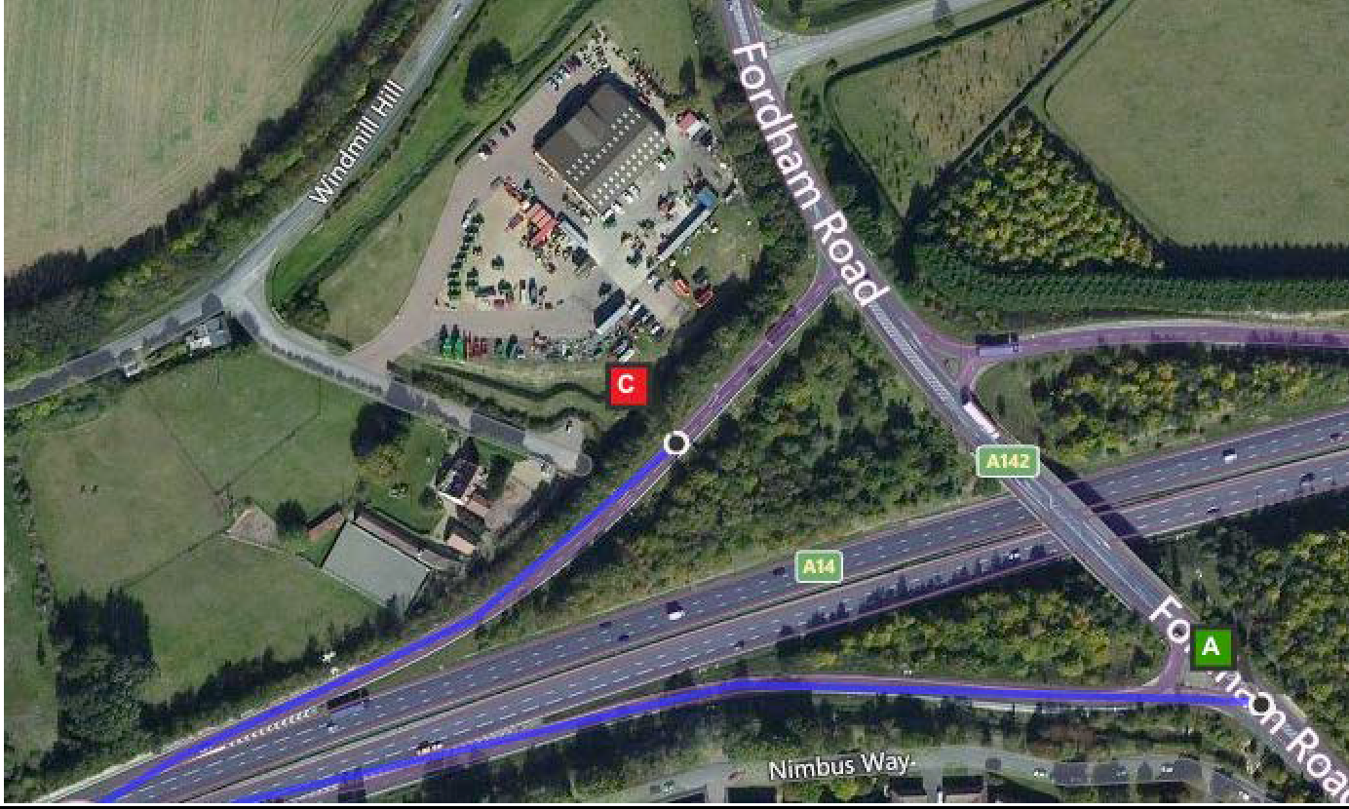

Aerial view of the turn at Four Went Ways
