Start Sheet for the

Northampton & District Cycling Association

12.8 mile Time Trial (TT Series Event 7 of 8)

Saturday 15th July 2023 starting at 9 am | FOUNDED 1935
 | PRESIDENT:
Promoted for and on behalf of Cycling Time Trials under their Rules and Regulations | Sue Holliday
This event is a counting event for all categories of the N&DCA Time Trial Series Championships and is organised on behalf of the N & DCA by Team Salesengine.co.uk and its Members.)

For the latest points tables visit the results website:
http://www.northamptondca.org.uk/

Headquarters:

Rockingham Forest Wheelers Clubhouse
11 Ashley Rd, Middleton, Market Harborough LE16 8YP

Facilities:

The HQ will be open from just after 7am for toilets.

Pleas park in the field past the clubhouse on Ashley lane it will be signposted.

Timekeepers: Sharon Fensom and Jon Thorne

Start Line Official: (To ‘manage’ the start line and assist the start timekeeper):

Event Secretary: Phil Wilkinson 32 Tarrant Way, Moulton NN3 7US 07500505087

Prize  Values | Handicap Prize
1st | £15
2nd | £12
3rd | £10
4th | £ 8
5th | £ 5

Please note that:
The handicap prize for this event is based on best improvement against predicted Spindata times. In the event of no Spindata prediction being generated which might be the case if not many events have been ridden recently, the time to beat will be the rider’s PB for 10 miles as supplied by the CTT entry form data. To be eligible for this prize competitors must have a 10 mile best time to beat.

Two spot prizes per event have been kindly donated by 76 Projects. Details of their products are available using this link https://76projects.com/. These will be awarded to the middle placed rider in the TT bike and road bike categories (if there is an even number then this will be awarded to the faster rider).
Local Regulations:

NO U-TURNS are allowed within sight of either the start or the finishing points. Riders carrying out this dangerous manoeuvre are liable for DISQUALIFICATION from the event and further disciplinary action by the district committee.

Please also remember that there is a need for good behaviour and consideration towards other road users and local residents in order to avoid any complaints being received.

Numbers:

These will be available at the Event Headquarters, not at the Start. Each number will have pins in each corner, please remove and place in box if not needed because you are using a NoPinz pocket. Also only use the corner pin holes and do not make more holes if using pins. Please ensure that the body number is clearly visible from behind and fixed on the lower back.

Signing In/Out:

Please ensure that you sign the “Signing-On” Sheet when collecting your number and clearly call out your number when crossing the finish line. Please ensure you return your number to HQ and sign-out, using the “Signing-on/off” Sheet. Failure to do so could result in your exclusion from the Results.

Road Bike category

For your ride in this event to be eligible for the season long Road Bike category please indicate this on the signing on sheet by ticking the appropriate box or writing RB next to your name. The start line assistant will check your bike meets the road bike criteria at the same time as checking lights. To be eligible your bike must not have “tri-bars” or equivalent, disc wheels, less than 12 spokes or other fairings. In event of a dispute regarding RB eligibility, the organisers decision is final.

Compulsory Front/Rear Lights and Helmets:

Regulation 14(i) requires all Competitors to have affixed to the rear of their machine a working rear red light, either flashing or constant, that is illuminated and in a position that is clearly visible to other road users.
Regulation 14(j) requires all Competitors to have affixed to the front of their machine a working front white light, either flashing or constant, that is illuminated and in a position that is clearly visible to other road users.
Regulation 15 requires that all Competitors must wear a properly affixed helmet which must be of hard/soft shell construction. Helmets should conform to a recognised Standard such as SNELL B95, ANSI Z90.4, AUS/NZS 2063:96, DIN 33-954, CPSC or EN 1078.
Failure of any of the above three points will render the competitor not being allowed to start the event.

Doping Control:

This event may be subject to Doping Control. As soon as you have finished you should return to HQ as it is your responsibility to check if you are required for a Doping Control. Race numbers required for Doping Control will be displayed at the HQ adjacent to the Result Board. If your number is displayed you should report immediately to Doping Control which will be nearby. Remember, it is up to you to check and ensure you comply.

Ride to the Start Point:

From the Race HQ follow Mill Road and then Station Road back towards the motorway and underbridge. At the junction with the A507 turn left at the roundabout and continue until you reach traffic lights. At that junction turn right and follow the Bedford Road through the outskirts of Brogborough to the top of the hill, where the course starts. Please use the same route to return. It is highly recommended that you DO NOT travel to and from the course via M1 junction 13.

COURSE IDENTIFICATION: COURSE NUMBER NC13C

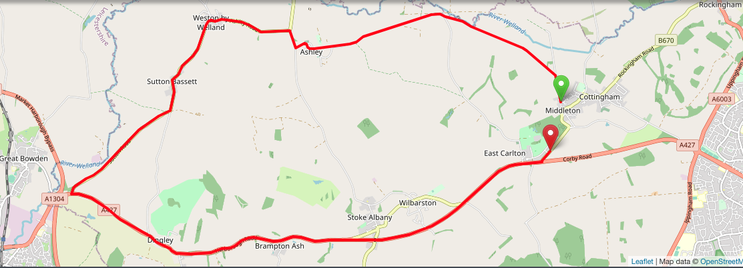
COURSE NOTES:

START Outside the Rockingham Forest Wheelers Clubroom, 11 Ashley Road, Middleton, in line with fence between the clubhouse and adjoining garages. Proceed along the road to Ashley and continue through Ashley to the T-junction with the B664
TURN LEFT onto the B664 and proceed through Weston-by-Welland and Sutton Bassett to the junction of the B664 and the A427 where
TURN LEFT onto A427 and proceed through Dingley to the junction of the A427 and B670 at East Carlton where
TURN LEFT ono the B670. Continue on the B670 to
FINISH 10 yards past the gates to East Carlton Park, opposite the ‘East Carlton’ village sign.as required by the Course ‘Risk Assessment’. The onus is still on you the rider, so familiarise yourself with the course details.

Competitors:

- = Association Club

Categories: S = Senior W = Woman J = Junior/ Juvenile
Masters Men: A = 50-54, B = 55-59, C = 60-64, D = 65-69, E = 70-74, F = 75 plus
Masters Women: A = 40-44, B = 45-49, C = 50-54, D = 55-59, E = 60-64, F = 65 plus

*NB Masters age category is age on day of first N&DCA event ridden this year.
Juniors/Juveniles:
For the 2023 season there are no separate juvenile or junior sections, only a single U19 category, i.e. Those Competitors aged under 18 or have their 18th birthday during 2022

Result Sheet app:

Subject to availability of sufficiently tech savvy volunteers, we will be trialling the Result Sheet application which will enable you to track times live via the application on your phone if you scan the printed QR code at the Race HQ. Alternatively you can also view the results on screen at the HQ whilst enjoying tea and home made cakes and some lively banter.

Season long competition prizes:

Please note that the actual value of the cash prizes awarded for performance in the various categories will be published after the last event of the season when the total prize fund is known as determined by the surplus generated by the event entry fee income.

Trophies:

Trophies and end of season competition prizes will be awarded at the annual Prize Award Lunch (usually held in January). NB Separate event prizes will be awarded after the last event in the series, not after each event.

The Association’s 12-hour trophies will be awarded to members of Association Clubs for their performances in any open 12-hour event held under CTT Rules & Regulations. The Association’s Long Distance BAR will be awarded to the highest placed rider of an Association Club in the National BBAR. Qualifying events are marked B in the CTT Handbook

For more information on the season long competitions and N&DCA trophies, including past winners, please refer to our website:
www.northamptondca.org.uk

1 | 09:01 | Patrick | Ellerbeck | St Neots CC | Male | Veteran
2 | 09:02 | John | Dainty | Rockingham Forest Wheelers | Male | Veteran
3 | 09:03 | Lynne | Scofield | Rockingham Forest Wheelers | Female | Veteran
4 | 09:04 | Norman | King | St Neots CC | Male | Veteran
5 | 09:05 | David | Cook | Bedfordshire Road CC | Male | Veteran
6 | 09:06 | Noel | Toone | Kettering CC | Male | Veteran
7 | 09:07 | Mark | Broster | MULE .C.C. | Male | Veteran
8 | 09:08 | Richard | Latimer | Welland Valley CC | Male | Veteran
9 | 09:09 | Michael | Walker | Guide Cycling | Male | Senior
10 | 09:10 | David | Hallam | Fenland Clarion CC | Male | Veteran
11 | 09:11 | Hayley | Moore | Ilkeston Cycle Club | Female | Veteran
12 | 09:12 | Steve | Clarke | Fenland Clarion CC | Male | Veteran
13 | 09:13 | Graeme | Hall | Rockingham Forest Wheelers | Male | Veteran
14 | 09:14 | Pete | Trotman | A5 Rangers CC | Male | Veteran
15 | 09:15 | Mike | Deely | Rockingham Forest Wheelers | Male | Veteran
16 | 09:16 | Martin | Webb | Icknield RC | Male | Veteran
17 | 09:17 | Paul | Russell | WVTri | Male | Senior
18 | 09:18 | Paul | Breeze | Peterborough CC | Male | Veteran
19 | 09:19 | Maria | Gent | Kettering CC | Female | Senior
20 | 09:20 | Pete | Bradshaw | Rockingham Forest Wheelers | Male | Senior
21 | 09:21 | Adam | Wells | Rockingham Forest Wheelers | Male | Senior
22 | 09:22 | Danny | Metherell | VéloElite RC | Male | Veteran
23 | 09:23 | Adrian | McHale | Peterborough CC | Male | Veteran
24 | 09:24 | Richard | Golding | Equipe Velo | Male | Veteran
25 | 09:25 | Lindsay | Clarke | Fenland Clarion CC | Female | Veteran
26 | 09:26 | Mark | Tomlinson | Peterborough CC | Male | Veteran
27 | 09:27 | Alex | Hodgkinson | Ilkeston Cycle Club | Male | Senior
28 | 09:28 | Cian | Leveridge | Team PB Performance | Male | Senior
29 | 09:29 | Sam | McDonald | St Neots CC | Male | Senior
30 | 09:30 | Malcolm | Smith | Peterborough CC | Male | Veteran
31 | 09:31 | Paul | Pardoe | Peterborough CC | Male | Veteran

