M&DTTA 25 MILE TIME TRIAL CHAMPIONSHIPSHIPS Incorporating race 8 of the Cheshire points series for 2022
Medals and trophies presented at the annual lunch on the 29^{th of} January 2023
Saturday 14th May 2022 (first rider 14:01)
HQ is Allostock Village Hall- Chapel Lane, Allostock, Knutsford WA16 9LP
Open from 12.30 pm
Winners in the Championship will Receive Association Medals and trophies. The championship is open to riders of all clubs affiliated to the M&DTTA
Timekeepers
START: Tony Millington FINISH: Martin Jackson
M&DTTA 25 MILE TIME TRIAL Results and Prizes
Race results will be published online as soon as possible after the event.
POS MALE WOMEN
1st fastest: Fitzroy Trophy + medal
2nd fastest: medal
3rd fastest: medal
1st fastest Lady: David Hamilton Cup + medal
Best Handicap - F D Brown Trophy and medal
Fastest Team of 3: Tom White Trophy + medals
All to be awarded at the M&DTTA lunch on 29 January 2023.
1 £35 £35
2 £30 £30
3 £25 £25
4 £20 £20
5 £15 £15
MALE VET ON STANDARD £15 FEMALE VET ON STANDARD £15 ESPOIR £15 BEST ON HANDICAPP £15 FASTEST TEAM – 3 to count £15 each FASTEST ROAD BIKE £15 FASTEST VET £15 1 rider 1 prize, not including team competition
Thanks to all the marshals and helpers for their assistance today and without these people the events would not happen. Further marshals needed for Saturdays event.

J4 / 8 COURSE DETAILS

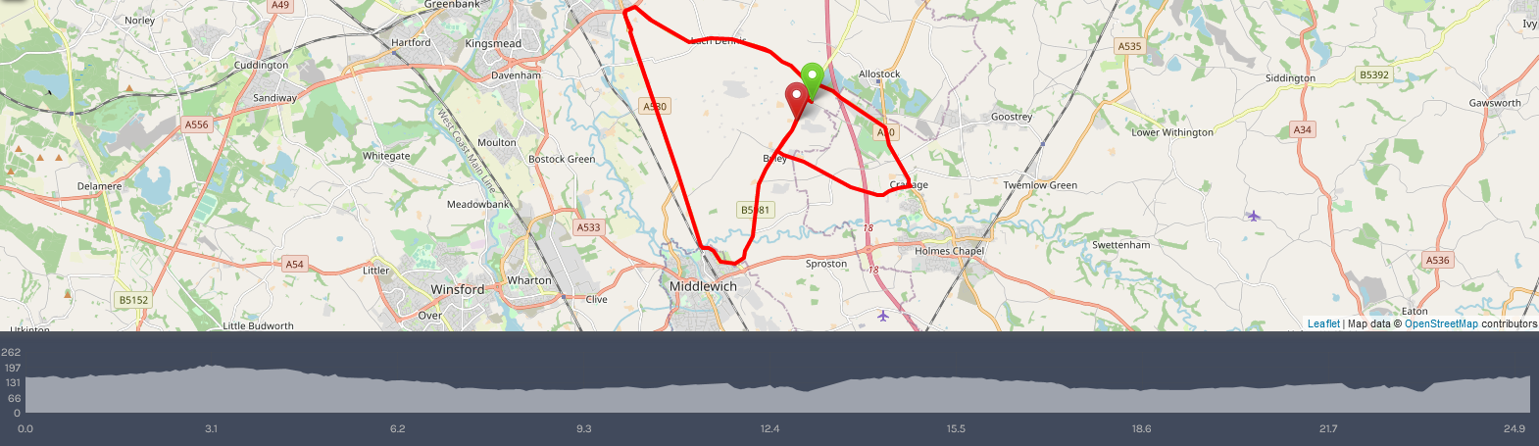
To the start from the HQ Allostock village hall- APPROX 3KM
Turn right out of HQ along princess road
Turn right onto wash lane
At “T” junction turn left onto Middlewich Road
Over motorway bridge to 4-way junction at the 3 greyhound’s public house
With caution straight across turning first left onto kings’ lane start is on right hand side.
No u turns in sight of the timekeepers please and all riders must keep social distancing when queuing up to start.
Start
start
start near FP McCann up to T junction with B0581. |  |  |  |  |  |  |  | approx. 500M
left on B5081 to Byley crossroads |  |  |  |  |  |  |  | approx. 1.11M
left onto moss lane and continue to the A50 at cranage. |  |  |  |  |  |  |  | approx. 3.23M
left along the A50 up to penny’s lane |  |  |  |  |  |  |  | approx. 4.13M
Left here and along the B5082 here to the a556 |  |  |  |  |  |  |  | approx. 8.23M
left here to the roundabout taking first left down the A530. |  |  |  |  |  |  |  | approx. 8.39M
along here turning left onto the B5309 |  |  |  |  |  |  |  | approx. 12.00M
along here left at the mini-roundabout onto centurion way |  |  |  |  |  |  |  | approx. 12.57M
left onto the B0581 and along here back the the 3-greyhound pub junction |  |  |  |  |  |  |  | approx. 15.47M
caution turning left onto the B0852 and along here back to the A556 |  |  |  |  |  |  |  | approx. 18.39M
caution turning left and first left back onto king street |  |  |  |  |  |  |  | approx. 18.61M
along the A530 to the B5309 |  |  |  |  |  |  |  | approx. 22.19M
along here left at the mini roundabout onto centurion way |  |  |  |  |  |  |  | approx. 22.81M
onto the B0581 and along here finishing near FP McCann the left-hand side. |  |  |  |  |  |  |  | 25M
Riders must continue past the finish with no stopping and be very mindful riders behind might be on their out lap and retrace the way back to the HQ. Which is continue to the three greyhounds public house (be cautious of riders on there second loop of the course.) With care straight across the junction to Wash Lane the first on your right and follow signs back to the HQ.
Caution on the course:
The course has a couple of tight 90 degree left turns onto fast roads. The first is after approx. 3 miles from the start turning off Moss Lane onto the A50 at Cranage. There is a coned section off the A556 top of Penny’s Lane as traffic is not allowed in the left lane. The cones will be amended slightly for a safe passage between Penny’s Lane and King Street turning left at the roundabout. This section should be traffic free but take care. The next tight left turn is on the second lap at the three greyhound public house again take care as it is a fast road.
Major Caution
The road surface is terrible on the motorway bridge over the M6 and is approx. 5 miles from the start. Take care here over this surface especially if wet with puddles which may hinder your view. The blue arrow is rider direction and both sides of the roadway as you can see needs some attention and might not show all the pot holes in this pictue. I have emailed East Cheshire Council over the surface and there has been many more over this section of road.
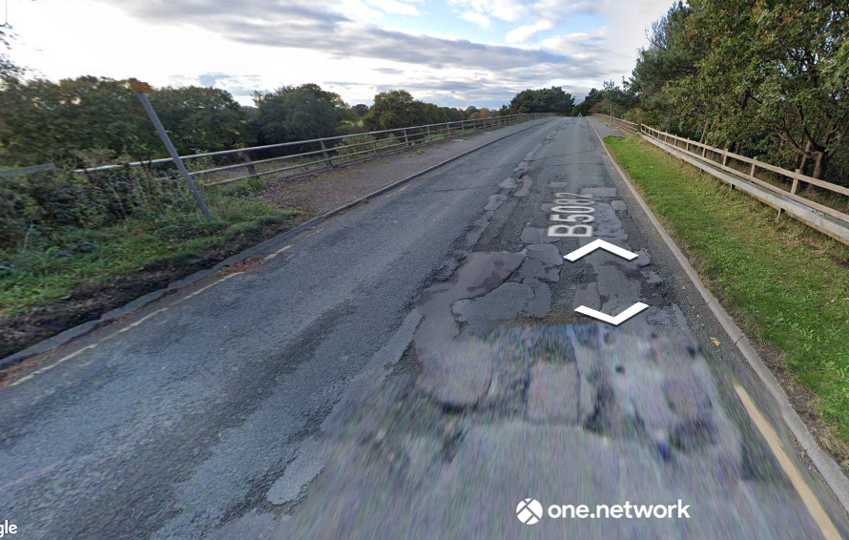

Road Bike category - General rules for road bike entries:
- No Tri bars, clip ons, or aero extensions to be used
- Hands must be on the handlebars/brake hoods at all times, ie no forearms resting on the bars • Maximum wheel depth, 65mm.
- No visors, no ear covering crash hats, including the Aerohead.

Before Collecting Numbers----All competitors MUST SIGN ON and SIGN-OFF when returning it, Failure to
do so will result in that rider being classified as DNF

Local Regulations
No Parking in Start or Finish Areas other than Timekeeper and Officials

Warnings:

Care at Junctions
Riders must exercise care at all junctions. Any competitor whose riding line causes him/her to cross THE WHITE LINE when approaching or leaving a junction will be liable to disqualification and may be reported to the district committee for further disciplinary action.

A competitor who swings out to the right before executing a left turn should ensure that the road behind is clear of traffic before doing so. The practice is not encouraged by the District Committee and competitors who ride in this manner are warned that in many circumstances this manoeuvre will be regarded as a contravention of regulation 47(i), (iii), (v).

No U Turns
Riders must not perform U turns in the vicinity of the start or finish of the event. Riders observed performing U turns will be reported to the District Committee who will consider disciplinary proceedings.

Safe riding
Riding with your head down such that you do not have a good view of the road ahead is dangerous - please watch out for potholes, obstacles, and other road users. Marshalls do not have the authority to control other road users, so please take care.

Helmets (CTT Reg 15) Note change to rule re: All competitors
All competitors must wear a properly affixed helmet which must be of hard/soft shell construction. Helmets should conform to a recognised Standard as detailed in CTT Reg 15.

Lights
Rear light. CTT Reg 14(i) No competitor shall be permitted to start either a Type A or Type B event unless such competitor has affixed to the rear of their machine a working rear red light, either flashing or constant, that is illuminated and in a position that is clearly visible to other road users.

Front Light. CTT Reg 14(j) No competitor shall be permitted to start either a Type A or Type B event unless such competitor has affixed to the front of their machine a working front white light, either flashing or constant, that is illuminated and in a position that is clearly visible to other road users.

Other notes A competitor overtaking another must pass without receiving or giving shelter. The onus of avoiding company riding shall be upon the rider overtaken. (CTT Reg 21)

COVID PRECAUTIONS
CTT has issued a document “Covid-19 Risk Assessment 09 08 21”. If you haven’t already read this, please download from the CTT website and read carefully
https://www.cyclingtimetrials.org.uk/documents/index/covid-19 . These are the key messages: -

- Competitors should not attend if they feel ill in ANY way especially if they or family members have any symptoms.
- The Village Hall building will be ventilated as well as possible and we advise all those entering the HQ be sensible regarding keeping a safe distance from one another.
- Please follow government guidelines on handwashing/sanitising.
- We recommend no changing at the HQ, please come dressed ready to ride.
- No assisted push-off. The M&DTTA have decided to continue to ask riders to set off unassisted from the Start timekeeper. Do not cross the start point until you get the signal from the timekeeper.
- We will be offering HQ catering and a Results board.
- Do not approach the timekeepers or any other officials.

Ensure that you review the Risk Assessment at time of signing on!

HQ Contacts on the Day Paul Ekgren 07456841594

start | firstname | lastname | club | CAT | vets std | H/CAP
14:01 | Vic | Trigger | Crewe Clarion Wheelers | MV76 | 1:23:37 | 33:54
14:04 | George | Comerford | Holmes Chapel velo | M27
14:05 | Philip | Gleave | Congleton CC | M27 |  | 10:08
14:06 | Robbie | Harcourt | Salford Cycling Club | MV58 | 1:09:56 | 15:07
14:07 | Lynsey | Astles | Congleton CC | FV46 | 1:13:27 | 16:16
14:08 | Sally | Cunliffe | Ruthin Cycling Club / Clwb Seiclo Rhuthun | FV65 | 1:19:13 | 20:01
14:09 | Amanda | Skeldon | Stockport Tri Club | FV46 | 1:13:27 | 32:40
14:10 | Andy | Wright | Total Tri Training | M32 |  | 10:06
14:11 | Richard | Collins | Wigan Whs CC | MV50 | 1:07:56 | 11:26
14:12 | Peter | Rogers | Chorlton Velo | MV56 | 1:09:23 | 13:56
14:13 | Dane | Stanley | Total Tri Training | MV44 | 1:06:44 | 16:17
14:14 | John | O'Hare | Manchester Triathlon Club | MV59 | 1:10:14 | 24:02
14:15 | Bradley | Murphy | SKCC | MV47 | 1:07:19 | 07:30
14:16 | John | Lowe | Withington Wheelers | MV53 | 1:08:37 | 13:18
14:17 | Russell | Ellis | Fibrax Wrexham RC | MV49 | 1:07:43 | 15:18
14:18 | Andy | Whitehead | Seamons CC | MV59 | 1:10:14 | 19:43
14:19 | Emma-Jane | Bradfield | Warrington Triathlon Club | FV53 | 1:15:09 | 28:28
14:20 | Lucy | Rogers | Congleton CC | FV53 | 1:15:09 | 13:29
14:21 | Daniel | Mathers | Seamons CC | MV49 | 1:07:43 | 11:20
14:22 | Tim | Whitefoot | Crewe Clarion Wheelers | MV45 | 1:06:55 | 13:53
14:23 | Cheryl | Hutchins | Total Tri Training | FV61 | 1:17:39 | 32:40
14:24 | Carl | Hitchenson | Weaver Valley CC | MV54 | 1:08:52 | 23:15
14:25 | James | Foggensteiner | University Of Manchester CC | M22 |  | 09:22
14:26 | Stuart | Ward | Weaver Valley CC | MV56 | 1:09:23 | 13:12
14:27 | David | Fox | Warrington Road Club/Horton Light Engineering | MV59 | 1:10:14 | 11:12
14:28 | Alice | Taylor | Congleton CC | F31 |  | 19:21
14:29 | Janet | Wyles | Total Tri Training | FV55 | 1:15:42 | 28:00
14:30 | Kelly | Murphy | The Independent Pedaler - Nopinz | F32 |  | 06:32
14:31 | Kelvin | Milward | Congleton CC | MV60 | 1:10:32 | 15:24
14:32 | Nick | Rose | Total Tri Training | MV50 | 1:07:56 | 13:51
14:33 | Luke | Buswell | Manchester Bicycle Club | M30 |  | 15:49
14:34 | Alan | Shuttleworth | Weaver Valley CC | MF75 | 1:17:04 | 27:51
14:35 | Andy | Gray | Congleton CC | MV46 | 1:07:07 | 08:52
14:36 | Paul | Basson | ABC Centreville | MV50 | 1:07:56 | 12:47
14:37 | Stephen | Costello | Bill Nickson Cycles | MV65 | 1:12:38 | 14:56
14:38 | Derek | Schofield | Rossendale RC | MV69 | 1:13:55 | 18:40
14:39 | Kerry | Gleave | Congleton CC | FV57 | 1:16:18 | 22:57
14:40 | Tristan | Pilling | University of Derby Cycling Club | ESP20 |  | 05:50
14:41 | Stephen | Turner | Westmead Team 88 | MV62 | 1:11:11 | 10:57
14:42 | Alan | Orme | Frodsham Wheelers | MV56 | 1:09:23 | 13:46
14:43 | Anna | Birrell | Congleton CC | F24 |  | 15:48
14:44 | Peter | Jackson | Macclesfield Wheelers | MV65 | 1:12:15 | 22:24
14:45 | Tim | Marshall | Seamons CC | MV45 | 1:06:55 | 08:35
14:46 | Warren | Giddins | Warrington Road Club/Horton Light Engineering | MV59 | 1:10:14 | 12:02
14:47 | Chris | Barlow | Holmes Chapel Velo | M29 |  | 14:41
14:48 | John | Leach | Rossendale RC | MV77 | 1:18:20 | 17:51
14:49 | Nev | Ashman | Manchester Velo Cycle Racing Club | MV83 | 1:23:07 | 24:50
14:50 | Alastair | Ribbands | Congleton CC | M38 |  | 05:50
14:51 | Steven | Hankey | Warrington Road Club/Horton Light Engineering | MV49 | 1:07:43 | 10:31
14:52 | Claire | Harrison | Congleton CC | FV48 | 1:13:54 | 15:37
14:53 | Neil | Cooper | Liverpool Century RC | MV54 | 1:08:52 | 13:33
14:54 | Alison | Stephenson | Congleton CC | FV52 | 1:14:53 | 22:20
14:55 | Stephen | Dooley | Seamons CC | M39 |  | 08:23
14:56 | Greg | Dancer | Stone Wheelers CC | MV68 | 1:13:28 | 14:14
14:57 | Nick | Bowden | Buxton CC/Sett Valley Cycles | MV54 | 1:08:52 | 14:28
14:58 | Graeme | McCulloch | Stretford Wheelers CC | MV60 | 1:10:32 | 17:33
14:59 | Dean | Jackson | Bolton Triathlon Club | MV47 | 1:17:19 | 24:16
15:00 | Adrian | Hughes | Seamons CC | MV54 | 1:08:52 | 05:15
15:01 | Kevin | Blades | Bury Clarion CC | MV51 | 1:08:10 | 10:12
15:02 | Steven | Hazeldine | Stone Wheelers CC | MV55 | 1:09:07 | 16:26
15:03 | Paul | Robinson | Lyme Racing Club | MV58 | 1:09:56 | 15:31
15:04 | Gaynor | Beckett | Total Tri Training | FV49 | 1:14:08 | 21:28
15:05 | Ian | Holbrook | Stone Wheelers CC | MV53 | 1:08:37 | 07:48
15:06 | Robert | Bagot | Warrington Road Club/Horton Light Engineering | MV46 | 1:07:07 | 11:54
15:07 | Phil | Robinson | Janus Road Club | MV53 | 1:08:37 | 11:36
15:08 | Kouros | Driscoll | Seamons CC | M27 |  | 07:24
15:09 | Louis | Thomas-Messenger | Macclesfield Wheelers | M22 |  | 13:32
15:10 | Alan | Chorley | Seamons CC | MV50 | 1:07:56 | 04:21

