Event
Veterans Time Trials Association
London & Home Counties Group
For and on behalf of Cycling Time Trials under their Rules & Regulations

Date
Sunday 8th May 2022 starts 8:31 am

Description
10 Mile Open Time Trial
Course F11/10

Headquarters
Tring Sports Centre
Mortimer Hill
Tring
HP23 5JD
What3words ///unfit.convert.neat
open from 7.31 am
Signing on will take place in the main sports hall which is accessed down the side passage on the left (it will be sign posted), and then look for the BIG red square. Do not enter via the main reception, otherwise you might end up going for a swim.
This recently rebuilt sports centre has plenty of toilets, changing rooms and showers. The floor is brand new so do not wear your cycling shoes in the hall.
2021 Winners

Angela Carpenter -…a3crg 21:06
Richard Oakes - Team Ohten 18:43

Don Byham Memorial Trophy

Don Byham was a much-liked stalwart of the
London & Home Counties Group.
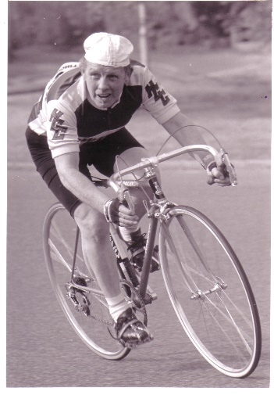
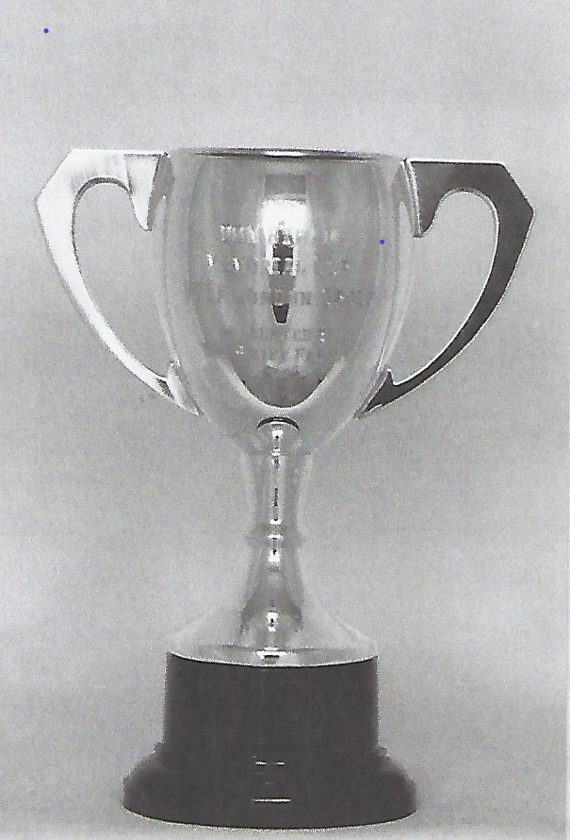

In the days long ago when teams were restricted to two due to shortage of riders, Don was so often one of the team members but never an event winner—bridesmaid but never the bride.

Don died just a few days before his retirement, just as he was anticipating that more time to train could mean that he would become a winner.

The Don Byham Memorial Trophy was presented by fellow member Terry Swift and first won in 1985 by John Webb (VC Slough). It is awarded to the second best on standard member of the London & Home Counties. The trophy is presented at the LH&C Annual Luncheon and Prize Presentation.

Organiser Contact Details
Geoff Perry
8 The Meadway, Loughton, Milton Keynes
07808 905879
geoffreyperry@aol.com

Officials
Start Time Keeper - Katja Rietdorf - London & Home Counties VTTA - (LNDC)
Finish Time Keeper - Mike Bannister (LNDC)

Marshalls
We have only the minimum number of marshals so take special care you know the course, especially on the first turn which has 2 large meandering roundabouts and several chances to go wrong! There will be no marshal where you enter the slip road from the DC for the first turn, but a sign will be placed. It is the very first slip road after the start, so no reason to go wrong.

Prize List
Awards are made to VTTA members only.
VTTA Gold-Silver-Bronze Medals for Men BOS (Best On Standard) 1-2-3, which will also be the same as Men Fastest 1-2-3 on Vets’ Handicap Times (VHT)
VTTA Gold-Silver-Bronze Medals for Women BOS/VHT 1-2-3
VTTA Golds-Medals (each) for Club Team of 3 BOS/VHT
VTTA Gold Medal - Fastest Man on Actual Time
VTTA Gold Medal - Fastest Woman on Actual Time

VTTA Gold Medals – Fastest Tandem BOS
VTTA Gold Medals – Fastest Tandem on Actual Time

1st Man & Woman BOS/VHT receive an invitation to the LH&C Annual Luncheon and Prize Presentation

Local Regulations

Numbers, Signing in and signing out
You sign on in advance of your start at the HQ where you can collect your number and receive any last minute instructions or warnings. You will also need to sign out of the event otherwise you will be DISQUALIFIED.

Local Regulation 1. – No U Turns should be made at any time while riding on the public highway.
Local Regulation 2. – Car Parking
There must be no parking of motor vehicles on any part of the A41 apart from those of the officials.

Local Regulation 3. – Finishing riders MUST leave the main carriageway at the START of the exit slip road to B489. Failure to do so will be recorded as DNF and no time given (see below)

F11/10 & DNFs
This course often sees several riders with no finishing time (DNF) because they DO NOT follow the course and the specific finishing instructions, which are in place for the rider’s safety, as cars enter the slip-road early and at high speed!
Carefully study the illustrations & photos which follow:
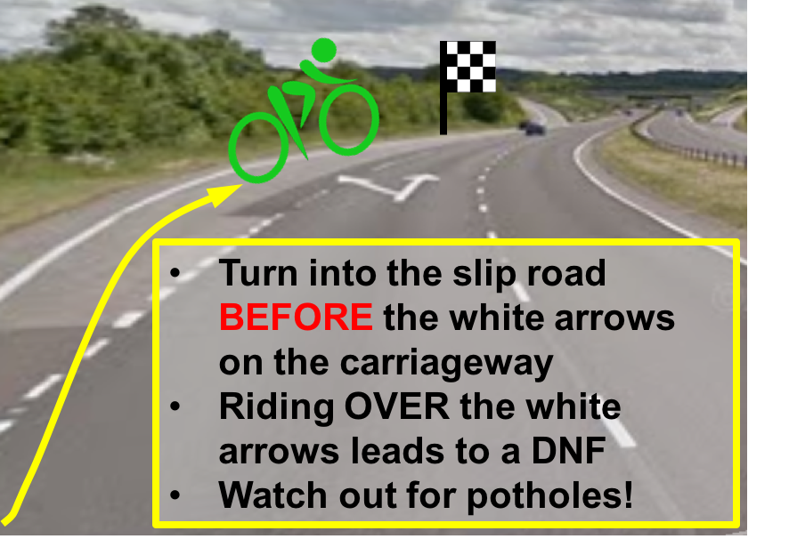

Cars do enter the slip road very early!
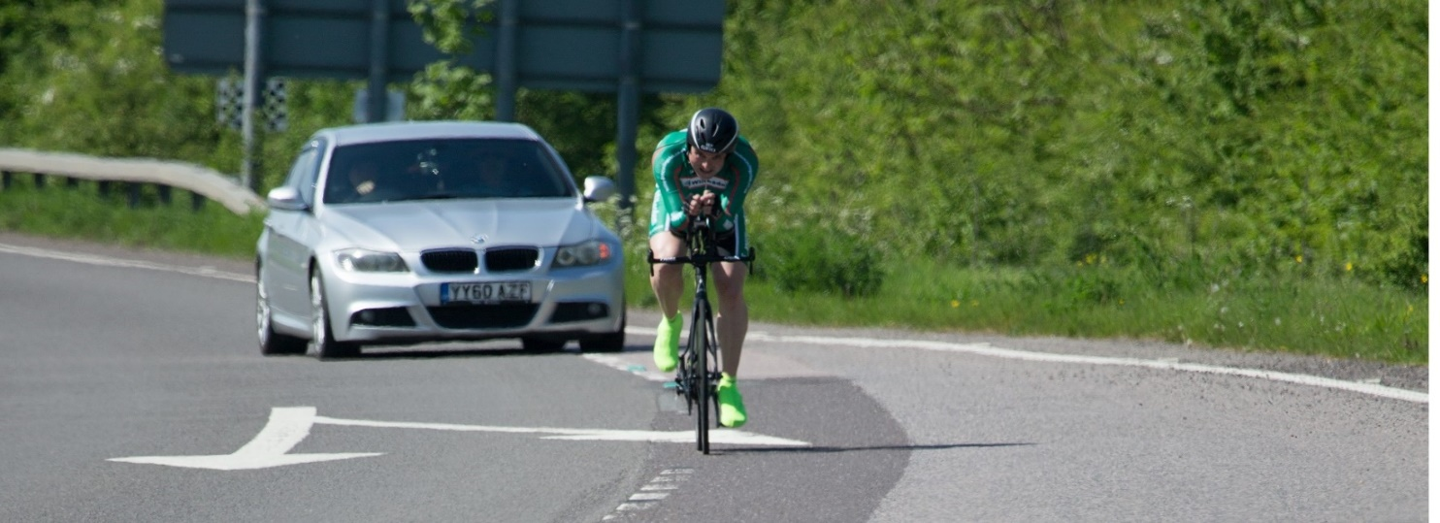

Heading off for another 10 miles? DNF
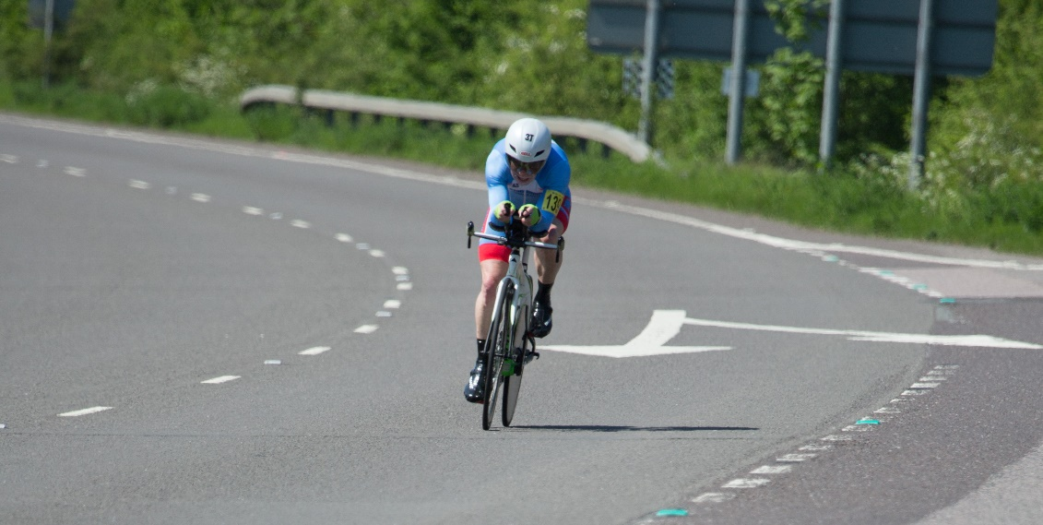
Copyright - David Lloyd - www.davidlloydphotography.smugmug.com
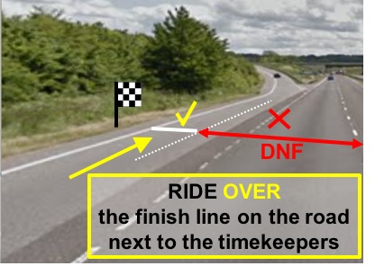

Route HQ to Start

Start
Local Regulation 1. – No U Turns should be made at any time while riding on the public highway.

Car Parking
There must be no parking of motor vehicles on any part of the A41 apart from those of the officials.

Directions
Start Maps location: for 51.79193351968347, -0.6874430467625308
Approximate location what3words ///mistaken.protect.shallower
1.7 miles (10 minutes)
Turn Right out of the HQ, proceed down Mortimer Hill.
At the T-junction turn left onto Brook Street (B488~) and then immediately right at the mini-roundabout into the High Street (B4635). Watch out for any speed ramps or cobbles.
Procced along the High Street to a larger Roundabout and take the 2nd exit (“straight over”) onto Western Road and proceed, as it is renamed Aylesbury Road, and climb the hill (about 30m in height gain) to the (familiar) start (1st exit) at the roundabout. (A41/B4009/Icknield Way).
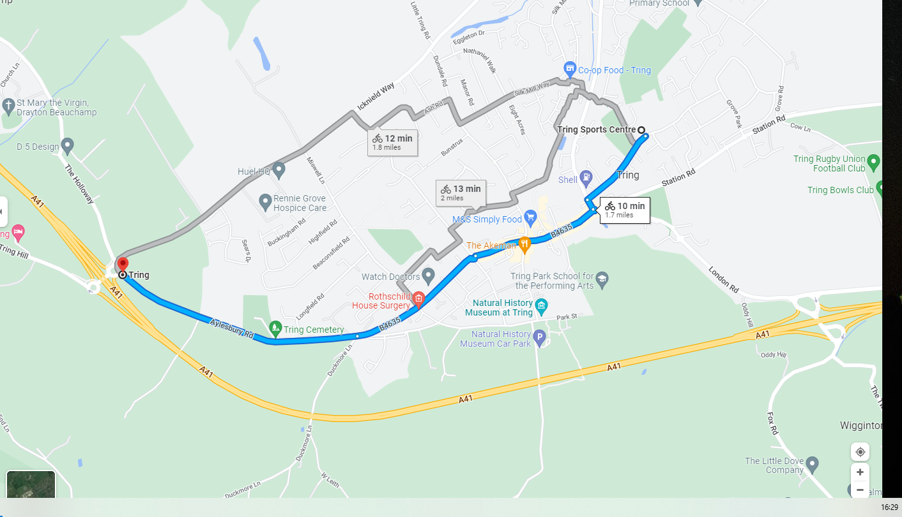......

Route Finish to HQ

Finish maps location: 51.79193351968347, -0.6874430467625308

Finish to HQ 3.1 miles (19 mins)
Continue up the Slip Road to the T-Junction
Turn left onto Lower Icknield Way and immediately turn right
Onto The Holloway (a country road). Proceed through Drayton Beauchamp
Climb up hill to the (now-familiar) start Roundabout (A41/B4009/Icknield Way)
Then retrace your route back to the HQ
Down Aylesbury Road, 2nd exit (“straight over”) at the roundabout, along the High Street, until the mini roundabout. Watch out for speed ramps and cobblestones.
At the roundabout, take the 1st left onto Brook St/B488, and immediately
Turn right onto Mortimer Hill and Climb the Hill to the Tring Sports Centre on the left.

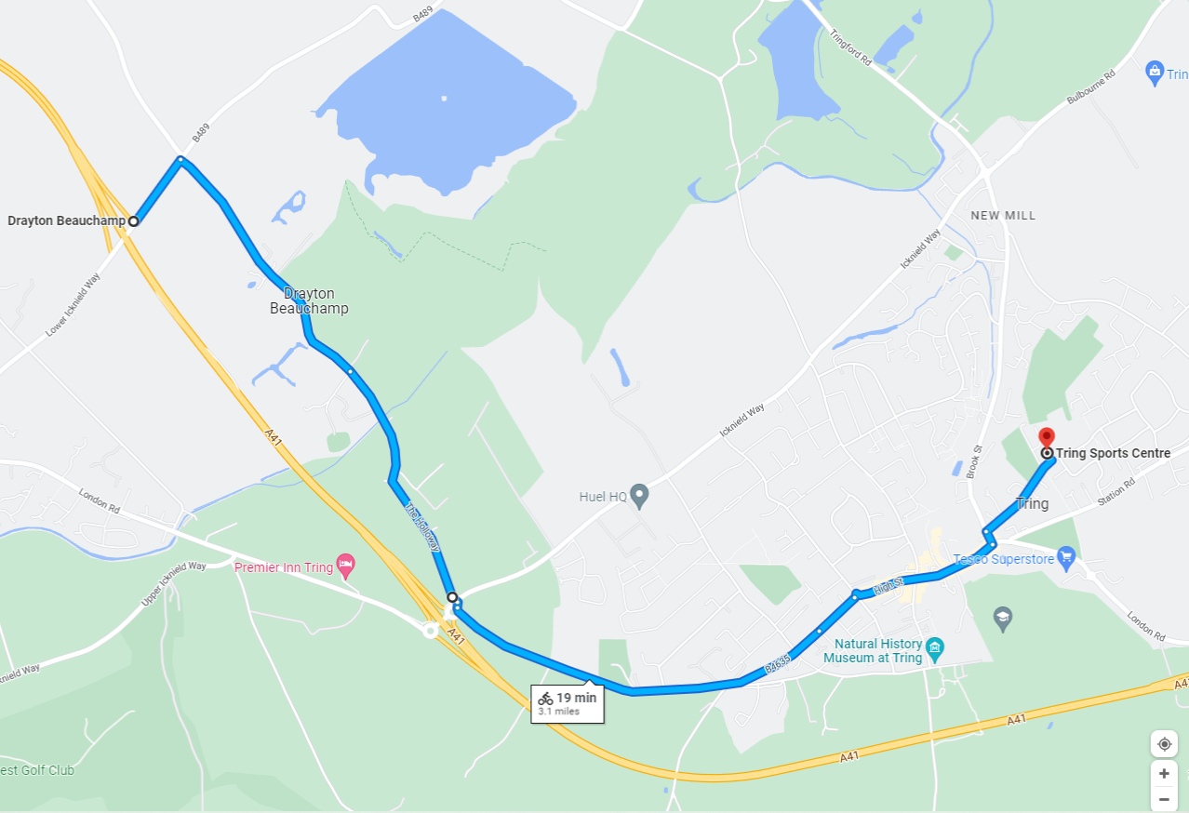

Course Details

Start (A on Map) on southbound slip road to A41 on the Western Tring junction approximately 40 yards from the start of the slip road.
Proceed along A41 to come off at first slip road (Eastern Tring junction) to

Turn (approximately 2.0 miles) by taking 4th exit out of roundabout (giving priority as to join first roundabout to traffic on your right with restricted view) and under the A41, going around 2nd roundabout to take 2nd exit back (slip road) onto the A41 westbound and continue past all junctions to roundabout at end of Aston Clinton by-pass to

Turn (7.87 miles) by taking 3rd exit out of roundabout back along the by-pass, again ignoring College Road junction to

Finish (B on Map) on Buckland slip road 9 yards south-east of manhole cover on grass verge, about 91 yards north-west of (i.e. before) separation of slip road and main carriageway, also about 460 yards north-west of the B489 overbridge.

Finishing riders MUST leave the main carriageway at the START of the exit slip road to B489. Failure to do so will be recorded as DNF and no time will be recorded.

Quite a good way to visualize the course is that it is a series of 2-mile ‘intervals’. 2-miles flat to the first RAB, ‘recover’ on the RAB, 2-miles flat to the top of the hill, 2-mile ‘recovery’ down the hill, 2-miles flat to the RAB, ‘recover’ on the RAB then a final 2-miles flat to the finish.
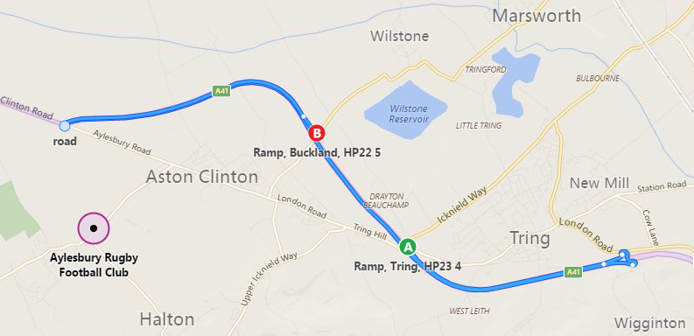
First DOUBLE Roundabout after 2 miles – Many riders like to explore the wide selection of exits and even ride the wrong way up entrances to the roundabout, where they will unsurprisingly meet vehicles head-on! If you go wrong here the walk-of-shame back to the HQ is only 0.7 miles!
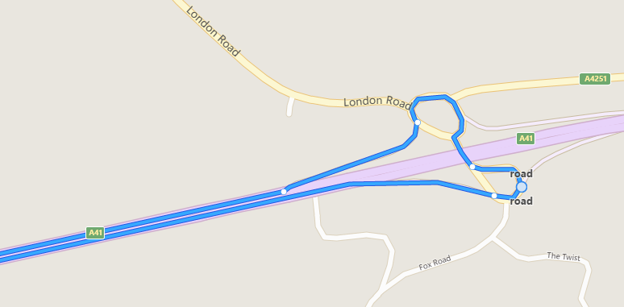

Last roundabout – 2 miles to go to the finish – give full gas.
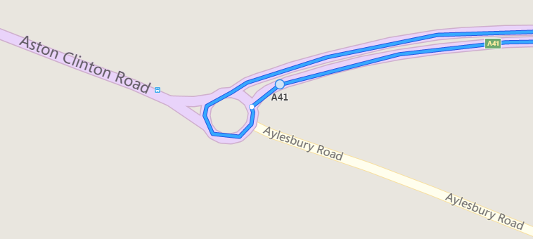
Roundabouts
At roundabouts the traffic coming from the right has PRIORITY over you, so give way. The first RAB at the bottom of the off slip road DOES NOT have good line of sight of traffic so take GREAT CARE. Make yourself familiar with the layout of the 1st roundabout as riders all too frequently go wrong and waste a fast time, BREAK the Highway Code and risk being DISQUALIFIED. Because of the location of the HQ many of you will have navigated part of this RAB whilst driving to the HQ.

Start List
BIB | Start | Rider | Club | M/F | Bike / Trike | VTTA STD | Vets' Handicap | VTTA Grp
1 | 08:31 | Matthew Reader | Verulam CC | M | B | 27:01 | 0:55 | L&HC
2 | 08:32 | James Wooldridge | Team Milton Keynes | M | B | 26:14 | 0:08 | L&HC
3 | 08:33 | Richard Moule | Bossard Whs | M | B | 28:30 | 2:24 | L&HC
4 | 08:34 | Kevin Humphreys | Sherwood CC | M | B | 28:06 | 2:00 | EMID
5 | 08:35 | Nick Morgan | Hitchin Nomads CC | M | B | 26:14 | 0:08 | #N/A
6 | 08:36 | Colin Harrison | East Grinstead CC | M | B | 27:30 | 1:24 | EA
7 | 08:37 | Robert Saunders | North Bucks RC | M | B | 28:06 | 2:00 | L&HC
8 | 08:38 | David Cook | Bedfordshire Road RT | M | B | 28:39 | 2:33 | L&HC
9 | 08:39 | Andrew Knight | Bedfordshire Road CC | M | B | 26:36 | 0:30 | L&HC
10 | 08:40 | Joel Stewart | Team Ohten Aveas | M | B | 26:36 | 0:30 | L&HC
11 | 08:41 | Sheehan Quirke | VC Veldrijden | M | B | 27:30 | 1:24 | NMID
12 | 08:42 | Gary Pamment | CC Sudbury | M | B | 26:56 | 0:50 | EA
13 | 08:43 | Mark Halliday | North Bucks RC | M | B | 27:37 | 1:31 | L&HC
14 | 08:44 | Philip Skinner | Welwyn Whs | M | B | 27:24 | 1:18 | L&HC
15 | 08:45 | Keith Lea | Paceline RT | M | B | 27:01 | 0:55 | #N/A
16 | 08:46 | Michael Bennett | Bicester Millennium CC | M | B | 27:07 | 1:01 | L&HC
17 | 08:47 | Tim Davies | CC Luton | M | B | 27:12 | 1:06 | L&HC
18 | 08:48 | David Marshall | Hemel Hempstead CC | M | B | 27:24 | 1:18 | L&HC
19 | 08:49 | James Hunt | Oxonian CC | M | B | 26:27 | 0:21 | #N/A
20 | 08:50 | Graham Winstone | ZeroBC Race Team | M | B | 26:46 | 0:40 | L&HC
21 | 08:51 | Peter Younghusband | Petersfield Tri Club | M | B | 27:30 | 1:24 | WSX
22 | 08:52 | Conall Yates | Team Solo Vinci | M | B | 26:10 | 0:04 | S/S
23 | 08:53 | James Harris | Catford CC Ltd | M | B | 26:19 | 0:13 | #N/A
24 | 08:54 | Mike Kirby | Banbury Star CC | M | B | 28:13 | 2:07 | L&HC
25 | 08:55 | Colin McDermott | Festival Road Club | M | B | 27:12 | 1:06 | S/S
26 | 08:56 | Graham Harman | Sotonia CC | M | B | 26:56 | 0:50 | #N/A
27 | 08:57 | Peter Cottington | Bath Cycling Club | M | B | 27:51 | 1:45 | L&HC
28 | 08:58 | Chris Grimble | Bicester Millennium CC | M | B | 26:41 | 0:35 | #N/A
29 | 08:59 | Martin Wright | Eat Plants Not Pigs CC | M | B | 26:27 | 0:21 | MIDS
30 | 09:00 | Tim Lewis | Ful-on Tri | M | B | 26:23 | 0:17 | #N/A
31 | 09:01 | Andrew Grant | Cambridge CC | M | B | 29:08 | 3:02 | EA
32 | 09:02 | Geoff Reynolds | Hemel Hempstead CC | M | B | 27:24 | 1:18 | EA
33 | 09:03 | Peter Main | 34 Nomads CC | M | B | 27:24 | 1:18 | EA
34 | 09:04 | Tim Butler | Gloucester City CC | M | B | 26:36 | 0:30 | #N/A
35 | 09:05 | Brett Davis | DRAG2ZERO | M | B | 26:46 | 0:40 | S/S

BIB | Start | Rider | Club | M/F | Bike / Trike | VTTA STD | Vets' Handicap | VTTA Grp
36 | 09:06 | Simon Hall | Stourbridge CC | M | B | 26:14 | 0:08 | #N/A
37 | 09:07 | Timothy Budd | Hounslow & District Whs | M | B | 26:14 | 0:08 | #N/A
38 | 09:08 | Matthew Smith | Colour Tech RT | M | B | 26:14 | 0:08 | #N/A
39 | 09:09 | Christopher Rosam | Epsom CC | M | B | 27:58 | 1:52 | S/S
40 | 09:10 | Alastair Luxford | Full Gas Racing Team | M | B | 26:06 | 0:00 | #N/A
41 | 09:11 | Martin O'Sullivan | Teddington & Turing Velo | M | B | 26:36 | 0:30 | L&HC
42 | 09:12 | Jez Willows | Sherwood CC | M | B | 27:24 | 1:18 | EMID
43 | 09:13 | Hans Nilsson | London Phoenix CC | M | B | 28:39 | 2:33 | L&HC
44 | 09:14 | Cliff Voller | Newbury RC | M | B | 29:30 | 3:24 | WEST
45 | 09:15 | Mark Arnold | VTTA (East Anglia Group) | M | B | 26:36 | 0:30 | EA
46 | 09:16 | Neil Gerrard | Thanet RC | M | B | 26:10 | 0:04 | KENT
47 | 09:17 | Ragnar Laan | Twickenham CC | M | B | 26:23 | 0:17 | L&HC
48 | 09:18 | Adam Lowe | Metropolitan Police CC | M | B | 27:01 | 0:55 | EA
49 | 09:19 | Martin Simmons | C C C P | M | B | 27:24 | 1:18 | KENT
50 | 09:20 | Gaz Poulson | Royal Air Force CA | M | B | 27:12 | 1:06 | EMID
51 | 09:21 | Ian Woodcock | Bedfordshire Road RT | M | B | 26:41 | 0:35 | L&HC
52 | 09:22 | Martin Stanley | Droitwich Cycling Club | M | B | 27:18 | 1:12 | MIDS
53 | 09:23 | Andrew Halliday | Westerley Cycling Club | M | B | 26:51 | 0:45 | L&HC
54 | 09:24 | Neil Barford | 45 RC | M | B | 27:30 | 1:24 | #N/A
55 | 09:25 | Stuart Hourigan | VeloRefined Rule 5 | M | B | 26:32 | 0:26 | KENT
56 | 09:26 | Mark Hamer | Stratford Cycling Club | M | B | 26:36 | 0:30 | MIDS
57 | 09:27 | Mike Watson | Lowestoft Wheelers CC | M | B | 27:37 | 1:31 | EA
58 | 09:28 | Michael Edmunds | Verulam Really Moving | M | B | 27:24 | 1:18 | L&HC
59 | 09:29 | Paul James | VTTA West Group | M | B | 26:51 | 0:45 | WEST
60 | 09:30 | James Fawcett | ...a3crg | M | B | 27:24 | 1:18 | WSX
61 | 09:31 | Paul Newman | Shorter Rochford RT | M | B | 26:56 | 0:50 | L&HC
62 | 09:32 | Scott Beard | Shaftesbury CC | M | B | 26:41 | 0:35 | EA
63 | 09:33 | Alan Allcock | Didcot Phoenix CC | M | B | 28:49 | 2:43 | L&HC
64 | 09:34 | Phil Laing | Lea Valley CC | M | B | 26:10 | 0:04 | #N/A
65 | 09:35 | Jeremy Redford | Army Cycling | M | B | 26:46 | 0:40 | WEST
66 | 09:36 | Antony Bee | Wigmore CC | M | B | 27:37 | 1:31 | KENT
67 | 09:37 | Stan Nwaka | Verulam CC | M | B | 27:51 | 1:45 | L&HC
68 | 09:38 | Nick Taylor | Metropolitan Police CC | M | B | 27:12 | 1:06 | EA
69 | 09:39 | Simon Hunt | VéloElite RC | M | B | 26:56 | 0:50 | EMID
70 | 09:40 | Ian Hope | Team Ohten Aveas | M | B | 26:41 | 0:35 | EA

BIB | Start | Rider | Club | M/F | Bike / Trike | VTTA STD | Vets' Handicap | VTTA Grp
71 | 09:41 | Richard Gifford | trainSharp | M | B | 27:44 | 1:38 | S/S
72 | 09:42 | Jason Davies | Royal Air Force CA | M | B | 26:51 | 0:45 | EA
73 | 09:43 | George Turner | VTTA (L&HC) | M | B | 26:14 | 0:08 | L&HC
74 | 09:44 | Mike Boyce | ...a3crg | M | B | 28:39 | 2:33 | WSX
75 | 09:45 | David Rumm | Southborough & Dist. Whs | M | B | 27:12 | 1:06 | S/S
76 | 09:46 | Andy King | Kettering CC | M | B | 27:58 | 1:52 | EMID
77 | 09:47 | Adrian Cox | Team Milton Keynes | M | B | 27:58 | 1:52 | L&HC
78 | 09:48 | Ian Radburn | Oxonian CC | M | B | 27:12 | 1:06 | L&HC
79 | 09:49 | John J Murphy | Gloucester City CC | M | B | 32:17 | 6:11 | WEST
80 | 09:50 | Matt Boulton | Swindon Wheelers | M | B | 26:06 | 0:00 | WEST
81 | 09:51 | Tim Cox | Hemel Hempstead CC | M | B | 26:32 | 0:26 | L&HC
82 | 09:52 | Daniel Homer | London Phoenix CC | M | B | 26:56 | 0:50 | #N/A
83 | 09:53 | Steven Loraine | Legato Racing Team (LRT) | M | B | 28:30 | 2:24 | MIDS
84 | 09:54 | Mark Vowells (Tricycle) | San Fairy Ann CC | M | T | 31:20 | 5:14 | KENT
85 | 09:55 | Steven Cottington | Bath Cycling Club | M | B | 27:51 | 1:45 | WEST
86 | 09:56 | Dan Jenkins | Southend Wheelers | M | B | 27:12 | 1:06 | EA
87 | 09:57 | Stephen Murphy | Shaftesbury CC | M | B | 28:39 | 2:33 | EA
88 | 09:58 | Andrew Grant | Chelmer CC | M | B | 28:13 | 2:07 | EA
89 | 09:59 | David England | Crabwood Cycling Club | M | B | 31:05 | 4:59 | WSX
90 | 10:00 | Nick Dwyer | DRAG2ZERO | M | B | 27:37 | 1:31 | S/S
91 | 10:01 | Stephen Wilkinson | TWB - On Time Race Team | M | B | 27:24 | 1:18 | KENT
92 | 10:02 | Paul Smith | VeloRefined Rule 5 | M | B | 26:51 | 0:45 | KENT
93 | 10:03 | Michael Parker | TMG Horizon Cycling Team | M | B | 27:30 | 1:24 | L&HC
94 | 10:04 | Chris Dyason | Cambridge CC | M | B | 30:07 | 4:01 | EA
95 | 10:05 | Grant Orsborn | Bedfordshire Road RT | M | B | 27:58 | 1:52 | EA
96 | 10:06 | Ed Watson | Ratae RC | M | B | 26:36 | 0:30 | EMID
97 | 10:07 | Stu Carver | North Hampshire RC | M | B | 27:24 | 1:18 | WSX
98 | 10:08 | David Prom | San Fairy Ann CC | M | B | 27:01 | 0:55 | KENT
99 | 10:09 | Paul Valks | Lewes Wanderers CC | M | B | 31:05 | 4:59 | S/S
 |  | WOMEN
101 | 10:11 | Kirsty McSeveney | ...a3crg | F | B | 28:38 | 2:32 | WSX
102 | 10:12 | Danuta Tinn | Maidenhead & District CC | F | B | 30:08 | 4:02 | L&HC
103 | 10:13 | Jayne Paine | Les Filles Racing Team | F | B | 30:01 | 3:55 | L&HC
104 | 10:14 | Rachel Green | Cheltenham & County CC | F | B | 30:31 | 4:25 | WEST
105 | 10:15 | Claire Emons | ...a3crg | F | B | 29:41 | 3:35 | WSX

BIB | Start | Rider | Club | M/F | Bike / Trike | VTTA STD | Vets' Handicap | VTTA Grp
106 | 10:16 | Lisa Davis | DRAG2ZERO | F | B | 29:07 | 3:01 | #N/A
107 | 10:17 | Joy Payne | High Wycombe CC | F | B | 31:15 | 5:09 | L&HC
108 | 10:18 | Gillian Reynolds | Willesden CC | F | B | 32:49 | 6:43 | L&HC
109 | 10:19 | Lorna Rowland | Twickenham CC | F | B | 29:35 | 3:29 | #N/A
110 | 10:20 | Kim Barfoot-Brace | Bath Cycling Club | F | B | 28:38 | 2:32 | WEST
 |  | TANDEMS
112 | 10:22 | Richard May | Islington Cycling Club | M | TAN | 26:11 | #N/A | L&HC
 |  | David Shannon | Islington Cycling Club | M | TAN | 26:11 | #N/A | L&HC
114 | 10:24 | Christopher York | Maldon & District CC | M | TAN | 27:10 | #N/A | #N/A
 |  | Joanne York | Maldon & District CC | F | TAN | 27:10 | #N/A | #N/A
116 | 10:26 | Andrew Hutchison | Lowestoft Wheelers CC | M | TAN | 27:46 | #N/A | EA
 |  | Catherine Hutchison | Lowestoft Wheelers CC | F | TAN | 27:46 | #N/A | EA

VTTA National Age Records
As the F11/10 is one of the fastest 10 mile courses in the country a number of records have been set on the course (course record 17:16). So for ease of reference these are the age records at the end of 2021, covering the age range of those riders schedule to compete in the event.
Solo Men |  | Age |  | Year |  | Course |  | Record
James Rix |  | 41 |  | 2017 |  | V718 |  | 17:47
Stephen Irwin |  | 45 |  | 2016 |  | V718 |  | 17:49
Stephen Irwin |  | 46 |  | 2017 |  | V718 |  | 17:59
Ian Guilor |  | 50 |  | 2017 |  | V718 |  | 18:02
Richard Oakes |  | 52 |  | 2021 |  | F11/10 |  | 18:08
Kevin Tye |  | 56 |  | 2018 |  | E2/10 |  | 18:44
Kevin Tye |  | 57 |  | 2019 |  | P881 |  | 19:01
Kevin Tye |  | 59 |  | 2021 |  | E2/10 |  | 19:11
Keith Ainsworth |  | 62 |  | 2021 |  | F11/10 |  | 19:23
Roger Iddles |  | 65 |  | 2009 |  | V718 |  | 19:51
Andrew Grant |  | 66 |  | 2019 |  | F11/10 |  | 20:08
Andrew Grant |  | 68 |  | 2021 |  | F11/10 |  | 20:15
Terry Icke |  | 73 |  | 2017 |  |  |  | 20:21
Brian Sunter |  | 74 |  | 2017 |  | V718 |  | 21:08
Michael Allen |  | 75 |  | 2021 |  | E2/10 |  | 22:19
Vincent Jenkins |  | 76 |  | 2016 |  | V718 |  | 22:26
Frank Kerry |  | 77 |  | 2012 |  | V718 |  | 22:31
Derek Stewart |  | 78 |  | 2015 |  | V718 |  | 22:35
Ron Hallam |  | 79 |  | 2009 |  | L1015 |  | 22:42
Dennis Milsom |  | 80 |  | 2008 |  | P613 |  | 22:56
Dennis Milsom |  | 82 |  | 2010 |  |  |  | 23:20
Ron Hallam |  | 85 |  | 2015 |  | O10/3 |  | 23:46
Solo Women
Rider | Age |  | Year |  | Course |  | Record
Angela Carpenter | 52 |  | 2021 |  | E2/10 |  | 20:27
Jackie Field | 53 |  | 2018 |  | E2/10 |  | 21:20
Jackie Field | 56 |  | 2021 |  | E2/10 |  | 21:26
Sarah Matthews | 58 |  | 2018 |  | P881R |  | 21:33
Lindsay Clarke | 59 |  | 2021 |  | A10/3 |  | 22:01
Carole Gandy | 61 |  | 2005 |  | Q10/19 |  | 22:09
Carole Gandy | 66 |  | 2010 |  |  |  | 22:21
Carole Gandy | 67 |  | 2011 |  | V718 |  | 22:28
Carole Gandy | 68 |  | 2012 |  | V718 |  | 23:51
Arja Scarsbrook | 70 |  | 2018 |  | P881/R |  | 24:18
Arja Scarsbrook | 71 |  | 2019 |  | P881R |  | 24:42
Gillian Reynolds | 72 |  | 2021 |  | F11/10 |  | 24:59
Arja Scarsbrook | 73 |  | 2021 |  | R10/17 |  | 25:15
Gill Henshaw | 74 |  | 2008 |  | V718 |  | 25:41

Tandem Men
Riders | Age | Year | Course | Record
Eddie Green & Martyn Winter | 107 | 1987 |  | 19:07
Eddie Green & Martyn Winter | 109 | 1988 |  | 19:08
Cliff Beldon & Simon Beldon | 118 | 2017 | V718 | 19:28

Tandem Mixed
Riders | Age | Year | Course | Record
Alex Deck & Richard Dixon | 104 | 2017 | V718 | 18:22
Vic Haines & Sue Fenwick | 106 | 2010 |  | 20:23
Paul Bennett & Nikki Hunt | 116 | 2000 | E2/10 | 20:24

