Gil Jessop Memorial 'Sporting 14' Time Trial
24th edition

Promoted for and on behalf of Cycling Time Trials under their Rules and Regulations

Sunday 12th February 2017

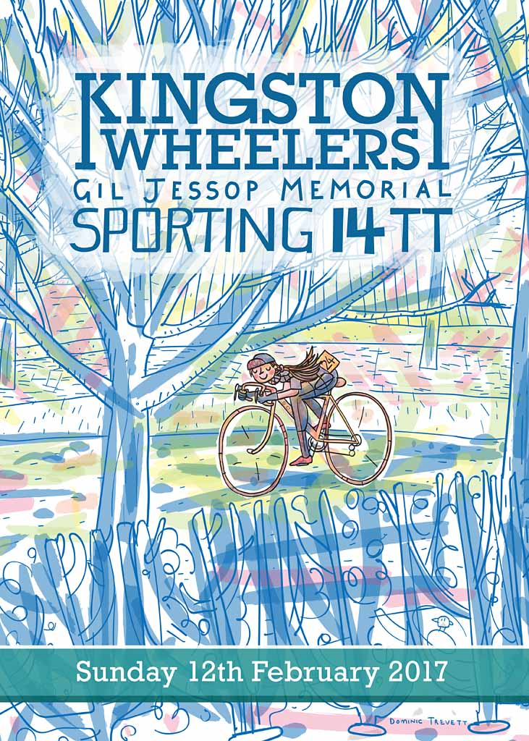

With thanks to:
Timekeepers Mike Labram and Kathleen Collard Berry
Event Secretary Mr Rob Gardner

Event Organisers Mr Henrik Persson, Miss Alice Lethbridge
Course Records

John Dewey 30.07 from Rob Sharland 30:31 (2016)

Prizes
KW Gil Jessop Sporting 14 Trophy John Dewey

Men
1st | John | Dewey | Team Bottrill / HSS Hire | 00:30:07
2nd | Robert | Sharland | Paceline RT | 00:30:11
3rd | Matt | Langworthy | Mid Devon CC | 00:31:41
4th | Pat | Wright | Paceline RT | 00:31:55
5th | Andrew | Snook | Kingston Wheelers CC | 00:33:32

Veteran Men
1st | Liam | Maybank | Twickenham CC | 00:30:45
2nd | James | Wright | Charlotteville Cycling Club | 00:32:57
3rd | Les | Liddiard | Team Jewson - MI Racing | 00:35:35

Women
1st | Alice | Lethbridge | DRAG2ZERO | 00:35:33

Junior Men
1st | Thomas | Cornwell | In-Gear Quickvit Trainsharp RT | 00:38:19

Men Road Bike
1st | Paul | Moore | Paceline RT | 00:34:05
2nd | Mark | Aldred | Kingston Wheelers CC | 00:34:40
3rd | Tom | Herbert | Kingston Wheelers CC | 00:36:21

Women Road Bike
1st | Helen | Bridgman | Kingston Wheelers CC | 00:43:51

Team
Paceline RT – 1.35.49

Finish Times

Rank | Rider No. | Name | Club | Cat | First Lap | Finish Time | +/- standard
1 | 85 | John Dewey | Team Bottrill / HSS Hire | M | 00:14:50 | 00:30:07
2 | 100 | Robert Sharland | Paceline RT | M | 00:15:05 | 00:30:11
3 | 90 | Liam Maybank | Twickenham CC | Mv | 00:15:09 | 00:30:45 | +00:05:06
4 | 95 | Matt Langworthy | Mid Devon CC | M | 00:15:15 | 00:31:41
5 | 80 | Pat Wright | Paceline RT | M | 00:15:45 | 00:31:55
6 | 60 | James Wright | Charlotteville Cycling Club | Mv | 00:16:13 | 00:32:57 | +00:02:54
7 | 46 | Andrew Snook | Kingston Wheelers CC | M | 00:16:27 | 00:33:32
8 | 55 | Henrik Persson | Kingston Wheelers CC | M | 00:16:46 | 00:33:39
9 | 92 | thomas whatley | Paceline RT | M | 00:16:38 | 00:33:43
10 | 67 | Paul Moore | Paceline RT | M | 00:16:43 | 00:34:05
11 | 50 | Neil Grunshaw | Kingston Wheelers CC | M | 00:17:01 | 00:34:32
12 | 73 | Mark Aldred | Kingston Wheelers CC | M | 00:17:14 | 00:34:40
13 | 41 | James Griffin | Kingston Wheelers CC | M | 01:17:06 | 00:34:44
14 | 81 | Eddie Allen | Redmon CC | M | 00:17:10 | 00:34:50
15 | 86 | Andy Lack | Paceline RT | Mv | 00:17:18 | 00:35:07 | +00:01:03
16 | 65 | Alice Lethbridge | DRAG2ZERO | F | 00:17:32 | 00:35:33
17 | 96 | Les Liddiard | Team Jewson - MI Racing | Mv | 00:17:28 | 00:35:35 | +00:02:06
18 | 97 | Tom Herbert | Kingston Wheelers CC | M | 00:17:52 | 00:36:21
19 | 76 | Jonathan Pontin | Addiscombe CC | M | 00:18:14 | 00:36:39
20 | 82 | Harry Bunnell | Kingston Wheelers CC | M | 00:18:15 | 00:36:53
21 | 59 | Andy Leatherbarrow | Kingston Wheelers CC | M | 00:18:12 | 00:37:00
22 | 45 | Martin Winter | Twickenham CC | Mv | 00:18:18 | 00:37:27 | -00:00:46
23 | 48 | Nic Rowe | Kingston Wheelers CC | M | 00:18:43 | 00:37:54
24 | 47 | philip deacon | Epsom CC | Mv | 00:18:42 | 00:37:56 | -00:02:24
25 | 71 | Damian Poulter | Hounslow & District Whs | Mv | 00:18:48 | 00:38:03 | -00:02:24
26 | 40 | Thomas Cornwell | In-Gear Quickvit Trainsharp RT | Mj | 00:20:19 | 00:38:19
27 | 36 | Craig Lawrence | Kingston Wheelers CC | M | 00:18:41 | 00:38:22
28 | 43 | Elliot Banks | Imperial College Cycling Club | M | 00:18:50 | 00:38:31
29 | 57 | Daniel Loveday | Charlotteville Cycling Club | Mv | 00:19:15 | 00:38:48 | -00:03:23
30 | 93 | Chris Phillips | Charlotteville Cycling Club | M | 00:19:11 | 00:39:09
31 | 77 | Luca Palazzo | Kingston Wheelers CC | M | 00:19:10 | 00:39:24
32 | 72 | Daniel Sharp | Charlotteville Cycling Club | Mv | 00:19:16 | 00:39:29 | -00:03:38
33 | 79 | Luke Snellin | Kingston Wheelers CC | M | 00:19:48 | 00:39:58
34 | 94 | Derrick Thirlwell | Kingston Wheelers CC | M | 00:19:49 | 00:40:21
35 | 98 | Jamie Freeland | South London Harriers | Mv | 00:19:50 | 00:40:30 | -00:04:39
36 | 78 | Lee Williams | Wimbledon Windmilers | Mv | 00:20:17 | 00:42:01 | -00:05:26
37 | 84 | Jack Knivett | Charlotteville Cycling Club | M | 00:20:46 | 00:42:17
38 | 53 | Dominic Trevett | Kingston Wheelers CC | M | 00:21:20 | 00:43:15
39 | 63 | Helen Bridgman | Kingston Wheelers CC | F | 00:21:35 | 00:43:51
40 | 69 | Jack Hartrey | Kingston Wheelers CC | Mj | 00:23:08 | 00:47:20
41 | 38 | Nicholas Rowe | Kingston Wheelers CC | M | 00:28:43 | 00:47:54
42 | 58 | David Eccles | Redmon CC | Mv | 00:23:54 | 00:48:03 | -00:08:40
43 | 44 | Chris Brewer | Redmon CC | Mv | 00:26:28 | 00:53:39 | -00:16:30
44 | 56 | Richard Hoskin | Redmon CC | F | 00:30:05 | 01:01:06
45 | 37 | Sophie Household | SSLL Racing Team | Mv | D.N.S. | D.N.F.
46 | 39 | Michael Draper | Charlotteville Cycling Club | Mj | D.N.S. | D.N.F.
47 | 42 | Theo Tadros | In-Gear Quickvit Trainsharp RT | M | D.N.S. | D.N.F.
48 | 49 | David Sharman | Wimbledon Windmilers | M | D.N.S. | D.N.F.
49 | 51 | Neil Hornett | PMR @ Toachim House | M | D.N.S. | D.N.F.
50 | 52 | Tom Hampshire | Paceline RT | Mv | D.N.S. | D.N.F.
51 | 54 | Andrew Cain | Charlotteville Cycling Club | F | D.N.S. | D.N.F.
52 | 61 | joscelin lowden | Lewes Wanderers CC | F | D.N.S. | D.N.F.
53 | 62 | Rachel Przybylski | Charlotteville Cycling Club | Fv | D.N.S. | D.N.F.
54 | 64 | Kim Bainbridge | Viceroys Triathlon Club | Mv | D.N.S. | D.N.F.
55 | 66 | David Churchill | Bigfoot CC | Mv | D.N.S. | D.N.F.
56 | 68 | David Ryan | London Dynamo | Mv | D.N.S. | D.N.F.
57 | 70 | Peter Tadros | In-Gear Quickvit Trainsharp RT | Mv | D.N.S. | D.N.F.
58 | 74 | James Horan | South Downs Bikes / Casco Europe | Mv | D.N.S. | D.N.F.
59 | 75 | Keith Lea | Paceline RT | Mv | D.N.S. | D.N.F.
60 | 83 | Luke Horsfield | Wimbledon Windmilers | M | D.N.S. | D.N.F.
61 | 87 | Jacob Law-Sales | LFGSS CC | Mv | D.N.S. | D.N.F.
62 | 88 | Harry Skinner | Kingston Wheelers CC | M | D.N.S. | D.N.F.
63 | 89 | John Dent | Newcomers Cycling Club | M | D.N.S. | D.N.F.
64 | 91 | Dale Lush | Kingston Phoenix | Mv | D.N.S. | D.N.F.
65 | 99 | nick harmon | Viceroys Triathlon Club | Mv | D.N.S. | D.N.F.

Kingston Wheelers Cycling Club
www.kingstonwheelers.com

