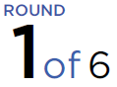
Promoted for and on behalf of Cycling Time Trials under their rules and regulations.
Headquarters
The Allendale Centre, Hanham Road, Wimborne. Dorset. BH21 1AS. Open from 8am for registration.
Printed copies of the start sheet will be available for collection, along with race numbers. There are toilet facilities and tea, coffee and cakes will be available.
Event Secretary
Paul Dytham
26 Queens Road, Blandford Forum, Dorset DT11 7JY
07775637568
pauldytham@hotmail.com

Time Keepers, Marshals and Volunteers
Start Time Keepers: Bob Richardson
Finish Time Keeper: Ros Spencer
Recorder: Marcia Rendall
Signing On & Off: Willie Kirkland and Anne Kirkland
Marshals: Members and friends of the Wessex Road Club
A full list of everyone who helped out will be with the results sheet. Without all of these fantastic volunteers we would have no race.
Prizes for Each Event
The prizes below are provided by CTT as listed on the cover of the start sheet.
 | 1st | 2nd | 3rd
Men | £20 | £15 | £10
Women | £20 | £15 | £10
Veteran (Scratch) | £20 | £15 | £10
Veteran (Target) | £20 | £15 | £10
Junior | £20 | £15 | £10
Paracyclist | £20 | £15 | £10
Road Bike (Men) | £20 | £15 | £10
Road Bike (Women) | £20 | £15 | £10
Road Bike (Junior) | £20 | £15 | £10

Instructions to riders
- Observers may be in attendance along the course;
- Riders must not make U-turns in the vicinity of the Start and Finish;
- This is a residential area please give consideration to local residents;
- NO warming up on the course;
- Your attention is drawn to the following CTT regulations:
  - Regulation 14(j) - Front light & Regulation 14(j) - Rear light. No competitor will be allowed to start without a working front and rear light, either flashing or constant, fitted to their machine in a position clearly visible to following road users and active whilst the machine is in use;
  - Regulation 15 - Helmet. All competitors MUST wear a hard/soft shell helmet that meets internationally accepted safety standards;
  - Regulation 20 - observance of the law;
  - Regulation 21 - paced and company riding.

Prize Presentation
If you can, please stay for the prize presentation, which takes place as soon after the finish as possible.
Parking
There is limited parking at The Allendale Centre for staff and blue badge holders. The main parking for the event is the pay & display Allenview carparks adjacent to the Centre.
From the HQ, turn left, straight across the first roundabout, left / 1st exit at the second roundabout onto Allenview Road then first left into the car park. There is NO parking at start or finish.
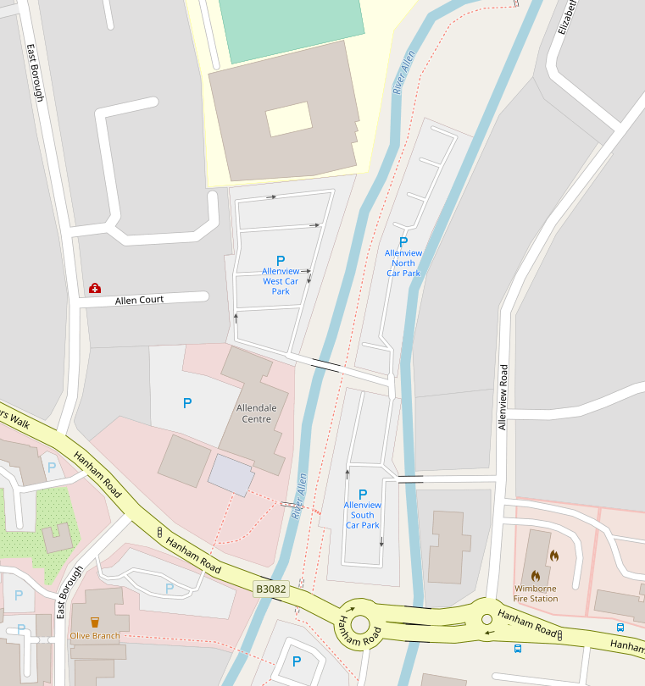

Course details
P427: START at milestone "Wimborne 1m" on B3078. (GR SU 011015). Proceed north to the Horton Inn (4.8m) where turn left on minor road to junction with A354 (CARE at narrow bridge oncoming traffic stay left). Turn left (GREAT CARE) onto A354 to Blandford bypass RBT (14.71m) where left / 1st exit to next RBT (15.59m). Left / 1st exit on B3082 to outskirts of Wimborne to FINISH approx. 200 yards short of Queen Elizabeth school.
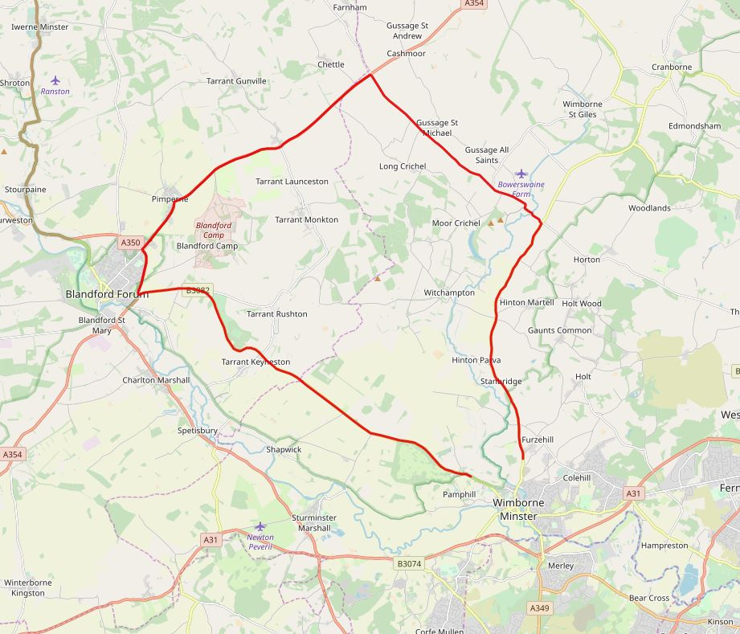

Safe route to start (Allow approx. 10-15 mins)
Turn right out of Allendale Centre HQ. Follow road right through traffic lights to follow B3078 signposted Cranborne. Go straight over the next traffic lights – take care over narrow bridge at the River Allen – and continue approximately 600 yards straight on to the start at the entrance of the layby / milestone.
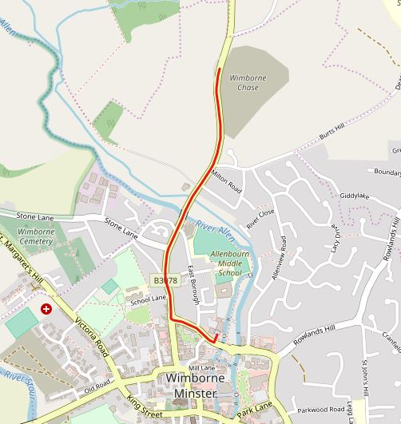

Safe route to HQ from finish
After the finish, continue straight on to traffic lights where fork left. Turn right at traffic lights at bottom of descent. Follow road left through next traffic lights then Allendale Centre HQ on left after approximately 200 yards.
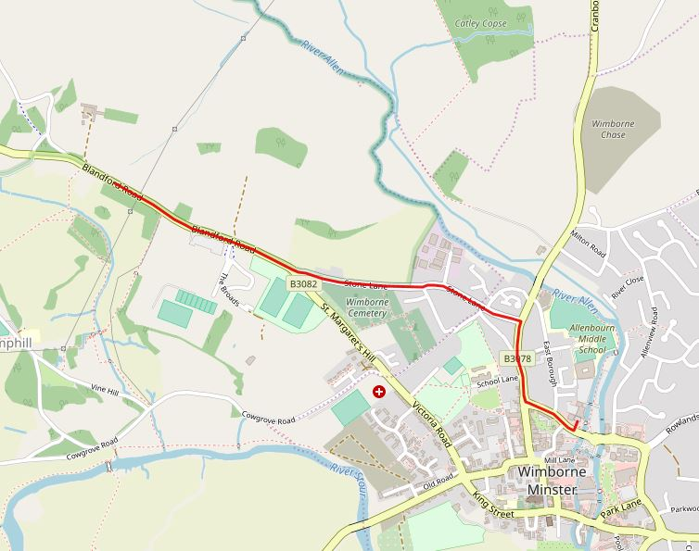

No. | Start | Name | Club | Age/Gen. | Category | Factor
 |  | Paracyclists
1 | 09:01:00 | Simon Richardson | TORQ Performance | 55 | C4 | 1.106
2 | 09:02:00 | Graeme Church | QN Racing | 56 | C1 | 1.237
3 | 09:03:00 | Martin Hailstone | Chapeau! Vive Le Velo | 53 | C4 | 1.106
4 | 09:04:00 | Nicholas Fairfield | City RC (Hull) | 51 | C4 | 1.106
5 | 09:05:00 | David Murphy | Liverpool Mercury CC | 24 | C5 | 1.058
 |  | Road Bikes
6 | 09:06:00 | Jennifer Lemen | PDQ Cycle Coaching | W 33
7 | 09:07:00 | Caroline Heighton | Ferryhill Whs | W 44
8 | 09:08:00 | Louisa Cooper | Bournemouth Jubilee Whs | W 39
9 | 09:09:00 | Bithja Jones | Pankhurst Cycles | W 42
10 | 09:10:00 | Michael Ashurst | Royal Air Force Cycling Association | 70
11 | 09:11:00 | Brett Wheeler | Poole Wheelers Cycling Club | 35
12 | 09:12:00 | Josh O'Brien | Wessex Road Club | 28
13 | 09:13:00 | Daniel Mahony | Velo Club Venta | 53
14 | 09:14:00 | Stephen Skinner | Velo Club St Raphael | 65
15 | 09:15:00 | Pete Bishop | Exeter Whs CC | 61
16 | 09:16:00 | Alex Cassar | Petersfield Triathlon Club | 39
17 | 09:17:00 | William Simmons | Christchurch Bicycle Club | 70
18 | 09:18:00 | Toby Manning | Wessex Road Club | 23
19 | 09:19:00 | Les Liddiard | GS Vecchi | 65
20 | 09:20:00 | Darren Orchard | Wessex Road Club | 43
21 | 09:21:00 | Malcolm Cox | Velo Club St Raphael | 54
22 | 09:22:00 | Giles Greening | Tri UK | 34
23 | 09:23:00 | Howard Heighton | Ferryhill Whs | 48
24 | 09:24:00 | Richard Porter | Wessex Road Club | 49
25 | 09:25:00 | Dave Dent | GS Stella | 58
 |  | Juniors
26 | 09:26:00 | Sophie Heighton | Ferryhill Whs | W 15
27 | 09:27:00 | Abbey Thompson | Stonham Barns Park – SYRT | W 13
28 | 09:28:00 | Finlay Tarling | Flanders Color Galloo Team | 15
 |  | Women / Vets |  |  |  | Target
29 | 09:29:00 | Joanna Blackburn | High North Performance | W 38
30 | 09:30:00 | Emma O'Toole | DHC (Districts of Hamwic Cyclesport) | W 29
31 | 09:31:00 | Lilly Chant | Southampton University Road Cycling Club (SURC) | W 22
32 | 09:32:00 | Leanne Thompson | Podium Addict | W 36
33 | 09:33:00 | Lucy Gadd | Storey Racing | W 20
34 | 09:34:00 | Sally Turner | trainSharp | W 42 |  | 1:04:34
35 | 09:35:00 | Terry Belbin | Poole Wheelers Cycling Club | 58 |  | 1:08:27
36 | 09:36:00 | Pete Wilson | Bournemouth Arrow CC | 69 |  | 1:14:12
No. | Start | Name | Club | Age/Gen. | Category | Factor
37 | 09:37:00 | Ian Taylor | Beacon Roads CC | 50 |  | 1:04:34
38 | 09:38:00 | Michael Naulls | Velo Club Venta | 51 |  | 1:05:02
39 | 09:39:00 | Stuart Peckham | Velo Club St Raphael | 51 |  | 1:05:02
40 | 09:40:00 | Giles White | Sherwood CC | 57 |  | 1:07:57
41 | 09:41:00 | Simon Dighton | Beacon Roads CC | 58 |  | 1:08:27
42 | 09:42:00 | Tim Phillips | Team Catenary | 52 |  | 1:05:31
43 | 09:43:00 | Justin Webb | ...a3crg | 43 |  | 1:01:20
44 | 09:44:00 | Simon Smith | TY Cycles | 47 |  | 1:03:09
45 | 09:45:00 | Mark Sanders | Mid Devon CC | 62 |  | 1:10:29
46 | 09:46:00 | Gareth Williams | Twickenham CC | 56 |  | 1:07:28
47 | 09:47:00 | Malcolm Smith | Peterborough CC | 58 |  | 1:08:27
48 | 09:48:00 | Paul Jones | Primera-Teamjobs | 51 |  | 1:05:02
49 | 09:49:00 | Paul Pardoe | Peterborough CC | 41 |  | 1:00:26
50 | 09:50:00 | Leon Wright | Race Hub | 40 |  | 1:00:00
 |  | Men
51 | 09:51:00 | Thomas Piloni | Poole Wheelers Cycling Club
52 | 09:52:00 | Sam Thompson | Podium Addict
53 | 09:53:00 | Jordan Giles | Primera-Teamjobs
54 | 09:54:00 | Samuel Wadsley | Primera-Teamjobs
55 | 09:55:00 | Thomas Day | Elevate Home Solutions Soenens

