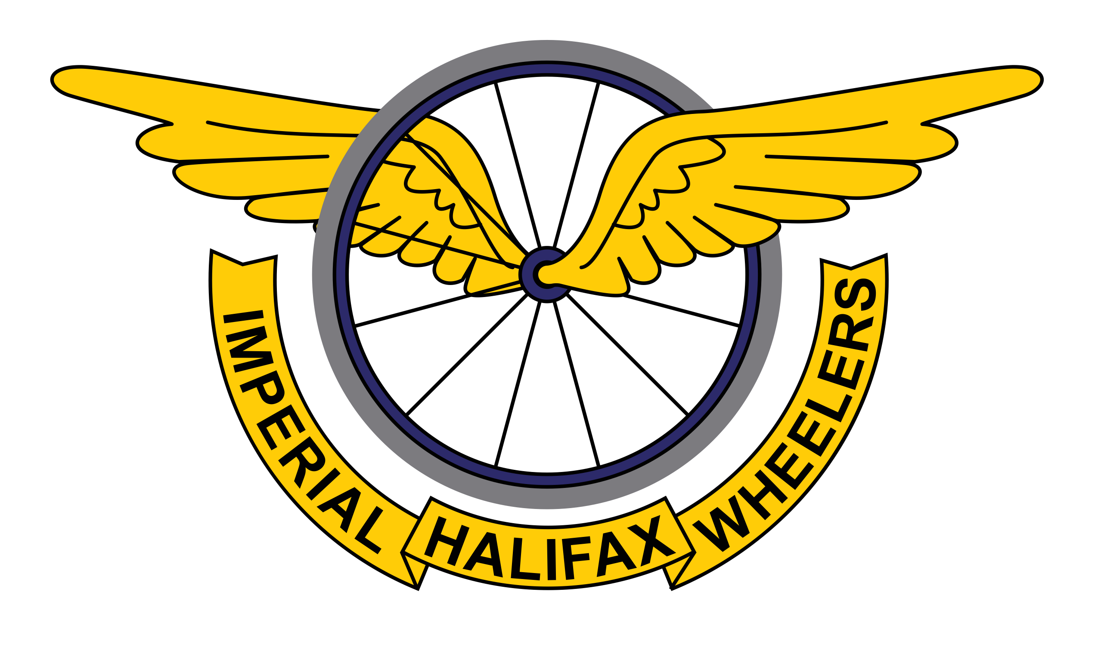

**Please support our sponsors if you are able:**

**Triangle Bakehouse** are open from 8am -12pm and are approx. 1km from the race start. They do the best sourdough in West Yorkshire (IMHO!) and amazing pastries and coffee too.

Commercial Mills, Oldham Road, Ripponden. Find them on Instagram and Facebook

[**www.Fit2Ride.cc**](http://www.Fit2Ride.cc) offers bike fitting and Sidas insoles. Also located in Commercial Mills but more info can be found on Instagram, Facebook and via the website link.

**Mamil Café Bar** is located in Brighouse and houses a bike workshop alongside cracking food, beers and coffee

**The Old Bridge Inn** – probably the oldest pub in Yorkshire – a short walk from HQ and does fab food and beer

**Fastest female and male times across both Imperial Wheelers Events** – prizes sponsored by Mamil Café Bar

**Lantern Rouge-** prize sponsored by Triangle Bakehouse

**Male**

1st Male – Bike Fit from Fit2Ride.cc

2nd Male - £30

3rd Male - £15

Vet 40 Male – £30

Vet 50 Male – £30

Vet 60 Male – £30

Espoir Male- £25

Junior Male – £25

Juvenile Male – £25 sponsored by Pye Nest Day Nursery

First time male – prizes sponsored by OTE Sports and Triangle Bakehouse

**Female**

1st Female – Holiday at Barend Holiday Lodges

2nd Female -£30

3rd Female - £15

Vet 40 Female – £30

Vet 50 Female – £30

Juvenile Female – £25 sponsored by Pye Nest Day Nursery

First time female – prizes sponsored by OTE Sports and Triangle Bakehouse

Ripponden Bank Hill Climb 2021 - Prizes