Shropshire Cycling Clubs Association
Open 100 Mile Time Trial
Sunday 25th July 2021
Incorporating West Cheshire TTCA and Manchester & District TTA 100 mile Championship
Incorporating the Friction Hydraulic Services Shropshire Championship Point Series Round 12 of 16
The Brian Mears (Bricks) Ltd Shropshire Championship 100

Promoted for and on behalf of Cycling Time Trials under its Rules & Regulations
Course: D100/6A Start Time: 06:00 Timekeepers: Kate Wooder, Dominic McGuiness
Event secretary: David Drew 4 Pantulf Road, Wem, SY4 5LT
Tel: 01939 234073 email: drew5lt@btinternet.com
Course D100/6A
The start will be at Market Drayton and will comprise 3 laps of Market Drayton – Shawbirch – Market Drayton via the A53 and A442 and then a final leg along the A53 once more to finish approaching Espley RAB
Headquarters: Wollerton Bowls and Social Club, near Hodnet postcode TF9 3NE, will be open from 5am

There is a reasonable amount of parking on site but an overflow car park will be available in the field adjacent to Wollerton United Reform Church approx.. 400 yds away from HQ. (signposted)

Directions to HQ – On A53 approx 2.1 miles from Tern Hill RAB towards Espley RAB, turn right at sign for Wollerton.
Follow lane into Wollerton, go over old railway bridge, HQ is immediately on the right. If travelling from Espley RAB Wollerton Lane turn is after approx. 1.2 miles on the left.

Event HQ is approx.. 4.5 miles from the start. To reach the start, turn right out of the club driveway to Wollerton crossroads (approx. 200m). Turn right onto Drayton Road and proceed for 1.2 miles to junction with A53. Turn left onto A53 to Tern Hill RAB go straight across on A53 via Muller RAB and Drayton Meadows RAB to Market Drayton RAB, encircle this and retrace for approx. 300m to start.

It is with regret that because of the uncertainty of the lifting of Covid restrictions there will be no pusher off, no refreshments before or after the event and no results board, so you are asked please to observe current Covid arrangements for TTs, please bring your own pen and leave your numbers in the container as directed.

Awards

Please note – One rider – One Prize Rule Applies – except for Team Prize.

Place | Group A | Group B | Group C | Women | Vet on Std
1st | £40 | £25 | £25 | £40 | £40
2nd | £30 | £15 | £15 | £30 | £30
3rd | £20 | £10 | £10 | £20 | £20

1st Team | £45 | £15 per rider

Course Description

Location | Direction | Inter Dist | Total Dist
Start | Start at drain cover at west end of lay-by approx. 300m west of Market Drayton RAB | 0 | 0
Circuit 1 | Proceed west on A53 to Tern Hill RAB  Take 2nd exit and proceed on A53 to Espley RAB  Take 1st exit and proceed along A442 to Shawbirch RAB  Encircle RAB and retrace on A442 to Espley RAB  Take 3rd exit and retrace on A53 to Tern Hill RAB  Take 2nd exit and proceed on A53 to Market Drayton RAB junction with A529 | 2.83  3.32  9.43  9.40  3.37  2.97 | 2.83  6.15  15.59  24.98  28.35  31.32
Circuit 2 | Encircle RAB and proceed on A53 to Tern Hill RAB  Take 2nd exit and proceed on A53 to Espley RAB  Take 1st exit and proceed along A442 to Shawbirch RAB  Encircle RAB and retrace on A442 to Espley RAB  Take 3rd exit and trace on A53 to Tern Hill RAB  Take 2nd exit and proceed on A53 to Market Drayton RAB junction with A529 | 3.06  3.32  9.43  9.40  3.37  2.97 | 34.37  37.70  47.13  56.53  59.89  62.86
Circuit 3 | Encircle RAB and proceed on A53 to Tern Hill RAB  Take 2nd exit and proceed on A53 to Espley RAB  Take 1st exit and proceed along A442 to Shawbirch RAB  Encircle RAB and retrace on A442 to Espley RAB  Take 3rd exit and trace on A53 to Tern Hill RAB  Take 2nd exit and proceed on A53 to Market Drayton RAB junction with A529 | 3.06  3.32  9.43  9.40  3.37  2.97 | 65.92  69.24  78.67  88.07  91.44  94.40
Finish | Encircle RAB and proceed on A53 to Tern Hill RAB  Take 2nd exit and proceed on A53 to finish immediately before junction to Stoke-on-Tern | 3.06  2.74 | 97.46  100.20

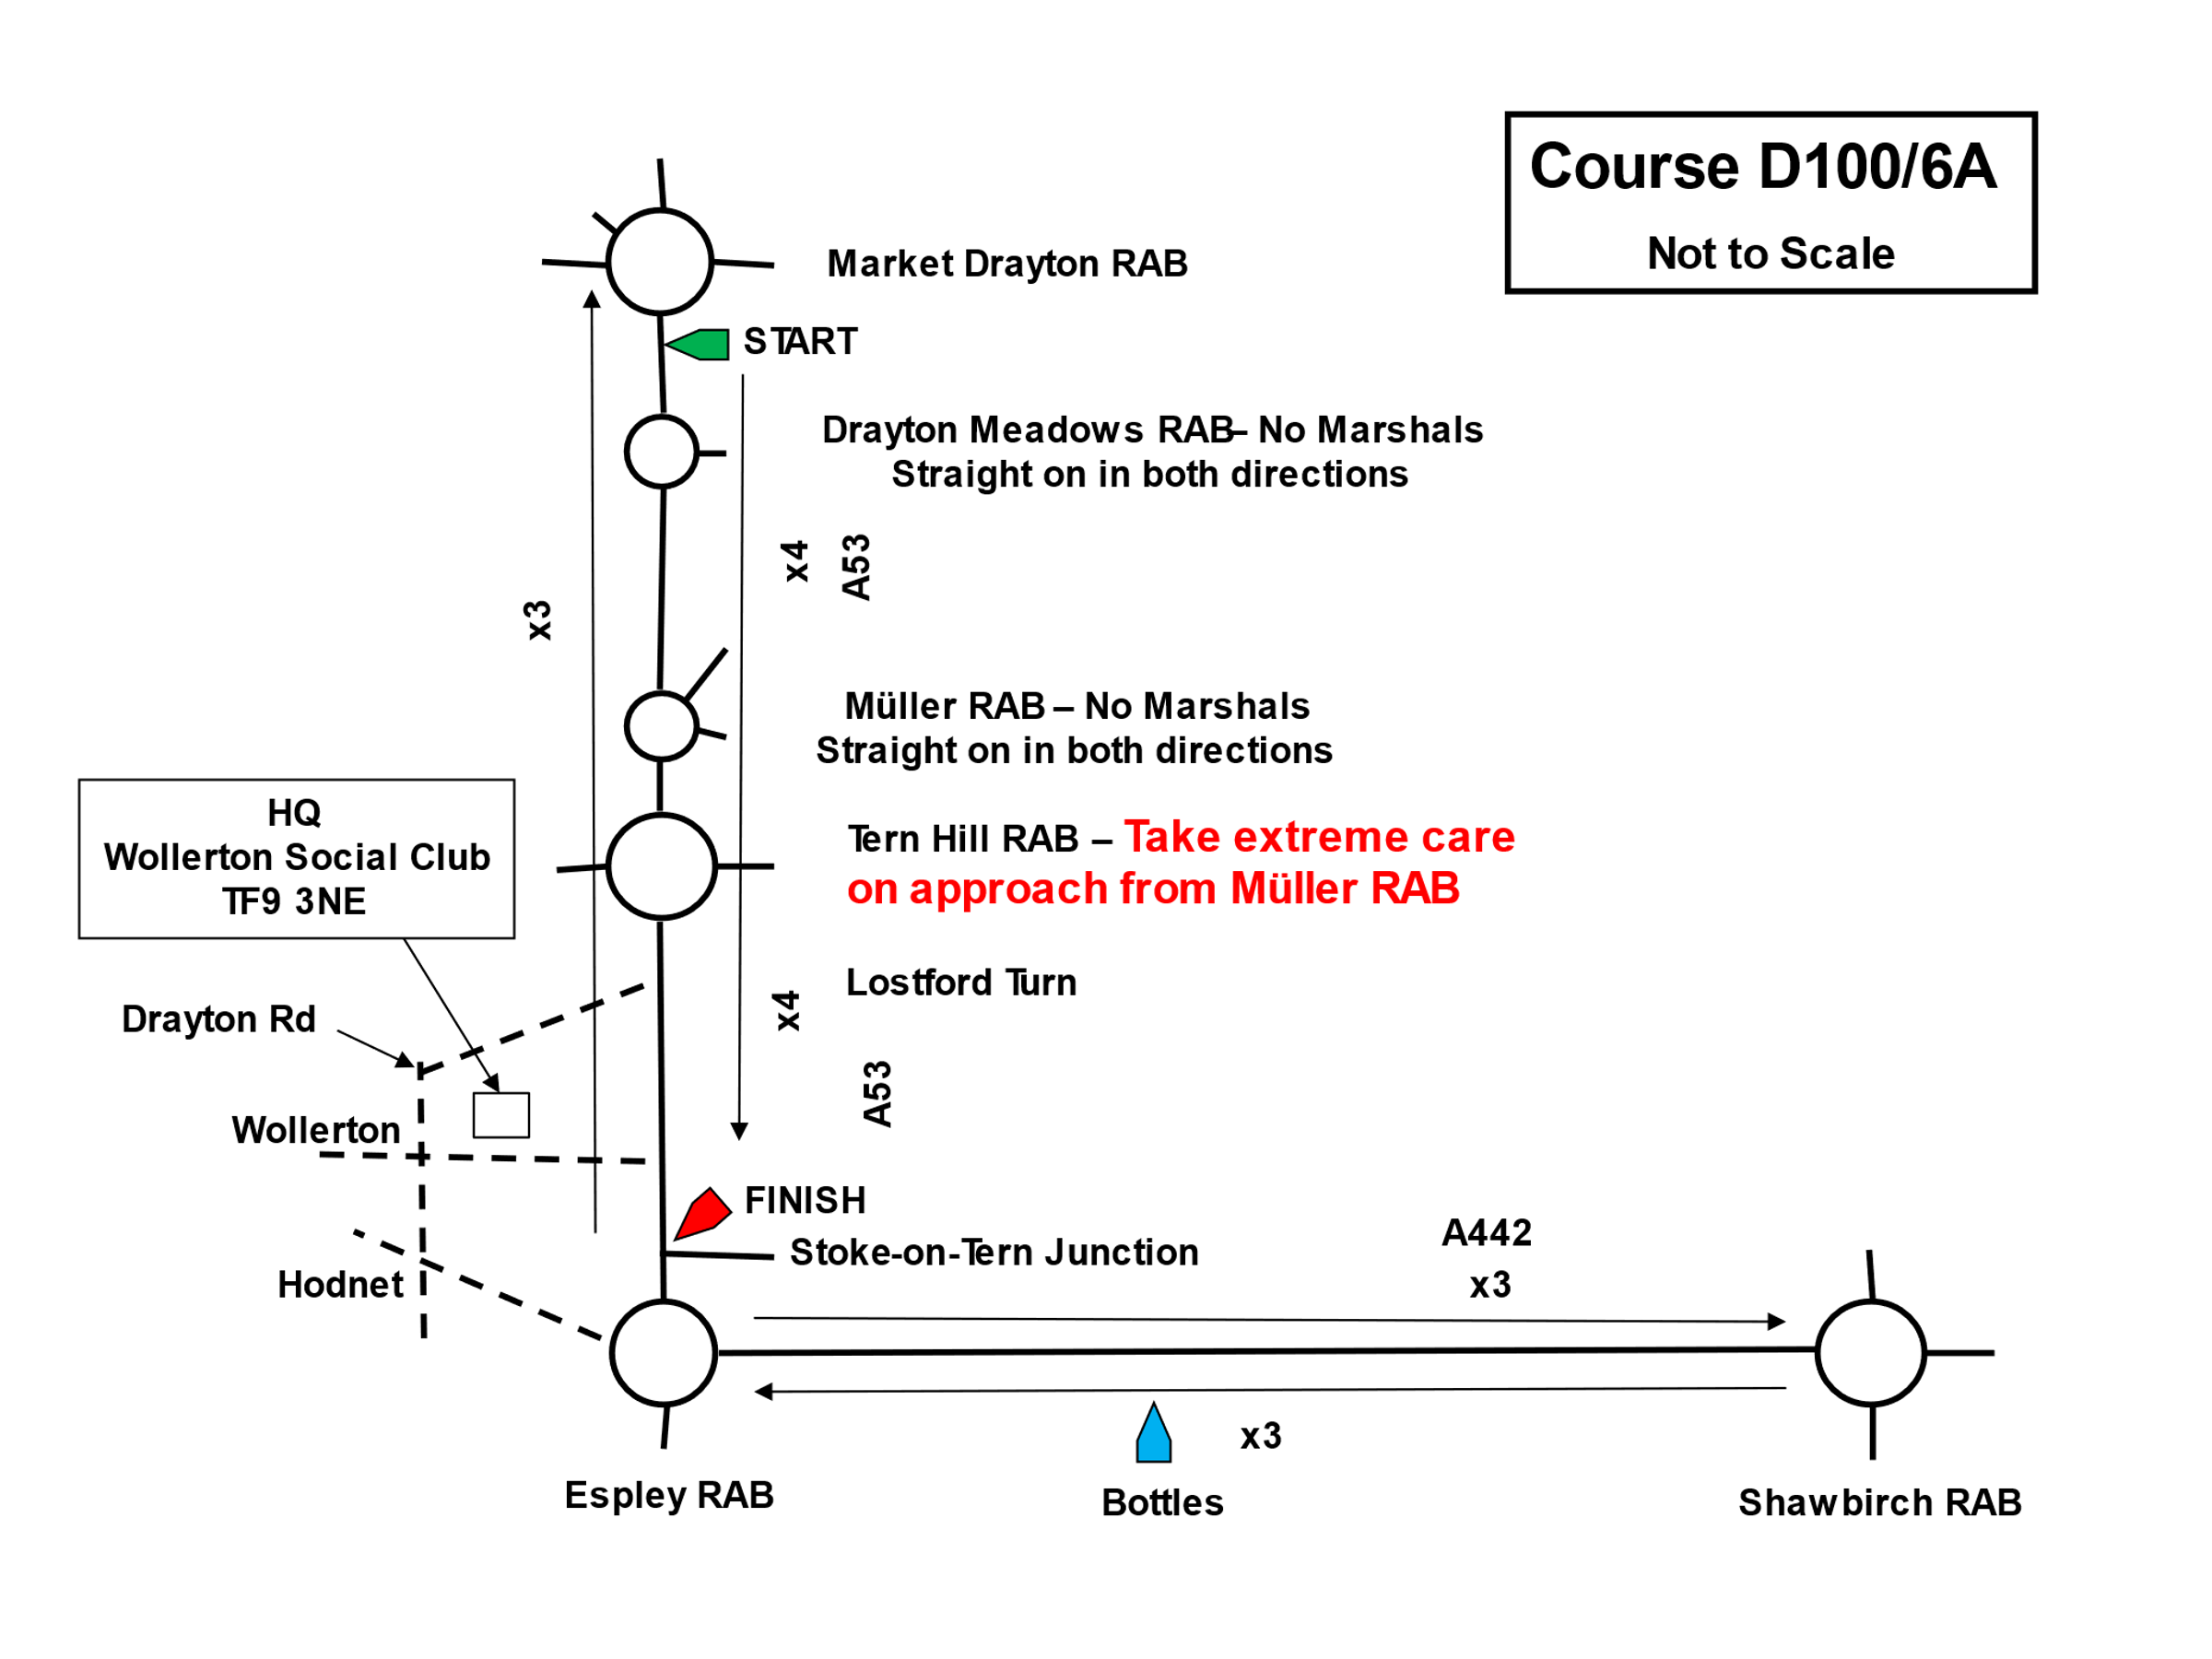

COMPETITOR’S NOTES – PLEASE READ THESE CAREFULLY

Each competitor must sign on when collecting AND RETURNING their race numbers at the HQ, this is a CTT requirement. Any rider not signing off within a reasonable time of the finish of the event will be recorded as Did Not Finish.

Both arm and back numbers must be worn for the event. Single arm numbers must be worn on the left upper arm
and be visible to the timekeepers. Large numbers must be fixed to the lower back area.

You are not allowed to wear either trade team kit (unless you happen to ride for that team) or kit with any advertising that is not an official sponsor of your club or team.

Distance from HQ to start is 4.5 miles SO ALLOW ADEQUATE TIME.

Any rider performing a U-turn within sight of the start or finish may be disqualified, please proceed to Muller Island to make your turn to the start.

There will be number checkers at Market Drayton and Shawbirch RABs. Any rider whose number is not visible to the timekeeper and checkers may not be given a finishing time. Make sure you shout your number at the finish, otherwise your time may not be recorded.

Tern Hill Roundabout

The event crosses Tern Hill RAB seven times during the event, it is the intersection of the A41 and A53 and it is a very busy junction, particularly from mid-morning onwards.
The approach from Muller RAB is slightly downhill and can be fast. Traffic crossing the RAB has limited visibility so all riders must approach Tern Hill from both directions with extreme caution and be prepared to give way, do not ride in anyway which causes possible conflict or impedes other traffic. You may also encounter queuing traffic on the approach to Tern Hill RAB in either direction, do not overtake or pass other traffic if it is unsafe to do so.

There is know a Local District Regulation which states that riders MUST NOT USE their tribars/extensions between the first bollard they pass on entering the Island and the last bollard they pass leaving it. Any rider seen to be in breach of this regulation will be disqualified from the event and may be reported for further disciplinary action.

After the Finish

After crossing the finish line, continue along the A53 to Espley RAB and turn right to Hodnet village, at the top of the village bear right (by the Bear Hotel) and continue for approx. 1 mile to the Wollerton crossroads, turn right back to the HQ.

Doping Control

The event may be subject to doping control. It is your responsibility to check whether or not you are required for Doping Control. Race numbers required for Doping Control will be displayed adjacent to the results board. If your number is displayed, you must report immediately to Doping Control which will be nearby.

Regulation 22C – Use of Motor Vehicles

In accordance with Reg.22, riders are permitted support from a motorised vehicle and its occupants, to assist with the competitors reasonable feeding and other requirements as the event distance exceeds 100km.
See CTT handbook or website for details.
All support vehicles must be registered with the event secretary (or via the signing on steward) before or by the competitors start time using the Riders Supporting Vehicle Form, available from the CTT website.

Riders with their own support may be given bottles and food at any safe part of the course but must not stop on the carriageway and must not impede other riders, officials or traffic. Bottles and food must not be handed out near Market Drayton, Tern Hill or Shawbirch RABs due to traffic levels. There is a large area on the A442 on the approach to Espley RAB where support vehicles may be parked off the road.

Drinks & Food Station

At previous events we have had a manned drinks and food station in the lay-by on the circuit just north of Cold Hatton, please note THIS WILL NOT BE THE CASE FOR THIS EVENT, Covid restrictions may have only just been lifted but not all adults and therefore riders may have had been vaccinated therefore for the protection of the volunteers there will be no drinks/food station at this event, it is therefore your responsibility to provide your own support.

Cycling Time Trials and the event promoter strongly advise that you wear a hard shell helmet that meets an internationally accepted safety standard. It is a condition of entry that all riders under 18 years of age must wear an approved cycle helmet. It is mandatory that a working rear light is fitted to the machine, you will not be allowed to start without a working rear light.

Thanks you for entering the event and may I wish all riders a safe and enjoyable race.
Event Secretary
To whom all issues and correspondence should be addressed
Dave Drew
4 Pantulf Road, Wem , Shropshire, SY4 5LT
01939 234073
07306317343
drew5lt@btinternet.com

