Wessex Road Club 50 mile Time Trial

P417 13th June 2021
Course Map and Description
Promoted for and on behalf of Cycling Time Trials under their rules and regulations.
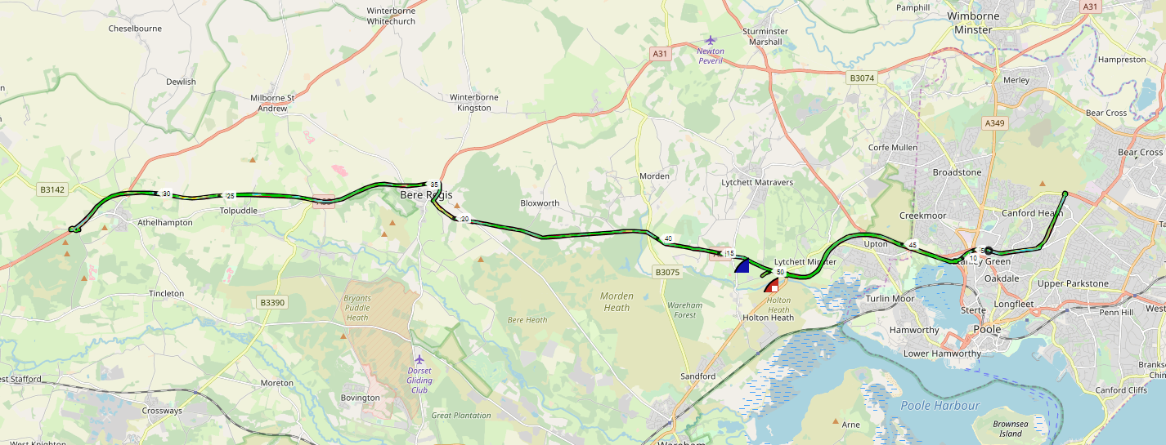
https://www.strava.com/routes/18511996

Full Course Description
START at drain cover in acceleration lane to A35, 85 yards east of Pikes Farm junction.
Proceed east on A35 to straight over (2nd exit) at Bakers Arms roundabout (1.02m).
Straight over (2nd exit) at Holes Bay roundabout (4.56 miles).
Bear left (filter lane) at roundabout.
Circle and retrace (4th exit) at Canford Way / Dorset Way roundabout (7.26 miles).
Straight over (2nd exit) at Holes Bay roundabout (10.05 miles).
Straight over (2nd exit) following A35 at Bakers Arms roundabout (13.60 miles).
At Bere Regis, right (2nd exit) at first roundabout, straight over following A35 (2nd exit) at second roundabout (20.83 miles).
Follow A35 to Troytown, where fork left down slip road to right (3rd exit) at small roundabout (27.85 miles).
Follow underpass to rejoin A35 eastbound.
At Bere Regis, straight over (2nd exit) at first roundabout (35.17 miles) then left (1st exit) at second roundabout, following A35.
Straight over (2nd exit) at Bakers Arms roundabout (42.36 miles).
Circle and retrace (4th exit) at Holes Bay roundabout (45.93 miles)
Straight over (2nd exit) at Bakers Arms roundabout then shortly fork left (sp Organford) on minor road to
FINISH at electricity sub-station.

http://www.southdc.org.uk/courses/p417.htm

