Lea Valley Cycling Club TA East Autumn 25

100th Year of The COMET 25

4th October 2020 THE REPORT Course : E1 25/b

In lieu of a result sheet, and with information for the Riders and Marshals

My commiserations with everybody after the cancellation of the Comet 25 Riders and Marshals alike were disappointed, especially those who hadn’t received their Cancellation Email in time. Thank you to the Riders who emailed me with their support.

We will not be re-running the Event. Police notifications for a new date has to be sent six weeks in advance. This would put the event back to November 22. Riders will be re-imbursed by CTT with a large part of their entry fee.

The work put into this Event, especially with the Covid-19 precautions meant that it was with very heavy hearts that Frida and I decided to cancel the race. The safety of the Riders was overriding. Most of the E1 would have been unpleasant, but on the stretch of the B1383 between Audley End and Littlebury, both carriageways were flooded across. Kia-ora hill, south of Newport, was also flooded to the centre, south bound. The ride to the Start was flooded, in several places.

Our best wishes go to Adam Bishop, sprained ankle, and Tom Watts, broken wrist, James Moss, self isolating (false alert), and condolences to Caroline Soubeyroux for her family loss.

My thanks to the RHQ and Covid deep clean Crew, Frida Wezel, Alan Hedges, and Ian Taylor, with help from Mark Freeman, John Summerhayes, Dave McCarthy and Stan Broom.

And to the Race Team: Timekeepers Frida Wezel, Ian Taylor and Alan Hedges. Marshals Trevor Whittock, Phil Laing, Julian Loxton, John Summerhayes, Joe Mumford, Dan Haines, Adam Bishop, Rob Smart and Armin Hersch, and the HQ Stewards Mark Freeman and Stan Broom. Lastly to Keith West (Shaftesbury CC) and Sally Withey (CTT)For their invaluable help with the Start Sheet .

All the best for next year, see you at the Comet in 2021. Stay safe, Michael Keen

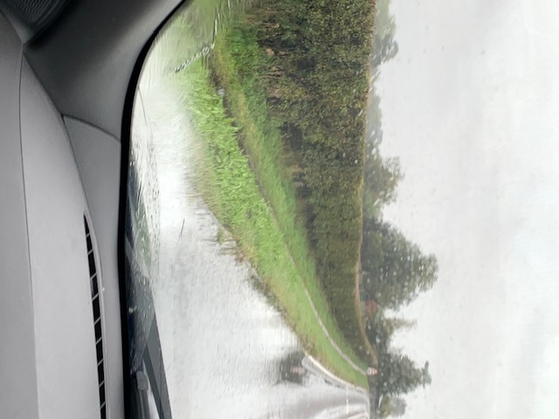

Email: keen3wheel@gmail.com
Photo taken after the event, near Audley End

