Number Collection area will be open from 13:00 Hours
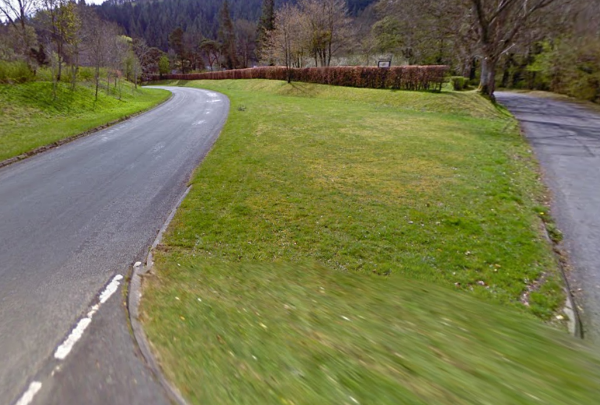
HQ / NUMBER COLLECTION – UNMANNED
IT IS YOUR RESPONSIBILITY TO SIIGN IN & OUT
NUMBERS ARE DISPOSABLE OR SOUVENIR
ENTRANCE TO NUMBER COLLECTION
FROM THE WEST CROSS HERE EVERYONE COME IN THIS ENTRANCE
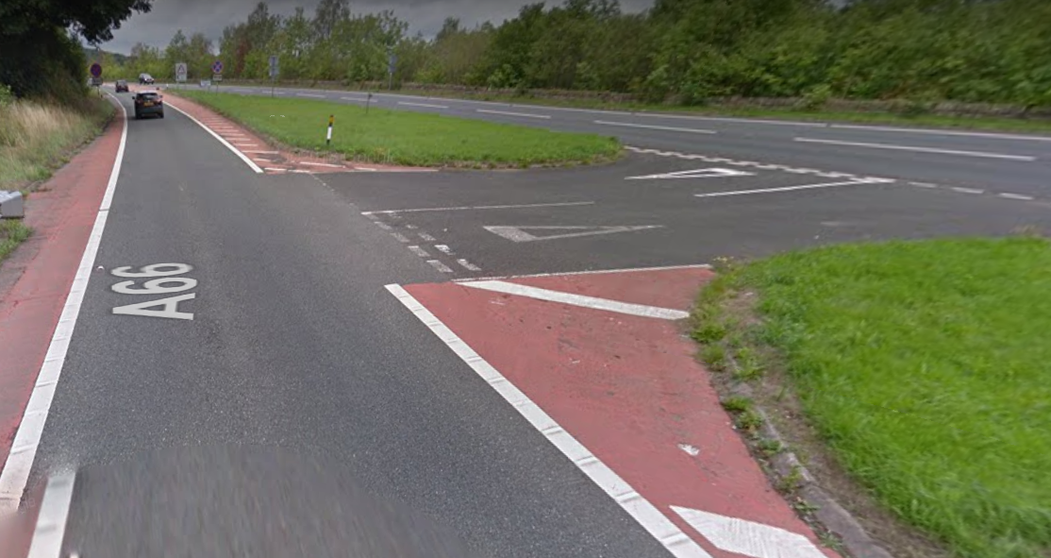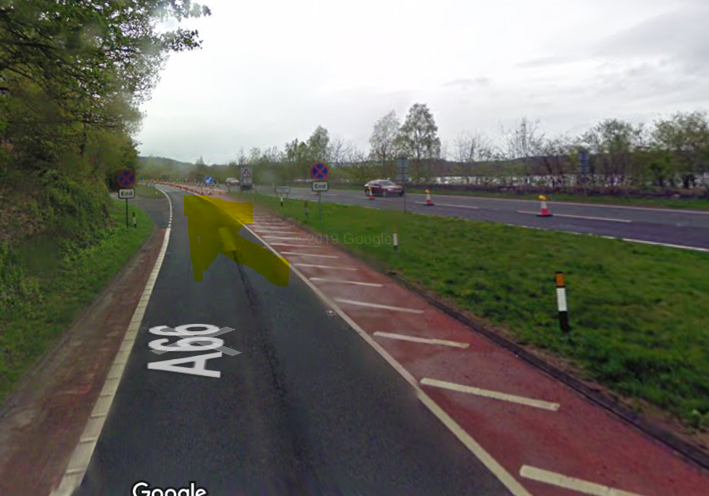
Exit for CARS AND RIDERS NO PARKING IN THIS AREA
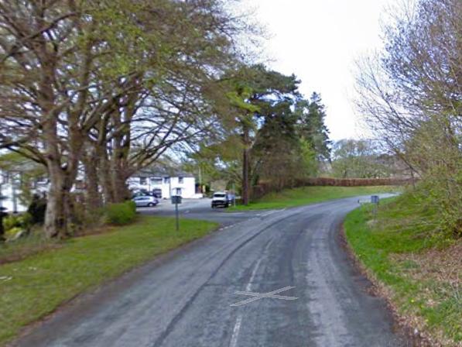
START 2 miles East along the A66 >>>>>>>>>
Please park as highlighted!
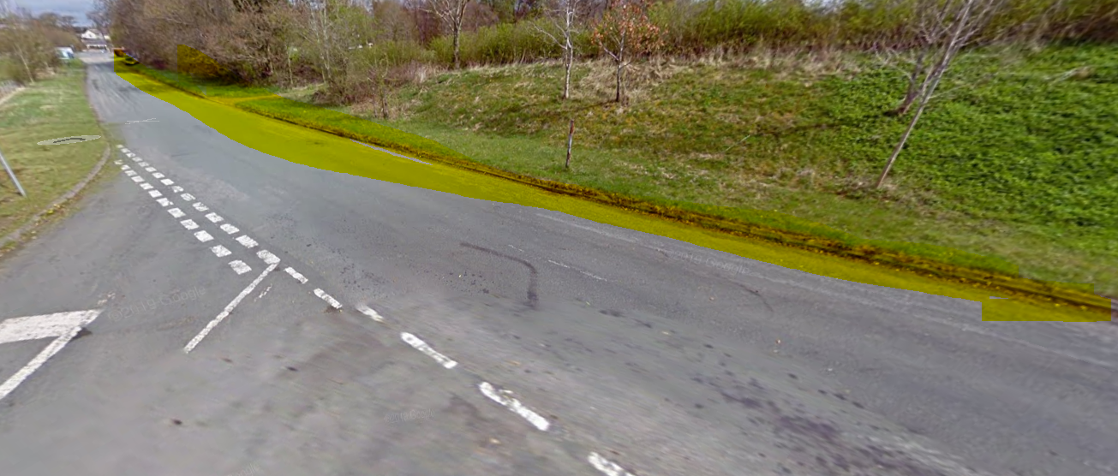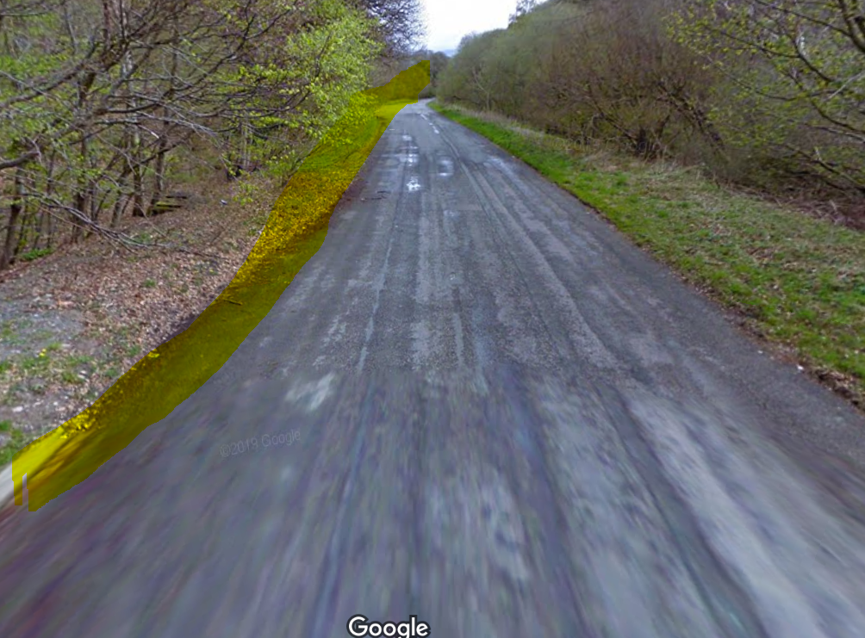

Number | Number | Earliest Arrival Time | Departure time – ASAP
1 | 20 | 13:00 | PLEASE LEAVE THE NUMBER COLLECTION AREA NO LATER THAN 30 MINUTES AFTER FINISHING YOUR RIDE!  10MINS TO RIDE BACK  20MINS TO PACK UP
21 | 40 | 13:20
41 | 60 | 13:40
61 | 80 | 14:00
81 | 100 | 14:20
101 | 120 | 14:40
121 | 140 | 15:00
141 | 160 | 15:20
Reserves |  | Starting Numbers will be advised as soon as slots become available!
Please follow the below arrival and departure guidelines

If you are more comfortable parking away from others see highlighted laybys and parking areas along the course in below map.
No Parking in the Start Lay By!
If utilising these other areas please drive in from the East Side Access to the Number collection area collect number sign in and head out from exit on the west side
For those parking in the Number collection area please can we start parking on the North / Easterly side of the road (Opposite the Pheasant / same side as the train at the West Exit end)
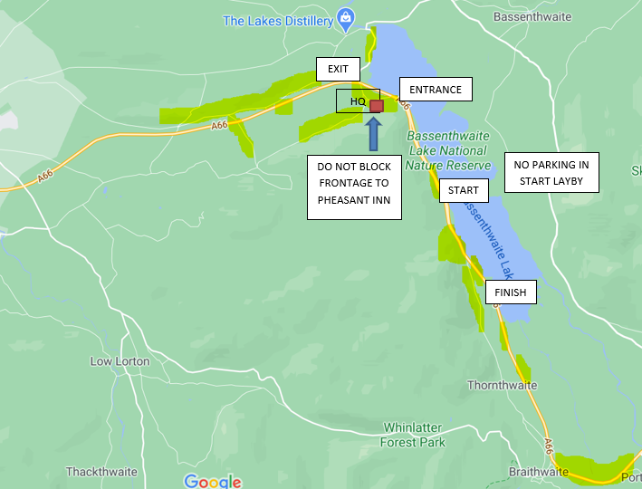
Additional Parking for 30 – 40 cars In each of the turning circles /side roads off the WEST bound side of the A66 – but all riders must retrace the A66 to cross onto Eastbound carriageway
DO NOT CROSS INTO ONCOMING TRAFFIC OPPOSITE THE START AS THIS IS A DANGER ZONE AS CARS RACE TO GET PAST BEFORE THE SINGLE CARRIAGEWAY STARTS

START
Start Area is at the end of the Red Hatching in layby
Riders position between hatching and the solid white line
Time Keepers Car / Van Parked in Layby
AS A CLUB BEACON WHEELERS PROHIBIT ACCESS TO THE START BY CROSSING THE CARRIAGEWEY
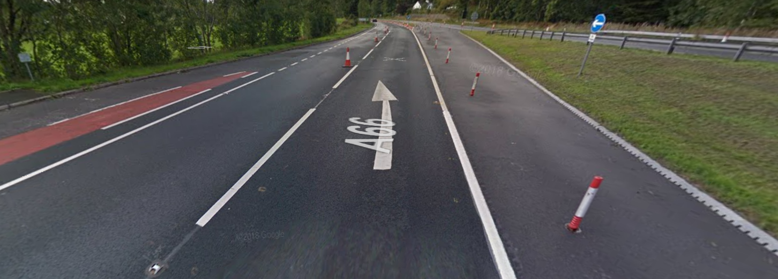

Turn – 4th Exit to retrace to finish approx 1 mile short of the start!
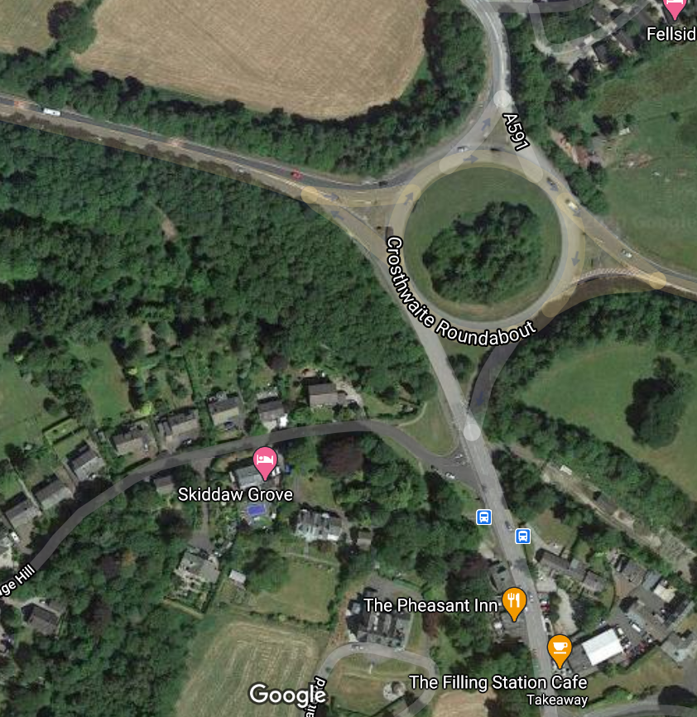
FINISH – Time keepers will be in Field gate on the left!
