OPEN 10 MILE TIME TRIAL
Saturday 5th September 2020
Event Start Time 14:00 / First Tandem off at 14:02hrs / First Solo off 14:10
Promoted for and on behalf of Cycling Time Trials under their rules and regulations.
START SHEET
Start Timekeeper: Sharon Dyson Finish Timekeepers: Keith Bickley / Richard Abram
Event Secretary: Russell McLean 132 Scholars Green Wigton Cumbria Tel - 07956032797
EVENT HEADQUARTERS
Due to COVID 19 Restrictions – HQ will be Gazebo on the Side Road off the A66 towards Phesant Inn CA13 9YE
Access - Heading EAST on A66 Turn RIGHT off the A66 Signed Wythop Mill / Pheasant Inn
Heading West on A66 Turn Left as you exit DC signed Pheasant Inn
Course Risk assessment will also be located here.
IF YOU ARE NOT WELL OR ARE SHOWING SIGNS OF COVID-19
PLEASE DO NOT COME TO THIS EVENT.
SPECIAL COVID 19 RISK MEASURES - See full guidelines on final page!
CLICK HERE - CTT - COVID 19 RISK ASSESMENT
PLEASE PAY ATTENTION TO RECOMMEDED ARRIVAL TIME
PLEASE SOCIALLY DISTANCE AT ALL TIMES
PLEASE RETURN TO HQ AREA BY EASTERN MOST ACCESS POINT TO EASE RIDER FLOW!
DISPOSABLE Number collection Sign-on & Sign Out is all that will be in the HQ area
Please utilise toilets in Keswick and Cockermouth prior to attending
PLEASE BRING YOUR OWN PEN AND PINS IF REQUIRED
PLEASE SANITISE HANDS WITH PROVIDE SANITISER BEFORE SIGNING IN / OUT
TAKING NUMBER OFF THE DISTRIBUTION LINE (washing line)
MOVE ON FROM EVENT AS SOON AS POSSIBLE AFTER YOUR RIDE!
The Start is 2 miles East of the Headquarters please allow sufficient time!
Cross the A66 Safely!
Course - L1010 – Keswick
Course Description
START in the lay-by at the Bassenthwaite Lake side of the A66 road at the eastern end of the dual carriageway in line with the white mark 5 yards west of the easterly end of the tarmac footpath section.
Proceed in a south-easterly direction along the A66
Turn - encircle the Roundabout at the junction with the A591 Keswick/Bothell road (5.3 miles). (Take the 4th Exit signed Workington / Cockermouth A66)
Retrace along the A66 to
FINISH at the white mark at grate in the roadside immediately east of a farm gateway approximately 0.2 miles before the Thornthwaite junction and 0.8 mile short of the start (10 MILES).
Please Park considerately and do not annoy the residents by using turbo trainers / rollers in the vicinity of residential or commercial properties
Other parking available in the turning circles nr the start / finish areas
Do not park in start layby!
DO NOT CROSS THE A66 at the START coming EAST to WEST
This is a DISQUALIFICATION OFFENCE!!
Please see overleaf for local regulations
We have a small pool of reserve riders so if you will not be attending then please let us know by messaging me on 07956032797 or email beacontimetrials@yahoo.com
I wish you all a safe and fast ride, most of all STAY SAFE!
Rgds
Russell McLean

COVID 19 Guidelines
Please operate a One Way System when returning to HQ after your ride
HQ
When returning from completing your race use the highlighted access to HQ Area
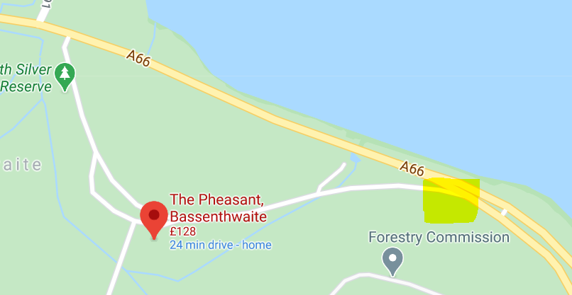
- IF YOU ARE NOT WELL OR ARE SHOWING SIGNS OF COVID-19 PLEASE DO NOT COME TO THIS EVENT
- PLEASE SOCIALLY DISTANCE AT ALL TIMES
- IF YOU ARE MORE COMFORTABLE IN A MASK PLEASE WEAR ONE
- Competitors MUST present at the start area ready to race
- NO JACKETS BOTTLES ETC to be left with timekeepers / marshals
- SIGN ON WITH ONLY YOUR OWN PEN!
- BRING YOUR OWN PINS
- PIN ON YOUR OWN NUMBER
- DISPOSABLE NUMBERS TAKEN FROM WASHING LINE – SOUVENIR FOR THE DAY!
- DO NOT ASSIST FELLOW COMPETITORS

- Event HQ
Event HQ is probably a bit of an over stretch. It’s an area to park and collect numbers / sign in/out.
There are no toilet, changing or refreshment facilities at this location.
You are asked to not urinate in this area or change in full view of the general public!
All future references to “HQ” in this document are referring to this facility.
- Please DO NOT arrive too early or you might be asked to stay in your vehicle, There will be no gatherings permitted in the number collection area
- Riders not following guidelines or instructions from officials will not be permitted to race and will be reported to CTT.
- Sign-On
No hugging, no kissing and no exchanging of niceties. But there are some other restrictions in place. You will be expected to follow them. We will ask you to respect the social distancing rules and maintain 2m distance between people in all directions at all times. This is to ensure that resumption of racing is successful and that any curtain twitchers have no material to send to the local gossip column/social media outlet/news outlet.
- We are all in this together so please respect the volunteer team and their decisions. Riders not adhering to the restrictions in place will not be permitted to race, will be reported to CTT and will be refused entry to future events.
- Rider temperatures may be taken at any time by a medical professional

- Race Protocol
Participants will be asked to maintain social distancing. No gatherings in groups, If you arrive early you will be permitted to ride on the roads to warm up or sit in your car. please only arrive at the start line a maximum of 4 minutes before your time listed below.
You will not be permitted to wait if you arrive earlier. Please do not bring friends or family members: they will not be permitted to leave their car. The only exception to this is minors who can be accompanied by a guardian from within their own household or “bubble”. They are however not permitted to enter the start area. Riders are not permitted to warm up on course, there are plenty of other roads where this is possible.
- The Time Keepers
They will be checking that riders a) have their number attached and, b) have a working rear light.
Either of these are missing and you will not be permitted to race.
- Pusher OFF
There will be no “pusher offer” and you will have to do a standing start on your own. Rolling start will not be permitted.
- Finish Area
Make it easy for the finish time keeper, when you cross the line, shout your number. As loud as you can. Do not approach the finish time keeper at any point for any reason.
- Once you have finished your race you will be asked to return to your vehicle and head home as soon as is possible
- We realise this is not the norm and the social aspect of racing is a big part of the fun, however, we need to show we are able to follow these guidelines if we are to see these types of events continue.
- Race Results
Race results will be published on a live leaderboard during the event – link will hopefully be on event page or accessed via Beacon Wheelers Facebook page.
All intial results will be provisional!
We will collate the results and post them online to the Beacon wheelers website and our social media channels and CTT site as soon as is practically possinble
We will then email the participants using the address supplied at pre-registration.
Riders having pre-registered that do not race will be given a DNS on the results sheet.
- Start List
This is the rider list with the number assigned to you. This is the number that must be collected from the HQ upon arrival. Please do not swap numbers: your emergency contact details are assigned to this number, we really don’t want to be phoning the wrong person in case of an emergency. If you are unable to attend, DO NOT swap your name with someone else. Riders found doing this will not be permitted to race, will be reported to the CTT and will not be accepted in future events.
- Vehicles on course
Time trialling under CTT regulations is unsupported. Riders must not be followed, for any reason whilst on course. Any rider suspected of this will be disqualified and reported to the CTT.
- In these unusual circumstances we find ourselves having to change the way we run events. The team has put a lot of work into making sure we are able to follow the government guidelines, the CTT guidance and make sure that the risk to you, us and the general public of transmitting or catching COVID-19 are kept to an absolute minimum. These restrictions are not here to make life difficult for you or the volunteer team, they are here for the above reasons but also to ensure that we are allowed to run these events.
- Let's not screw it up. Thank you for your support!
- SNOTTING / CLEARING THROAT ETC
We all know our sport can make us cough splutter lots of strange liquids at best of times please do not do this in vicinity of others
- Passing Bubble
When passing another competitor look behind so safe to do so and make a wide socially distanced pass.

LOCAL CTT NORH DC REGULATIONS
The following local regulations have been approved by the CTT National Committee in accordance with Regulation 38.
Any breaches may lead to disciplinary action being taken.
Local reg No. 5: In all events, competitors prior to starting are not permitted to ride past the finish timekeeper during the duration of the event.
Local reg No. 6: Any competitor making a ‘U’ turn in the vicinity of the start or finish will be disqualified from the event.
Local reg No. 15: Riders must keep to the left hand side of the road except when overtaking. Failure to comply with the above may lead to disqualification.
Local Guidance
Riders must give their number at the finish and elsewhere on the course if requested.
Riders must NOT stand in the road at the start or finish. (This constitutes obstruction, and is a breach of regulations).
Riders must NOT ride with their heads down.
Riders must sign in & out failure to comply will result in disqualification from the results.
Helmets & Lights
All competitors under the age of 18and/or Juniors must wear a HELMET of HARD/SOFT SHELL construction that conforms to a recognised standard (See regulation 15).
CTT strongly recommends ALL competitors wear such a helmet.
FOR 2020 IN ALL CTT EVENTS a working rear light, either constant or flashing, MUST BE fitted to the machine in a position clearly visible to following road users and MUST BE active while the machine is in use.

Donation of Profits to the below good causes

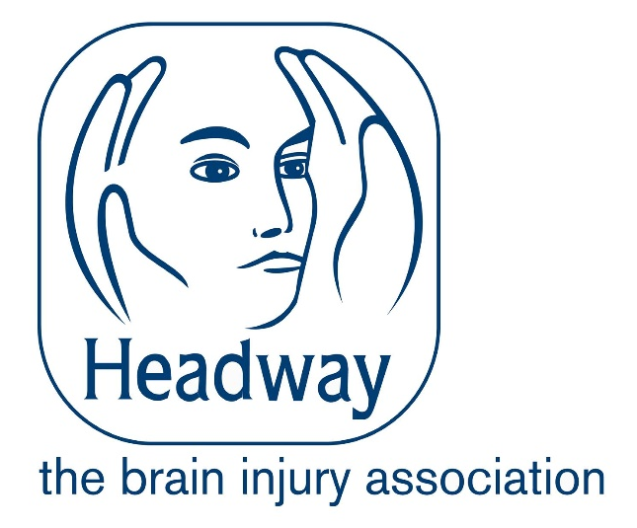

Donation to the Jack Earl Memorial Trophy

Thanks for riding our events in 2020

