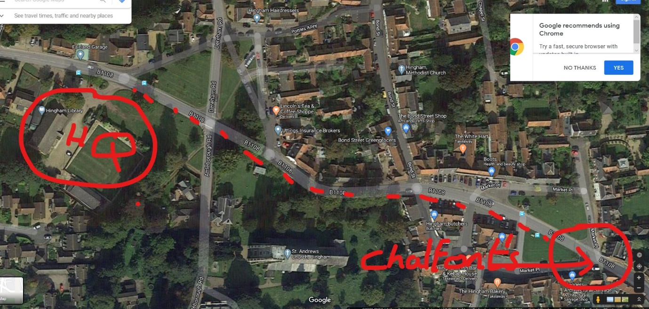

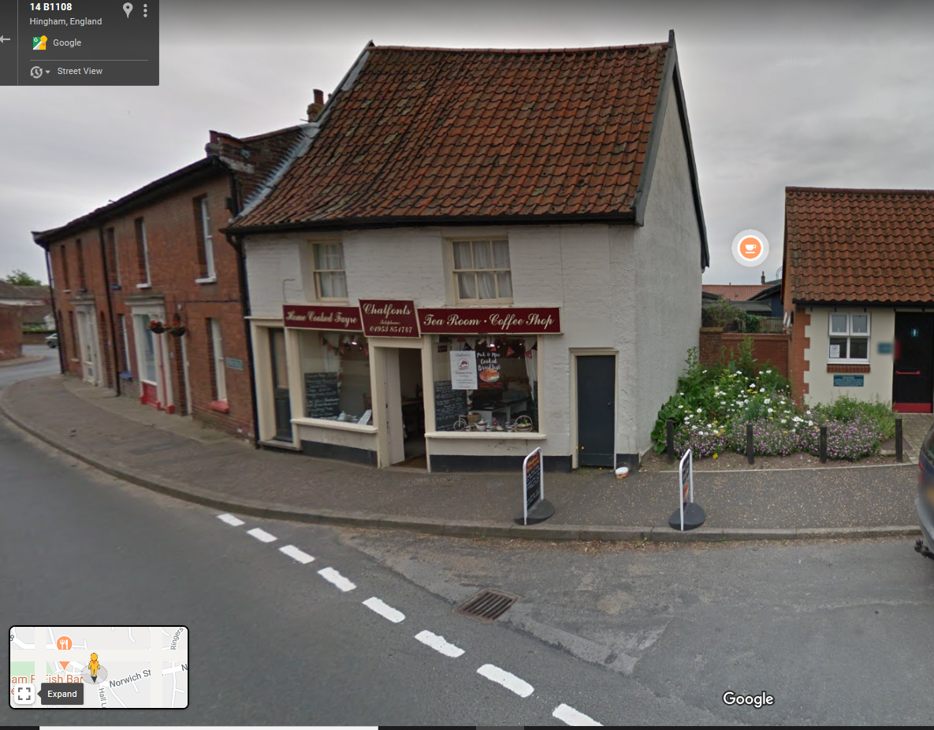

Chalfonts café which will be open on Sunday for takeaway drinks, cakes etc. Easy walking distance from the HQ approx.. ¼ mile.

