+

WWW.SCCU.CO.UK

SOUTHERN COUNTIES CYCLING UNION
1898-2020
PRESIDENT – JAN SOMMERFELD

28th Weekend of Sporting Events
Promoted for and of behalf of Cycling Time Trials under its rules and regulations

Open 10 Miles Time Trial Saturday 21st March 2020

Course G10/46
Qualifying event for SPOCO South East (but register prior to event) and Sussex CA SPOCO

Open 25 Miles Time Trial Sunday 22nd March 2020

Course G25/43
Qualifying event for Sussex CA SPOCO
Event secretary – Robin Johnson (Brighton Mitre CC), 7 Gorselands, Billingshurst, West Sussex, RH14 9TT, 01403 783368 07733 132043 on day of event.
Email: mr_rjohnson@outlook.com

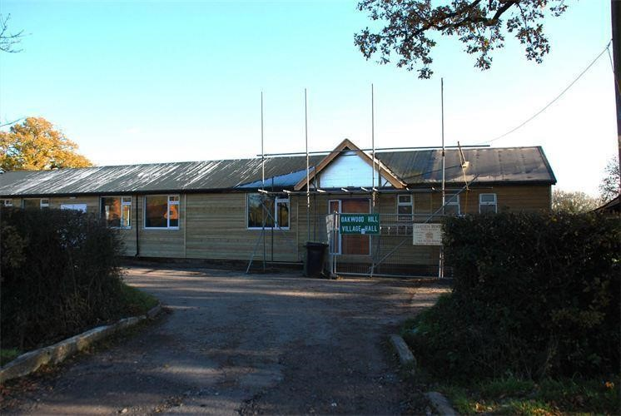
HQ
Oakwood Hill Village Hall
Honeywood Lane
Oakwoodhill
Surrey,
RH5 5PY

Parking is limited at the village hall. Then use ONLY the East side of the road, South of the Village Hall with all the wheels off the road. Please ensure that your vehicle is OFF the road – it might be YOU that gets baulked on the initial circuit.

Thank you in advance for not wearing cycling shoes or CLEATS in the Village hall.

Numbers at HQ ONLY.

After the event, please remember to return to the HQ with your number to sign out after your ride. You can exchange your number for a FREE drink.

10 Miles Event – HQ to start 0.04 miles, and 0.46 miles from the finish 25 Miles Event – HQ to start 0.04 miles, and 0.38 miles from the finish.
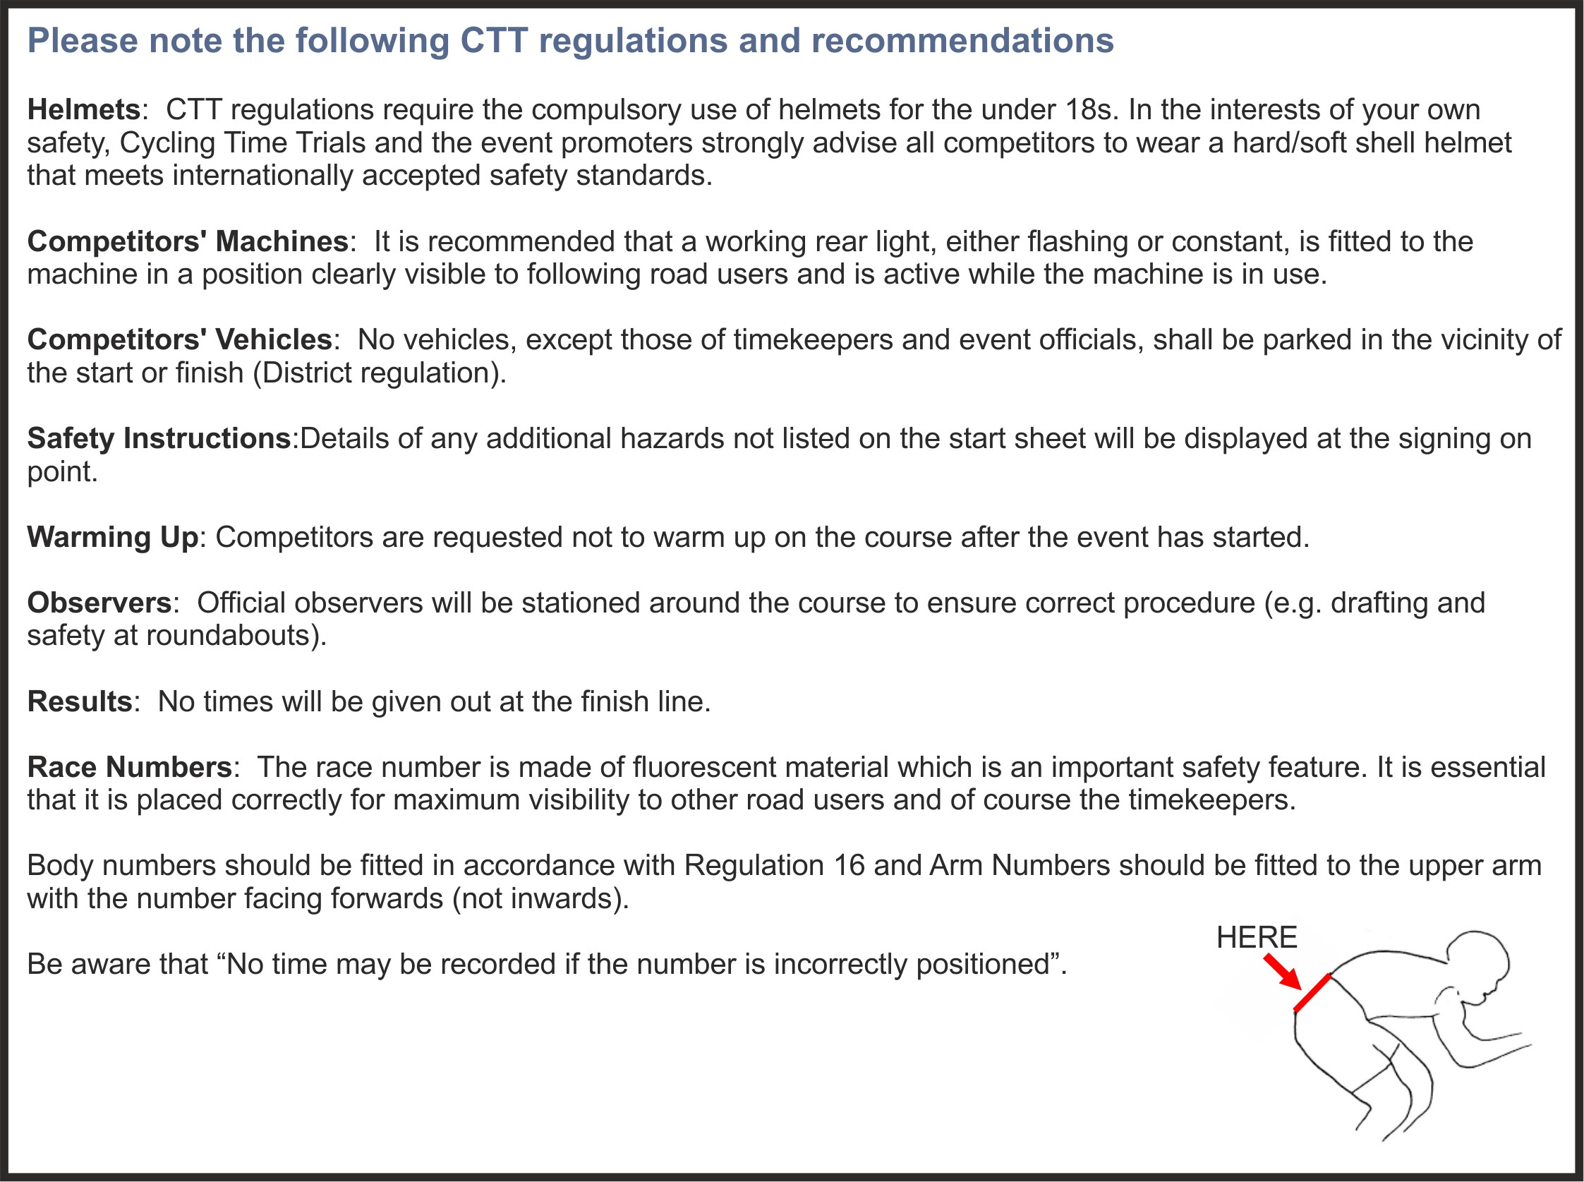

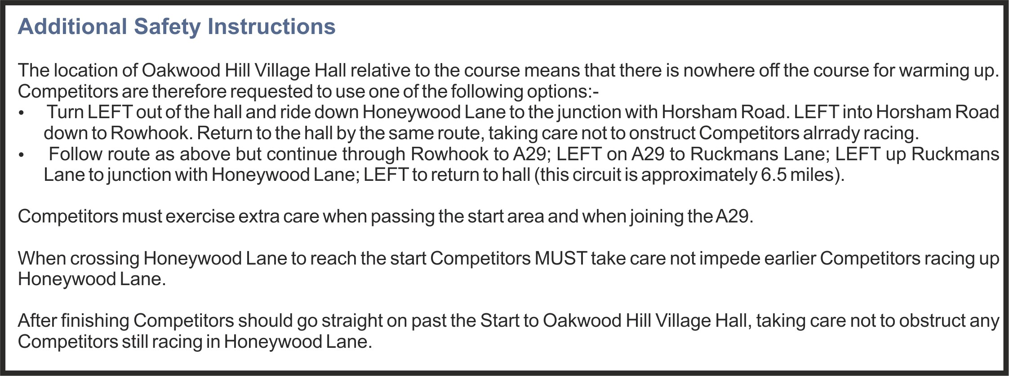

O p e n 1 0 m i l e s T i m e T r i a l S a t u r d a y 21st M a r c h 2020
Course G10/46

TIMEKEEPERS

Start: Paul Tunnell Addiscombe CC
Finish :Kathy Collard-Berry A3crg

 | Course Records – “10”
Scratch: | 21:28 | Elliott Porter | 2014
Vets | 22:11 | Pete Tadros | 2014
Ladies: | 24:42 | Suzetta Guerrini | 2014
 |  | Prizes
1st _{Man} £30 + Champagne (value £30) 1st Veteran (40-44) Wine (value £5)
2nd _{Man} £20 + Wine (value £5) 1st Veteran (45-49) Wine (value £5)
3rd _{Man} £15+ Wine (value £5) 1st Veteran (50-54) Wine (value £5)
4th _{Man} £10 + Wine (value £5) 1st Veteran (55-59) Wine (value £5)
5th _{Man} Wine (value £5) 1st Veteran (60-64) Wine (value £5)
1st Veteran (65-69)
Wine (value £5)
1st Veteran (70-74)
Wine (value £5)
1st Veteran (75-79)
Wine (value £5) BOTH SEXES ELIGIBLE.

1st Woman £15 + Wine (value £5)
2nd Woman £10 + Wine (value £5)
3rd Woman £7 + Wine (value £5)

BOTH SEXES ELIGIBLE:
Fastest Road Bike Wine (value £5)
(no tri-bars)
1st Team £10 + Wine (value £5) each
2nd Team Wine (value £5) each
1st 20 min ride on this course £20

Prize Presentation | To be held as soon as possible after the event.
 | Please stay to receive your awards and/or applaud the recipients.
Lottery Prizes | A bottle of wine, value £5, to each of the first three names drawn.
 | To be eligible, be present at the prize presentation and be a finisher

O p e n 1 0 m i l e s T i m e T r i a l S a t u r d a y 21st M a r c h 2020
Course G10/46

ALL COMPETITORS – PLEASE BE AWARE OF CTT REGULATION 14(i):

NO COMPETITOR SHALL BE PERMITTED TO START EITHER A TYPE A OR TYPE B EVENT UNLESS SUCH COMPETITOR HAS AFFIXED TO THE REAR OF THEIR MACHINE A WORKING REAR RED LIGHT, EITHER FLASHING OR CONSTANT, THAT IS ILLUMINATED AND IN A POSITION THAT IS CLEARLY VISIBLE TO OTHER ROAD USERS.

…………………………………………NO REAR LIGHT = NO RIDE……………………………………..

COMPETITORS MUST NOT USE ANY AUDIO EQUIPMENT EXCEPT PRESCRIBED HEARING AIDS.
Nb. A COMPETITOR IN BREACH OF THIS REGULSTION SHALL BE DISQUALIFIED.
Nb. COMPETITORS MUST NOT USE A MOBILE PHONE WHILE MOUNTED ON THEIR MACHINES.

UNDER 18 AGE ENTRIES MUST DOWNLOAD PARENTAL CONSENT FORMS IN ORDER TO COMPLETE ON-LINE ENTRY.
PLEASE BRING THE COMPLETED FORM WITH YOUR HELMET AND PRESENT THESE BEFORE SIGNING-ON.
NO HELMET AND NO PARENTAL CONSENT FORM = NO RIDE………………………………………….

WOMEN – S.C.C.U. trophies: YOUR RIDES IN THE SPORTING EVENTS COUNT TOWARDS THESE TROPHIES.

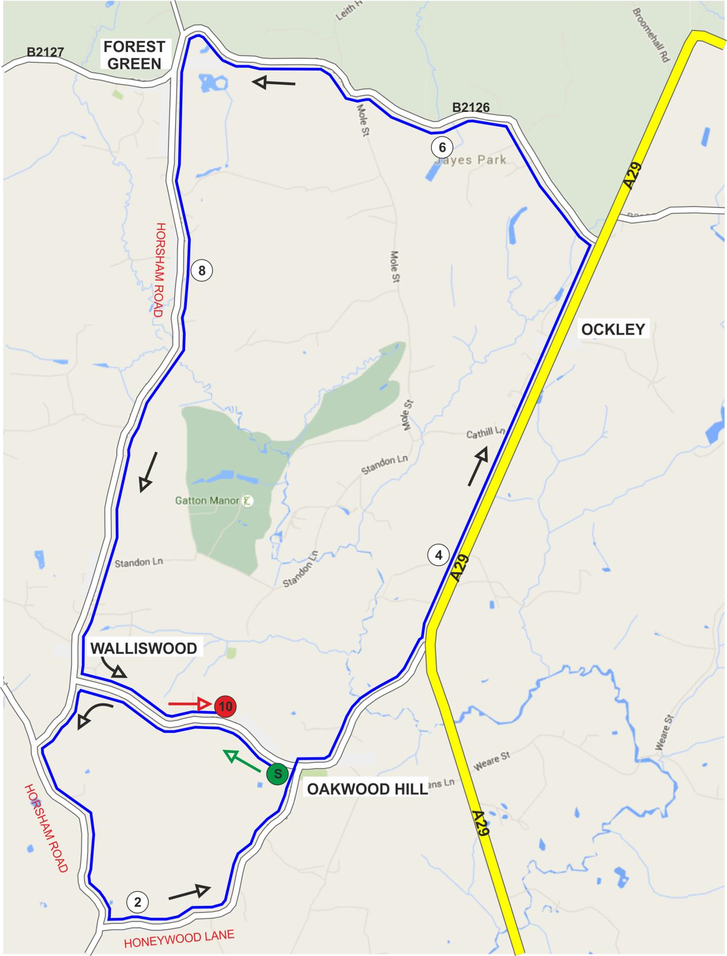

O p e n 1 0 m i l e s T i m e T r i a l S a t u r d a y 21st M a r c h 2020

Course G10/46

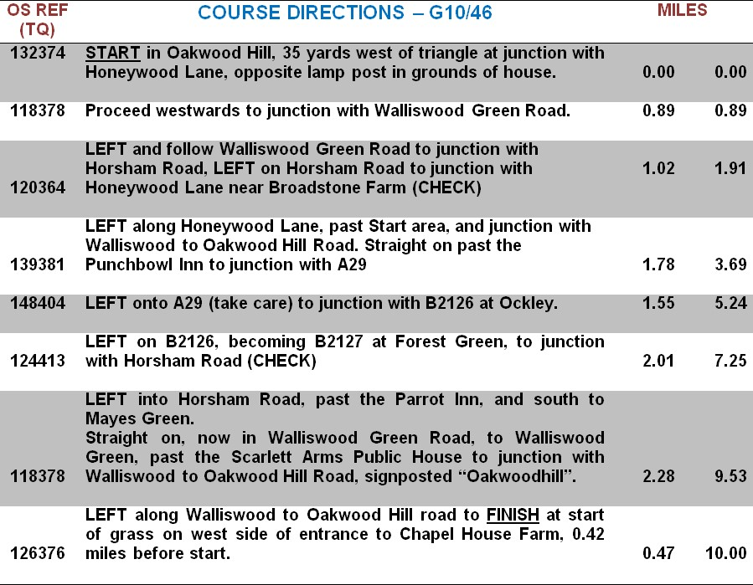

Mileage Signs at 5, 4, 3, 2, 1 mile(s) to go.

BOTH EVENTS – PLEASE REMEMBER TO SIGN ON FOR YOUR NUMBER.

AFTER FINISHING, SIGN BACK IN WHEN RETURNING YOUR NUMBER………………………….

ALL COMPETITORS – PLEASE BE AWARE OF CTT REGULATION 14(i): NO COMPETITOR SHALL BE PERMITTED TO START EITHER A TYPE A OR TYPE B EVENT UNLESS SUCH COMPETITOR HAS AFFIXED TO THE REAR OF THEIR MACHINE A WORKING REAR RED LIGHT, EITHER FLASHING OR CONSTANT, THAT IS ILLUMINATED AND IN A POSITION THAT IS CLEARLY VISIBLE TO OTHER ROAD USERS.………………………………………… NO REAR LIGHT = NO RIDE…………………………………….. COMPETITORS MUST NOT USE ANY AUDIO EQUIPMENT EXCEPT PRESCRIBED HEARING AIDS. Nb. A COMPETITOR IN BREACH OF THIS REGULATION SHALL BE DISQUALIFIED. Nb. COMPETITORS MUST NOT USE A MOBILE PHONE WHILE MOUNTED ON THEIR MACHINES. UNDER 18 AGE ENTRIES MUST DOWNLOAD PARENTAL CONSENT FORMS IN ORDER TO COMPLETE ON-LINE ENTRY PLEASE BRING THE COMPLETED FORM WITH YOUR HELMET AND PRESENT THESE BEFORE SIGNING-ON. NO HELMET AND NO PARENTAL CONSENT FORM = NO RIDE………………………………………….

G25/43 Course Records – “25”
Scratch: |  | 55:04 |  | Pat Wright | 2017
Vets |  | 58:21 |  | Mark Smith | 2017
Ladies: |  | 1:08:46 |  | Michelle Arthurs | 2017
 | Trike |  | 1:20:35 | Lez Young 2017
 | TIMEKEEPERS: Start |  | Clive Walton, Redmon CC | Finish: Kathy Collard-Berry, A3crg.
 |  |  |  | Prizes
MEN: FIRST £30 + Champagne (value £25) BOTH SEXES: 1st Veteran (40-44)
2nd £20+ Wine (value £5) Wine (value £5)
3rd £15 + Wine (value £5)
4th £10 + Wine (value £5) and each 5 years’ band
5th £5 + Wine (value £5)

1st Woman £15 + Wine (value £5)
2nd Woman £10 + Wine (value £5)
3rd Woman Wine (value £5)
BOTH SEXES:
1st Team £15 + Wine (value £5) each
2nd Team Wine (value £5) each

Prize Presentation To be held as soon as possible after the event.
Please stay to receive your awards and/or applaud the recipients.
Lottery Prizes A bottle of wine, value £5, to each of the first three names drawn.
To be eligible, be present at the prize presentation and be a finisher

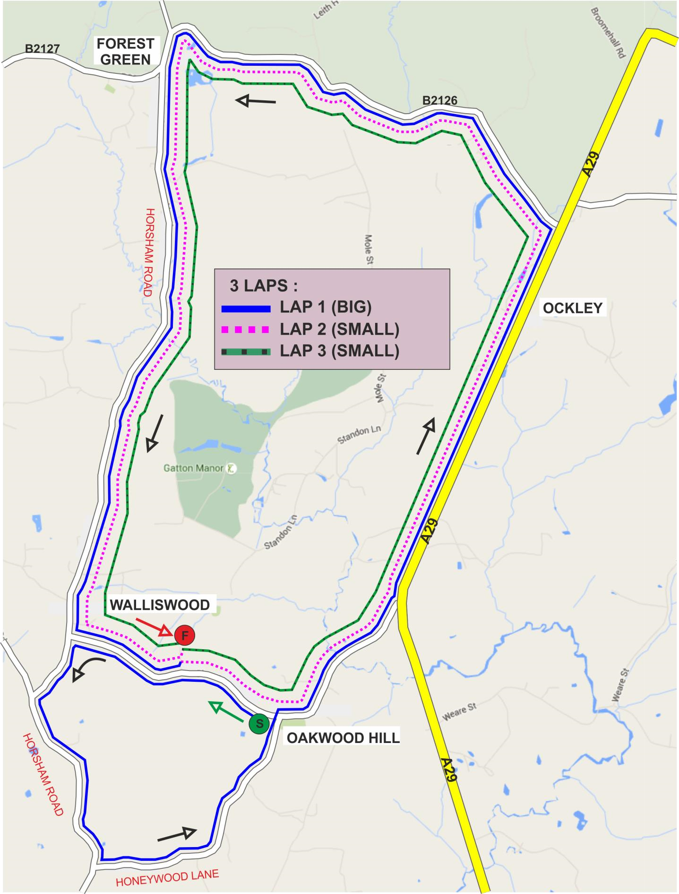

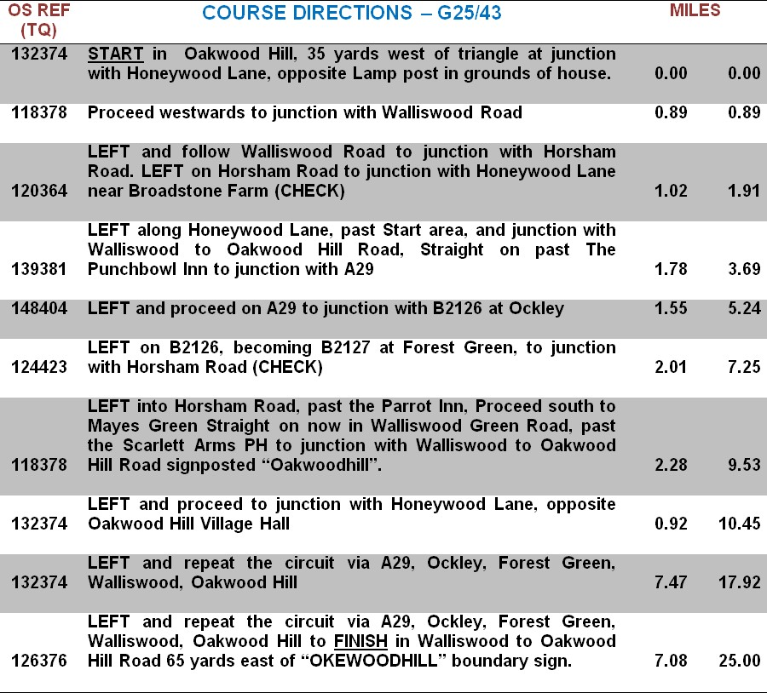

NOTICE TO ALL COMPETITORS:
Mileage Signs relate to distances from the finish on the third lap.

PAST WINNERS

 | “10” |  | “25” |  | OVERALL
1993 | Gary Dodd | 24:00 | Nick McCormick | 1:02:27 | Chris Weekly
1994 | Peter Main | 23:31 | Peter Main | 1:00:59 | Peter Main
1995 | Peter Main (2 wins) | 22:37 | Steve Dennis | 59:41 | Steve Dennis
1996 | Tim Stevens | 22:19 | Tim Stevens | 56:40 | Tim Stevens
1997 | Tim Stevens | 22:33 | Tim Stevens | 56:21 | Tim Stevens
1998 | Keith Reed | 22:58 | Keith Reed | 58:39 | Keith Reed
1999 | David Akam | 22:23 | Tim Stevens | 56:54 | Tim Stevens
2000 | Bryan Taylor | 24:07 | Mark Jones | 1:00:32 | Bryan Taylor
2001 | Paul Smith | 24:06 | Tim Stevens (4 wins) | 59:00 | Tim Stevens
2002 | Steve Dennis | 23:32 | Steve Dennis | 58:47 | Steve Dennis
2003 | Tim Stevens | 23:12 | Paul Pickup | 57:54 | Tim Stevens
2004 | Jason White | 22:40 | Mark Jones (2 wins) | 59:47 | Tim Stevens (6 wins)
2005 | Tim Stevens (4 wins) | 23:00 | Paul Mill | 55:56 | Colin McDermott
2006 | Steve Dennis (2 wins) | 23:22 | Steve Dennis | 58:29 | Steve Dennis (3 wins)
2007 | Peter Tadros | 22:40 | Peter Tadros | 57:21 | Peter Tadros
2008 | Matthew Miles & Jerome Walters | Both 23:28 | Not held; snowed | ---- | ----
2009 | Ben Instone | 22:07 | Ben Instone | 53:18 | Ben Instone
2010 | Peter Tadros | 22:10 | Ben Instone (2 wins) & Steve Dennis | 53:40 | Peter Tadros (2 wins)
2011 | Nic Hutchings | 22:27 | Steve Dennis (5 wins) | 55:01 | George Brent
2012 | Rupert Burbridge | 22:32 | Jerome Walters | 54:13 | Rupert Burbridge
2013 | Wouter Sybrandy | 22:08 | Sebastian Ader | 54:14 | Steve Kane
2014 | Elliott Porter | 21:28 | Elliott Porter | 53:50 | Elliott Porter
2015 | Chris McNamara | 22:24 | John Dewey | 57:05 | Jack Donaldson
2016 | Pat Wright | 21:33 | Steve Kane | 59:09 | Steve Kane
2017 | Rob Sharland | 21:55 | Pat Wright | 55:04 | Mark Newton
2018 | Mark Smith | 23:21 | Not held; snow. |  | -
2019 | Pat Wright | 21:55 | Pat Wright | 55:36 | Pat Wright
2020

