John Bornhoft Memorial Hill Climb - 28th September 2019
Promoted for and on behalf of Cycling Time Trials under its rules and regulations.

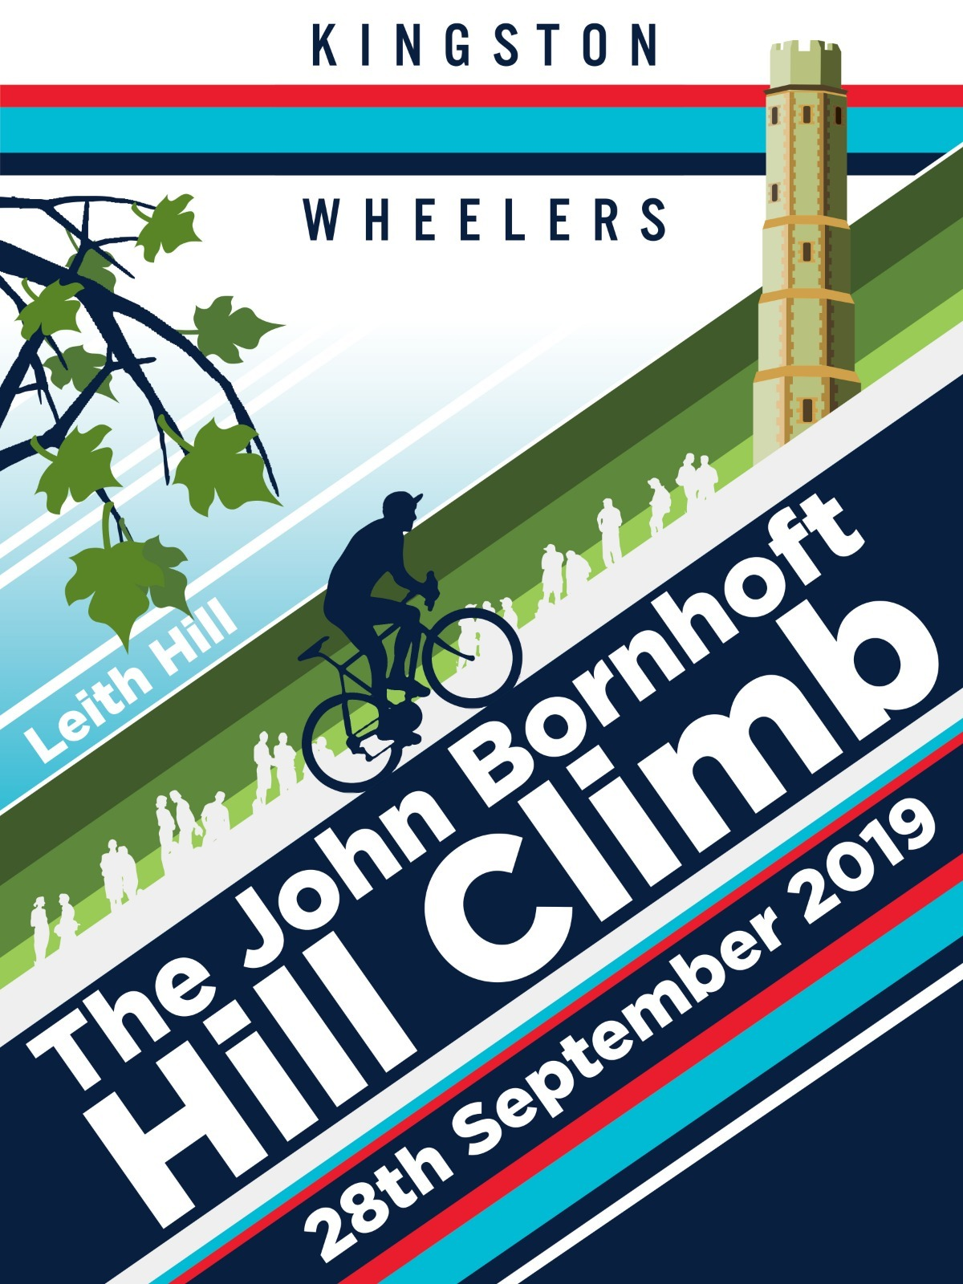

With special thanks to:
Paul Tunnell and Rob Gardner for timekeeping
Darren Marshall for the Artwork dazpix.co.uk

All the marshalls and helpers from KWCC

Photography
Photos available from rogerbrownphoto@icloud.com from Wednesday 2nd October

Prizers
Men Overall
Position | Name | Team | Time | Prize
1 | Andrew Feather | ChampionSystem UK | 3:31:2 | £50
2 | Charlie Mactear (J) | High Wycombe CC | 3:44:9 | £40
3 | Mark Aldred | Kingston Wheelers CC | 3.45.8 | £30
4 | Chris Newberry | Redhill CC | 3:46:1 | £20
5 | David Ross | LFGSS CC | 3:49:4 | £10

Women Overall
Position | Name | Team | Time | Prize
1 | Olivia Bentley | Vision Innovative Leisure Racing Team | 4:37:0 | £50
2 | Gemma Hobson (V) | Sussex Nomads CC | 5:11:3 | £40
3 | Kate Palmer | Brixton Cycles Club | 5:15:1 | £30

Men’s Veteran
Position | Name | Team | Time | Prize
1 | Peter Tadros | trainSharp | 4:04.2 | £30
2 | Edward Francis | Paceline RT | 4:14.0 | £20
3 | Ben Speller | Kingston Wheelers CC | 4:55.9 | £10

Women’s Veteran
Position | Name | Team | Time | Prize
1 | Katja Rietdorf | Born to Bike - Bridgtown Cycles | 6:20.8 | £30

Junior
Position | Name | Team | Time | Prize
1 | Theo Tadros | trainSharp | 4:01:7 | £30

Juvenile
Position | Name | Team | Time | Prize
1 | Finlay Hawker | VC de Londres | 4:24:6 | £30

Team of 3
Position | Team | Team | Time | Prize
1 | Kingston Wheelers CC | Mark Aldred  Neil Grunshaw  Harry Bunnell | 3:45:8  4:26:0  4:28:0 | £45

Prize winners please email Alice Lethbridge timetrial@kingstonwheelers.com with your bank details to arrange payment of prize money

Position | Name |  | Club | Time | Gender | Category
1 | Andrew | Feather | ChampionSystem(UK) | 00:03:31.2 | Male | Senior
2 | Charlie | Mactear | High Wycombe CC | 00:03:44.9 | Male | Junior
3 | Mark | Aldred | Kingston Wheelers CC | 00:03:45.8 | Male | Senior
4 | Chris | Newberry | Redhill CC | 00:03:46.1 | Male | Senior
5 | David | Ross | LFGSS CC | 00:03:49.4 | Male | Senior
6 | Thomas | Willan | East London Velo | 00:03:51.4 | Male | Senior
7 | Ian | Middleton | Foran CCC | 00:03:52.8 | Male | Senior
8 | Guy | Tucker | Team Tor 2000 | KALAS | 00:03:57.2 | Male | Espoir
9 | Tom | Hazelton | Dulwich Paragon CC | 00:04:01.3 | Male | Senior
10 | Theo | Tadros | trainSharp | 00:04:01.7 | Male | Junior
11 | Peter | Tadros | trainSharp | 00:04:04.2 | Male | Veteran
12 | Jon | Saunders | Charlotteville Cycling Club | 00:04:04.4 | Male | Senior
13 | Chris | Hartono | LFGSS CC | 00:04:09.3 | Male | Senior
14 | Matt | Phipps-taylor | VELOSPORT CC | 00:04:11.0 | Male | Senior
15 | Daniel | Pink | GS Avanti | 00:04:11.2 | Male | Senior
16 | Edward | Francis | Paceline RT | 00:04:14.0 | Male | Veteran
17 | Thomas | Seller | Oxted Cycle Club | 00:04:18.5 | Male | Senior
18 | Finlay | Hawker | VC de Londres | 00:04:24.6 | Male | Juvenile
19 | Ollie | Smith | Paceline RT | 00:04:25.3 | Male | Senior
20 | Chris | Carroll | Velo Club Godalming & Haslemere | 00:04:25.8 | Male | Senior
21 | Neil | Grunshaw | Kingston Wheelers CC | 00:04:26.0 | Male | Senior
22 | Tomos | Shaw | Chichester City Riders | 00:04:26.3 | Male | Senior
23 | Harry | Bunnell | Kingston Wheelers CC | 00:04:28.0 | Male | Senior
24 | Peter | Hair | Kingston Wheelers CC | 00:04:29.1 | Male | Senior
25 | Kieran | Presland | Kingston Wheelers CC | 00:04:33.6 | Male | Espoir
26 | Olivia | Bentley | Vision Innovative Leisure Racing Team | 00:04:37.0 | Female | Senior
27 | Ivan | Newsome | Epsom CC | 00:04:40.7 | Male | Junior
28 | Jack | Hartrey | Kingston Wheelers CC | 00:04:42.6 | Male | Juvenile
29 | Scott | Leeson | London Dynamo | 00:04:44.6 | Male | Senior
30 | Sam | Dorkings | GS Avanti | 00:04:49.2 | Male | Senior
31 | Luca | Palazzo | Kingston Wheelers CC | 00:04:53.6 | Male | Senior
32 | Ben | Speller | Kingston Wheelers CC | 00:04:55.9 | Male | Veteran
33 | Leo | Downing | Kingston Phoenix RC | 00:05:08.2 | Male | Senior
34 | Peter | Adams | Tri Surrey | 00:05:09.4 | Male | Veteran
35 | Gemma | Hobson | Sussex Nomads CC | 00:05:11.3 | Female | Veteran
36 | Peter | Kilby | Lewes Wanderers CC | 00:05:14.3 | Male | Veteran
37 | Will | Rostron | Kingston Wheelers CC | 00:05:14.8 | Male | Veteran
38 | Kate | Palmer | Brixton Cycles Club | 00:05:15.1 | Female | Senior
39 | Haddi | Conant | Datalynx-Parenesis Cycling | 00:05:17.1 | Female | Espoir
40 | Calvin | Martin | Westerley Cycling Club | 00:05:19.8 | Male | Espoir
41 | Colin | Gray | Norwood Paragon CC | 00:05:26.3 | Male | Veteran
42 | Jacintha | Hamilton-love | Dulwich Paragon CC | 00:05:27.8 | Female | Senior
43 | Mark | Montgomery | Tamar Velo | 00:05:38.1 | Male | Veteran
44 | Robin | Snook | Velo Club Godalming & Haslemere | 00:05:40.9 | Male | Veteran
45 | Rachel | Przybylski | Charlotteville Cycling Club | 00:05:46.5 | Female | Senior
46 | Danielle | Forshaw | Velo Club Godalming & Haslemere | 00:05:46.6 | Female | Senior
47 | Ria | Woodfield | Kingston Wheelers CC | 00:06:03.9 | Female | Senior
48 | Katja | Rietdorf | Born to Bike - Bridgtown Cycles | 00:06:20.8 | Female | Veteran
 | Samuel | Brealey | RUE MORGUE CC | DNS | Male | Senior
 | Nicola | Soden | Datalynx-Parenesis Cycling | DNS | Female | Senior
 | Helen | Mckay | Les Filles Racing Team | DNS | Female | Veteran
 | Tom | Portsmouth | Charlotteville Cycling Club | DNS | Male | Junior
 | David | Marshall | Hemel Hempstead CC | DNS | Male | Veteran
 | Rosamund | Bradbury | Sigma Sports | DNS | Female | Senior
 | Tim | Cheyne | Kingston Wheelers CC | DNS (A) | Male | Veteran
 | Daniel | Sharp | Charlotteville Cycling Club | DNS (A) | Male | Veteran
 | Sandra | Mackay | Datalynx-Parenesis Cycling | DNS (A) | Female | Veteran
 | Jack | Kellam | Cambridge University CC | DNS (A) | Male | Senior
 | Artur | Kaczmarek | Kingston Wheelers CC | DNF | Male | Senior

Kingston Wheelers Cycling Club
www.kingstonwheelers.com

