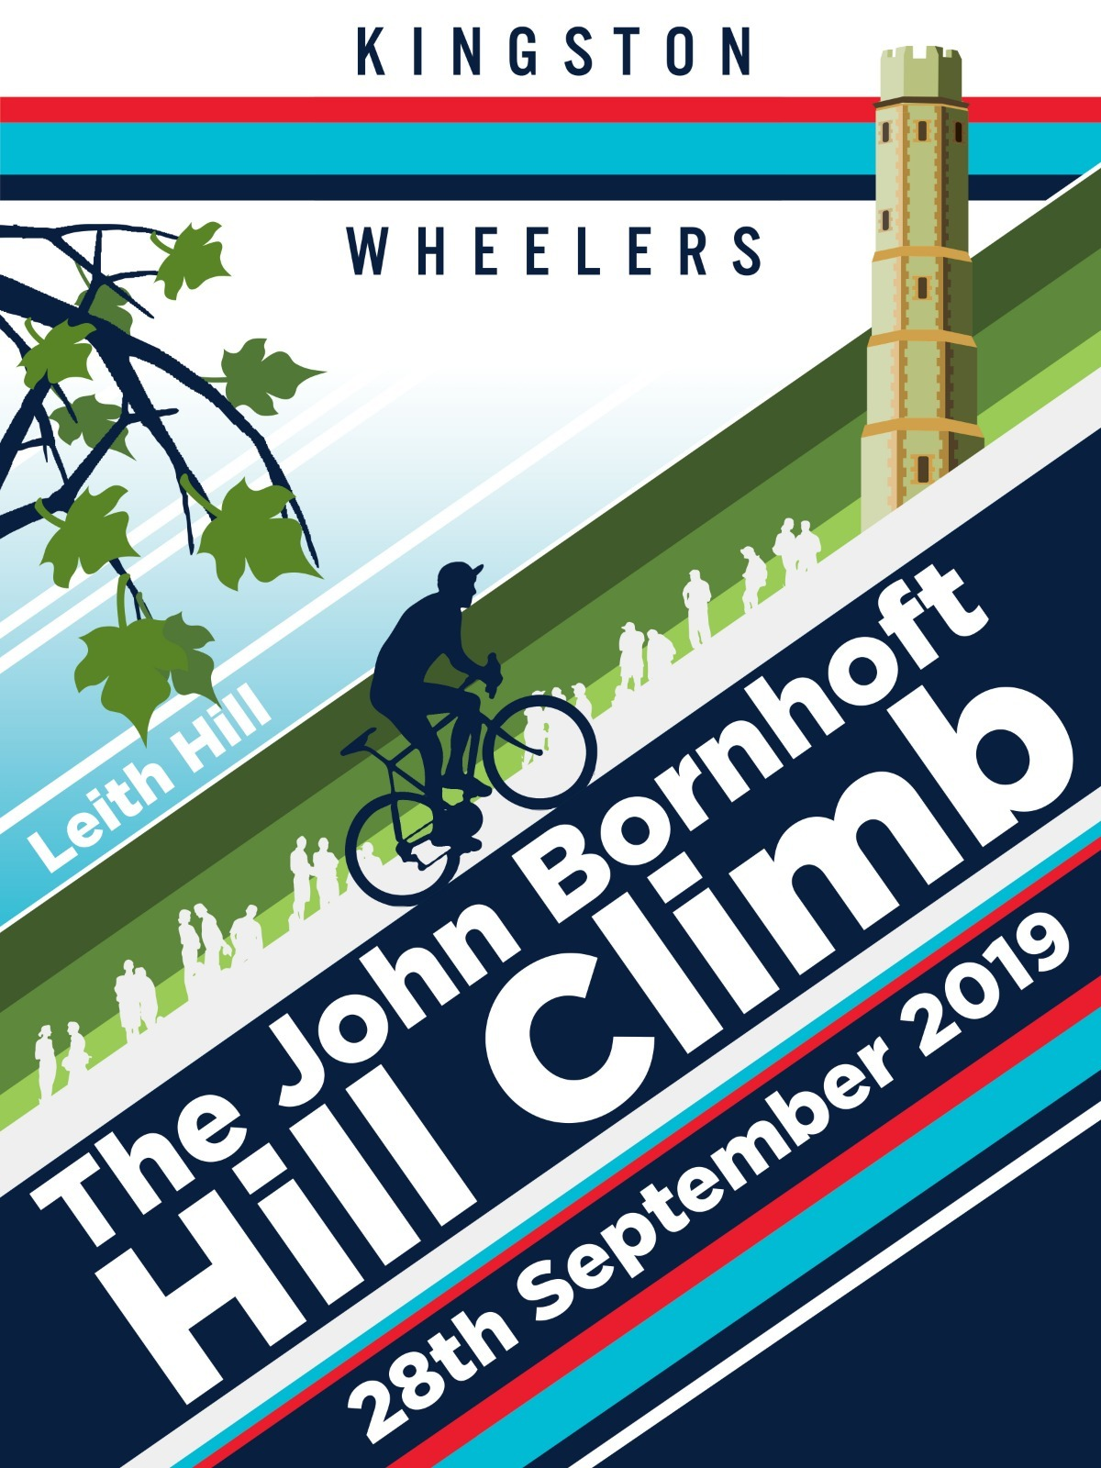
John Bornhoft Memorial Hill Climb - 28th September 2019
Promoted for and on behalf of Cycling Time Trials under its rules and regulations.
Artwork by Darren Marshall dazpix.co.uk

Organiser: Alice Lethbridge timetrial@kingstonwheelers.com
Contact on the day: Dean Kirkwood 07961 075480

Event Headquarters - John Venus Hall, Broomehall Road, Coldharbour, RH5 6HF
The course start is approximately 1.8 miles from the hall Turn left from HQ onto Abinger Road and proceed to the junction with Leith Hill Lane ( approx 1.2miles). Turn left onto Leith Hill Lane and descrend with caution to the start. Please take care not to impede riders racing the event. https://www.strava.com/routes/21834020
Number collection and signing on will be at the Village Hall from 9.30am. Please sign on at least 30 minutes before your allocated start time.
Course details: 1.4km, CTT LONDON SOUTH DC – 1,570 YARD HILL CLIMB – GH/42 (see map below https://www.strava.com/segments/768470?filter=overall)
OS REF | DETAILS | DISTANCE
134418 | START in Abinger Road , just east of Forest Green, at a gate on the west side of the road opposite the footpath to New Barn House at the bottom Leith Hill 580 yards north of the junction with the B2126 | 0.00
131431 | Proceed in a northerly direction past Leith Hill place to FINISH near summit of hill opposite grey metal painted post 70 yards before bridleway to Leith Hill Tower. | 1570 yds

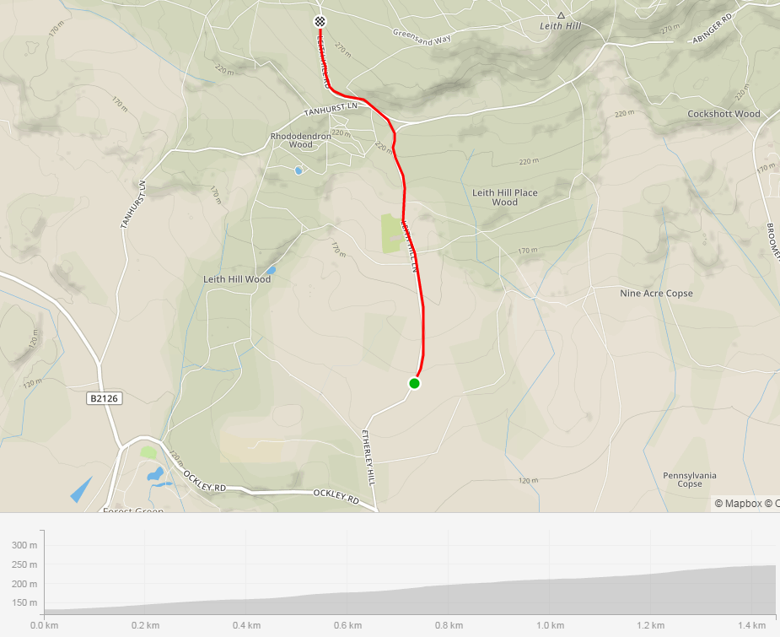

Time keepers:
Start - Rob Gardner
Finish - Paul Tunnell

Competitor information
London South District Regulation: No vehicles shall be parked on the highway within sight of the starting and finishing points.
Competitors are requested not to warm up on the course after the first competitor has started.
Details of any hazards not listed on this start sheet will be displayed or advised at the signing on point. All competitors must take note of these details when they sign on.
Protective Helmets
All competitors under the age of 18 years and / or Juniors must wear a properly affixed helmet which must be of hard / soft shell construction. Helmets should conform to a recognised Standard such as SNELL B95, ANSI Z90.4, AUS/NZS 2063:96, DIN 33-954, CPSC or EN 1078. It is the responsibility of the rider (or parent or guardian if the rider is under 18 years of age) to:
(a) Select a Helmet that offers protection against head injury and does not restrict the rider's vision or hearing.
(b) Ensure that the helmet is properly fitted, is undamaged and in good condition.
Competitors under the age of 18 years may only compete with the written consent of their parent or guardian given on the form(s) currently prescribed by the National Committee. No form – No ride!

YOUR RESULT WILL BE CALCULATED FROM YOUR SCHEDULED START TIME AND NOT ADJUSTED FOR A LATE START.

NUMBERS MUST BE FIXED BELOW WAIST
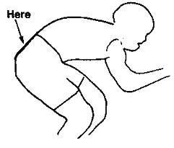

NO TIME MAY BE RECORDED IF NUMBER IS NOT CORRECTLY POSITIONED
Local Area Requirements
There are good toilets at the HQ, please use them rather than anywhere else
No riding ‘three abreast’
No swearing or hand gestures at car drivers
Please be respectful of horse and their riders – do not ride up behind them quietly so as to startle the horse!
Prizes:
Prizes | 1 | 2 | 3 | 4 | 5
Women’s overall | £50 | £40 | £30
Men’s Overall | £50 | £40 | £30 | £20 | £10
Women’s Vet | £30
Men’s Vet | £30 | £20 | £10
Juniors | £30
Juveniles | £30
Team of 3 | £45

To be awarded to the first man, first woman and first KWCC rider: a commemorative framed print by Darren Marshall.
One prize per ride (prize of the highest value will be awarded), with the exception of the team prize.
Prizes will be presented as soon as possible after the last rider has completed the course

NOTES TO COMPETITORS:
17. Signing-on Sheet and Signing-out Sheet
(a) The competitors in all types of events must make themselves aware of any special safety instructions for the event and sign the official signing-on sheet when collecting their number.
(b) In Type A events a competitor must return to the event HQ either during the event or within a reasonable time after the last rider has finished the event and must
(i) return their race number(s); and
(ii) sign the official signing-out sheet. A rider who fails to so sign the official signing-out sheet shall be recorded as DNF.

This event may be subject to a Doping Control As soon as you have finished you should return to the event HQ as it is your responsibility to check if you are required for Doping Control. Race numbers required for Doping Control will be displayed at the HQ adjacent to the result board. If your number is displayed you should report immediately to Doping Control which will be nearby. Remember, it is up to you to check and ensure that you comply. If required you must report to Doping Control after finishing without delay.

Start Times
bib | start_time | firstname | lastname | club | gender | category
2 | 11:02:00 | Mark | Aldred | Kingston Wheelers CC | Male | Senior
3 | 11:03:00 | Haddi | Conant | Datalynx-Parenesis Cycling | Female | Espoir
4 | 11:04:00 | Robin | Snook | Velo Club Godalming & Haslemere | Male | Veteran
5 | 11:05:00 | Colin | Gray | Norwood Paragon CC | Male | Veteran
6 | 11:06:00 | Tim | Cheyne | Kingston Wheelers CC | Male | Veteran
7 | 11:07:00 | Mark | Montgomery | Tamar Velo | Male | Veteran
8 | 11:08:00 | Tomos | Shaw | Chichester City Riders | Male | Senior
9 | 11:09:00 | Artur | Kaczmarek | Kingston Wheelers CC | Male | Senior
10 | 11:10:00 | Ollie | Smith | Paceline RT | Male | Senior
11 | 11:11:00 | Tom | Hazelton | Dulwich Paragon CC | Male | Senior
12 | 11:12:00 | Scott | Leeson | London Dynamo | Male | Senior
13 | 11:13:00 | Peter | Adams | Tri Surrey | Male | Veteran
14 | 11:14:00 | Daniel | Sharp | Charlotteville Cycling Club | Male | Veteran
15 | 11:15:00 | Nicola | Soden | Datalynx-Parenesis Cycling | Female | Senior
16 | 11:16:00 | Ben | Speller | Kingston Wheelers CC | Male | Veteran
17 | 11:17:00 | Katja | Rietdorf | Born to Bike - Bridgtown Cycles | Female | Veteran
18 | 11:18:00 | Peter | Kilby | Lewes Wanderers CC | Male | Veteran
19 | 11:19:00 | Helen | Mckay | Les Filles Racing Team | Female | Veteran
20 | 11:20:00 | Jacintha | Hamilton-love | Dulwich Paragon CC | Female | Senior
21 | 11:21:00 | Danielle | Forshaw | Velo Club Godalming & Haslemere | Female | Senior
22 | 11:22:00 | Finlay | Hawker | VC de Londres | Male | Juvenile
23 | 11:23:00 | Ria | Woodfield | Kingston Wheelers CC | Female | Senior
24 | 11:24:00 | Chris | Hartono | LFGSS CC | Male | Senior
25 | 11:25:00 | Jack | Hartrey | Kingston Wheelers CC | Male | Juvenile
26 | 11:26:00 | Sandra | Mackay | Datalynx-Parenesis Cycling | Female | Veteran
27 | 11:27:00 | Ivan | Newsome | Epsom CC | Male | Junior
28 | 11:28:00 | Tom | Portsmouth | Charlotteville Cycling Club | Male | Junior
29 | 11:29:00 | Charlie | Mactear | High Wycombe CC | Male | Junior
30 | 11:30:00 | Theo | Tadros | trainSharp | Male | Junior
31 | 11:31:00 | Olivia | Bentley | Vision Innovative Leisure Racing Team | Female | Senior
32 | 11:32:00 | Rachel | Przybylski | Charlotteville Cycling Club | Female | Senior
33 | 11:33:00 | Daniel | Pink | GS Avanti | Male | Senior
34 | 11:34:00 | Kate | Palmer | Brixton Cycles Club | Female | Senior
35 | 11:35:00 | Thomas | Seller | Oxted Cycle Club | Male | Senior
36 | 11:36:00 | Gemma | Hobson | Sussex Nomads CC | Female | Veteran
37 | 11:37:00 | David | Marshall | Hemel Hempstead CC | Male | Veteran
38 | 11:38:00 | Rosamund | Bradbury | Sigma Sports | Female | Senior
39 | 11:39:00 | Matt | Phipps-taylor | VELOSPORT CC | Male | Senior
40 | 11:40:00 | Chris | Carroll | Velo Club Godalming & Haslemere | Male | Senior
41 | 11:41:00 | Guy | Tucker | Team Tor 2000 | KALAS | Male | Espoir
42 | 11:42:00 | Calvin | Martin | Westerley Cycling Club | Male | Espoir
43 | 11:43:00 | Jack | Kellam | Cambridge University CC | Male | Senior
44 | 11:44:00 | Kieran | Presland | Kingston Wheelers CC | Male | Espoir
45 | 11:45:00 | Peter | Tadros | trainSharp | Male | Veteran
46 | 11:46:00 | Will | Rostron | Kingston Wheelers CC | Male | Veteran
47 | 11:47:00 | Leo | Downing | Kingston Phoenix RC | Male | Senior
48 | 11:48:00 | Luca | Palazzo | Kingston Wheelers CC | Male | Senior
49 | 11:49:00 | Ian | Middleton | Foran CCC | Male | Senior
50 | 11:50:00 | Chris | Newberry | Redhill CC | Male | Senior
51 | 11:51:00 | Thomas | Willan | East London Velo | Male | Senior
52 | 11:52:00 | Sam | Dorkings | GS Avanti | Male | Senior
53 | 11:53:00 | Edward | Francis | Paceline RT | Male | Veteran
54 | 11:54:00 | Neil | Grunshaw | Kingston Wheelers CC | Male | Senior
55 | 11:55:00 | David | Ross | LFGSS CC | Male | Senior
56 | 11:56:00 | Peter | Hair | Kingston Wheelers CC | Male | Senior
57 | 11:57:00 | Jon | Saunders | Charlotteville Cycling Club | Male | Senior
58 | 11:58:00 | Harry | Bunnell | Kingston Wheelers CC | Male | Senior
59 | 11:59:00 | Samuel | Brealey | RUE MORGUE CC | Male | Senior
60 | 12:00:00 | Andrew | Feather | ChampionSystem(UK) | Male | Senior

