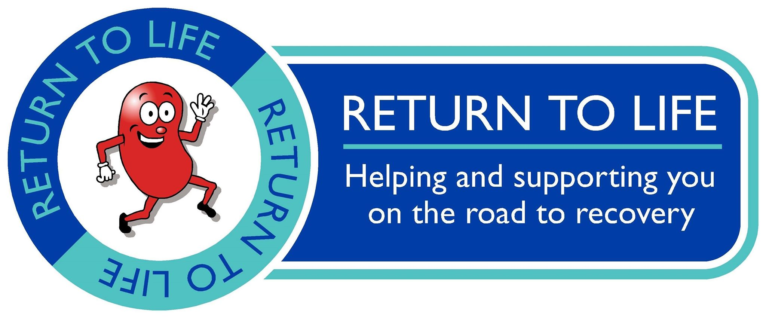

Welcome to the GTR/Return to Life charity 10 mile TT on the world famous A78 Eglinton Park course.
Race hq Eglinton park (KA12 8TA) car park/shelter. Sign on from 1700hrs on Saturday 10th August.
Remember to hand your number in and sign out on your return.
It’s a pretty straightforward course, cycle out 5 miles to the papermill/dundonald camp roundabout, turn round and ride 5 miles back, you can’t go wrong. That being said it’s the riders responsibility to familiarise yourself with the course and LOOK where you are going.
Where the road goes from three lanes to two you MUST look over your shoulder to check it is safe, and only do so when the filter lane begins, NOT BEFORE……(Riders must change lanes after exit line paint has commenced but before solid white paint)……………offending riders from previous events you know who you are, I don’t want old Bill coming down to ruin the day for us as currently thanks to my charm and likeability they are on side. Same for the turn, IT IS NOT the marshals responsibility to tell you it’s safe or not, please don’t risk your life in a fish and chipper.
We have had problems in the past getting to use this course due to inconsiderate riders turning up with bikes not maintained and consequently crashing, thankfully these riders know not to enter GTR events. However, If we see anyone whose bike is not 100% WE WILL prevent you from starting. We will not jeopardise future races on this course.
As this is a night time event please use a rear light, It’s not mandatory but I’d like you to.
Finally, as this is a charity event with the aim of raising funds for Return to Life, I’m running on a minimum budget (apart from prizes), old school, back of the car job. Public parking is plentiful within the park.
Enjoy!!

Course description
10 Mile TT

AY4 - Start at lamp no.R5 opposite entrance to Eglinton Country Park. Follow A78 south, under two interchanges and turn at Dundonald Camp Roundabout. Return to finish on slip road at Eglinton Interchange.

http://www.gmap-pedometer.com/?r=5913085

