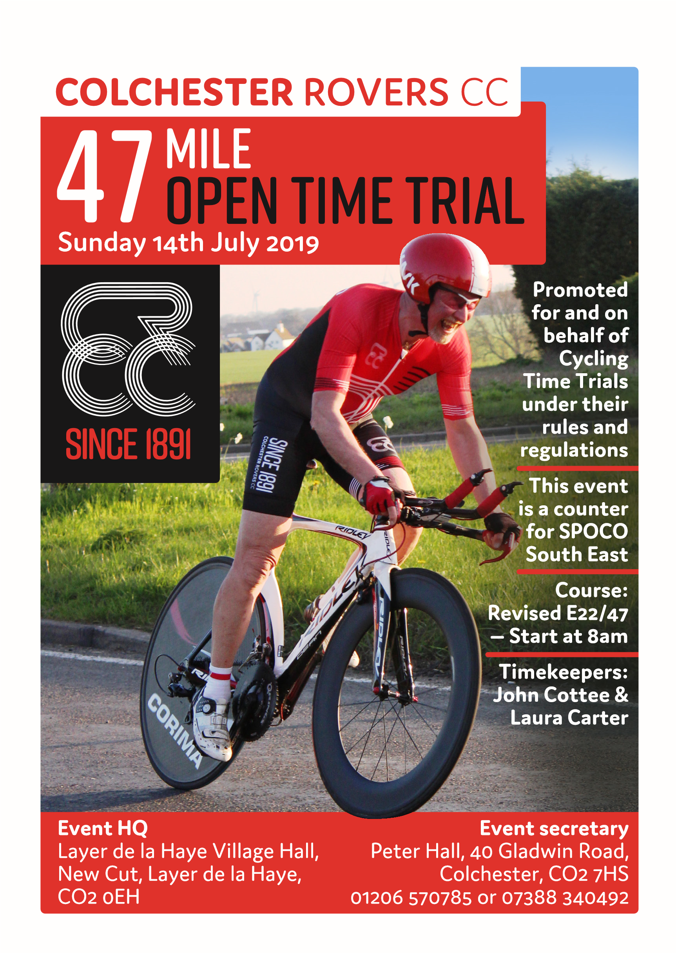
Race H.Q. will be at Layer de la Haye village hall.
New Cut, Layer de la Haye. Postcode CO2 0EH

Revised E22/47 (47 miles) COURSE DETAILS. Due to new HQ at Layer De La Haye

START (GR 953149)
At telegraph pole No. 10, just beyond the former Kings Head public house. Continue for 1 mile to turn left (M), crossing Abberton Reservoir. Go through Layer Breton and Birch. Proceed to junction with B1022, where turn sharp left (M) (GREAT CARE). Proceed through Tiptree (GREAT CARE across double Mini RAB), Proceed through Great Totham, at Heybridge turn left at Mini RAB onto Goldhanger Road B.1026 (M) to Tolleshunt D'Arcy until reaching former 'Kings Head' public house. Turn left (M) & continue past the start for a second circuit. On reaching the former Kings Head for the second time, Turn left (M) pass the start continue 1 mile to junction follow round to right (B1026) (M) Proceed to Abberton Reservoir on towards Layer Church to FINISH at the 30 mph sign (GR966 190)

Please be aware that the roads through the villages of Layer Breton, Birch and Great Totham have significant on street parking and narrow lanes. Take great care.

There is a double mini roundabout in Tiptree. Give way to traffic from the right and give clear signals of your intended route.

The start is approximately 3 miles from the HQ , so please allow plenty of time to get there.

CTT LOCAL REGULATIONS

4.8.2 NO “U” TURNS are allowed within sight of either the start or the finishing points. Riders carrying out this dangerous manoeuvre are liable for disqualification from the event and further disciplinary action by the District Committee.

4.8.3 Body numbers are to be situated at the event headquarters for ALL open, semi-open and association events.

4.8.4 Static trainers — In respect of consideration for local residents, the use of static trainers, e.g. turbo trainers, is banned from all morning events held in London East District.

No parking at start or finish other than the timekeeper’s car.

In the interest of your own safety, Cycling Time Trials strongly advise you to wear a hard shell safety helmet that meets an internationally accepted safety standard. All juniors and/or riders under the age of 18 years are required to wear a suitably approved helmet.

AWARDS

Overall Men & Women
1st. £25.00
2nd. £20.00
3rd £15.00

www.colchesterrovers.org.uk

Number | Start Time |  |  |  | Club
1 | 8.01 |  | Colin | White | Colchester Rovers CC
2 | 8.02 |  | Ian | Braybrook | Basildon CC
3 | 8.03 |  | Wolfgang | Emmerich | London Phoenix CC
4 | 8.04 |  | Dan | Carter | Essex Roads CC
5 | 8.05 |  | Timothy | Chilvers | Maldon & District CC
6 | 8.06 |  | Rob | Chaplin | East London Velo
7 | 8.07 |  | Dan | Foster | 3T-RACING
8 | 8.08 |  | Gill | Carter | Essex Roads CC
9 | 8.09 |  | Richard | Pimlott | Finsbury Park CC
10 | 8.10 |  | Peter | Harding | Chelmer CC
11 | 8.11 |  | Peter | Tibbitts | Ford CC
12 | 8.12 |  | Neal | Marrin | Finsbury Park CC
13 | 8.13 |  | Graham | Hurrell | Basildon CC
14 | 8.14 |  | Lisa | Hurrell | Maldon & District CC
15 | 8.15 |  | Christopher | Smith | Eat Plants Not Pigs CC
16 | 8.16 |  | Lee | Kennedy | Army Cycling
17 | 8.17 |  | Jeremy | Greenwood | Finsbury Park CC
18 | 8.18 |  | Gavin | Lewis | Velo Schils Interbike RT
19 | 8.19 |  | Malcolm | Strickland | Thornton Road Club
20 | 8.20 |  | Colin | Ward | Essex Roads CC
21 | 8.21 |  | Jim | Reed | Colchester Rovers CC
22 | 8.22 |  | Paul | Ruffy | Eat Plants Not Pigs CC
23 | 8.23 |  | Matt | Haigh | Essex Roads CC
24 | 8.24 |  | Adam | Chamberlin | TPH Racing
25 | 8.25 |  | Stuart | Weatherley | TPH Racing
26 | 8.26 |  | Andrew | Turnock | Finsbury Park CC
27 | 8.27 |  | Giles | Askham | Colchester Rovers CC
28 | 8.28 |  | Paul | Dewberry | Colchester Rovers CC
29 | 8.29 |  | Robin | Johnson | Brighton Mitre CC

