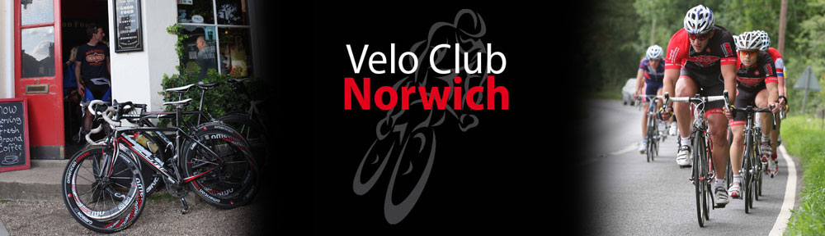

Open 25m TT. 3rd August 2019

OPEN 25 MILES SOLO & TANDEM TIME TRIAL, SATURDAY 3rd August @ 3pm
Promoted for and on behalf of cycling time trials under their rules and regulations
Event secretary:
Markos Janes, 14 Ecton Walk, Old Catton, Norwich, NR67ES. 07442259525
Timekeepers:
TBC

Race H.Q:
East Harling Youth Centre, Church Rd, East Harling, NR16 2NA Opposite the church, Open from 1500 Starting stewards, recorders, marshals and refreshments: Members and friends of VC Norwich
Parking:
Parking at the Youth Centre is limited but there is also parking at the Sports & Social Club next door and there is ample parking on roads adjacent to the HQ.
There is also parking near the start. Follow the B111 until approximately 200m from the start, turn right and right again and you can park on the verge.
Course:
B25/8 (Larling-Wymondham-Larling). START at the paint mark on kerb – by drain – on B1111 in underpass under A11 at LARLING. Proceed to turn LEFT onto slip road to A11 EASTBOUND to join A11 carriageway. Proceed EAST via ATTLEBOROUGH RAB to slip road signed MULBARTON.

Take slip road and proceed to BROWICK RAB (1). Take 3rd exit and proceed over bridge (13.2 miles) to BROWICK RAB (2). Take 2nd exit to rejoin A11 WESTBOUND and proceed via ATTLEBOROUGH RAB to finish at paint mark on the kerb – at point half way along layby between SNETTERTON and LARLING. After finish exit next slip road.
To the start:
The start is approximately 1.6 miles from the HQ. Turn left out of the HQ onto the B111 for 1.6miles.
Back to HQ:
After finish exit next slip road, proceed along B111 for 1.6miles back to HQ.
Signing IN & OUT:
After SIGNING IN at Race HQ you can collect your numbers*. All competitors are now required to SIGN OUT when returning their number*
1. Failure to sign out will result in the competitor being recorded as DNF. * Please do not damage the numbers with adhesive or by using pins other than through the eyelets. *1 CTT Handbook, Rule 17B, page 343.
Refreshments: On return of the number, riders will be provided with a free drink. Donations will be gratefully received in aid of the VCN charity of the year.
CTT EAST DSTRICT LOCAL REGULATIONS
Turbo Trainers As this is a PM event, the use of turbo trainers is permitted but please be mindful of space in the car park.
U Turns U-turns will not be permitted on the course or on roads adjacent to the start and finish areas while the event is in progress. NOTE: A U-TURN is defined as a 180 degree turn completed within the width of the carriageway whilst astride the bicycle. It is recommended that the rider(s) should dismount, check the road is clear in both directions then with the bicycle walk across the road.
Warming Up
No riding along the course by competitors once the event has started. Any breaking of these regulations in the first case may mean disqualification from the event. Further cases will be referred to the District Committee.
Safety LED rear lights
It is recommended that a working rear light either flashing or constant is fitted to the machine in a position visible to following road users and is active whilst the machine is in use.
Cycling Helmets IN THE INTERESTS OF YOUR OWN SAFETY Cycling Time Trials and the Event Promoter strongly advise you to wear a hard-shell helmet that meets internationally accepted safety standard. All competitors under the age of 16 years and/or juniors must wear properly affixed protective helmets which must be of hard/soft shell construction.
Helmets should conform to recommended standard such as SHELL B95, ANZI Z90.4, AUS/NZS 2063:96, DIN 33-954m, CPSC or EN1078.
It is the responsibility of the rider (or parent/guardian) if the rider is under 18 years of age to:-
a) Select a standard of protective headgear that offers protection against head injury and does not restrict the rider’s vision or hearing
b) Ensure that the headgear is properly fitted, is undamaged and in good condition
Course Records:
Men Ryan Perry (Langdale Lightweights) 00:46:31 (2016)
Women Rebecca Murley (Wisbeach Wheelers) 00:55:29 (2018)
PRIZE LIST
SCRATCH 1st £20 2nd £15 3rd £10
WOMEN 1st £20 2nd £15 3rd £10
VET on STD 1st £20 2nd £15 3rd £10
Tandem 1st £20 2nd £15 3rd £10 Team £20 each
Course record £30
ONE RIDER, ONE PRIZE

Sponsored By

