



**Presents VC ST Raphael Middle Markers 10 Mile TT**

**Saturday 25th May 2019 3:00pm**

Liphook – Liss – Liphook A3 ~ Course P881r 10 mile

(Promoted for and on behalf of Cycling Time Trials under their Rules Regulations)

The Headquarters: Bohunt School, Longmoor Road, Liphook, GU30 7NY

Headquarters open from 1.00pm onwards.

Timekeepers: Kathy Collard-Berry 3crg, Dave Collard-Berry a3crg.

Results: Martin Whitty...a3crg, Patrick Brennan ...a3crg

Start Line Stewards & Marshals: VC St Raphael Friends and Family

**Prizes**

Women’s Winner 40.00 Men’s 40.00 First Team 45.00

Second Place 30.00 Second Place 30.00 Second Team 30.00

Third Place 20.00 Third Place 20.00 Third Team 15.00

Women’s Vets Winner 30.00 Men’s Vets Winner 30.00

Women’s Second Vet 20.00 Men’s Vets Second 20.00

Women’s Third Vet 15.00 Men’s Vets Third 15.00

Espoir Winner 15.00.

Look forward to seeing you all on the day and remember heads up and most of all enjoy your race.

Event organiser Peter Hatt

33 Blounts Court, Potterne, Devizes, Wiltshire SN105QE

Mobile:07725656734

Landline: 01380-730154

Email: petehatt@hotmail.co.uk

IN THE INTERESTS OF YOUR OWN SAFETY, Cycling Time Trials and the event promoters strongly advise you to wear a HARD-SHELL HELMET, that meets an international accepted safety standard. It is recommended that a WORKING REARLIGHT, either flashing or constant, is fitted to the machine in a position visible to following road users and is active while the machine is in use.

Course Details: (Liphook - Liss - Liphook)

Course Record: 17:55 Hamish Bond (14th June 2017)

Map of the Course

P881 R

Please note no warming up on the course during or before the event, it is a very busy road, hence the start time of 3:00pm. We don’t want to lose this course.

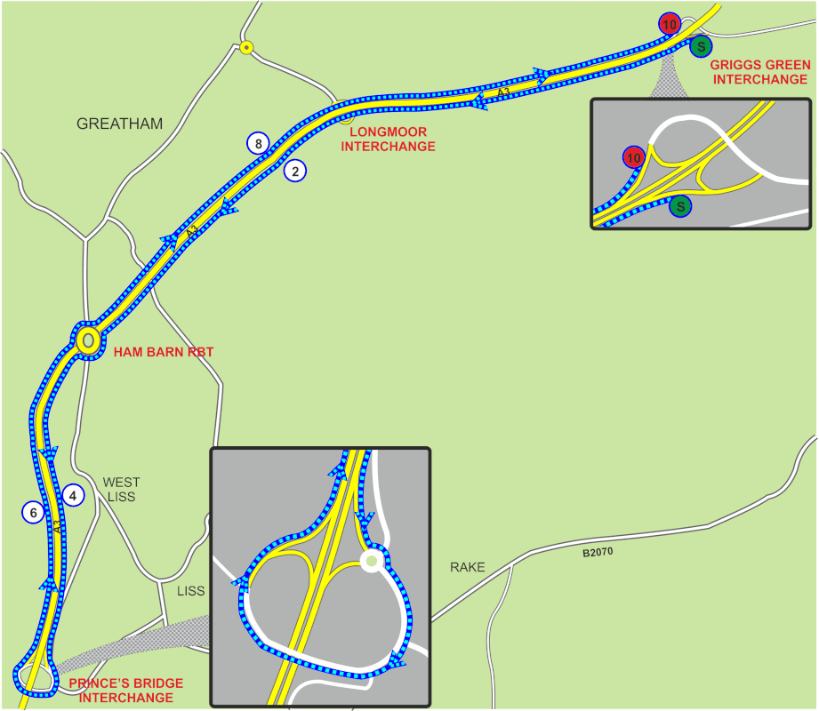

START on Entry Slip Road to A3 at Griggs Green Interchange.

South West to join A3 (signposted Petersfield and Portsmouth).

Proceed on A3 passing exit slip road at Longmoor Interchange (Signposted A325

Farnham) to Ham Barn RAB (SU 772295)

Take 2nd Exit and continue on A3 until reaching the exit slip road signposted Liss

(1/2 mile past the lay-by) where take this Exit Slip Road to the Prince’s Bridge

RAB (SU 770270). Take 2nd Exit and then bear RIGHT following the sign A3

Guildford to cross Prince’s Bridge Flyover where TURN (5.00 Miles).

Re-join the A3 and proceed North to Ham Barn RAB (SU 772295)

Take 2nd Exit and proceed North East on A3 passing the exit slip road at

Longmoor Interchange (signposted A325 Farnham).

Take the 2nd Exit Slip Road (signposted Griggs Green) to

FINISH on Exit Slip Road at Griggs Green Interchange.

Riders Notes:

1.To get to the start, turn left out of the headquarters, allow 10 minutes.

2. Please be aware only 4 riders will be allowed to be near the

starting line and a Marshall will be there to control the situation This is a

Police Control to allow the event to proceed.

3. There will be observers at Ham Barn roundabout, please abide by the

rules of the road at all times.

4. Please return your number to the signing on desk and sign out. Check

you are not required for a Dope Control.

5. Please ensure you have a working rear light.

Refreshments will be available back at the HQ and free of charge donations are willingly accepted.

|  |  |  |  |  |  |  |  |
| --- | --- | --- | --- | --- | --- | --- | --- |
| bib | start time | first name | last name | club | gender | category |  |
| 4 | 15:04:00 | Martin | Beale | Velo Club St Raphael | Male | Veteran |  |
| 5 | 15:05:00 | Jerry | Bromyard | ...a3crg | Male | Veteran |  |
| 6 | 15:06:00 | Alan | Robinson | Central Sussex CC | Male | Veteran |  |
| 7 | 15:07:00 | Steve | Hutt | Portsmouth North End CC | Male | Veteran |  |
| 8 | 15:08:00 | Phil | Morris | Fareham Wheelers CC | Male | Veteran |  |
| 9 | 15:09:00 | Guy | Chappelle | ...a3crg | Male | Veteran |  |
| 10 | 15:10:00 | Paul | Morris | Fareham Wheelers CC | Male | Senior |  |
| 11 | 15:11:00 | Carly | Ibbitson | Fareham Wheelers CC | Female | Senior |  |
| 12 | 15:12:00 | Matt | Carolan | Charlotteville Cycling Club | Male | Veteran |  |
| 13 | 15:13:00 | Lorna | Rowland | Twickenham CC | Female | Veteran |  |
| 14 | 15:14:00 | Steve | Hoskins | Devizes Town Cycling Club | Male | Veteran |  |
| 15 | 15:15:00 | Adrian | Talley | Portsmouth North End CC | Male | Veteran |  |
| 16 | 15:16:00 | Imogen | Gifford | trainSharp | Female | Junior |  |
| 17 | 15:17:00 | Alun | Tribe | Blazing Saddles | Male | Veteran |  |
| 18 | 15:18:00 | Robert | Jolliffe | New Forest CC | Male | Veteran |  |
| 19 | 15:19:00 | Martin | Howes | Tornado Road Cycling Club | Male | Senior |  |
| 20 | 15:20:00 | Peter | Lynk | Bournemouth Jubilee Whs | Male | Veteran |  |
| 21 | 15:21:00 | Gareth | Smith | Southdown Velo | Male | Veteran |  |
| 22 | 15:22:00 | Ken | Rayson | ...a3crg | Male | Veteran |  |
| 23 | 15:23:00 | Mat | Jessop | Tornado Road Cycling Club | Male | Senior |  |
| 24 | 15:24:00 | Norman | Harvey | Sotonia CC | Male | Veteran |  |
| 25 | 15:25:00 | Martin | Andrews | Velo Club Venta | Male | Veteran |  |
| 26 | 15:26:00 | Bethany | Spencer | Kettering CC | Female | Junior |  |
| 27 | 15:27:00 | Gerry | Peppin | Corinium Cycle Club | Male | Veteran |  |
| 28 | 15:28:00 | Rachel | Przybylski | Charlotteville Cycling Club | Female | Senior |  |
| 29 | 15:29:00 | Simon | Craig-mcfeely | ...a3crg | Male | Veteran |  |
| 30 | 15:30:00 | Spencer | Kirkham | Worthing Excelsior CC | Male | Veteran |  |
| 31 | 15:31:00 | Mike | Noad | Bayside Tri Club | Male | Veteran |  |
| 32 | 15:32:00 | Charles | Dennison | Southborough & Dist. Whs | Male | Veteran |  |
| 33 | 15:33:00 | Peter | Knipe | Fareham Wheelers CC | Male | Veteran |  |
| 34 | 15:34:00 | John | Isard | Hampshire Road Club | Male | Veteran |  |
| 35 | 15:35:00 | Trevor | Leeding | Worthing Excelsior CC | Male | Veteran |  |
| 36 | 15:36:00 | Daniel | Loveday | Charlotteville Cycling Club | Male | Veteran |  |
| 37 | 15:37:00 | Fenella | Brown | Beacon Roads CC | Female | Veteran |  |
| 38 | 15:38:00 | Edward | Mellor | Mapperley CC | Male | Veteran |  |
| 39 | 15:39:00 | Andrew | Booty | Lewes Wanderers CC | Male | Veteran |  |
| 40 | 15:40:00 | Shaun | Smart | Southdown Velo | Male | Veteran |  |
| 41 | 15:41:00 | Jerry | Keen | Eastbourne Rovers CC | Male | Veteran |  |
| 42 | 15:42:00 | Mark | Henrick | V C Meudon | Male | Veteran |  |
| 43 | 15:43:00 | Paul | Paradise | Devizes Town Cycling Club | Male | Senior |  |
| 44 | 15:44:00 | Matt | Hill | Velo Club Godalming & Haslemere | Male | Veteran |  |
| 45 | 15:45:00 | Peter | Lloyd | N+1 - Lindfield Coffee Works | Male | Veteran |  |
| 46 | 15:46:00 | Robert | Oliver | Fareham Wheelers CC | Male | Veteran |  |
| 47 | 15:47:00 | Rachel | Clay | GS Vecchi | Female | Veteran |  |
| 48 | 15:48:00 | Bruce | English | Eastbourne Rovers CC | Male | Veteran |  |
| 49 | 15:49:00 | Deborah | Sheridan | Warwickshire Road Club | Female | Veteran |  |
| 50 | 15:50:00 | Duncan | Emery | Twickenham CC | Male | Veteran |  |
| 51 | 15:51:00 | Peter | Drabble | WORX Factory Racing Powered by Silverstone | Male | Juvenile |  |
| 52 | 15:52:00 | Jo | Buckland | PDQ Cycle Coaching | Female | Veteran |  |
| 53 | 15:53:00 | Steve | Potts | Velo Club St Raphael | Male | Veteran |  |
| 54 | 15:54:00 | Alan | Doney | Portsmouth Triathletes | Male | Veteran |  |
| 55 | 15:55:00 | Michael | Stevens | Fareham Wheelers CC | Male | Veteran |  |
| 56 | 15:56:00 | Colin | Barton | Worthing Excelsior CC | Male | Veteran |  |
| 57 | 15:57:00 | Paul | Beck | Hampshire Road Club | Male | Veteran |  |
| 58 | 15:58:00 | Jonathan | Lacey | Southdown Velo | Male | Veteran |  |
| 59 | 15:59:00 | Peter | Noble | Epsom CC | Male | Veteran |  |
| 60 | 16:00:00 | Perry | Lee | Southdown Velo | Male | Veteran |  |
| 61 | 16:01:00 | John | Mcglashan | Redmon CC | Male | Veteran |  |
| 62 | 16:02:00 | James | Cheeseman | N+1 - Lindfield Coffee Works | Male | Senior |  |
| 63 | 16:03:00 | Leighton | Smith | Poole Whs | Male | Senior |  |
| 64 | 16:04:00 | Stuart | Grace | GA Cycles | Male | Veteran |  |
| 65 | 16:05:00 | Adam | Stone | North Road CC | Male | Senior |  |
| 66 | 16:06:00 | Matt | Robinson | Westbury Wheelers | Male | Veteran |  |
| 67 | 16:07:00 | Mike | Boyce | ...a3crg | Male | Veteran |  |
| 68 | 16:08:00 | Adriano | Dos Santos | Swindon Road Club | Male | Veteran |  |
| 69 | 16:09:00 | Derek | Dowden | Hampshire Road Club | Male | Veteran |  |
| 70 | 16:10:00 | Craig | Weston | Poole Whs | Male | Veteran |  |
| 71 | 16:11:00 | Martin | Canes | Chelmer CC | Male | Senior |  |
| 72 | 16:12:00 | Conor | Boyle | Woking Cycle Club | Male | Veteran |  |
| 73 | 16:13:00 | Daniel | Ellis | Eastbourne Rovers CC | Male | Senior |  |
| 74 | 16:14:00 | Matt | Linham | Portsmouth North End CC | Male | Senior |  |
| 75 | 16:15:00 | Mike | O'gorman | Worthing Excelsior CC | Male | Veteran |  |
| 76 | 16:16:00 | Liam | Smith | Kingston Wheelers CC | Male | Senior |  |
| 77 | 16:17:00 | Iain | Cotton | Alton CC/Owens Cycles | Male | Veteran |  |
| 78 | 16:18:00 | Richard | Bradley | 3C Cyclexperience | Male | Veteran |  |
| 79 | 16:19:00 | Antonio | Maschio | Sotonia CC | Male | Veteran |  |
| 80 | 16:20:00 | James | Dick | Tri Team Wessex | Male | Veteran |  |
| 81 | 16:21:00 | Steve | Skinner | Bognor Regis CC | Male | Veteran |  |
| 82 | 16:22:00 | Robert.a. | Engers | Shorter Rochford RT | Male | Veteran |  |
| 83 | 16:23:00 | Tom | Herbert | Kingston Wheelers CC | Male | Senior |  |
| 84 | 16:24:00 | Ian | Sherin | 3C Cyclexperience | Male | Veteran |  |
| 85 | 16:25:00 | John | Glaysher | ...a3crg | Male | Veteran |  |
| 86 | 16:26:00 | Chris | Wallis | Blazing Saddles | Male | Veteran |  |
| 87 | 16:27:00 | Steve | Bray | Salt and Sham Cycle Club | Male | Veteran |  |
| 88 | 16:28:00 | Alex | Rice | Southdown Velo | Male | Veteran |  |
| 89 | 16:29:00 | Daniel | Sharp | Charlotteville Cycling Club | Male | Veteran |  |
| 90 | 16:30:00 | Gary | Ferrett | Hampshire Road Club | Male | Veteran |  |
| 91 | 16:31:00 | Jon | Wiggins | PDQ Cycle Coaching | Male | Senior |  |
| 92 | 16:32:00 | John | French | Oxford City RC | Male | Veteran |  |
| 93 | 16:33:00 | Deborah | Smith | Southdown Velo | Female | Veteran |  |
| 94 | 16:34:00 | Sam | Day | CS Grupetto | Male | Veteran |  |
| 95 | 16:35:00 | Stuart | Peckham | New Forest CC | Male | Veteran |  |
| 96 | 16:36:00 | Deanna | Ferrett | Hampshire Road Club | Female | Veteran |  |
| 97 | 16:37:00 | Michael | Cope | Kettering CC | Male | Veteran |  |
| 98 | 16:38:00 | James | Ibbitson | Fareham Wheelers CC | Male | Senior |  |
| 99 | 16:39:00 | Martin | Booker | South Downs Bikes / Casco Pet | Male | Veteran |  |
| 100 | 16:40:00 | Harry | Johnson | Velo Club St Raphael | Male | Espoir |  |
| 101 | 16:41:00 | Elliot | Brown | Velo Club Godalming & Haslemere | Male | Senior |  |
| 102 | 16:42:00 | Chris | Tomsett | JAM Cycle Race Team coached by BPC | Male | Senior |  |
| 103 | 16:43:00 | Paul | Longman | ...a3crg | Male | Veteran |  |
| 104 | 16:44:00 | Kirsty | Mcseveney | ...a3crg | Female | Senior |  |
| 105 | 16:45:00 | Greg | Harding | Farnham RC | Male | Veteran |  |
| 106 | 16:46:00 | Robert | Charles | Blazing Saddles | Male | Veteran |  |
| 107 | 16:47:00 | Andrew | Curley | Warwickshire Road Club | Male | Veteran |  |
| 108 | 16:48:00 | Michael | Naulls | Velo Club Venta | Male | Veteran |  |
| 109 | 16:49:00 | Tim | Cooke | Sotonia CC | Male | Veteran |  |
| 110 | 16:50:00 | Dan | Pullen | N+1 - Lindfield Coffee Works | Male | Veteran |  |
| 111 | 16:51:00 | Tim | Peters | Horsham Cycling | Male | Veteran |  |
| 112 | 16:52:00 | Rob | Luff | GS Stella | Male | Veteran |  |
| 113 | 16:53:00 | Chris | Lord | Brighton Excelsior CC | Male | Veteran |  |
| 114 | 16:54:00 | Mark | Jones | GS Stella | Male | Veteran |  |
| 115 | 16:55:00 | Stuart | Thompson | Velo Club St Raphael | Male | Veteran |  |
| 116 | 16:56:00 | Matthew | Butler | Charlotteville Cycling Club | Male | Senior |  |
| 117 | 16:57:00 | Simon | Steeles | Worthing Excelsior CC | Male | Veteran |  |
| 118 | 16:58:00 | Henry | Salmon | University of Southampton RC | Male | Espoir |  |
| 119 | 16:59:00 | Nolan | Heather | Worthing Excelsior CC | Male | Veteran |  |
| 120 | 17:00:00 | Lee | Turner | Sigma Sports | Male | Veteran |  |