www.brightonmitre.co.uk
1894 - 2019
PRESIDENT – ROBIN JOHNSON

12th Annual Flat 10 Miles Time Trial – Monday 27th May 2019
Course G.10/97
18th Annual Very Hilly 10 Miles Time Trial – Monday 27th May 2019
Course GS/995

Event Secretary: Robin Johnson, | 7 Gorselands, Billingshurst, West Sussex, RH14 9TT.  Email: mr_rjohnson@outlook.com  Tel: 01403 783368 (or 07733 132043 on day of event)

Promoted for and on behalf of Cycling Time Trials under its rules and regulations

HQ  Cuthman Centre,  Horsham Road,  Steyning  West Sussex  Postcode BN44 3RX.  Open from 05:30. | Same HQ as 2018, but different to 2017.  On the north side of Steyning, next to Steyning Leisure Centre which is the first building on the left as you come in from the north and the northern side of the by-pass.  Large car park on the north side of the road.
Plenty of free parking is available.

Thank you in advance for not wearing cycling shoes or cleats in the hall.

Numbers at HQ only. After the event please return your race number to the event HQ in exchange for a cup of tea or coffee.

HQ to start: 1.1 miles Finish to HQ: 0.7 mile (G.10/97)

HQ to start: 1.1 miles Finish to HQ: 1.6 miles (GS/995)

Route to start: Right out of the car park; go north to the A283 junction. Left and continue west on A283 for 0.7 mile.

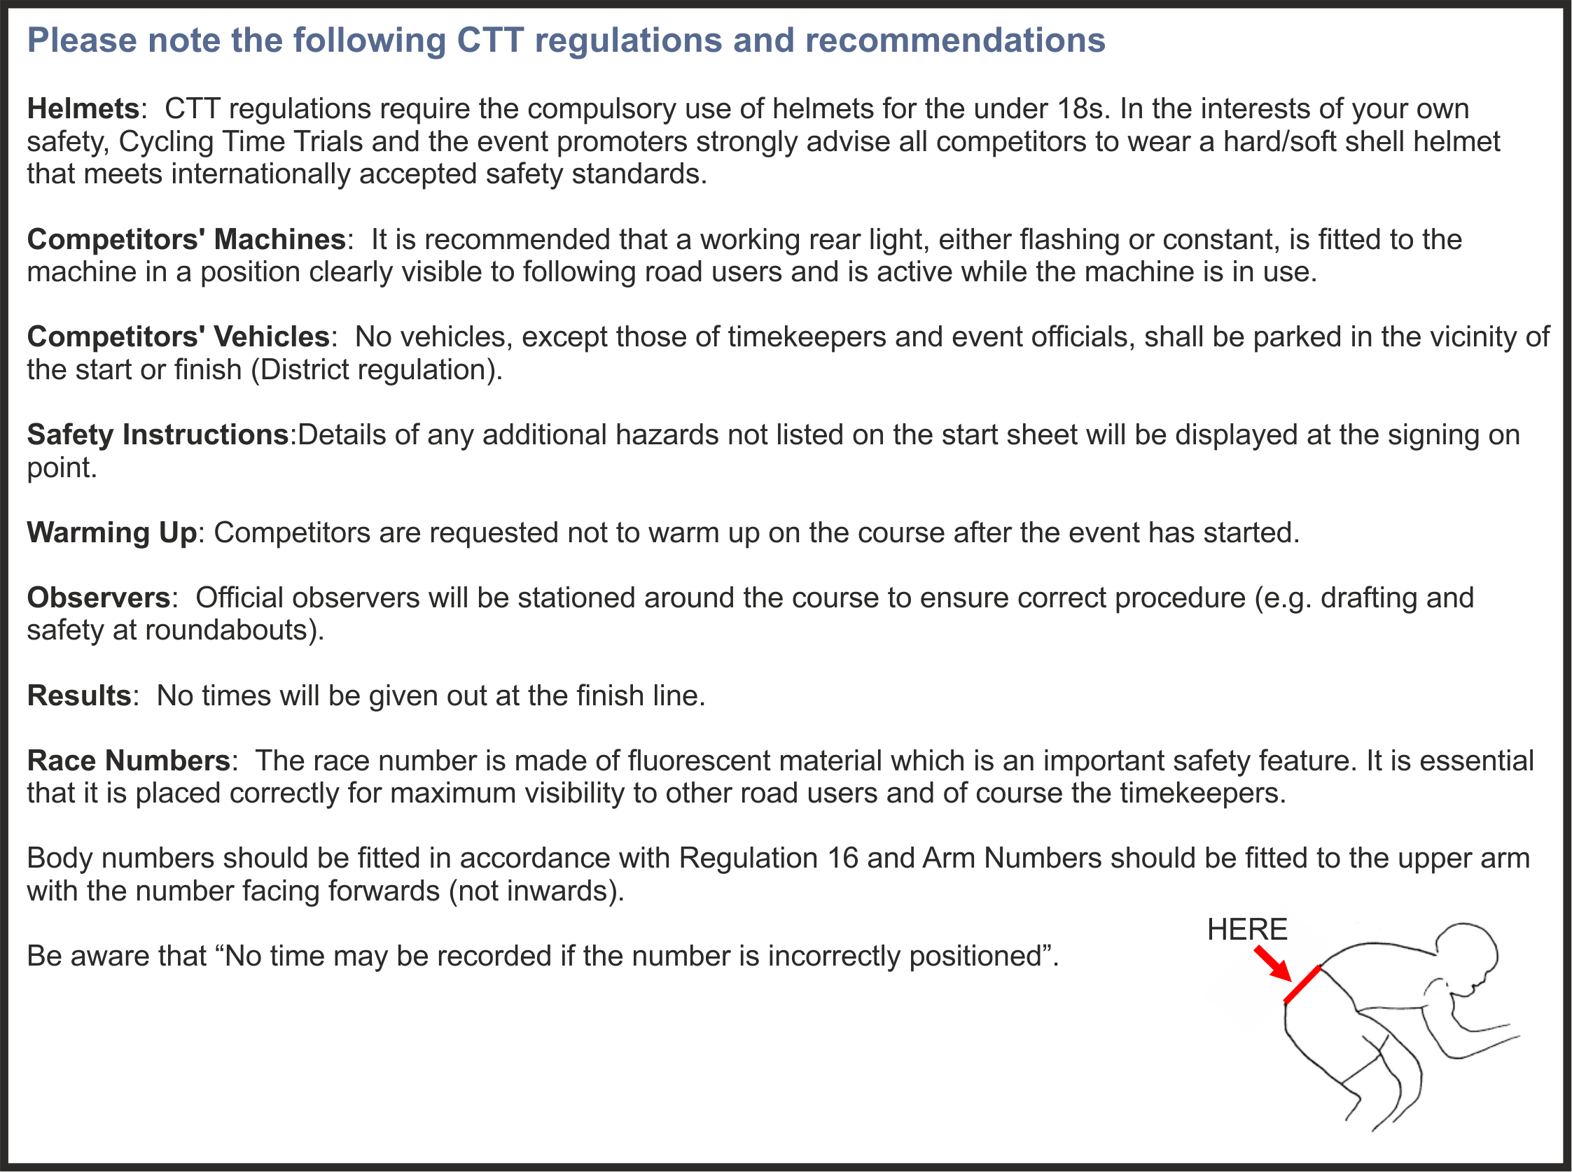

IF RIDING MORE THAN ONE EVENT……………………..sign in for all your numbers.

GENTLE REMINDER – sign out after your rides.
Open 10 miles Flat Time Trial Monday 27th May 2019
Course G10/97
OFFICIAL TIME KEEPERS
 | Start: | Peter Delve | Horsham Cycling
 | Finish: | Kathy Collard-Berry | A3crg

Course Records
 | Mens: | 00:19:18 | James Rix | 2018
 | Ladies: | 00:21:48 | Joanna Rowsell | 2013
 | Vets: | 00:19:18 | James Rix | 2018
 | Junior: | 00:21:20 | Michael Renardson | 2018
 | Juveniles: | 00:23:01 | Joshua Ballinger | 2018

PRIZES
MEDIUM GEAR (72") "10" | 1st | £15 + bottle of wine, value £5.
 | 2nd | £8 + bottle of wine, value £5
 | 3rd | Bottle of wine, value £5
HUB GEAR (TIN CAN) "10" | 1st | A bottle of wine, value £5
ROAD BIKES "10" | 1st | £10 + bottle of wine, value £5.
(no tri-bars) | 2nd | Bottle of wine, value £5.
WOMEN’S+ JUNIORS’ "10" | 1st woman | £25 + bottle of champagne, value £25
 | 2nd woman | £15 + bottle of wine, value £5
 | 3rd woman | £10 + a bottle of wine, value £5
 | 4th woman | £5 + bottle of wine, value £5.
 | 5th woman | Bottle of wine, value £5.
 | 1st junior | £20 + bottle of non-alcoholic drink, value £3.
 | 2nd junior | £10 + bottle of non-alcoholic drink, value £3.
THE FLAT (BLING) "10" | 1st | £25 + Bottle of champagne, value £25
 | 2nd | £15 + bottle of wine, value £5
 | 3rd | £10 + bottle of wine, value £5
 | 4th | £5 + bottle of wine, value £5
 | 5th | Bottle of wine, value £5
 | 1st Vet (40-44) | Bottle of wine, value £5
 | 1st Vet (45-49) | Bottle of wine, value £5
 | 1st Vet (50-54) | Bottle of wine, value £5
 | 1st Vet (55-59) | Bottle of wine, value £5
 | 1st Vet (60-64) | Bottle of wine, value £5
 | 1st Vet (65-69) | Bottle of wine, value £5
 | 1ST Vet (70-74) | Bottle of wine, value £5
 | 1st Vet (75-79) | Bottle of wine, value £5.
 | 1st Team | £10 + Bottle of wine, value £5 each
 | 2nd Team | Bottle of wine, value £5. each
PLEASE NOTE
Prize Presentation | To be held as soon as possible after the hilly "10".
 | Please stay to receive your awards and/or applaud the recipients.
Lottery Prizes | To be awarded at the prize presentation.
 | A bottle of wine, value £5, to each of the first four names drawn.
 | To be eligible, be present and be a finisher.

MEDIUM GEAR (72”) “10”:
Bib | Start Time | Firstname | Lastname | Club | Gender | Category | Age On Day
1 | 06:31:00 | Robin | Johnson | Brighton Mitre CC | Male | Veteran | 71
2 | 06:32:00 | Mike | Marchant | Southdown Velo | Male | Veteran | 62
3 | 06:33:00 | Peter | Owen | Norwood Paragon CC | Male | Veteran | 58
4 | 06:34:00 | Gary | Holder | VTTA (Surrey/ Sussex) | Male | Veteran | 53
5 | 06:35:00 | Richard | Hutt | Harp RC | Male | Veteran | 61
6 | 06:36:00 | Theo | Tadros | trainSharp | Male | Junior | 17
7 | 06:37:00 | Andrew R | Green | Bec CC | Male | Veteran | 44
8 | 06:38:00 | Peter | Tadros | trainSharp | Male | Veteran | 48

ROAD BIKES – NO TRI BARS
Bib | Start Time |  |  | Firstname |  |  | Lastname |  | Club |  | Gender | Category | Age On Day
31 | 07:01:00 |  | Paul |  |  | Hulse |  |  | Brighton Mitre CC |  | Male | Veteran | 56
32 | 07:02:00 |  | Jack |  |  | Dunne |  |  | N+1 - Lindfield Coffee Works |  | Male | Senior | 24
33 | 07:03:00 |  | John |  |  | Ferguson |  |  | Brighton Mitre CC |  | Male | Veteran | 51
34 | 07:04:00 |  | Barry |  |  | Packman |  |  | Dorking Cycling Club |  | Male | Veteran | 73
35 | 07:05:00 |  | Colin |  |  | Mcdermott |  |  | Festival Road Club |  | Male | Veteran | 51
36 | 07:06:00 |  | Peter |  |  | Tadros |  |  | trainSharp |  | Male | Veteran | 48
37 | 07:07:00 |  | Nolan |  |  | Heather |  |  | Worthing Excelsior CC |  | Male | Veteran | 43

 | BLING “10”:
Bib |  | Start Time | Firstname | Lastname | Club | Gender | Category |  | Age On Day
41 |  | 07:11:00 | Jamie | Smith | Brighton Mitre CC | Male | Veteran |  | 47
42 |  | 07:12:00 | Stu | Nisbett | Crawley Wheelers | Male | Veteran |  | 45
43 |  | 07:13:00 | Peter | Davies | Brighton Mitre CC | Male | Veteran |  | 62
44 |  | 07:14:00 | Stuart | Payne | Central Sussex CC | Male | Veteran |  | 56
45 |  | 07:15:00 | Richard | Gifford | trainSharp | Male | Veteran |  | 56
46 |  | 07:16:00 | Rupert | Robinson | Crawley Wheelers | Male | Veteran |  | 47
47 |  | 07:17:00 | David | Churchill | Direct Power Cycling Team | Male | Veteran |  | 60
48 |  | 07:18:00 | James | Stone | Brighton Excelsior CC | Male | Veteran |  | 50
49 |  | 07:19:00 | Donald | Parker | Brighton Mitre CC | Male | Veteran |  | 70
50 |  | 07:20:00 | Mark | Emsley | Wellington Wheelers Cycling Club | Male | Senior |  | 30
51 |  | 07:21:00 | Colin | Harrison | East Grinstead CC (Merlin Cycle Coaching) | Male | Veteran |  | 54
52 |  | 07:22:00 | Ben | Cumpstone | Brighton Mitre CC | Male | Veteran |  | 49
53 |  | 07:23:00 | Michael | Leonard | South Downs Bikes / Casco Pet | Male | Veteran |  | 55
54 |  | 07:24:00 | Chris | Summers | Sotonia CC | Male | Veteran |  | 67
55 |  | 07:25:00 | David | Pollard | In-Gear | Male | Veteran |  | 62
56 |  | 07:26:00 | Christian | Yates | East Grinstead CC (Merlin Cycle Coaching) | Male | Veteran |  | 56
57 |  | 07:27:00 | James | Cheeseman | N+1 - Lindfield Coffee Works | Male | Senior |  | 33
58 |  | 07:28:00 | Alan | Dainty | Sussex Nomads CC | Male | Veteran |  | 51
59 |  | 07:29:00 | Barrie | Foster | Anerley BC | Male | Veteran |  | 70
60 |  | 07:30:00 | Dan | Sadler | AeroCoach | Male | Veteran |  | 42
61 |  | 07:31:00 | Tom | Houghton | Brighton Excelsior CC | Male | Veteran |  | 47
62 |  | 07:32:00 | Jon | Fry | Horsham Cycling | Male | Veteran |  | 48
63 |  | 07:33:00 | Mike | O'gorman | Worthing Excelsior CC | Male | Veteran |  | 67
64 |  | 07:34:00 | Mike | Oliver | Team ASL | Male | Veteran |  | 58
65 |  | 07:35:00 | Nick | Dwyer | Lewes Wanderers CC | Male | Veteran |  | 55
66 |  | 07:36:00 | Chris | Jolliffe | Crawley Wheelers | Male | Veteran |  | 61
67 |  | 07:37:00 | Martin | Gibbs | Team ASL | Male | Senior |  | 33
68 |  | 07:38:00 | Mark | Vowells-Trike | CC Bexley | Male | Veteran |  | 66
69 |  | 07:39:00 | Russell | Thorne-jones | Crawley Wheelers | Male | Veteran |  | 46
70 |  | 07:40:00 | Nik | Allen | Worthing Excelsior CC | Male | Veteran |  | 47
71 |  | 07:41:00 | Simon | Church | In-Gear | Male | Veteran |  | 53
72 |  | 07:42:00 | Christian | Benneyworth | WyndyMilla | Male | Veteran |  | 46
73 |  | 07:43:00 | Mike | Boyce | ...a3crg | Male | Veteran |  | 63
74 |  | 07:44:00 | Marek | Shafer | Brighton Mitre CC | Male | Senior |  | 36
75 |  | 07:45:00 | Jesse | Yates | Team Wiggins | Male | Senior |  | 22
76 |  | 07:46:00 | George | Welfare | Eastbourne Rovers CC | Male | Senior |  | 34
77 |  | 07:47:00 | Sam | Dix | trainSharp | Male | Veteran |  | 48
78 |  | 07:48:00 | Richard | Woodward | East Grinstead CC (Merlin Cycle Coaching) | Male | Veteran |  | 57
79 |  | 07:49:00 | Simon | Craig-mcfeely | ...a3crg | Male | Veteran |  | 60
80 |  | 07:50:00 | Simon | Mcnamara | South Downs Bikes / Casco Pet | Male | Veteran |  | 44
81 |  | 07:51:00 | Bob | Richardson | Bournemouth Jubilee Whs | Male | Veteran |  | 53
82 |  | 07:52:00 | Dan | Pullen | N+1 - Lindfield Coffee Works | Male | Veteran |  | 43
83 |  | 07:53:00 | Paul | Wishart | Brighton Phoenix Athletic Club | Male | Veteran |  | 51
84 |  | 07:54:00 | Alan | Robinson | Central Sussex CC | Male | Veteran |  | 78
85 |  | 07:55:00 | Christopher | Mcnamara | Nuun-Sigma Sport-London RT | Male | Veteran |  | 44
86 |  | 07:56:00 | Neil | Crowther | Blazing Saddles | Male | Veteran |  | 46
87 |  | 07:57:00 | Peter | Owen | Norwood Paragon CC | Male | Veteran |  | 58
HUB GEAR “10”:
Bib | Start Time | Firstname | Lastname | Club | Gender | Category | Age On Day
89 | 07:59:00 | Mike | Marchant | Southdown Velo | Male | Veteran | 62

Rider  No | Start  Time | Name |  | Club | Cat
TANDEM “10”:
None

WOMEN + JUNIORS’ “10”:
Bib | Start Time | Firstname | Lastname | Club | Gender | Category | Age On Day
92 | 08:02:00 | Theo | Tadros | trainSharp | Male | Junior | 17
93 | 08:03:00 | James | Gilmore | Preston Park Youth Cycling Club | Male | Junior | 16
94 | 08:04:00 | Amanda | Harman | Brighton Mitre CC | Female | Veteran | 53
95 | 08:05:00 | Anna | Dwyer | Lewes Wanderers CC | Female | Senior | 24
96 | 08:06:00 | Alice | Gilmore | Brighton Mitre CC | Female | Junior | 18
97 | 08:07:00 | Lenka | Vackova | Rapha Cycling Club | Female | Senior | 33
98 | 08:08:00 | Imogen | Gifford | trainSharp | Female | Junior | 17
99 | 08:09:00 | Wendy | Harman | Brighton Mitre CC | Female | Veteran | 53
100 | 08:10:00 | Olivia | Webb | Eastbourne Rovers CC | Female | Veteran | 50

Open 10 miles Hilly Time Trial Monday 27th May 2019
Course GS/995
TIMEKEEPERS
 | Start: | Peter Delve | Horsham Cycling
 | Finish: | Mick Irons | Worthing Excelsior CC

Course Records
 | Mens: | 00:23:11 | Pat Wright | 2018
 | Vets: | 00:23:28 | Pete Tadros | 2012
 | Ladies: | 00:29:58 | Sarah Phelps | 2017
 | Juniors: | 00:27:08 | Matt Green | 2006
 | Juveniles: | 00:29:02 | Theo Tadros | 2017

Bib | Start Time | Firstname | Lastname | Club | Gender | Category | Age On Day
105 | 08:15:00 | Robin | Johnson | Brighton Mitre CC | Male | Veteran | 71
106 | 08:16:00 | Rupert | Robinson | Crawley Wheelers | Male | Veteran | 47
107 | 08:17:00 | Donald | Parker | Brighton Mitre CC | Male | Veteran | 70
108 | 08:18:00 | Ben | Fielden | GS Stella | Male | Veteran | 77
109 | 08:19:00 | Jez | Tate | Brighton Mitre CC | Male | Veteran | 53
110 | 08:20:00 | Richard | Hutt | Harp RC | Male | Veteran | 61
111 | 08:21:00 | Stu | Nisbett | Crawley Wheelers | Male | Veteran | 45
112 | 08:22:00 | James | Stone | Brighton Excelsior CC | Male | Veteran | 50
113 | 08:23:00 | John | Ferguson | Brighton Mitre CC | Male | Veteran | 51
114 | 08:24:00 | Katerina | Avramides | Brighton Mitre CC | Female | Senior | 38
115 | 08:25:00 | David | Churchill | Direct Power Cycling Team | Male | Veteran | 60
116 | 08:26:00 | Andrew R | Green | Bec CC | Male | Veteran | 44
117 | 08:27:00 | Jamie | Smith | Brighton Mitre CC | Male | Veteran | 47
118 | 08:28:00 | Francis | Schofield | Brighton Mitre CC | Male | Junior | 17
119 | 08:29:00 | Theo | Tadros | trainSharp | Male | Junior | 17
120 | 08:30:00 | Mark | Emsley | Wellington Wheelers Cycling Club | Male | Senior | 30

PRIZES
HILLY "10" | 1st man | £20 + bottle of champagne, value £25.
 | 2nd man | £12 + bottle of wine, value £5
 | 3rd man | £7 + bottle of wine, value £5
 | 4th man | Bottle of wine, value £5
 | 1st woman | £20 + bottle of champagne, value £25.
 | 1st Vet (40-44) | Bottle of wine, value £5
 | 1st Vet (45-49) | Bottle of wine, value £5
 | 1st Vet (50-54) | Bottle of wine, value £5
 | 1st Vet (55-59) | Bottle of wine, value £5
 | 1st Vet (60-64) | Bottle of wine, value £5
 | 1st Vet (65-69) | Bottle of wine, value £5
 | 1st Vet (70-74) | Bottle of wine, value £5
 | 1st Vet (75-79) | Bottle of wine, value £5
 | 1st Team of 3 | £10 + bottle of wine, value £5, each
 | 2nd Team of 3 | Bottle of wine, value £5, each

PLEASE NOTE
Prize Presentation | To be held as soon as possible after the hilly "10".
 | Please stay to receive your awards and/or applaud the recipients.
Lottery Prizes | To be awarded at the prize presentation.
 | A bottle of wine, value £5, to each of the first four names drawn.
 | To be eligible, be present and be a finisher.

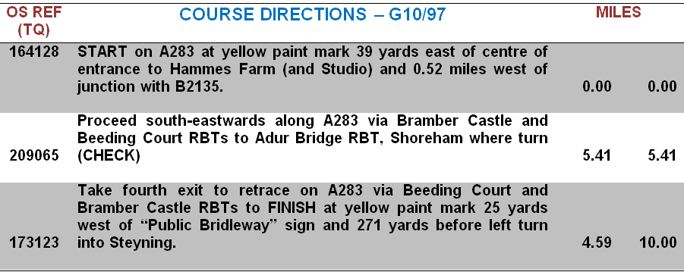

VERY HILLY “10”
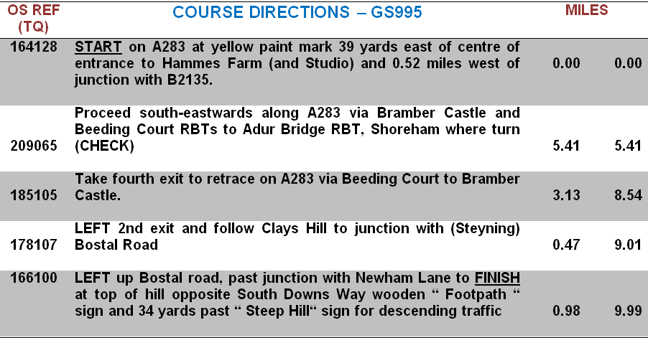

Open 10 miles Time Trials Monday 27th May 2019
Course G10/97 and GS/995

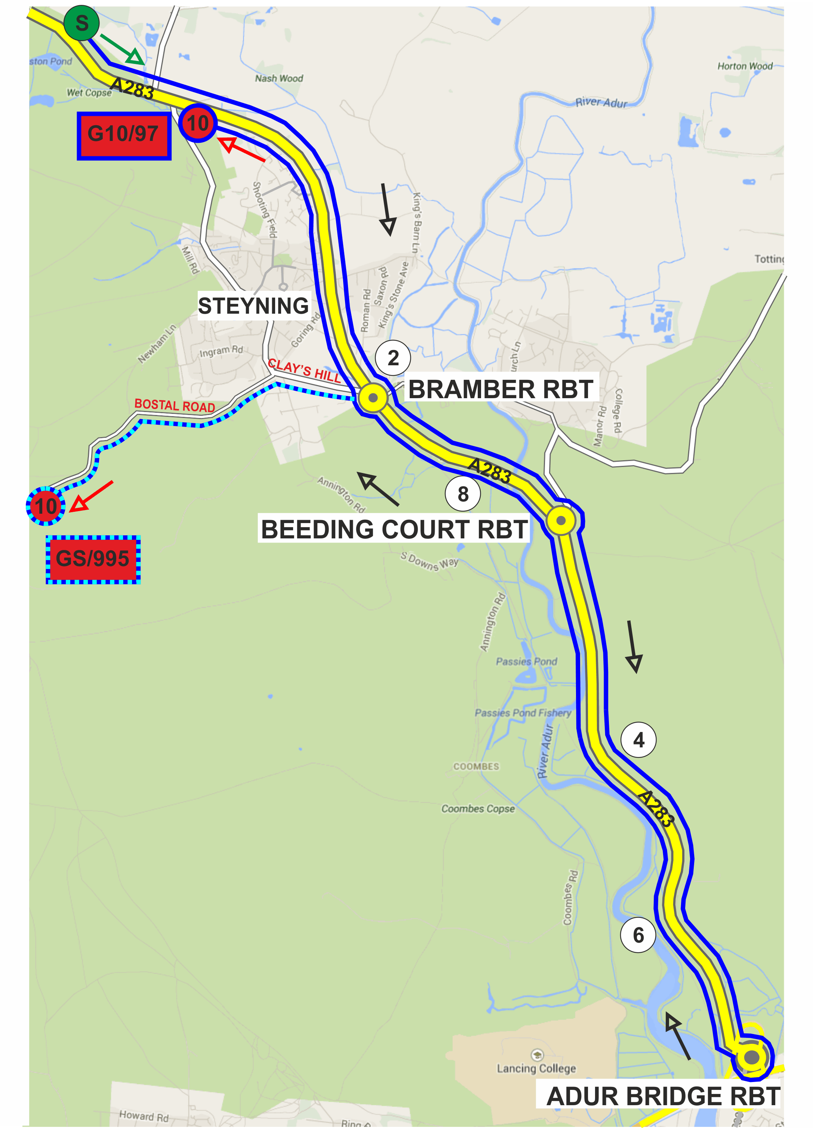

Note that course GS/995 finishes with a gradient of up to 17% in 2 places.

PAST WINNERS

MEDIUM GEAR (72”) “10”
2008 | Steve Frame | 24:26
2009 | Mike Marchant | 24:56
2010 | David French | 25:00
2011 | David French (2 wins) | 25:38
2012 | Mike Marchant (2 wins) | 25:24
2013 | Pete Tadros | 23:14
2014 | Pete Tadros | 22:50
2015 | Pete Tadros | 23:54
2016 | Gavin Hinxman | 23:15
2017 | Pete Tadros (4 wins) | 23:23
2018 | Richard Hutt | 24:20
2019

HUB GEAR (TIN CAN) “10”
2008 | David Eccles | 27:12
2009 | David French | 24:52
2010 | Mark Silver | 25:33
2011 | David French | 25:15
2012 | David Eccles | 26:10
2013 | David French | 26:36
2014 | David French | 23:43
2015 | David French | 24:42
2016 | David Eccles | 27:40
2017 | David Eccles (4 wins) | 28:35
2018 | David French (6 wins) | 24:54
2019

THE FLAT (“BLING”) “10”
2008 | Daniel Paine | 22:34
2009 | Pete Tadros | 20:56
2010 | Nick Dwyer | 20:58
2011 | Pete Tadros | 20:43
2012 | Pete Tadros | 20:21
2013 | Nick Dwyer (2 wins) | 20:40
2014 | Pete Tadros (4 wins) | 21:38
2015 | Simon McNamara | 21:20
2016 | James Copeland | 20:14
2017 | Mark Smith | 20:46
2018 | Simon McNamara (2 wins) | 19:57
2019

TANDEM “10”
2008 | Miranda Oberman & Neil Houldey | 22:50
2009 | (no entries)
2010 | David Eccles & Jon Frost | 23:24
2011 | David Abbott & Andy Smith | 23:00
2012 | David Eccles & Minoru Mitsumoto | 24:46
2013 | David Eccles & Jon Frost | 23:16
2014 | David Eccles & Jon Frost | 23:48
2015 | David Eccles & Jon Frost | 24:59
2016 | David Eccles & Jon Frost | 24:30
2017 | David Eccles & Jon Frost (6 wins) | 23:42
2018 | Mark Emsley & Sarah Phelps | 24:54
2019 | No entries

ROAD BIKES “10”
2008 | Barry Packman | 26:57
2009 | Jay Chisnall | 24:45
2010 | Tim Stevens | 23:21
2011 | Philip Allen | 25:19
2012 | Tim Stevens (2 wins) | 23:12
2013 | James Stuart | 22:51
2014 | Francisco Piai | 24:39
2015 | Gary Brind | 23:12
2016 | Elliot Lipski | 21:41
2017 | Steve Dennis | 22:36
2018 | David Pollard | 23:17
2019
HILLY “10”
2002 | Shane Faulkner | 25:10
2003 | Mike Coyle | 25:24
2004 | Mike Coyle | 25:04
2005 | Mike Coyle (3 wins) | 24:42
2006 | Rob English | 24:20
2007 | Graeme Stirzaker | 26:19
2008 | Ishmael Burdeau | 27:42
2009 | Ishmael Burdeau (2 wins) | 25:37
2010 | Pete Tadros | 24:14
2011 | Pete Tadros | 24:32
2012 | Pete Tadros | 23:28
2013 | Chris McNamara | 24:12
2014 | Pete Tadros | 24:52
2015 | Pete Tadros (5 wins) | 24:34
2016 | Mark Emsley | 24:22
2017 | Mark Smith | 24:11
2018 | Pat Wright | 23:13
2019

From 2009 - LADIES “10”
2009 | (no entries)
2010 | Claire Leonard | 26:25
2011 | Tamar Vanderhaas | 26:48
2012 | Emma Richards | 24:36
2013 | Joanna Rowsell | 21:48
2014 | Sarah Anne Nisbett | 25:46
2015 | Gina McGeever | 25:04
2016 | Sarah Phelps | 25:43
2017 | Ruth Summerford | 23:18
2018 | Ruth Summerford (2 wins) | 22:25
2019

