Medway Velo Club

Open 10 Mile Time Trial

To be held on Saturday 18th May, 2019 starting at 15.00 hrs
On Course Q10/24 (Isle of Grain)

Promoted for and on behalf of Cycling Time Trials under their Rules & Regulations

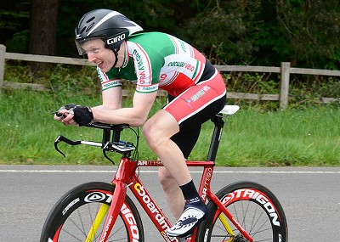

Awards

1st Fastest £30 Fastest Vet OAS £20 1st Woman £30
2nd Fastest £25 2nd Vet OAS £10 2nd Woman £25
3rd Fastest £20 3rd Vet OAS £5 3rd Woman £20
4th Fastest £15 4th Woman £15

1st Fastest Junior £10
2nd Fastest Junior £5

Fastest team of 3 riders £10 each
Second fastest team of 3 £5 each

Fastest time beating course record Men £50, Women £50

Men’s course record: 20:12 Robert Moore
Women’s course record: 23:23 Louise Mason

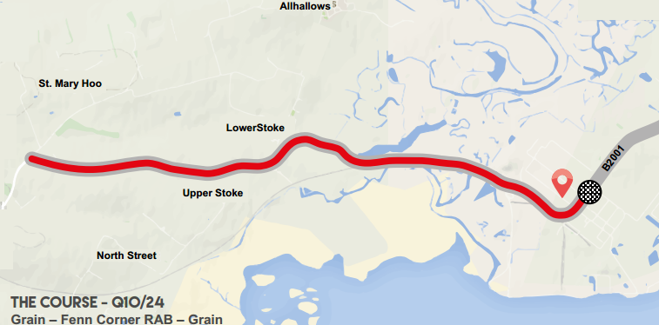

Course Details Q10/24

Grain – Fenn Corner RAB – Grain

Start on A.228 west of Grain village 14 metres north of the lamppost GFY26 on the Strood bound carriageway, by a minor access road to the National Grid site where the continuous white road edge line starts. Proceed west on A228 to turn at Fenn Corner roundabout (5.07 miles). Retrace on A.228 to finish directly opposite the lamppost GFY19 (situated on the Strood bound carriageway) (10 miles).

Event Headquarters:

St James Isle of Grain Village Hall, Chapel Road, Grain, ME3 0BY, which will be open from 14.00 hrs.

Event Secretary Timekeepers/Recorder

Rob Sapp Start – David Mackey (Medway Velo)
42 Ferry Road Finish – Ernie Mackey (Medway Velo)
Iwade Recorder – Phil Booth (Medway Velo)
ME9 8RH
07875877124

Marshals; Matt Nunn, Sean Farley, Rob Hatton
Sign on; Neil Ord
Start holder Rob Kennison
Result board / Runners: Tom Kennison/Steve Smith
All Medway Velo Club
Notes to riders:
- Start: It is approximately 1 mile from the HQ to the start – please allow enough time for this and be aware that other riders may be racing on the course. Please avoid warming up on the course once the race has started.
- NOTE: there is a raised manhole cover approx. 400 yards from the Stoke Bridge Crossing on the way to the turn. BE CAREFUL
- NOTE: there is a small manhole cover/pothole located on the last bend before the finish. BE CAREFUL.

- Numbers will be in the event headquarters hall and will be personally issued to each rider after they have signed on. Riders should refer to Regulation 16 - which states that ‘the number should be centrally positioned below the waist so as to be clearly visible from the rear when in the normal riding position’.
- Please remember to sign off when returning your race number
- Numbers may be exchanged for a drink on completion of the ride
- Please remove racing shoes before entering the hall.
- Do Not perform U turns in the start and finishing areas and do not use these areas as a public toilet as offenders risk disqualification.

- Rider Feedback Forms - Riders should note that these forms are available at the hall by the signing on, and can be used by riders/marshals with comments and suggestions that could significantly improve safety.
- All riders under the age of 18 years MUST wear recognised standard protective headgear. In the interests of safety it is recommended that all riders should wear a hard shell helmet that meets an internationally accepted safety standard. Reference to inhalers is no longer required.
- It is recommended that a working rear light, either flashing or constant, is fitted to the machine in a position visible to following road users and is active while the machine is in use.

Thank you for entering our event, I hope you have a safe and speedy ride.

.

Rob Sapp
Event Secretary

-

No | Start Time | First name | Last name | Club / Team | Category
1 | 15:01 | Steven | Waite | Medway Velo Club | V46
2 | 15:02 | Gary | Pullen | Folkestone Velo Club | V48
3 | 15:03 | Nick | Elson | Wildcats CC | Senior
4 | 15:04 | Daniel | Berkhauer | Direct Power Cycling Team | Senior
5 | 15:05 | Martin | Jones | Colour Tech RT | V48
6 | 15:06 | Tom | Morton | PMR | V64
7 | 15:07 | John | McGlashan | Redmon CC | V67
8 | 15:08 | Debbie | Percival | Kent Velo Girls/Boys | FV57
9 | 15:09 | Mark | Mason | Direct Power Cycling Team | V53
10 | 15:10 | Nick | Fennell | Thanet RC | Senior
11 | 15:11 | Lee | Turner | Sigma Sports | V50
12 | 15:12 | Rob | Milnes | Thanet RC | Senior
13 | 15:13 | Natasha | Jarman | Southborough & Dist. Whs | Female Senior
14 | 15:14 | Scott | Lewis | Manchester and District TTA | V54
15 | 15:15 | Pete | Elms | Colour Tech RT | V51
16 | 15:16 | Helen | Mckay | Les Filles Racing Team | FV41
17 | 15:17 | Matthew | Hall | Thanet RC | Senior
18 | 15:18 | Kamran | Ezel | Southgate CC | Senior
19 | 15:19 | Lawrence | Martin | Thanet RC | V60
20 | 15:20 | Malcolm | Adams | De Laune CC | V80
21 | 15:21 | Mark | Hill | VeloRefined.com Aerosmiths | V51
22 | 15:22 | Hugh | Williams | Pro Vision Cycle Clothing | V51
23 | 15:23 | Jeremy | Parker | Metropolitan Police Cycle Club | V50
24 | 15:24 | Sally | Smith | Medway Velo Club | Female Senior
25 | 15:25 | Anthony | Bee | Wigmore CC | V55
26 | 15:26 | David | Churchill | Direct Power Cycling Team | V60
27 | 15:27 | Grant | Cousins | Thanet RC | Senior
28 | 15:28 | Graham | Strugnell | Kassei CC TeknoFuel | V71
29 | 15:29 | Doug | Finch | Southborough & Dist. Whs | V68
30 | 15:30 | Jon | Puleston-jones | Dulwich Paragon CC | V47
31 | 15:31 | Paul | Smith | VeloRefined.com Aerosmiths | V47
32 | 15:32 | Steve | Jezzard | PMR | V56
33 | 15:33 | Paul | Kelk | Thanet RC | V52
34 | 15:34 | Simon | Charles | Thanet RC | V49
35 | 15:35 | Mark | Baker | Abellio - SFA Racing Team | V45
36 | 15:36 | Richard | Birtwhistle | Sydenham Whs | V63
37 | 15:37 | Marcus | Boret | Abellio - SFA Racing Team | V53
38 | 15:38 | Micheal | Coulter | Gravesend CC | V71
39 | 15:39 | Stephanie | Hopcraft | San Fairy Ann CC | Female Senior
40 | 15:40 | Kevin | Tye | VeloRefined.com Aerosmiths | V57
41 | 15:41 | Simon | Henderson | Thanet RC | V56
42 | 15:42 | Martin | Foord | Abellio - SFA Racing Team | V56
43 | 15:43 | Mick | James | Kassei CC TeknoFuel | V62
44 | 15:44 | Tom | Knight | Medway Velo Club | V41
45 | 15:45 | Oliver | Robinson | Team Wiggins | Espoir
46 | 15:46 | Gary | Grayland | CC Bexley | V54
47 | 15:47 | Colin | Robinson | Thanet RC | V52
48 | 15:48 | Gary | Ricks | Woolwich CC | V61
49 | 15:49 | Michael | Daniels | Southborough & Dist. Whs | V84
50 | 15:50 | Neil | Lauder | Arctic Tacx RT | Senior
51 | 15:51 | Dave | Stocker | Abellio - SFA Racing Team | V54
52 | 15:52 | Eva | Nyirenda | ...a3crg | Female Senior
53 | 15:53 | Garfield | Hall | Woolwich CC | V59
54 | 15:54 | Sophie | Driscoll | Thanet RC | Female Espoir
55 | 15:55 | Mark | Newton | Elite Cycling | V52
56 | 15:56 | Michael | Porter | 34 Nomads CC | V52
57 | 15:57 | Mark | Wright | Rye & District Wheelers CC | V50
58 | 15:58 | Martin | Yardley | Southborough & Dist. Whs | V53
59 | 15:59 | Michael | Stanley | Medway Velo Club | V47
60 | 16:00 | Christopher | Fennell | The Independent Pedaler | Senior
61 | 16:01 | Fabien | Large | NOPINZ | Junior
62 | 16:02 | Lee | Kingston | Medway Velo Club | V44
63 | 16:03 | Charmaine | Pullen | Folkestone Velo Club | FV49
64 | 16:04 | Fraser | Blandford | Medway Velo Club | V49
65 | 16:05 | Emma | Lewis | The Independent Pedaler | Female Senior
66 | 16:06 | Stephen | Wilkinson | Folkestone Velo Club | V53

