THE WELLAND TROPHY OPEN TIME TRIAL

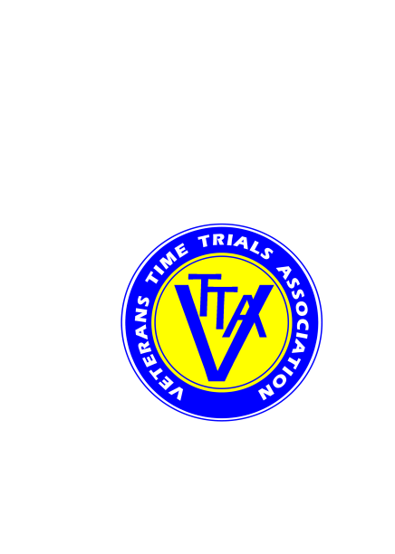

Supported by *ECHELON* Cycles, 124 High St, Pershore  WR10 1EA  01386 550606

(PROMOTED FOR AND ON BEHALF OF CYCLING TIME TRIALS UNDER THEIR RULES AND REGULATIONS)

SATURDAY 6 APRIL 2019, COURSE K47/15, WELLAND

RESULTS / PRIZES

EVENT ORGANISERS:

Michael Amery, 18 Giffard Drive, Welland, Worcestershire WR13 6SE Tel: 01684 310168 mike[amery58@gmail.](mailto:amery58@gmail.)com

Alan Colburn, The Willows, Jury Lane, Martley  WR6 6PE Tel: 01886 888575 / 0755 428 4607 alan.colburn@martley.org

TIMEKEEPERS: Mrs Susan Kelly and Mr Charlie Barnett

PRIZES: NB These are the prizes as awarded, following the ‘one prize per rider, except team’ rule. Full results are on the pdf file.

Fastest Men on Actual Time:

Mark Corbett, Worcester St Johns CC 32:53

Tim Wood, Team Echelon 32:54

Xavier Disley, AeroCoach 33:06

Fastest Women on Actual Time:

Emma Bexson, Stratford CC 39:39

Arja Scarsbrook, Bush Healthcare CRT 44:33

Veterans on VTTA Standard:

Richard Oakes, Team Jewson MI Racing 7:29

Jon Howard, Team Echelon 7:13

Mark Wise, Team Jewson MI Racing 7:01

John Simpkins, Drag2Zero 6:38

Simon Garrett, Team Echelon 6:32

Fastest Tricycles on Actual Time

Geoff Booker, Oxonian CC 44:22

Kenneth Trigger, Crewe Clarion Whls 51:04

Fastest 2-up on Actual Time

Richard Shimmell, CC Giro ) 33:20

Carl Bullingham, CC Giro )

2-ups on VTTA Standard:

William Davies, VC Sevale ) 4:55

Mike Amery, VC Sevale )

TEAM PRIZE - THE WELLAND TROPHY - LVRC

Richard Oakes

Mark Wise

Mark Corbett

Chris Davis

Gavin Francis

Richard Coleman

Richard Shimmell

Carl Bullingham

Thanks to all riders who took part, to our timekeepers, marshals, and other helpers, and our sponsor Echelon Cycles.

We hope you enjoyed this fifth joint LVRC–VTTA event in the Worcestershire countryside.

Congratulations to the winning LVRC team members (the aggregated team times are at the foot of the pdf).