Gil Jessop Memorial 'Sporting 14' Time Trial
26th edition

Promoted for and on behalf of Cycling Time Trials under their Rules and Regulations

Sunday 10th February 2019

With special thanks to:
Kathleen Collard Berry and Maria Golden for Time keeping
Darren Marshall for the Artwork

The volunteers at HQ and on the course

Veloforte for the free samples at sign on https://veloforte.cc

Photography
Photos available from Dave Hayward
https://www.davehaywardphotos.com/Cycling/Road/Kingston-Wheelers-Sporting-14-10-02-2019-Ripley

Course Records
Men Edmund Bradbury 29.18 (2018)
Women Alice Lethbridge 34.18 (2018)
Team Paceline RT (Pat Wright, Thomas Whatley, Keith Lea) 1.33.34 (2018)
Prizes
Category Winners
Men TT – Leo Hayter
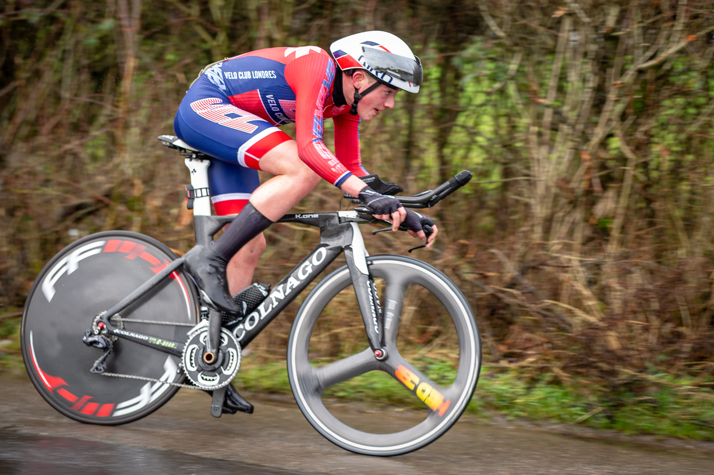

Women TT – Alice Lethbridge
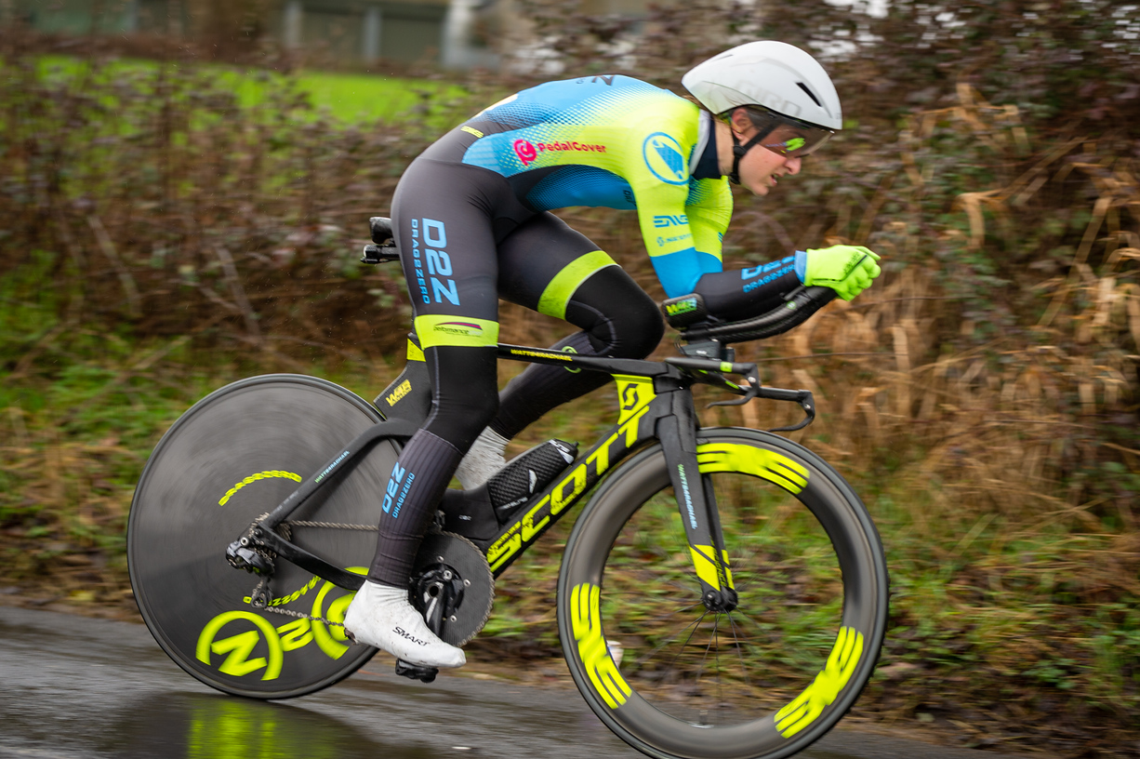

Men Road – Mark Aldred

Women Road – Rosamund Bradbury

Junior Men- Leo Hayter

Vets on Standard – Liam Maybank

Where a rider qualified for more than one prize category, the prize of the highest cash value has been awarded
Men Overall
1st | Leo Hayter (1st Junior) | VC de Londres | 30:13 | £60
2nd | Liam Maybank (1st Veteran on Plus) | Twickenham CC | 30:39 | £45
3rd | Ben Elliott | C and N Cycles RT | 31:24 | £30
4th | Pat Wright | Paceline RT | 31:25 | £20
5th | Andrew Bradbury | Paceline RT | 31:33 | £10

Women Overall
1st | Alice Lethbridge | DRAG2ZERO | 34:18 | £60
2nd | Rosamund Bradbury (1st female road bike) | Sigma Sports | 36:55 | £45
3rd equal | Samantha Fawcett  Sarah Matthews (3rd Veteran on Plus) | Lovelo Cycle Works  …a3crg | 37:57  37:57 | £30  £30

Men Road Bike
1st | Mark Aldred | Kingston Wheelers CC | 32:23 | £35
2nd | Thomas Whatley | Paceline RT | 32:38 | £25
3rd | Grant Fraser | Paceline RT | 33.49 | £15

Women Road Bike
1st | Esme Cole | Kingston Wheelers CC | 38:05 | £35
2nd | Vivienne Tomlin | 1904RT | 40:17 | £25
3rd | Jo Billings | London Women’s Racing CC | 40:58 | £15

Juvenile Men
1st | Mattie Dodd | VC de Londres | 35:47 | £15

Vets on Standard
1st | Keith Lea | Paceline RT | +3:53 | £30
2nd | Neil Harrigan (3rd Road bike) | Gravesend CC | +3.12 | £25
3rd | Andy Lack | Paceline RT | +3:09 | £20
4th | Francis Jago | Paceline RT | +3:02 | £15
5th | Sam Humpheson | Look Mum No Hands! | +2:49 | £10

Team
1st | Paceline A | Pat Wright  Andrew Bradbury  Thomas Whatley | 31:25  31:33  32:38  1:35:36 | £60
2nd | Kingston Wheelers CC | Neil Grunshaw  Mark Aldred  Seb Ashton | 32:15  32:23  34:44  1:39:22 | £45
3rd | Paceline B | Keith Lea  Grant Fraser  Andy Lack | 33:32  33:49  34:22  1:41:43 | £15

To claim prizes please email timetrial@kingstonwheelers.com

Finish Times
Overall
Bib | Name | Club | Age Group | Gender | Cat | Time
1 | Leo Hayter | VC de Londres | Junior | Men | TT | 00:30:13
2 | Liam Maybank | Twickenham CC | Veteran | Men | TT | 00:30:39
3 | Ben Elliott | C and N Cycles RT | Senior | Men | TT | 00:31:24
4 | Pat Wright | Paceline RT | Senior | Men | TT | 00:31:25
5 | Andrew Bradbury | Paceline RT | Senior | Men | Road | 00:31:33
6 | Neil Grunshaw | Kingston Wheelers CC | Senior | Men | TT | 00:32:15
7 | Mark Aldred | Kingston Wheelers CC | Senior | Men | Road | 00:32:23
8 | Thomas Whatley | Paceline RT | Senior | Men | Road | 00:32:38
9 | Keith Lea | Paceline RT | Veteran | Men | TT | 00:33:32
10 | Neil Harrigan | Gravesend CC | Veteran | Men | Road | 00:33:47
11 | Grant Fraser | Paceline RT | Senior | Men | Road | 00:33:49
12 | Sam Humpheson | Look Mum No Hands! | Veteran | Men | TT | 00:33:57
13 | Ollie Smith | Sigma Sports | Senior | Men | Road | 00:34:11
14 | Alice Lethbridge | DRAG2ZERO | Senior | Women | TT | 00:34:18
15 | Andy Lack | Paceline RT | Veteran | Men | TT | 00:34:22
16 | Jonathan Pontin | Addiscombe CC | Senior | Men | TT | 00:34:39
17 | Seb Ashton | Kingston Wheelers CC | Senior | Men | TT | 00:34:44
18 | Francis Jago | Paceline RT | Veteran | Men | Road | 00:34:48
19 | Liam Smith | Kingston Wheelers CC | Senior | Men | TT | 00:34:53
20 | Tom Herbert | Kingston Wheelers CC | Senior | Men | Road | 00:35:06
21 | Adam Wells | Paceline RT | Senior | Men | TT | 00:35:09
22 | Jason Ashby | Kingston Wheelers CC | Senior | Men | Road | 00:35:22
23 | Edward Cronan | Paceline RT | Senior | Men | Road | 00:35:28
24 | Alex Reid | Kingston Wheelers CC | Senior | Men | Road | 00:35:34
25 | Linton Van Zyl | Kingston Wheelers CC | Senior | Men | Road | 00:35:35
26 | Mattie Dodd | VC de Londres | Juvenile | Men | Road | 00:35:47
27 | James Joel Garner | ...a3crg | Veteran | Men | TT | 00:35:52
28 | Ali Cigari | Kingston Wheelers CC | Senior | Men | Road | 00:35:53
29 | Micha Gamper | Clapham Chasers | Senior | Men | TT | 00:36:00
30 | Harry Bunnell | Kingston Wheelers CC | Senior | Men | Road | 00:36:04
31 | Simon Pontin | Addiscombe CC | Senior | Men | TT | 00:36:09
32 | Philip Deacon | Epsom CC | Veteran | Men | Road | 00:36:18
33 | Jo Skelton | Look Mum No Hands! | Veteran | Men | Road | 00:36:39
34 | Derrick Thirlwell | Kingston Wheelers CC | Veteran | Men | TT | 00:36:39
35 | Rosamund Bradbury | Sigma Sports | Senior | Women | Road | 00:36:55
36 | Simon Trehearn | Kingston Phoenix RC | Veteran | Men | TT | 00:37:04
37 | Steven Hughes | Kingston Wheelers CC | Senior | Men | Road | 00:37:11
38 | David Scrivener | Epsom CC | Senior | Men | Road | 00:37:11
39 | Alexander Kew | Kingston Phoenix RC | Veteran | Men | Road | 00:37:12
40 | James Hatchley | Tri London | Veteran | Men | TT | 00:37:17
41 | Joseph Adlam-cook | Hillingdon Slipstreamers | Juvenile | Men | Road | 00:37:26
42 | Andrew Lindsay | Pure Motion Cycling Club | Senior | Men | Road | 00:37:34
43 | Samantha Fawcett | Lovelo Cycle Works | Senior | Women | TT | 00:37:57
44 | Sarah Matthews | ...a3crg | Veteran | Women | TT | 00:37:57
45 | Les Liddiard | Team Jewson - MI Racing ~Poly Pipe~McCann | Veteran | Men | TT | 00:38:01
46 | Esme Cole | JAM Cycle Race Team coached by BPC | Senior | Women | Road | 00:38:05
47 | Mark Weight | Kingston Wheelers CC | Veteran | Men | Road | 00:38:07
48 | John Way | ...a3crg | Veteran | Men | TT | 00:38:11
49 | Jeremy Sharland | Charlotteville Cycling Club | Veteran | Men | Road | 00:38:28
50 | Tim Richards | Njinga Cycling | Veteran | Men | Road | 00:38:34
51 | Ben Skelton | London Dynamo | Veteran | Men | Road | 00:38:53
52 | Mike Cook | Njinga Cycling | Veteran | Men | Road | 00:38:58
53 | Simon Halloway | Paceline RT | Senior | Men | TT | 00:39:12
54 | Angela Radden-rutt | JAM Cycle Race Team coached by BPC | Senior | Women | TT | 00:39:29
55 | Daniel Sharp | Charlotteville Cycling Club | Veteran | Men | Road | 00:39:34
56 | Ben Thornton | Audax UK | Veteran | Men | Road | 00:39:50
57 | David Mccarthy | Kingston Wheelers CC | Senior | Men | Road | 00:40:01
58 | Neil Meadows | Kingston Wheelers CC | Veteran | Men | Road | 00:40:03
59 | Vivienne Tomlin | 1904RT | Veteran | Women | Road | 00:40:17
60 | Sean Taylor | Redmon CC | Senior | Men | Road | 00:40:44
61 | Jo Billings | London Women's Racing CC | Veteran | Women | Road | 00:40:58
62 | Richard Johnson | VC de Londres | Veteran | Men | Road | 00:41:08
63 | Amy Shilliday | Lovelo Cycle Works | Senior | Women | Road | 00:41:22
64 | John Higham | Njinga Cycling | Veteran | Men | Road | 00:41:24
65 | Richard Evans | Kingston Wheelers CC | Veteran | Men | Road | 00:41:26
66 | Helen White | London Dynamo | Senior | Women | Road | 00:41:29
67 | Lenka Vackova | Rapha Cycling Club | Senior | Women | TT | 00:41:30
68 | Beverley Jerome | BellaVelo cc | Veteran | Women | Road | 00:41:31
69 | Michelle Sharland | Charlotteville Cycling Club | Veteran | Women | Road | 00:41:43
70 | Joanne Clarke | Velo Club Venta | Senior | Women | Road | 00:41:45
71 | Mike Anderson | Club Cycliste Moncontourais | Veteran | Men | Road | 00:42:18
72 | Angus Dodd | VC de Londres | Veteran | Men | Road | 00:42:19
73 | Lindsay Aqui | Ful-on Tri | Senior | Women | Road | 00:42:25
74 | David Percival | Kingston Phoenix RC | Veteran | Men | Road | 00:42:33
75 | Kelly Randall | Njinga Cycling | Senior | Women | TT | 00:42:48
76 | Alison Wyatt | Kingston Wheelers CC | Veteran | Women | Road | 00:43:03
77 | Dan Thisdell | Tandem Club | Veteran | Men | TT | 00:43:47
78 | Cassie Allen | Clapham Chasers | Senior | Women | Road | 00:43:48
79 | Brian Jones | Horsham Cycling | Veteran | Men | TT | 00:43:53
80 | Jack Hartrey | Kingston Wheelers CC | Juvenile | Men | Road | 00:44:29
81 | Lisa Price | London Women's Racing CC | Veteran | Women | Road | 00:44:39
82 | Nicola Whittock | BellaVelo cc | Veteran | Women | Road | 00:45:09
83 | Debbie Richards | Njinga Cycling | Veteran | Women | Road | 00:48:15
84 | Owain Williams | Kingston Wheelers CC | Juvenile | Men | Road | 00:50:20
85 | Vernon Schutte | Farnborough & Camberley CC | Veteran | Men | Road | 01:05:45
 | Alistair Chappelle | Ful-on Tri | Senior | Men | TT | DNS (A)
 | Cameron Stronge | Adalta Cycling Club | Senior | Men | Road | DNS (A)
 | Damien Breen | Brixton Cycles Club | Senior | Men | TT | DNS (A)
 | Fabien Large | NOPINZ | Junior | Men | TT | DNS (A)
 | Helen Sharp | Twickenham CC | Senior | Women | TT | DNS (A)
 | Henrik Persson | Kingston Wheelers CC | Senior | Men | TT | DNS (A)
 | Jane Adlam-cook | Njinga Cycling | Veteran | Women | TT | DNS (A)
 | Neill Keaney | Onyx RT | Senior | Men | TT | DNS (A)
 | Richard Carrington | London Dynamo | Veteran | Men | TT | DNS (A)
 | Rob Seager | LFGSS CC | Senior | Men | TT | DNS (A)
 | Suzanne Shaw | Kingston Phoenix RC | Veteran | Women | TT | DNS (A)
 | Tom Portsmouth | Charlotteville Cycling Club | Junior | Men | TT | DNS (A)
 | Hannah Johnson | VC de Londres | Juvenile | Women | TT | DNS
 | Adrian Feasby | Kingston Phoenix RC | Veteran | Men | TT | DNS
 | Ben Higham | Sigma Sports | Senior | Men | TT | DNS
 | Chris Brewer | Redmon CC | Veteran | Men | Road | DNS
 | Dale Lush | Kingston Phoenix RC | Veteran | Men | TT | DNS
 | Gavin Hughes | Kingston Phoenix RC | Veteran | Men | TT | DNS
 | Greg Bailey | Woking Cycle Club | Veteran | Men | TT | DNS
 | Karen Smith | Look Mum No Hands! | Veteran | Women | TT | DNS
 | Louise Harris | Njinga Cycling | Veteran | Women | TT | DNS
 | Niall Gaffney | Kingston Wheelers CC | Senior | Men | Road | DNS
 | Paul Padman | Addiscombe CC | Veteran | Men | TT | DNS
 | Richard Pearce | Paceline RT | Veteran | Men | TT | DNS
 | Rob Gardner | Kingston Wheelers CC | Veteran | Men | TT | DNS
 | Ross Harper | Clapham Chasers | Senior | Men | TT | DNS
 | Simon Berogna | Velo Club St Raphael | Veteran | Men | TT | DNS
 | Theo Tadros | trainSharp | Juvenile | Men | TT | DNS
 | Tony Sherwood | Njinga Cycling | Veteran | Men | Road | DNS
 | James Hey | Njinga Cycling | Veteran | Men | Road | DNF
 | Mike Boyce | ...a3crg | Veteran | Men | TT | DNF
 | Tania Smeda | Look Mum No Hands! | Veteran | Women | TT | DNF
 | Duncan Rimmer | Morden CRC | Veteran | Men | Road | DNF

Vets on Standard

Rank | Name | Club | Gender | Cat | Vet Std | Actual time | Plus
1 | Liam Maybank | Twickenham CC | Men | TT | 00:37:12 | 00:30:39 | 0:06:33
2 | Keith Lea | Paceline RT | Men | TT | 00:37:25 | 00:33:32 | 0:03:53
3 | Sarah Matthews | ...a3crg | Women | TT | 00:41:41 | 00:37:57 | 0:03:44
4 | Neil Harrigan | Gravesend CC | Men | Road | 00:36:59 | 00:33:47 | 0:03:12
5 | Andy Lack | Paceline RT | Men | TT | 00:37:31 | 00:34:22 | 0:03:09
6 | Francis Jago | Paceline RT | Men | Road | 00:37:50 | 00:34:48 | 0:03:02
7 | Sam Humpheson | Look Mum No Hands! | Men | TT | 00:36:46 | 00:33:57 | 0:02:49
8 | James Joel Garner | ...a3crg | Men | TT | 00:37:25 | 00:35:52 | 0:01:33
9 | Les Liddiard | Team Jewson - MI Racing ~Poly Pipe~McCann | Men | TT | 00:39:11 | 00:38:01 | 0:01:10
10 | Philip Deacon | Epsom CC | Men | Road | 00:36:52 | 00:36:18 | 0:00:34
11 | James Hatchley | Tri London | Men | TT | 00:37:44 | 00:37:17 | 0:00:27
12 | Alexander Kew | Kingston Phoenix RC | Men | Road | 00:37:25 | 00:37:12 | 0:00:13
13 | Jo Skelton | Look Mum No Hands! | Men | Road | 00:36:46 | 00:36:39 | 0:00:07
14 | Derrick Thirlwell | Kingston Wheelers CC | Men | TT | 00:36:39 | 00:36:39 | 0:00:00
15 | Simon Trehearn | Kingston Phoenix RC | Men | TT | 00:36:59 | 00:37:04 | -0:00:05
16 | Vivienne Tomlin | 1904RT | Women | Road | 00:40:03 | 00:40:17 | -0:00:14
17 | Tim Richards | Njinga Cycling | Men | Road | 00:38:12 | 00:38:34 | -0:00:22
18 | Mark Weight | Kingston Wheelers CC | Men | Road | 00:37:37 | 00:38:07 | -0:00:30
19 | Jeremy Sharland | Charlotteville Cycling Club | Men | Road | 00:37:25 | 00:38:28 | -0:01:03
20 | John Way | ...a3crg | Men | TT | 00:37:06 | 00:38:11 | -0:01:05
21 | Beverley Jerome | BellaVelo cc | Women | Road | 00:40:24 | 00:41:31 | -0:01:07
22 | Mike Cook | Njinga Cycling | Men | Road | 00:37:50 | 00:38:58 | -0:01:08
23 | Jo Billings | London Women's Racing CC | Women | Road | 00:39:48 | 00:40:58 | -0:01:10
24 | John Higham | Njinga Cycling | Men | Road | 00:40:09 | 00:41:24 | -0:01:15
25 | Michelle Sharland | Charlotteville Cycling Club | Women | Road | 00:40:17 | 00:41:43 | -0:01:26
26 | Ben Skelton | London Dynamo | Men | Road | 00:37:06 | 00:38:53 | -0:01:47
27 | Ben Thornton | Audax UK | Men | Road | 00:37:57 | 00:39:50 | -0:01:53
28 | Alison Wyatt | Kingston Wheelers CC | Women | Road | 00:40:52 | 00:43:03 | -0:02:11
29 | Daniel Sharp | Charlotteville Cycling Club | Men | Road | 00:37:12 | 00:39:34 | -0:02:22
30 | Neil Meadows | Kingston Wheelers CC | Men | Road | 00:37:37 | 00:40:03 | -0:02:26
31 | Richard Evans | Kingston Wheelers CC | Men | Road | 00:38:27 | 00:41:26 | -0:02:59
32 | Richard Johnson | VC de Londres | Men | Road | 00:38:04 | 00:41:08 | -0:03:04
33 | Mike Anderson | Club Cycliste Moncontourais | Men | Road | 00:38:52 | 00:42:18 | -0:03:26
34 | Brian Jones | Horsham Cycling | Men | TT | 00:40:23 | 00:43:53 | -0:03:30
35 | Lisa Price | London Women's Racing CC | Women | Road | 00:40:31 | 00:44:39 | -0:04:08
36 | Nicola Whittock | BellaVelo cc | Women | Road | 00:41:00 | 00:45:09 | -0:04:09
37 | Angus Dodd | VC de Londres | Men | Road | 00:37:44 | 00:42:19 | -0:04:35
38 | David Percival | Kingston Phoenix RC | Men | Road | 00:37:37 | 00:42:33 | -0:04:56
39 | Dan Thisdell | Tandem Club | Men | TT | 00:38:19 | 00:43:47 | -0:05:28
40 | Debbie Richards | Njinga Cycling | Women | Road | 00:41:15 | 00:48:15 | -0:07:00
41 | Vernon Schutte | Farnborough & Camberley CC | Men | Road | 00:39:44 | 01:05:45 | -0:26:01

Kingston Wheelers Cycling Club
www.kingstonwheelers.com

