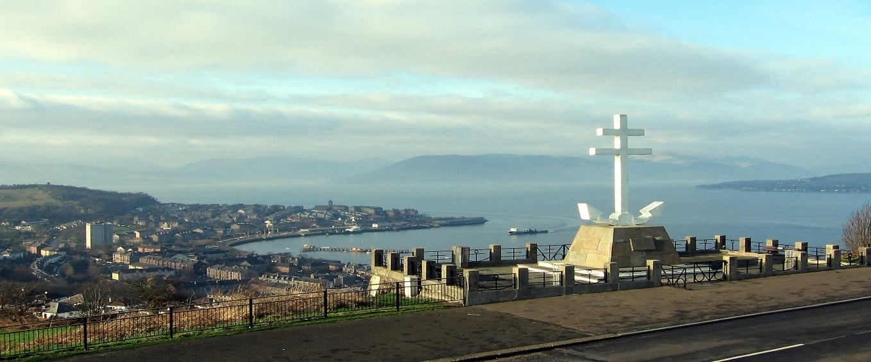

Its back, the epic 1-mile time trial up the Lyle Hill. Sadly, this race hasn’t been run for a few years due to lack of entries, but with your help and support we can put this event back on the map. The HQ will be under the bridge at the bottom of Lyle Road/Newark Street where the start is also located. Riders will be able to park in the Battery Park, warm up and use the toilets/facilities.
The Course…
The course starts under the Fort Matilda railway bridge at the bottom of Lyle road and ascends for 1 mile, past the Free French memorial and car parking bays where you will see the Chequered flag. You can check out the segment on Strava. All junctions will be marshalled. Conditions are looking reasonable for the time of year.
Pushing off- Hugh Jamison
Marshalls - Derek Robinson, Robert Stevenson, Grant Foley, George McCarter, Mark Smith
The Inverclyde Velo members have kindly donated money and various prizes for the event.

