** Withington Wheelers**

**Jim Forbes Memorial Hill-Climb**

**Peaslows Hill, Sunday 30th September 2018**

**First rider off at 2.31 p.m.**

**Prize List**

**Fastest Man** **£80**  and to hold the Jim Forbes Memorial Cup for one year.

**Second Man** **£40**

**Third Man** **£20**

**Fastest Woman** **£40**

**Second Woman £20**

**Third Woman £10**

**Fastest Junior £10**

**Fastest Team £10** **each** and to hold the Tom Frith Shield for one year.

***Course J9/1* -** Peaslows Hill, Blackbrook Lane, Chapel-en-le-Frith.

Length 980 yds. Gradient 1 in 7 average, 1 in 5 steepest. Start at the bridge over a small stream near Blackbrook Nursery. Post code SK23 0PU. Proceed up the hill towards Sparrowpit. Finish 980 yds opposite a corner in the wall on the right of the road, approximately 50 yards after the road on the left leading to Slackhall.

***Race Numbers* -** Collect at the start, SIGN ON at the start and SIGN OFF at the finish.

***Road Safety* -** Please pull off the road to park. Do not park within 75 yards of start or finish. The road is not closedto the public during the event, so care should be taken to ensure that the right-of-way of otherroad-users is not obstructed.

***IN THE INTERESTS OF YOUR OWN SAFETY* - Cycling Time Trials and the event promoters strongly advise you to wear a HARD SHELL HELMET that meets an internationally accepted safety standard. In accordance with Regulation 15 *ALL JUNIOR* competitors must wear protective hard shell helmets. It is recommended that a working rear light, either flashing or constant, is fitted to the machine in a position visible to following road users and is active while the machine is in use.**

***Officials***

Timekeepers **–** Christine White (start) andGraham Lawrence (finish)

Start Steward – Simon Myint-Maung

Finish Steward – Russ Forbes

Event Secretary - Tony Baxter, Barn Close, Riddings Lane, Curbar, Hope Valley, S32 3YT

email: [Valerieandtonybaxter@yahoo.co.uk](mailto:Valerieandtonybaxter@yahoo.co.uk) Tel: 07837 230120

Promoted for and on behalf of **Cycling Time Trials** under their rules and regulations.



**Directions to start**

**From Manchester/Stockport**

Take the A6 towards Buxton. On the Chapel-en-le-Frith bypass, leave the A6 on the slip road signposted *Chapel-en-le-Frith, Blackbrook, Rushup*. At the T junction, turn right, then immediately turn left on the slip road back towards the A6. After 200m, turn left signposted *Blackbrook* and the start is 400m down this lane.

**From Buxton**

Leave the A6 using the slip road signposted *Chapel-en-le-Frith B5470*. After 800m, turn right at the sign *Blackbrook, Bagshaw, Rushup*. Pass under the A6 and turn right signposted *Buxton A6*. After 200m, turn left signposted *Blackbrook* and the start is 400m down this lane.

**Parking**

There is limited parking near the start on Blackbrook Lane. There is more parking on the lane 800m up the hill on the left in the lane leading to Slackhall. Please do not park near the start or finish.

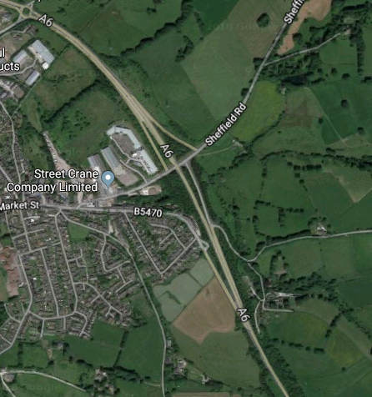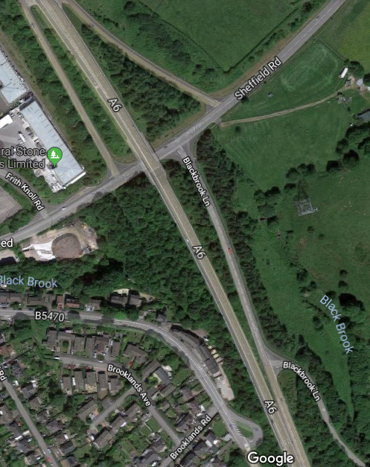

**Start**

**Exit A6**

**Start**

**Chapel-en-le-Frith**

**A6 from Buxton**

**A6 from Stockport**