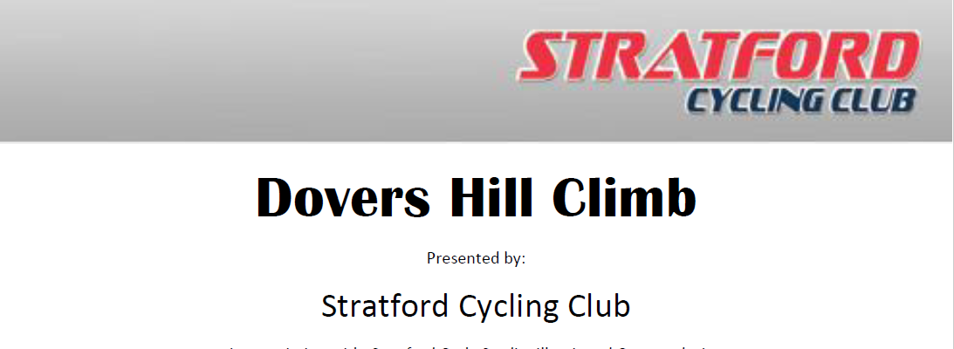

Promoted for, and on behalf of Cycling Time Trials under their Rules and Regulations

16/09/2018 10.00am

Event HQ:

Weston-Sub-Edge Village Hall,

Evesham Road,

GL55 6QJ

Time keepers: Charlie Barnet & Sue Walton

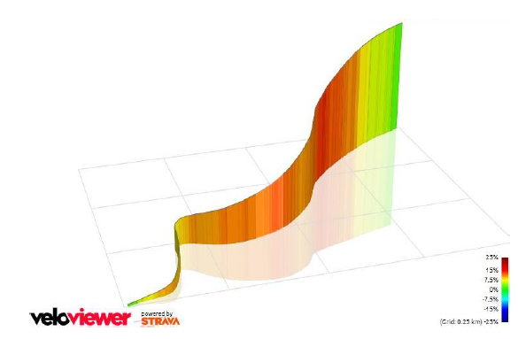

Event Sectary:

Tony Kiss

Cae Back Cottage,

Little Meadows

Pebworth

CV37 8XE

HQ and Course map:

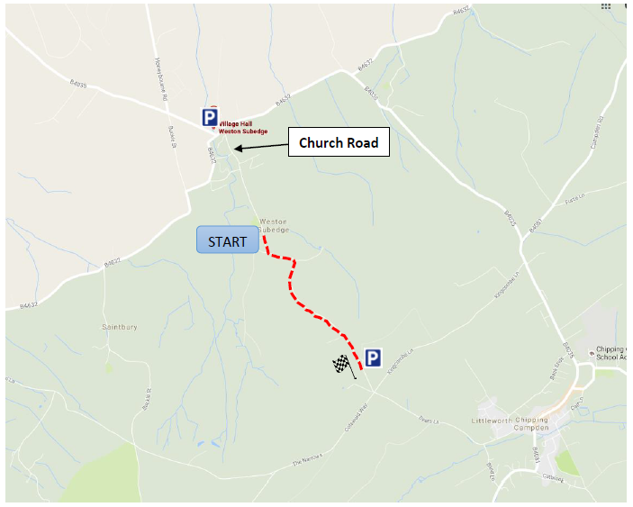

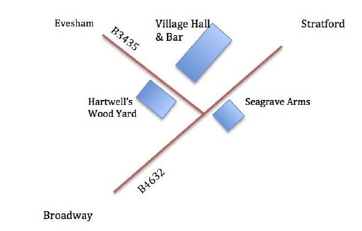

Start Sheet:

