Directions to Start B10/38 Rougham TT https://gb.mapometer.com/cycling/route_4538782
.Turn left out of New Green Centre (Thurston Community Centre) onto STATION ROAD. At the bottom of the hill at the mini roundabout TURN LEFT going under the Railway Bridge.
2. Continue to the CROSS ROADS on the junction of Fishwick Corner and New Road signed for Rougham and go STRAIGHT OVER.
3. At the next cross roads (Bury Road), go STRAIGHT OVER until you get to the right hand turn onto CHURCH ROAD.
4. Continue on Church Road, past the Church and School on your left to the next T junction signed ‘Bury St Edmunds 4 miles’ this is the BLACKTHORPE ROAD.
5. Continue for approx. ½ mile until you get to the RIGHT TURN signed for FELIXSTOWE / IPSWICH / BURY ST EDMUNDS (A14) & GREAT BARTON / ROUGHAM IND EST.
6. TURN RIGHT heading for the RAVENWOOD HALL HOTEL which will be on your right with the A14 Bridge ahead of you (Junction 45). The START POINT is on the North side of the A14 Bridge at the commencement of the A14 sliproad Eastbound. See diagram 2 below.
RETURN ROUTE - To return to New Green Centre, reverse the above on exiting the A14 west bound at Junction 45.
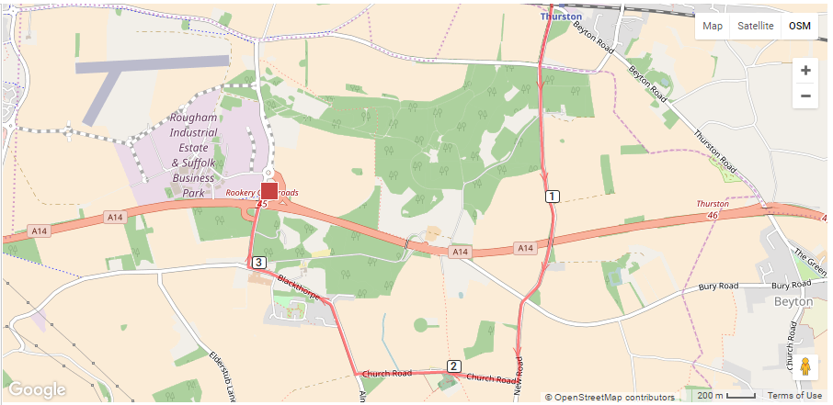
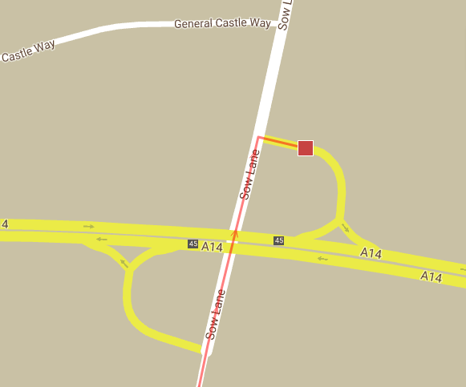
Rougham Ind Est
Start point is on the new slip road onto the A14 Eastbound junction 45 at Rougham

