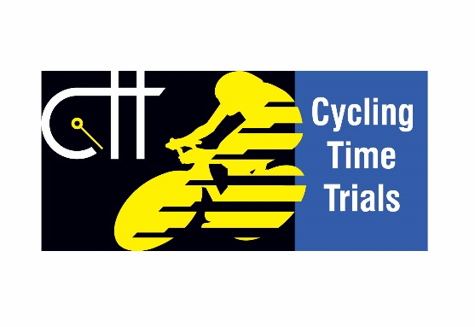

The Junior B.A.R. Competition
Entry Form and progress report
Competitor's Name in Full .....................…......................…......
Postal Address ......................................….................................
....................................…..............................................…...........
.......................................................................................……......
Date of
Birth........................................................................................ (A Birth Certificate may be required at the end of the Competition)
Club............................................................................................
Performances for consideration:
Distance | Eligible event | Date | Actual time | (Office use only)
10 Miles
10 Miles
25 Miles
25 Miles

How to enter the Competition:
There is no entry fee. Entry is made by each competitor returning the Form as soon as he has finished in two 10-miles and two 25-miles events. To be eligible events must be listed in the Handbook and be held not later than 30th September.
Further Forms will then be sent to him to be returned from time to time as he improves during the season. The final report must be in by October 15th.
This Form, when completed is to be posted to the National Secretary (Competitions & Development):
Stewart Smith, 614 Bellhouse Road, Sheffield. S5 0ET
stewart.smith@cyclingtimetrials.org.uk

The Junior Best All-Rounder Competitions
Conditions

- The Competitions shall be called the Junior Best All Rounder Competitions and shall comprise one for boys and one for girls.
- The Competitions shall be open to all amateur Juniors and Juvenile members of Clubs affiliated to Cycling Time Trials who have been continuously resident in Great Britain for the previous two years or who are of proven British nationality.
- Juveniles and Juniors may take part in their appropriate Competitions.
- Each Competition shall be based on each entrants’ fastest two performances at 10 miles and fastest two performances at 25 miles in any Open, Semi-Open or Association event held on or before 30th September in each year. Each performance shall be expressed (to three decimal places) in terms of miles per hour, and the average taken of the resultant speeds.
- Before 15th October in each year competitors must send in details of their qualifying performances to the National Competitions Secretary (from whom application forms can be obtained) who may require the production of the appropriate start and result sheets.
- Medallions will be awarded to the riders placed first, second and third in the Competition for boys and in the Competition for girls. Certificates will be awarded to all competitors who return an average speed of 22 mph or more in the Boys’ Competition and 20 mph or more in the Girls’ Competition.

