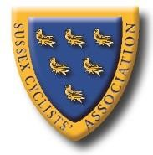
www.sussexca.org.uk

Sussex Cyclists’ Association
ESTABLISHED 1921
PRESIDENT - Kathy Collard-Berry, A3crg.

Open 10 miles Time Trial Saturday 25th August 2018
Course G10/45
Qualifying event for S.C.A. B.A.R., + S.C.A. SPOCO.
Promoted for and on behalf of Cycling Time Trials under their rules and regulations

 | Course Records
Scratch: | 20:45 James Boyman | 2017
Vets | 22:09 Alex Napier | 2016
Ladies: | 26:11 Lisa Davis | 2017
Juniors: | 23:55 Jack Donaldson | 2011
Juveniles | 26:51 Jack Churchill | 2015
Road Bikes | 24:11 Colin McDermott  Previous Winners | 2017
 | 20:45 James Boyman  20:57 James Boyman | 2018  2017  2016
 | 22:54 Carl Ferri | 2015
 | 21:31 Chris McNamara | 2014
 | 22:09 Chris McNamara | 2013
 | 22:10 Steve Dennis | 2012
 | 21:46 Felix English | 2011
 | 22:39 Nicolas Hutchings | 2010

Event Secretary Event HQ is
Robin Johnson, (Brighton Mitre CC), LOXWOOD SPORTS ASSOCIATION PAVILION,
7 Gorselands, Billingshurst, West Sussex RH14 9TT PLAISTOW ROAD,
Tel: 01403 783368 LOXWOOD RH14 0SX
(or 07733 132043 on day of event)
Open from 0900
Email: mr_rjohnson@outlook.com Large car park at HQ.
Licensed bar available, before and after event.

Official Timekeepers
Thank you in advance for not wearing cycling shoes or
Start: cleats in the hall
Mick Irons Worthing Excelsior CC
Finish:
Lesley Donington ‘34 Nomads CC

Please pay attention to the following Safety Notes

London South District Regulation: No vehicles, except those of the timekeepers and race officials, shall be parked in the vicinity of the start or finish areas.

CTT regulations require the compulsory use of helmets for the under 18’s. In the interests of your own safety,
Cycling Time Trials and the event promoters strongly advise all competitors to wear a hard/soft shell helmet that meets internationally accepted safety standards.

Competitors Machines It is recommended that a working rear light, either flashing or constant, is fitted to the machine in a position clearly visible to following road users and is active while the machine is in use.

www.sussexca.org.uk

Race Numbers
Numbers will be available at the event HQ. Please collect your number when you sign on.

Notice of any additional hazards to be aware of on the course will be displayed next to the signing on sheet
.
After the event please return your race number to the event HQ in exchange for a cup of tea or coffee
.
Please note: No times will be given out at the finishes

Warming Up and to the start
Competitors are requested not to warm up on the course after the event has started.

HQ to Start: 1.76 miles
Finish to HQ: 1.99 miles
(if retracing – take care turning around)

Prizes

1
st

£
15

Champagne (value £
25)
+

1
st

Vet
eran

(40
-
44)

Wine (value £5)

2
nd

£
8

+
Wine (value £
5)

1
st

Vet
eran

(4
5
-
4
9
)

Wine (value £5)

3
rd

£
5

5)
Wine (value £
+

1
st

Vet
eran

(
5
0
-
5
4)

Wine (value £5)

4
th

Wine (value £5)

1
st

Vet
eran

(
55
-
59
)

Wine (value £5)

1
st

Vet
eran

(
6
0
-
64
)

Wine (value £5)

1
st

Team

Wine (value £5) each

1
st

Vet
eran

(
65
-
69
)

Wine (value £5)

1
st

Vet
eran

(
7
0
-
74
)

Wine (value £5)

1
st

Lady

£12 + Wine (value £5) £5)£5)5)£25)

2
nd

1

Fastest Road Bike

Wine (value £5)

1
st

Junior

Soft Drink (value £2)

(
no tri
-
bars)

PLEASE NOTE
Prize Presentation | To be held as soon as possible after the event.  Please stay to receive your awards and/or applaud the recipients.
Lottery Prizes | To be awarded at the prize presentation.  A bottle of wine, value £5, to each of the first two names drawn.  To be eligible, be present and be a finisher.

SUSSEX C.A. ANNUAL LUNCHEON + PRIZE PRESENTATION
Date: | Sunday 25th November 2018.
Time: | 12:30
Venue: | Dial Post Village Hall.
Cost: | £10 to Robin Johnson no later than 22nd November 2018..
www.sussexca.org.uk

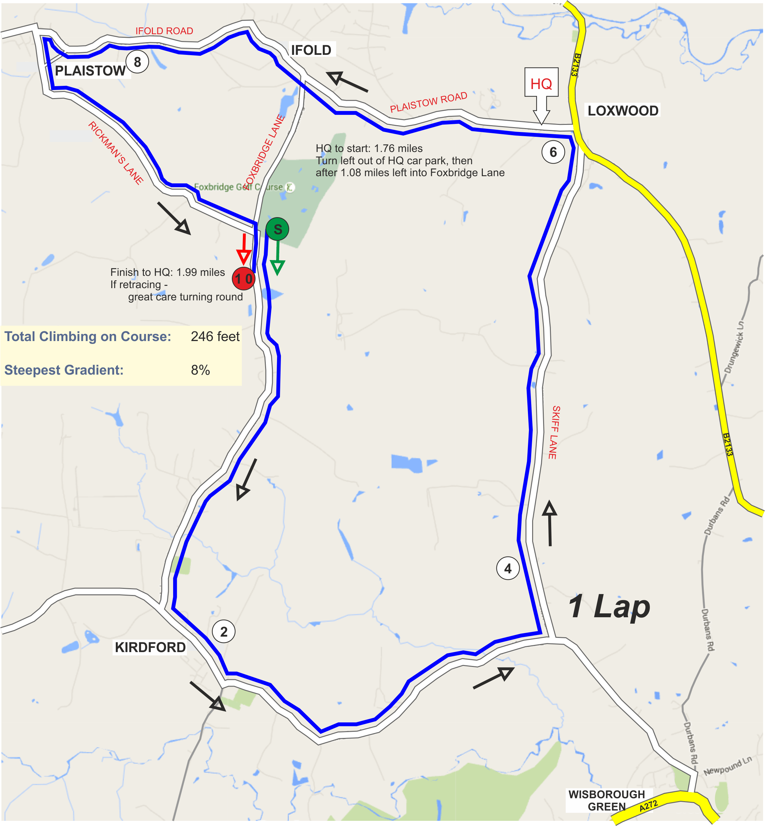
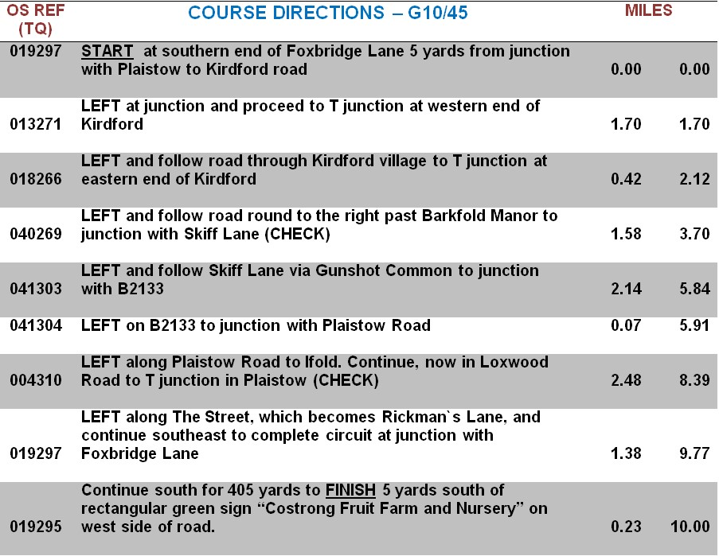
www.sussexca.org.uk

Bib | Start Time | Firstname | Lastname | Club | Gender | Category | Age On Day
1 | 10:01:00 | Robin | Johnson | Brighton Mitre CC | Male | Veteran | 70
2 | 10:02:00 | John | Allen | Redmon CC | Male | Veteran | 58
3 | 10:03:00 | Peter | Davies | Brighton Mitre CC | Male | Veteran | 61
4 | 10:04:00 | Michael | Johansen | London Dynamo | Male | Veteran | 62
5 | 10:05:00 | Andy | Tedd | South Downs Bikes / Casco Europe | Male | Veteran | 51
6 | 10:06:00 | George | Martin | Woolwich CC | Male | Espoir | 19
7 | 10:07:00 | Clive | Jackson | Central Sussex CC | Male | Veteran | 66
8 | 10:08:00 | Barrie | Foster | Anerley BC | Male | Veteran | 69
9 | 10:09:00 | Danny | Halpin | Bristol CX | Male | Veteran | 45
10 | 10:10:00 | Christian | Yates | East Grinstead CC | Male | Veteran | 55
11 | 10:11:00 | Andrew | Green | Old Portlians CC | Male | Veteran | 52
12 | 10:12:00 | Tom | Pemberton | New Malden Velo | Male | Senior | 31
13 | 10:13:00 | Mark | Corliss | Horsham Cycling | Male | Veteran | 63
14 | 10:14:00 | Mark | Hancock | Anerley BC | Male | Veteran | 56
15 | 10:15:00 | David | Shepherd | ...a3crg | Male | Veteran | 57
16 | 10:16:00 | Robert | Giles | PMR @ Toachim House | Male | Veteran | 71
17 | 10:17:00 | Gavin | Hughes | Kingston Phoenix RC | Male | Veteran | 51
18 | 10:18:00 | Peter | Noble | Epsom CC | Male | Veteran | 51
19 | 10:19:00 | Alan | Robinson | Central Sussex CC | Male | Veteran | 77
20 | 10:20:00 | Kevin | Plummer | South Downs Bikes / Casco Europe | Male | Veteran | 53
21 | 10:21:00 | Peter | Owen | Norwood Paragon CC | Male | Veteran | 57
22 | 10:22:00 | Ben | Fielden | GS Stella | Male | Veteran | 76
23 | 10:23:00 | Martin | Naylor | Brighton Excelsior CC | Male | Veteran | 48
24 | 10:24:00 | Stuart | Payne | Central Sussex CC | Male | Veteran | 56
25 | 10:25:00 | Dave | Dawkins | Portsmouth North End CC | Male | Veteran | 49
26 | 10:26:00 | Tim | Peters | Horsham Cycling | Male | Veteran | 45
27 | 10:27:00 | James | Cheeseman | Crawley Wheelers | Male | Senior | 32
28 | 10:28:00 | Clive | Jarman | trainSharp | Male | Veteran | 60
29 | 10:29:00 | Tim | Holmes | Brighton Excelsior CC | Male | Veteran | 56
30 | 10:30:00 | Stuart | Bettis | South Downs Bikes / Casco Europe | Male | Senior | 33
31 | 10:31:00 | Neil | Crowther | Worthing Excelsior CC | Male | Veteran | 45
32 | 10:32:00 | Jenny | Simmonds | Look Mum No Hands! | Female | Veteran | 47
33 | 10:33:00 | Lisa | Davis | Lewes Wanderers CC | Female | Veteran | 43
34 | 10:34:00 | Michael | Thyer | Sussex Nomads CC | Male | Veteran | 68
35 | 10:35:00 | Eddie | Allen | Redmon CC | Male | Senior | 25
36 | 10:36:00 | Brett | Davis | Lewes Wanderers CC | Male | Veteran | 45
37 | 10:37:00 | James | Horan | South Downs Bikes / Casco Europe | Male | Veteran | 49
38 | 10:38:00 | Mike | Marchant | Southdown Velo | Male | Veteran | 61
39 | 10:39:00 | Michael | Gowan | Festival Road Club | Male | Veteran | 75
40 | 10:40:00 | Mark | Bashford | East Grinstead CC | Male | Senior | 34
41 | 10:41:00 | Michael | Renardson | trainSharp | Male | Junior | 16
42 | 10:42:00 | Matthew | Butler | Charlotteville Cycling Club | Male | Senior | 24
43 | 10:43:00 | Geoff | Smith | Eastbourne Rovers CC | Male | Veteran | 68
44 | 10:44:00 | David | Eccles | Redmon CC | Male | Veteran | 70
45 | 10:45:00 | James | Boyman | Hoops Velo | Male | Senior | 30
www.sussexca.org.uk

