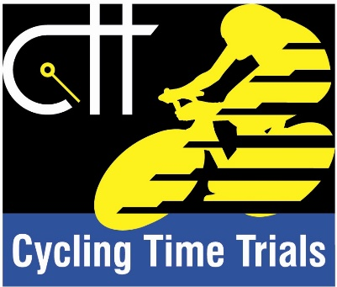

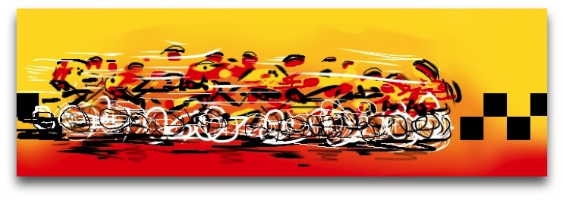
Dumfries Cycling Club
Loch Ken Open Time Trial
Saturday 18th August 2018
Promoted for and on behalf of Cycling Time Trials under their rules & regulations

Organiser: Cameron Scade, 29 Beck Avenue, Dumfries DG2 7BJ
racedumfriescc@gmail.com Mob: 0797961906
Timekeeper: Mr Gordon Johnston
Assistant Timekeeper: Mrs Helen Acklam
Observer: Mr John Sturgeon
FIRST RIDER OFF AT 09:01. List of competitors is below.

- Race HQ (Sign on/out)/parking/toilets: The Lochinvar Hotel, St. Johns Town of Dalry,
DG7 3UP

- HQ will be open from 08:00.

- A copy of the CTT Risk Assessment and specific safety points will be displayed at the event HQ.

Course details: The start point is 3 miles south of The Lochinvar Hotel so plan to give yourself enough time to reach the start on time. You will travel south to the Ken Bridge Hotel, turning left on to the A712 signposted New Galloway, then bear left on to the A762 in New Galloway. It is possible there will be significant traffic at Ken Bridge so you may need to pick your way through. Please do so sensibly and safely. Allow time.

Course: WS25/01 (adapted version) 25.5 miles
Start at top of hill on southern edge of New Galloway on the A762, opposite New Galloway Golf Club. The start line at the southern gatepost of entry to Ardlaggan House, used with permission of property owner.
Proceed along A762 through New Galloway and Mossdale towards Lauriston.
Left turn in Lauriston to join B795 and proceed to left turn at T Junction at Townhead of Greenlaw to join A713. **CAUTION. GIVE WAY TO TRAFFIC FROM THE RIGHT**
Follow A713 through villages of Crossmichael and Parton and on past Ken Bridge to finish at end of second large layby on the left.

*Care should be taken in and around the villages the course passes through, particularly Crossmichael and New Galloway, where there may be an increased likelihood of queuing traffic, parked vehicles and pedestrians. Extra care must also be taken on the descent just after the start New Galloway and the descent down to Glenlochar as you approach the left turn on to the A713. Great care must be taken at the left turn on to the A713. Marshals will be present but it is your responsibility to negotiate the turn safely, obeying the rules of the road and giving way to oncoming traffic from the right.

Total elevation gain for the course is 913ft.

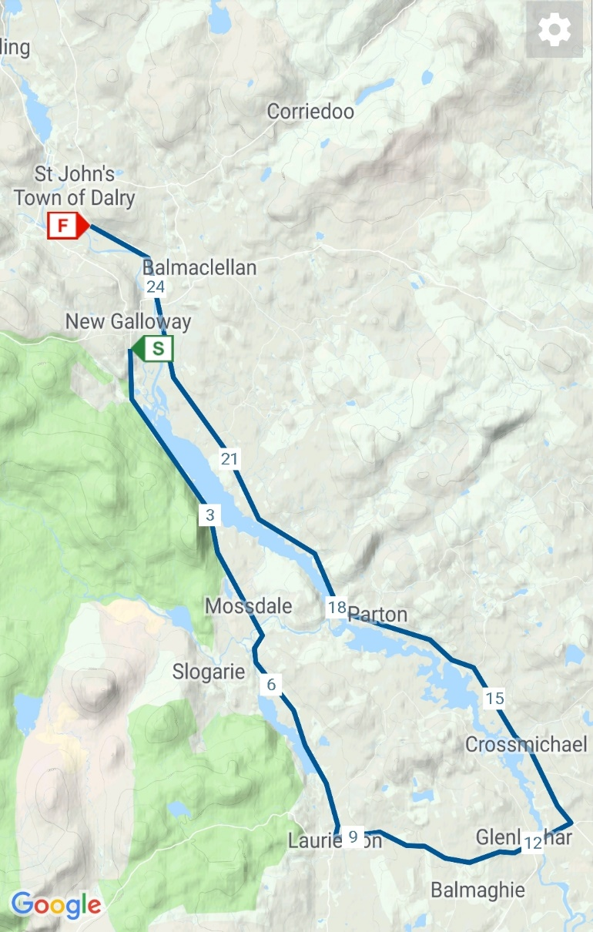
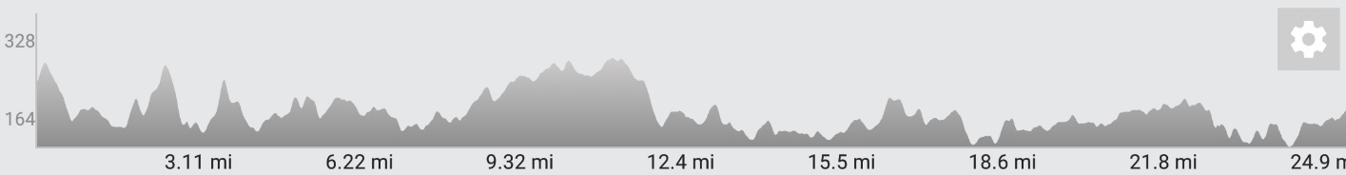

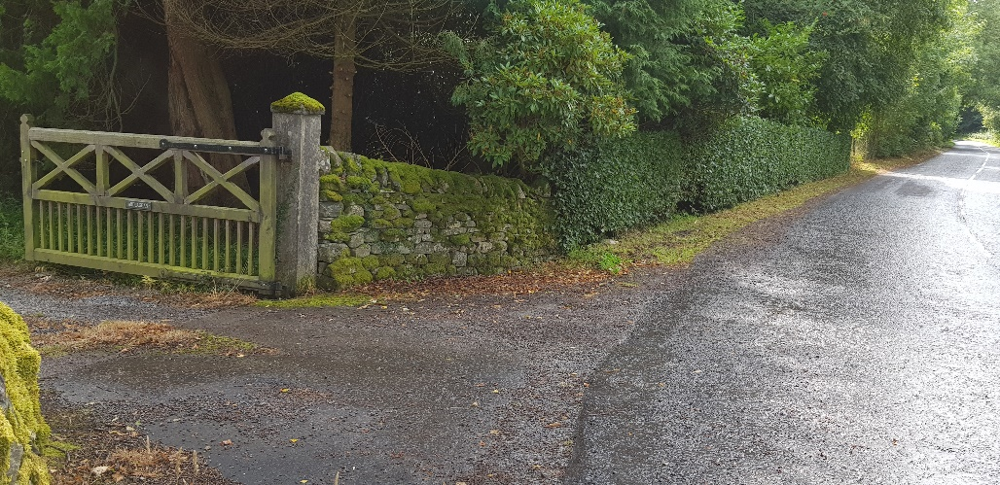
The Start Area at Ardlaggan. See below for info on Alison’s offer.
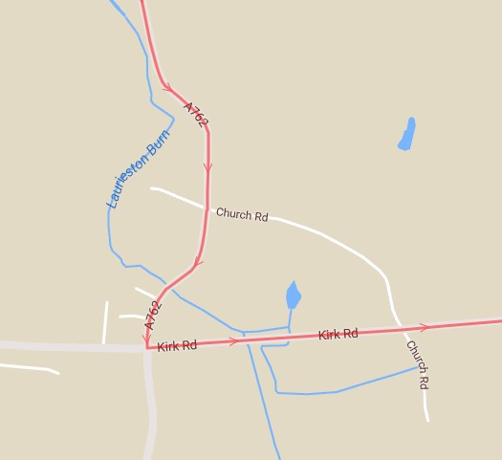

Left turn at Lauriston towards Glenlochar and left turn on to A713

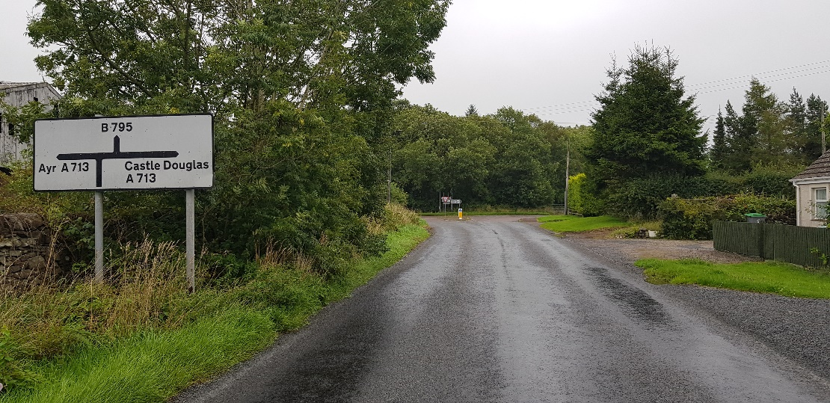
Approaching the left turn on to A713 – CAUTION.

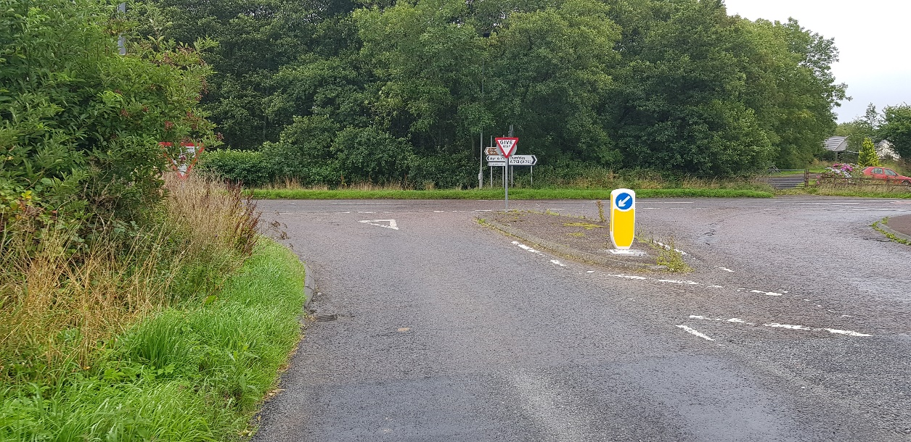
Approaching the left turn on to A713 – CAUTION.

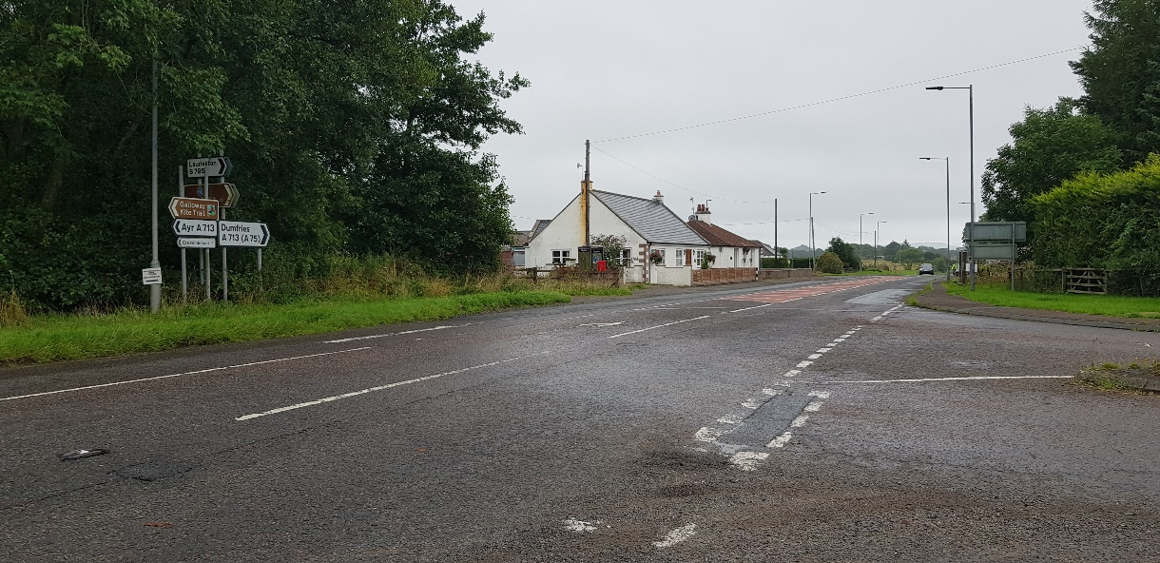
GIVE Way at the left turn on to A713 – CAUTION. Be prepared to STOP.

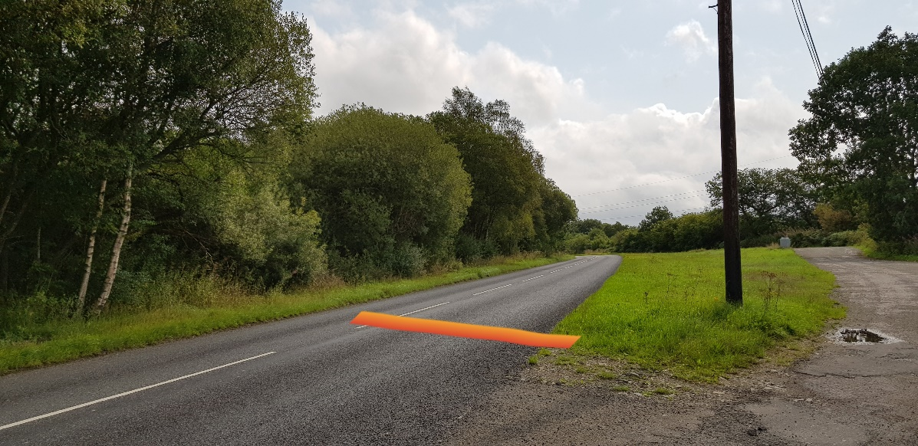
The Finish, 0.3 miles from St John’s Town of Dalry. Don’t park here, please.

Cars are parked at owners’ risk. Vehicles of competitors / officials / marshals / helpers must be parked safely and without hindrance to other road users. Limited parking is available at The Lochinvar Hotel, but please park considerately and don’t take up more space than is necessary. If parking elsewhere in the village, please do so with respect and consideration for residents. Do not park in the vicinity of the start or finish areas.
Alison Davis is the owner of Ardlaggan, the property the adapted course starts outside. She has been very generous and welcoming in allowing us to use the space at her gates for the start area. Furthermore, she has offered the use of the bathroom at the front of her house for riders who may need to take a pre-race natural break. DO NOT do this anywhere else. Alison will also make a track pump and allen keys available for any last-minute issues. Alison is great – be nice to her – please respect her property and her generosity.
- Please note that all competitors are required to sign the signing out sheet in person when returning their number. Failure to do so will result in the competitor being recorded as DNF.
- We don’t need any ID as deposit for your number but do expect that you return your number to us before leaving.
- Riders must ensure their machine is in a safe condition to use so as not to put themselves and others at unnecessary risk.
- Warming up on the course is not permitted for the duration of the event.
- Any competitor making a ‘U’ turn in the vicinity of the start or finish will be disqualified from the event.
- Riders must keep to the left-hand side of the left lane of the road except when overtaking.
- Riders must NOT ride with their heads down.
- Riders must not take pace from faster riders passing (drafting). It is the responsibility of the rider who has been passed to drop back.
- To assist the timekeepers please ensure your number is properly displayed and call out your number at the finish.
- Riders must ride with care and attention, follow the rules of the road and ride responsibly, within the limits of their ability and the road conditions.
- Failure to comply with the above may lead to disqualification.
HELMETS: All competitors under the age of 18 and/or Juniors must wear a HELMET of HARD/SOFT SHELL construction that conforms to a recognised Standard (See regulation 15). Cycling Time Trials strongly recommends ALL competitors wear such a helmet. Cycling Time Trials recommends that a working rear light, either constant or flashing, is fitted to the machine in a position clearly visible to following road users and is active while the machine is in use.

This event may be subject to a Doping Control
It is your responsibility to check. As soon as you have finished you should return to the event HQ as it is your responsibility to check if you are required for Doping Control. Race numbers required for Doping Control will be displayed at the HQ adjacent to the result board. If your number is displayed you should report immediately to Doping Control which will be nearby. Remember, it is up to you to check and ensure that you comply. If required you must report to Doping Control after finishing without delay.

Data Protection:
As an entrant to this event your information may be shared on the event or promoting club website, social media pages or in emails sent by or on behalf of the promoting club. This data will only be shared in relation to your participation in the event, e.g. the list of entrants, results or event reports. This data will be limited to your name, gender, age or age category, the name of the affiliated club or team of which you are a member and your finishing time and/or position.

AWARDS One rider, one prize:
Overall: 1st £25 2nd £15 3rd £10
Vets 60+ 1st £15 2nd £10 3rd £8
Vets 50 – 59 1st £15 2nd £10 3rd £8
Vets 40 – 49 1st £15 2nd £10 3rd £8
Women 1st £15 2nd £10 3rd £8
Espoir 1st £15 2nd £10 3rd £8
Junior 1st £10
The fastest Dumfries Cycling Club Rider will be awarded the Johnston Trophy.

Dumfries CC Loch Ken Open TT – 18 August 2018

 | Start Time | Rider | Club | Gender | Category
1 | 09:01:00 | Brian Morrell | Dumfries CC | Male | V50
2 | 09:02:00 | Gary Jamieson | Fechan Flyers | Male | V40
3 | 09:03:00 | Nicholas Foley | Bristol & District Triathletes (BAD TRI) | Male | Senior
4 | 09:04:00 | Ross Acklam | Dumfries CC | Male | Junior
5 | 09:05:00 | Kevin Jamieson | Fechan Flyers | Male | V40
6 | 09:06:00 | Mark Birkett | Berwick Wheelers | Male | Senior
7 | 09:07:00 | Lindsay Foster | Hitchin Nomads CC | Male | V50
8 | 09:08:00 | Peter Smith | Hawick Cycling Club | Male | V40
9 | 09:09:00 | John McKie | Ayr Roads CC | Male | V60
10 | 09:10:00 | Gregor Sharp | Hawick Cycling Club | Male | V50
11 | 09:11:00 | Jane Emslie | Edinburgh Road Club | Female | Senior
12 | 09:12:00 | Esther Hamill | Dumfries CC | Female | V40
13 | 09:13:00 | Melanie Martin | Studio VELO | Female | V40
14 | 09:14:00 | Gill McNeil | Dumfries CC | Female | V50
15 | 09:15:00 | Paul Lawson | Weaver Valley CC | Male | V40
16 | 09:16:00 | Donald McCalley | Dumfries CC | Male | V50
17 | 09:17:00 | David Robinson | Loudoun Road Club | Male | V50
18 | 09:18:00 | Glenn Marland | Dumfries CC | Male | V60
19 | 09:19:00 | William Ramsay | Loudoun Road Club | Male | V60
20 | 09:20:00 | Chris Godfree | Edinburgh Road Club | Male | V40
21 | 09:21:00 | Ally Hume | Loudoun Road Club | Male | Senior
22 | 09:22:00 | Sandy Laurie | Dumfries CC | Male | Senior
23 | 09:23:00 | Lester Grant | Auchencrow Thistle | Male | Senior
24 | 09:24:00 | Stuart Garner | Dumfries CC | Male | Senior
25 | 09:25:00 | Archie Arthur | Ayr Roads CC | Male | V40
26 | 09:26:00 | James Brown | Carrick CC | Male | V50
27 | 09:27:00 | Lewis Keoghan | Royal Albert CC | Male | Junior
28 | 09:28:00 | John Gemmell | Ayr Roads CC | Male | V60
29 | 09:29:00 | Gavin Church | Dumfries CC | Male | Senior
30 | 09:30:00 | Thomas McNeish | Royal Albert CC | Male | V60
31 | 09:31:00 | Gordon McNeil | Dumfries CC | Male | V50
32 | 09:32:00 | Mike Ferguson | Johnstone Wheelers | Male | V60
33 | 09:33:00 | Andrew McKinlay | Velo Club Vitesse | Male | V50
34 | 09:34:00 | Thomas Gooding-Hill | Ayr Roads CC | Male | V40
35 | 09:35:00 | Craig Gibson | Dumfries CC | Male | V40
36 | 09:36:00 | Ian Elliot | Hawick Cycling Club | Male | V60
37 | 09:37:00 | Andrew Parker | Dumfries CC | Male | V40
38 | 09:38:00 | Daniel Kirk | Ronde Cycling Club | Male | Senior
39 | 09:39:00 | David Fulton | Carrick CC | Male | V50
40 | 09:40:00 | Harry Brawley | Ayr Roads CC | Male | V50
41 | 09:41:00 | Neil Griffiths | Glasgow Wheelers | Male | V20
42 | 09:42:00 | Stevie Watters | Fullarton Wheelers | Male | V50
43 | 09:43:00 | Jim Sutherland | Loudoun Road Club | Male | V50
44 | 09:44:00 | William Hannay | Dumfries CC | Male | V40
45 | 09:45:00 | Tony Scott | Loudoun Road Club | Male | V40
46 | 09:46:00 | Alex McAllister | Ayr Roads CC | Male | V60
47 | 09:47:00 | Paul Robinson | Loudoun Road Club | Male | V40
48 | 09:48:00 | Derek Skinner | Fullarton Wheelers | Male | V40
49 | 09:49:00 | William Bonar | GTR - Return To Life | Male | Senior
50 | 09:50:00 | Scott Glasgow | Glasgow Nightingale | Male | V40
51 | 09:51:00 | Scott-Alexander McKendrick | Fullarton Wheelers | Male | V40
52 | 09:52:00 | Stephen Spellacy | Dumfries CC | Male | V40
53 | 09:53:00 | Allan Duncan | Fullarton Wheelers | Male | V50
54 | 09:54:00 | Peter Haigh | Nelson Wheelers CC | Male | V60
55 | 09:55:00 | Murray Doyle | Bute Wheelers | Male | V50
56 | 09:56:00 | Sean Quinn | Law Wheelers | Male | V40
57 | 09:57:00 | Colin Sinclair | Royal Albert CC | Male | V60
58 | 09:58:00 | Darren Carruthers | Glasgow Green CC | Male | Senior
59 | 09:59:00 | Calum MacDonald | Ayr Roads CC | Male | Senior
60 | 10:00:00 | David Blockley | RT 23 | Male | V50
61 | 10:01:00 | Marc Anderson | Loudoun Road Club | Male | V40
62 | 10:02:00 | Gordon Murdoch | GTR - Return To Life | Male | V40
63 | 10:03:00 | John Dunlop | Loudoun Road Club | Male | Senior
64 | 10:04:00 | Graham Smith | Law Wheelers | Male | V40
65 | 10:05:00 | Lewis Martin | Studio VELO | Male | Espoir
66 | 10:06:00 | Mark Skilling | Carrick CC | Male | V40
67 | 10:07:00 | David Baird | Loudoun Road Club | Male | V50
68 | 10:08:00 | Gavin Shirley | Dooley’s RT | Male | Senior
69 | 10:09:00 | Lewis Duff | GTR - Return To Life | Male | V40
70 | 10:10:00 | Joe Reilly | VITUS PRO CYCLING | Male | Espoir
71 | 10:11:00 | Douglas Watson | GTR - Return To Life | Male | V40
72 | 10:12:00 | Alexander MacRae | Dooley’s RT | Male | Espoir
73 | 10:13:00 | Chris Smart | GTR - Return To Life | Male | Senior

