**The HAROLD CRIBB memorial open 25 Mile Time Trial SUNDAY 29TH July 2018**

**Promoted for and on behalf of Cycling Time Trials under their rules and regulations.**

**Start Sheet**

Timekeepers: Start - Bev Wadsley, Poole Wheelers

Finish -Ros Spencer, Poole Wheelers

Recorder: Joan Price - Poole Wheelers

Event Organiser: Luke Rendell 95 Parkstone Road, Poole. BH15 2NZ

Tel – 07710 423857 e-mail - [lukerendell1989@gmail.com](mailto:lukerendell1989@gmail.com)

AWARDS

Seniors/Espoirs Ladies

1st Fastest £30.00 1st Fastest £30.00

2nd Fastest £20.00 2nd Fastest £20.00

3rd Fastest £10.00 3rd Fastest £10.00

**Veterans** **Vet On Standard** (Based on VTTA Std Times)

1st Fastest £30.00 1st Fastest £30.00

Fastest Team of Three £10.00 each

**One Prize per rider – Except Team prize**.

**EVENT HEADQUARTERS:**

**Lytchett Matravers Village Hall - High** St, Lytchett Matravers, Poole BH16

Numbers and signing on will be at the HQ, parking, refreshments and toilets will be at the HQ. Numbers can be exchanged for a drink afterwards.

**Riders** are reminded that they need to **sign out** after the event as well as **signing in**

**WE WILL HAVE A PRIZE PRESENTATION AT THE END SO PLEASE STAY ON IF YOU CAN.**

V2  **Page 1 of 5**

**From HQ to Start -** the start is just under 2miles from the HQ (mostly downhill) – right out of HQ, passed Tesco Express on your left and turn Right at Crossroads in to Wareham Road – follow all the way down the hill until you meet the A35 – Start is approx. 100 meter down slip road (to the left)

**COURSE P413**

START: at drain cover in acceleration lane to A35 85 yards east of Pikes Farm Junction (OS939931). Proceed on the A35 to Bakers Arms Roundabout (1.02m) where straight on along A35 to TURN at Holes Bay Rbt (4.59m). CIRCLE and retrace to TURN at Bakers Arms Rbt (8.18m) Circle and retrace to Holes Bay Rbt (11.81m) circle and retrace to Bakers Arms Rbt (15.40m) circle and retrace to Holes Bay Rbt (19.03m) circle and retrace to Bakers Arms rbt (22.61m) where take first left on A351 to TURN at Holton Heath Rbt (23.58m) ONLY ONCE AFTER FINAL LAP – circle and retrace to Bakers Arms Rbt where left on A35 then shortly left again to Organford to FINISH at electricity sub station (OS947925).

**Return to HQ** approximately 2 miles: straight on after the finish then RIGHT at Organford T junction then left then Right at staggered Crossroads when you meet A35 and then straight up Wareham Road at the top of the hill at Crossroads turn Left into the High Street to HQ on the left.

**IMPORTANT NOTES:**

1. Riders attention is drawn to CTT regulations particularly 14, 15, 17, 18, 19, 20 and 21.
2. There are emergency traffic lights at Holes Bay Roundabout for the fire Station.

**If the lights are ignored - Marshals have been asked to take rider numbers for disqualification.**

**Local South DC Regulation**

1. When approaching the Bakers Arms Roundabout competitors must keep to the left until they have passed the Left Hand ‘Reduce Speed Now’ sign. A marshal will be present.

**If this instruction is ignored – The Marshal will take the riders number for disqualification**

**Observers may be in attendance along the course.**

**IT IS RECOMMENDED THAT A WORKING REAR LIGHT, EITHER FLASHING OR CONSTANT IS FITTED.**

**IN THE INTERESTS OF YOUR OWN SAFETY CYCLING TIME TRIALS STRONGLY ADVISE YOU TO WEAR A HARD-SHELL HELMET THAT MEETS INTERNATIONAL SAFETY STANDARDS**

**HEADS UP ACCIDENTS DOWN**

V2 **Page 2 of 5**

**Map showing HQ and course**

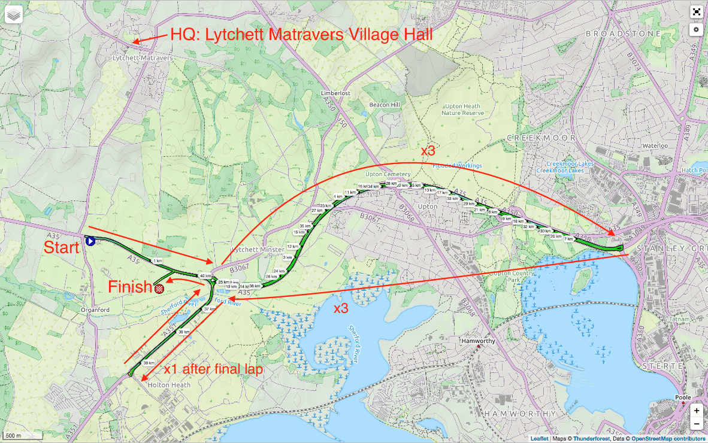

**Course profile**

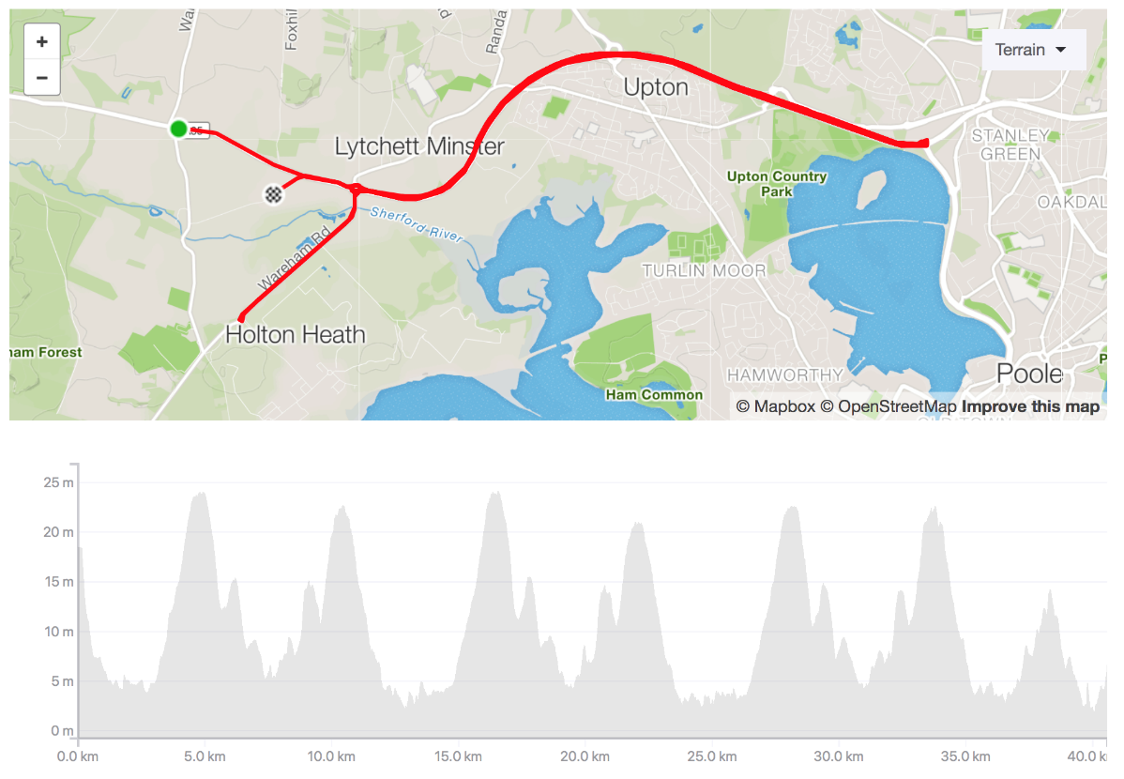V2**Page 3 of 5**

**Rider list**

|  |  |  |  |  |  |  |  |
| --- | --- | --- | --- | --- | --- | --- | --- |
| **No** | **Start Time** | **Name** | **Name** | **Club** | **Gender** | **Category** | **VTTA Std Time** |
|  |  | **Tandem** |  |  |  |  |  |
| 1 | 07:01 | Gordon | Scott | CC Weymouth | Male | Veteran |  |
| 1 | 07:01 | Jemma | Scott | CC Weymouth | Female | Senior |  |
|  |  | **Solo's** |  |  |  |  |  |
| 2 | 07:02 | Terry | Belbin | Poole Whs | Male | Veteran | 01:08:52 |
| 3 | 07:03 | Andrew | Mayfield | Bournemouth Arrow CC | Male | Veteran | 01:08:52 |
| 4 | 07:04 | Martin | Bastable | Wheels of Dorset | Aero Testing | Bike Fitting | Male | Veteran | 01:07:03 |
| 5 | 07:05 | Stuart | Martingale | Sotonia CC | Male | Veteran | 01:08:02 |
| 6 | 07:06 | Michael | Akers | Julian Porter Cycling | Male | Senior |  |
| 7 | 07:07 | Matt | Blythe | Bournemouth Arrow CC | Male | Veteran | 01:07:26 |
| 8 | 07:08 | Richard | Wyeth | Tornado Road Cycling Club | Male | Veteran | 01:06:39 |
| 9 | 07:09 | Leighton | Smith | Bournemouth Arrow CC | Male | Senior |  |
| 10 | 07:10 | Adrian | Murray | Bournemouth Jubilee Whs | Male | Veteran | 01:08:02 |
| 11 | 07:11 | Stuart | Thompson | Velo Club St Raphael | Male | Veteran | 01:06:39 |
| 12 | 07:12 | Darren | Lyons | Velo Club Venta | Male | Senior |  |
| 13 | 07:13 | Pete | Wilson | Bournemouth Arrow CC | Male | Veteran | 01:11:58 |
| 14 | 07:14 | Ian | Hayden | Tornado Road Cycling Club | Male | Veteran | 01:08:52 |
| 15 | 07:15 | John | Sibley | Utag RT | Male | Veteran | 01:07:50 |
| 16 | 07:16 | Tim | Cooke | Sotonia CC | Male | Veteran | 01:08:02 |
| 17 | 07:17 | David | England | Crabwood CC | Male | Veteran | 01:16:59 |
| 18 | 07:18 | Damon | Payne | Royal Navy & Royal Marines CA | Male | Veteran | 01:06:00 |
| 19 | 07:19 | Richard | Norris | Yeovil Cycling Club | Male | Veteran | 01:07:03 |
| 20 | 07:20 | Charles | Rees | Wheels of Dorset | Aero Testing | Bike Fitting | Male | Senior |  |
| 21 | 07:21 | Bryce | Riglar | CC Weymouth | Male | Senior |  |
| 22 | 07:22 | Lauren | Bishop | Poole Whs | Female | Senior |  |
| 23 | 07:23 | Emma | Needham | CC Weymouth | Female | Senior |  |
| 24 | 07:24 | Erica | Fogg | Sotonia CC | Female | Senior |  |
| 25 | 07:25 | Michelle | Walter | Bournemouth Arrow CC | Female | Veteran | 01:15:09 |

V2  **Page 4 of 5**

|  |  |  |  |  |  |  |  |
| --- | --- | --- | --- | --- | --- | --- | --- |
| **No** | **Start Time** | **Name** | **Name** | **Club** | **Gender** | **Category** | **VTTA Std Time** |
| 26 | 07:26 | Richard | Hamilton | Sarum Velo | Male | Senior |  |
| 27 | 07:27 | Peter | Lynk | Bournemouth Jubilee Whs | Male | Veteran | 01:08:26 |
| 28 | 07:28 | Colin | Brumble | CC Weymouth | Male | Veteran | 01:08:52 |
| 29 | 07:29 | Chris | Summers | Sotonia CC | Male | Veteran | 01:12:20 |
| 30 | 07:30 | Simon | Berogna | Velo Club St Raphael | Male | Veteran | 01:06:51 |
| 31 | 07:31 | John | Chapman | CC Weymouth | Male | Veteran | 01:09:19 |
| 32 | 07:32 | Mark | German | 1st Chard Wheelers | Male | Veteran | 01:10:04 |
| 33 | 07:33 | Neil | Dyble | Bournemouth Arrow CC | Male | Veteran | 01:08:52 |
| 34 | 07:34 | William | Simmons | Christchurch Bicycle Club | Male | Veteran | 01:12:20 |
| 35 | 07:35 | Julian | Lockwood | Primera-Teamjobs | Male | Veteran | 01:08:39 |
| 36 | 07:36 | Mike | Williams | Poole Whs | Male | Veteran | 01:08:39 |
| 37 | 07:37 | Nick | Frewin | Bournemouth Jubilee Whs | Male | Veteran | 01:10:38 |
| 38 | 07:38 | Adrian | Watkins | Tornado Road Cycling Club | Male | Veteran | 01:08:02 |
| 39 | 07:39 | Colin | White | Bournemouth Jubilee Whs | Male | Veteran | 01:07:50 |
| 40 | 07:40 | Greg | Woodford | Reading CC | Male | Veteran | 01:09:34 |
| 41 | 07:41 | Stuart | Peckham | New Forest CC | Male | Veteran | 01:07:38 |
| 42 | 07:42 | David | Butt | CC Weymouth | Male | Veteran | 01:11:36 |
| 43 | 07:43 | Ian | Hatch | Sotonia CC | Male | Veteran | 01:08:02 |
| 44 | 07:44 | Harry | Loader | Mid Devon CC | Male | Senior |  |
| 45 | 07:45 | Neil | Mackley | Fareham Wheelers CC | Male | Veteran | 01:08:52 |
| 46 | 07:46 | Dave | Dent | GS Stella | Male | Veteran | 01:09:05 |
| 47 | 07:47 | Jon | Brumfield | CC Weymouth | Male | Veteran | 01:07:03 |
| 48 | 07:48 | Alex | Allen | Royal Navy & Royal Marines CA | Male | Senior |  |
| 49 | 07:49 | Steven | Pink | Poole Whs | Male | Veteran | 01:06:00 |
| 50 | 07:50 | Andy | Langdown | Blazing Saddles | Male | Veteran | 01:07:50 |
| 51 | 07:51 | Samuel | Wadsley | Primera-Teamjobs | Male | Espoir |  |
| 52 | 07:52 | Greg | Parker | CC Weymouth | Male | Veteran | 01:08:52 |
| 53 | 07:53 | Gary | Chambers | NOPINZ | Male | Senior |  |

V2  **Page 5 of 5**