[](http://73degreesbicycleshop.com/)[](http://www.westsidecoaching.co.uk/)

**WTTA Hardriders 2018**

**ON SUNDAY July 29th 2018, STARTING AT 08:26 HOURS**

**Time Keepers: Ian Boon and Bridget Boon**

**HEADQUARTERS**

Burrington Combe Parish Council Hall

Burrington

Bristol

Sign on/HQ is open from 0700 hrs and is 0.6 miles from the start

Limited parking available at HQ so please use car park next to start

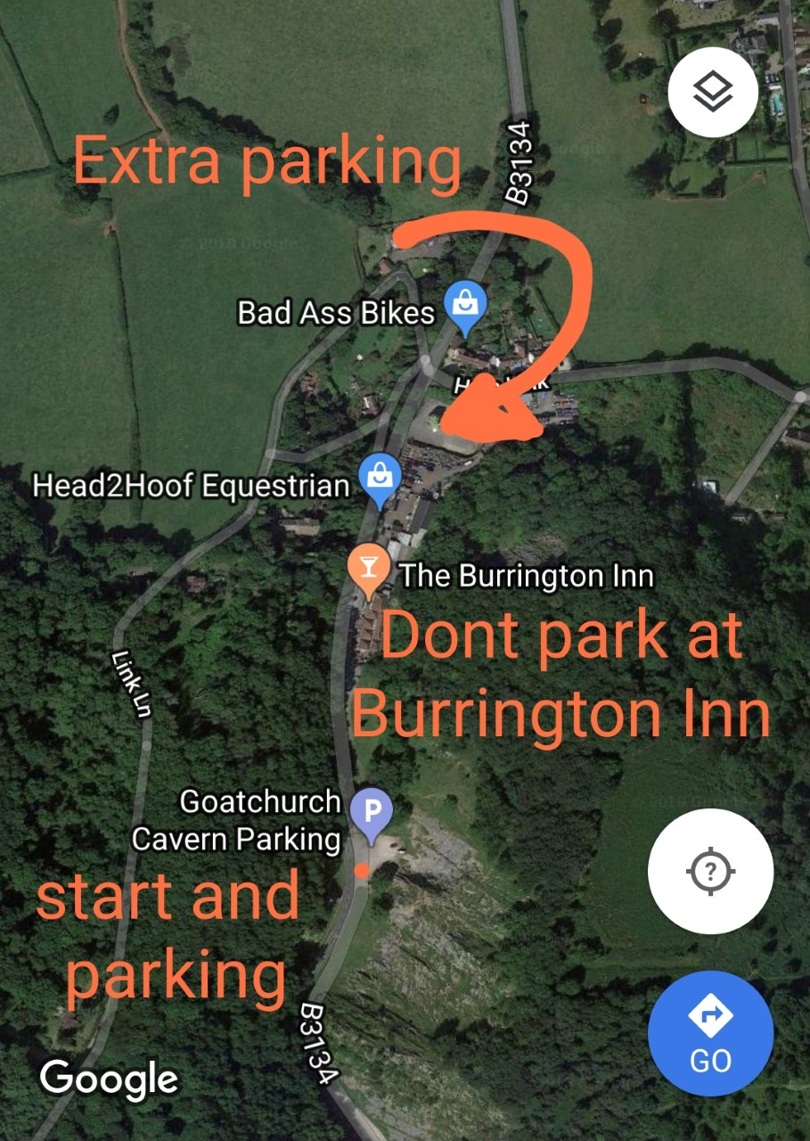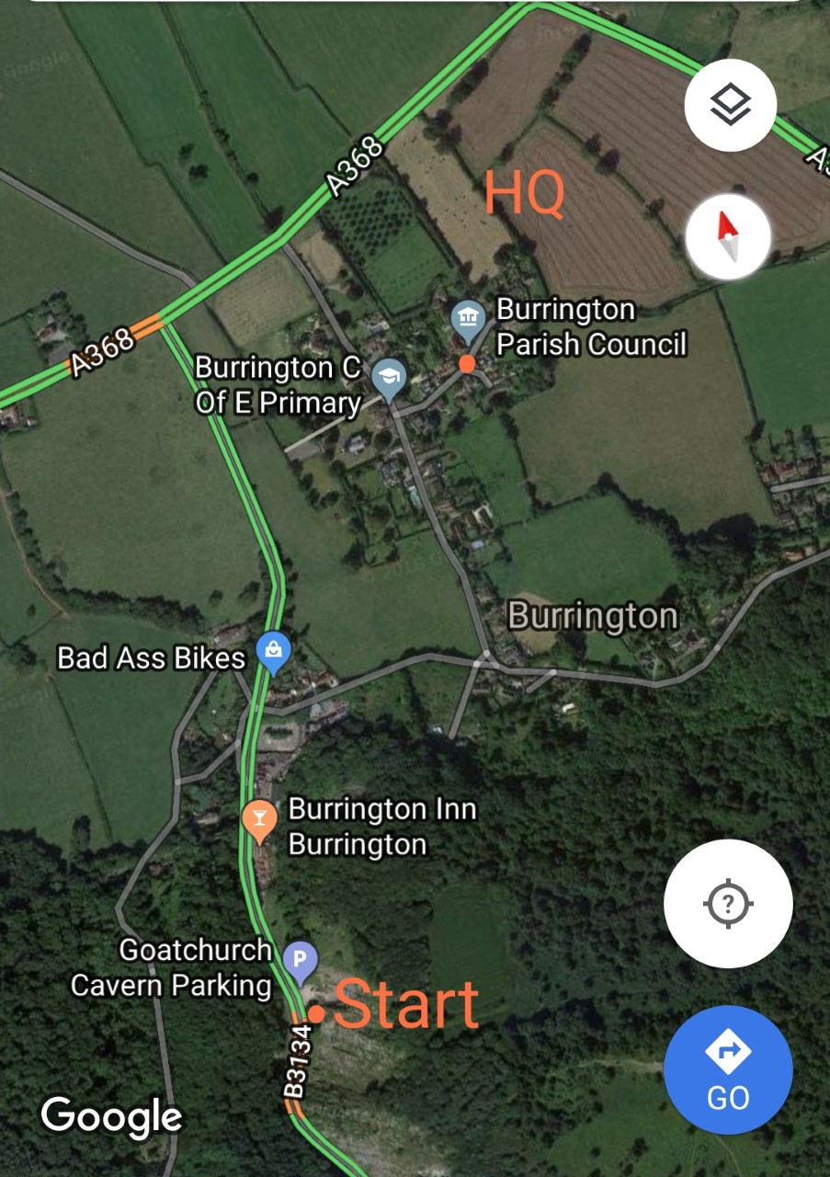

*Additional parking is available at Goatchurch Cavern parking next to the start,*

*Please do not park in the Burrington Inn car park. Extra parking available below the Equestrian centre*

**PRIZE LIST**

**1 Prize per winner (Except Team Prize)**

**Scratch:** 1st £20 2nd £15 3rd £10

**Vets:** 1st £20 2nd £15 3rd £10 **Women:** 1st £20 2nd £15 3rd £10

**Road Bike:** 1st £20 2nd £15 3rd £10

**Team:** 1st £5 per rider

**There is a special prize if first overall is on a road bike**

Road bike rules -

Obviously road bike with drop bars

No aero bar extensions

No tri spokes, disk or 5 spokes wheels etc

Wheel depth 50mm max

No calf guards, no overshoes or aero socks

Normal road helmet, no TT helmet

No long sleeve TT Skinsuit

**Please remember to sign out after returning your number**

**Otherwise you will be parked down as DNF**

***Cycling Time Trials Ltd recommends the use of hard shell helmets in time trials***

**Organiser (entries)** :

Glyndwr Griffiths –

Email: dggriffiths@hotmail.co.uk

Mob: 07425133091

*This event is run for and on behalf of Cycling Time Trials under their Rules and Regulations*

*By* [*73 Degrees Bicycles*](http://73degreesbicycleshop.com/) *and* [*WestSide Coaching*](http://www.westsidecoaching.co.uk/)

**U28 – Course Description**

**Start is next to bus stop sign at the car park**

**It is the RIDERS responsibility to know the course.**

**This course is hilly and therefore as well as including some climbing this also includes some fast technical descents. We advise all riders to pre ride the descent before racing in the event.**

**Please be careful and remember that your safety is important to us as a team.**

**Course Description:**

Start 20 Metres after first Cattle grid up Burrington Combe

At 3.3 km at the top of Burrington Combe carry straight on

At (5.7 Miles) 9.2 km turn sharp left onto Gibbet Brow/Old Bristol Rd/Harptree hill

**\* Caution Technical Descent \***  
At (8.2 Miles) 13.3 km turn sharp left at the bottom of Harptree hill to head onto A368  
Continue on this road through Compton Martin

At (11.8 Miles) 19 km in Blagdon turn left to head up hill on Street End to join Rodyate then Two trees

At (13 Miles) 21 km turn left at T junction to head onto the B3134.  
At (16.7 Miles) 27 km turn sharp left to turn onto Gibbet Brow/Old Bristol Rd/Harptree hill

**\* Caution Technical Descent \***  
At (19.3 Miles) 31 km turn sharp left at the bottom of Harptree hill to head onto A368  
Continue on this road through Compton Martin

At (22.9 Miles) 36.8 km in Blagdon turn left to head up hill on Street End to join Rodyate then Two trees

At (23.9 Miles) 38.4 km Finish on brow of hill next to lay by 30 metres before the Junction

**Ride with GPS link -** [**https://ridewithgps.com/routes/14651366**](https://ridewithgps.com/routes/14651366)

**CTT link -** [**https://cyclingtimetrials.org.uk/race-details/12492**](https://cyclingtimetrials.org.uk/race-details/12492)

**Course record holder** [**Tavis Walker**](https://www.cyclingtimetrials.org.uk/race-results/15194#anchor) **TT bike 1 hr 6 mins and 21 secs**

**Ladies course record** [**Joanne Jago**](https://www.cyclingtimetrials.org.uk/race-results/12492#anchor) **TT bike 1 hr 21 mins and 34 secs**

[](http://www.westsidecoaching.co.uk/)[](http://73degreesbicycleshop.com/)