HAMPSHIRE ROAD CLUB
PHIL SMITH MEMORIAL 10 MILE TIME TRIAL – SATURDAY 21st July 2018

COURSE: P881 START TIME: 1700 HRS

Promoted for and on behalf of Cycling Time Trials under their rules and regulations
In the interests of your own safety; Cycling Time Trials, Hampshire Road Club and the event promoter strongly advise you to wear a hard shell helmet that meets an internationally accepted safety standard (a “safe” helmet)

Event Secretary: Paul Beck Start timekeeper: Kathie Whitmore
3 Oaks Coppice
Waterlooville Finish timekeeper: Kathie Collard-Berry
Hants
PO8 9QR Recorder: Peter Courtnell

T: 023 9259 8270
M: 07971 839566
Event headquarters: Liss Village Hall (see map overleaf)

Car parking: DO NOT USE THE PUB CAR PARK NEXT TO THE H.Q.
The event car park is opposite and a few yards south of the H.Q. (see map overleaf). If the car park is full turn right out of the car park and right again for road side parking, or use the sports ground car park which is right out of the car park and then on the left

Please note: Riders must sign the signing on sheet when collecting their number
Riders under the age of 18 must wear a “safe” helmet (see above)
To enable time trials to be held on the P881, the Police have requested that all competitors have a working rear light and switch it on during their participation in the time trial. Thus the Hampshire Road Club require this also.

COURSE DETAILS (M) indicates a marshal

There is a safer route to the start than crossing the A3 at the Ham Barn roundabout (see map overleaf). Turn right from the H.Q. then right at the mini roundabout and follow the road to Greatham. Ride time about 15 minutes. This route will be signed from the mini roundabout.

START on the B3006 Selbourne Road, 190 yards north of Ham Barn RAB on A3, at a point 17 yards north of the centre of three concrete manhole covers in the tarmac path. (SU 772297)

Proceed to Ham Barn RAB (M) and take 1st exit on to A3 (signposted Guildford and London)

Proceed north east on A3 passing two exit slip roads (1) the A325 to Farnham and (2) an unclassified road to Griggs Green

Take 3rd exit slip road (M) on to B2171 (signposted to Haslemere and Liphook) to cross Bramshot flyover where TURN (SU 843324) (5.2 miles)

Take 1st exit to turn LEFT on to slip road (M) to rejoin the A3 and proceed south west (signposted Petersfield and Portsmouth)

Retrace on A3 to FINISH at point 10 yards south west of entry to lay-by, after passing under bridge and 0.554 miles north east of Ham Barn RAB (SU 775297) (10 miles)

AFTER FINISHING, TURN LEFT AT HAM BARN ROUNDABOUT AND LEFT AGAIN INTO LISS (SEE MAP OVERLEAF)

Course record: Chris Bartley 18:22 30 May 2018

No times will be given at the finish
Riders must:
- not make any U turns in the vicinity of the Start or Finish
- not warm up on the course or near the Start area
- keep to the side of the road when waiting to start and must not obstruct the view of the Time Keeper the Holder-up (pusher off), of approaching traffic
- exercise care when joining the A3 after the Start and the Turn
- exercise care when passing exit and entry slip roads at all interchanges on the A3
- not stop at the Finish, but continue to the Event Headquarters

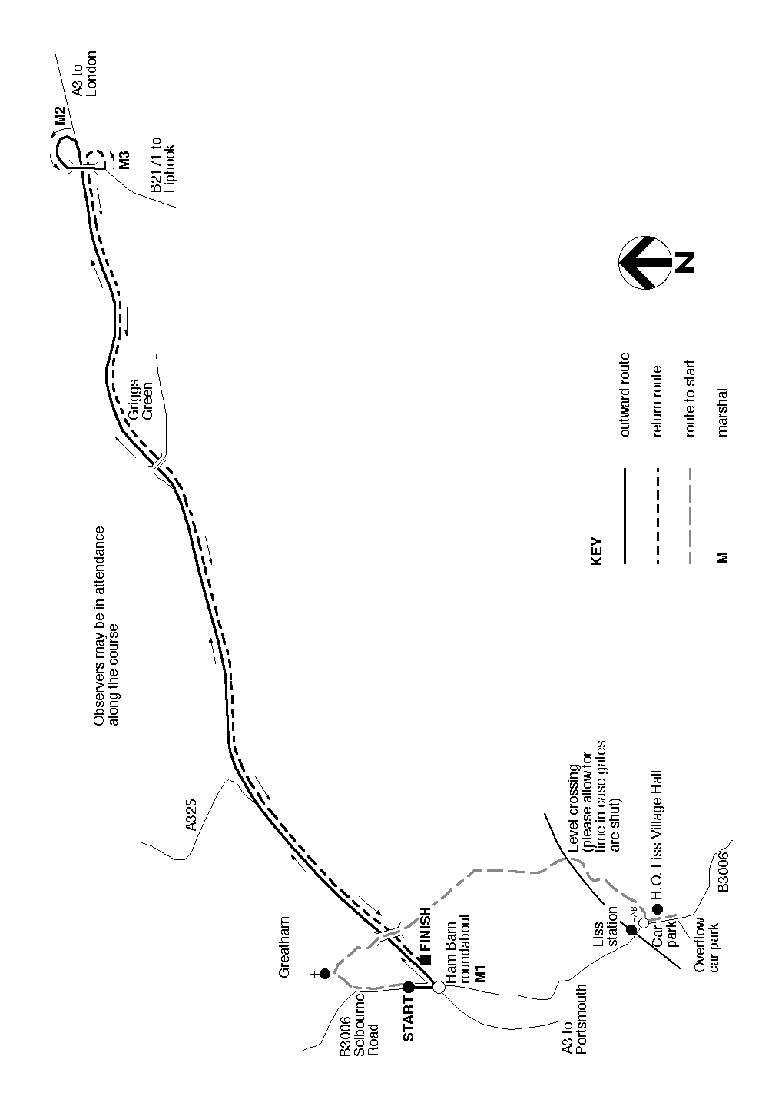
Start Time | Number | Name | Club | Group
17.01 | 1 | Deanna Ferrett | Hampshire Road Club | Veteran
17.02 | 2 | Richard Moore | WyndyMilla | Veteran
17.03 | 3 | Peter Lynk | Bournemouth Jubilee Whs | Veteran
17.04 | 4 | Chris Summers | Sotonia CC | Veteran
17.05 | 5 | Jan Farmer | Serpentine Running Club | Veteran
17.06 | 6 | Peter Hatt | Velo Club St Raphael | Veteran
17.07 | 7 | David Walters | Velo Club Godalming & Haslemere | Veteran
17.08 | 8 | Andrew Gibson | Gravesend CC | Veteran
17.09 | 9 | Gerry Peppin | Corinium Cycle Club | Veteran
17.10 | 10 | Nick Dwyer | Lewes Wanderers CC | Veteran
17.11 | 11 | Barrie Watkinson | Bournemouth Arrow CC | Veteran
17.12 | 12 | Gary Ferrett | Hampshire Road Club | Veteran
17.13 | 13 | Paul Beck | Hampshire Road Club | Veteran
17.14 | 14 | Adrian Talley | Portsmouth North End CC | Veteran
17.15 | 15 | Phil Wilks | Sotonia CC | Senior
17.16 | 16 | Lee Turner | Sigma Sports | Veteran
17.17 | 17 | Tom Houghton | Brighton Excelsior CC | Veteran
17.18 | 18 | Ron Hooper | Fareham Wheelers CC | Veteran
17.19 | 19 | Evan Jardine-skinner | Sotonia CC | Veteran
17.20 | 20 | James Fawcett | Hampshire Road Club | Veteran
17.21 | 21 | James Ayton | Portsmouth North End CC | Veteran
17.22 | 22 | Mark Duncan | ...a3crg | Veteran
17.23 | 23 | Matthew Butler | Charlotteville Cycling Club | Senior
17.24 | 24 | Steve Skinner | Bognor Regis CC | Veteran
17.25 | 25 | Jason Gault | Primera-Teamjobs | Veteran
17.26 | 26 | Shaun Smart | Southdown Velo | Veteran
17.27 | 27 | Martin Beale | Velo Club St Raphael | Veteran
17.28 | 28 | Andrew Mayfield | Bournemouth Arrow CC | Veteran
17.29 | 29 | Barrington Day | Fareham Wheelers CC | Veteran
17.30 | 30 | Matt Peel | C and N Cycles RT | Senior
17.31 | 31 | Kelly Stokes | Portsmouth Triathletes | Senior
17.32 | 32 | Angela Carpenter | ...a3crg | Veteran
17.33 | 33 | Michelle Walter | Bournemouth Arrow CC | Veteran
17.34 | 34 | Sophie Needham | Hampshire Road Club | Senior
17.35 | 35 | Mike Williams | Poole Whs | Veteran
17.36 | 36 | Patrick Brennan | ...a3crg | Veteran
17.37 | 37 | Oliver Handley | Southampton University Road Cycling | Senior
17.38 | 38 | Chris Aitken | Thames Valley Triathletes | Senior
17.39 | 39 | Pippa O'brien | RT PODA | Veteran
17.40 | 40 | Angus Macinnes | Royal Air Force Cycling Association | Veteran
17.41 | 41 | James Fritchley | Wheels of Dorset | Aero Testing | Bike Fitting | Senior
17.42 | 42 | Stuart Peckham | New Forest CC | Veteran
17.43 | 43 | Emma Angove | 73Degrees CC, WestSide Coaching | Senior
17.44 | 44 | Kate & John Bosley | Abellio - SFA Racing Team | Veteran
17.45 | 45 | Kevin Baker | Andover Wheelers | Senior
17.46 | 46 | Stuart Carver | North Hampshire RC | Veteran
17.47 | 47 | Tim Peters | Horsham Cycling | Veteran
17.48 | 48 | Nicholas Cosgreave | Farnborough & Camberley CC | Veteran
17.49 | 49 | Neil Crowther | Worthing Excelsior CC | Veteran
17.50 | 50 | Colin Barton | Worthing Excelsior CC | Veteran
17.51 | 51 | Steve Legg | ...a3crg | Veteran
17.52 | 52 | David Bew | Hampshire Road Club | Veteran
17.53 | 53 | Kirsty Mcseveney | Fareham Wheelers CC | Senior
17.54 | 54 | David French | Weybridge Wheelers | Veteran
17.55 | 55 | Brendan Reese | Army Cycling Union | Veteran
17.56 | 56 | Dave Dent | GS Stella | Veteran
17.57 | 57 | Carl Bond | Kenton RC | Veteran
17.58 | 58 | Michael Harrison | North Hampshire RC | Veteran
17.59 | 59 | Rachael Lamont | Hampshire Road Club | Veteran
18.00 | 60 | Sam Clarke | Team Bottrill / Vanguard | Senior
18.01 | 61 | Peter Drabble | WORX Factory Racing Pow’d by Silverstone | Juvenile
18.02 | 62 | Mike O'gorman | Worthing Excelsior CC | Veteran
18.03 | 63 | Adam Wells | Paceline RT | Senior
18.04 | 64 | Graham Harman | Sotonia CC | Veteran
18.05 | 65 | Nick Jones | Bournemouth Jubilee Whs | Veteran
18.06 | 66 | Nigel Sign | Fareham Wheelers CC | Veteran
18.07 | 67 | Neil Dyble | Bournemouth Arrow CC | Veteran
18.08 | 68 | Derek Dowden | Hampshire Road Club | Veteran
18.09 | 69 | Courtney Edmonds | Bike Jockey CC | Senior
18.10 | 70 | Matthew Buckley | Andover Wheelers | Senior
18.11 | 71 | Neil Mackley | Fareham Wheelers CC | Veteran
18.12 | 72 | Andrew Thomas | ...a3crg | Senior
18.13 | 73 | James Goward | Farnborough & Camberley CC | Veteran
18.14 | 74 | Barry Eeles | North Hampshire RC | Veteran
18.15 | 75 | David Rumm | Southborough & Dist. Whs | Veteran
18.16 | 76 | Tim Childs | Westerley Cycling Club | Veteran
18.17 | 77 | Clive Jackson | Central Sussex CC | Veteran
18.18 | 78 | Rachel Green | Cheltenham & County Cycling Club | Veteran
18.19 | 79 | Martin Whitty | ...a3crg | Veteran
18.20 | 80 | Robert Moore | Nuun-Sigma Sport-London RT | Senior
18.21 | 81 | Thomas Goodyer | Portsmouth North End CC | Senior
18.22 | 82 | Glenn Sievewright | Bognor Regis CC | Veteran
18.23 | 83 | Adam Holleyman | Wightlink Wight Mountain Race Team | Senior
18.24 | 84 | Richard Keeping | Full Gas Racing Team | Senior
18.25 | 85 | Richard Gifford | trainSharp | Veteran
18.26 | 86 | Richard Weatherstone | C and N Cycles RT | Veteran
18.27 | 87 | Dale Buckett | Bike Jockey CC | Senior
18.28 | 88 | David Pothecary | Southdown Velo | Veteran
18.29 | 89 | Colin Harrison | East Grinstead CC | Veteran
18.30 | 90 | Andy Langdown | Blazing Saddles | Veteran
18.31 | 91 | James Griffin | trainSharp | Senior
18.32 | 92 | Ben Briffett | Blazing Saddles | Espoir
18.33 | 93 | Richard Birtwhistle | Sydenham Whs | Veteran
18.34 | 94 | Sean Heaton | Royal Navy & Royal Marines CA | Veteran
18.35 | 95 | Chris Martin | Yeovil Cycling Club | Veteran
18.36 | 96 | Roxane Heaton | Leeds & Bradford Tri Club | Senior
18.37 | 97 | Craig Weston | Poole Whs | Veteran
18.38 | 98 | Deborah Smith | Southdown Velo | Veteran
18.39 | 99 | Rhys Thomas | Southampton Uni Road Cycling | Senior
18.40 | 100 | Kevin Tye | VeloRefined.com Aerosmiths | Veteran
18.41 | 101 | Paul Byford | Crawley Wheelers | Veteran
18.42 | 102 | Stephen Wood | Antelope Racing Team | Veteran
18.43 | 103 | Mike Garner | ...a3crg | Veteran
18.44 | 104 | John Beer | Kingston Phoenix RC | Veteran
18.45 | 105 | Andy Smith | Velo Club St Raphael | Veteran
18.46 | 106 | Mark Bashford | East Grinstead CC | Senior
18.47 | 107 | Peter Baker | Lewes Wanderers CC | Veteran
18.48 | 108 | Perry Lee | Southdown Velo | Veteran
18.49 | 109 | James Lewis | Yeovil Cycling Club | Espoir
18.50 | 110 | Gary Chambers | NOPINZ | Senior
18.51 | 111 | Stuart Martingale | Sotonia CC | Veteran
18.52 | 112 | Edward Mellor | Mapperley CC | Veteran
18.53 | 113 | Mark Newton | Elite Cycling | Veteran
18.54 | 114 | Nigel Pratt | Andover Wheelers | Veteran
18.55 | 115 | Simon Mcnamara | South Downs Bikes / Casco Europe | Veteran
18.56 | 116 | Joe Reynolds | Portsmouth North End CC | Senior
18.57 | 117 | William Sawyer | Andover Wheelers | Veteran
18.58 | 118 | Darren Webb | Somerset Road Club | Senior
18.59 | 119 | Mark Stafford | Portsmouth North End CC | Veteran
19.00 | 120 | Jonathan Wears | NOPINZ | Senior

Prize List
1st Scratch £50 Fastest Woman £40
2nd Fastest £30 2nd Fastest Woman £20
3rd Fastest £10 3rd Fastest Woman £10

Team of 3
1st £30
2nd £15

Prizes will be awarded after the race, please stay behind to applaud the victors!

