Addiscombe Cycling Club
Open 10 mile Time Trial
For the Arthur Rayner Trophy
(Promoted for and on behalf of Cycling Time Trials under their Rules and Regulations)
14:00 Saturday July 21st 2017 – Course G10/42
Event Record: 19:51 W Sybrandy 2010
HQ: North Holmwood Village Hall
Spook Hill, North Holmwood, Surrey, RH5 4JP
Promoter Name: Ian Bray
Address: 22 Purley Bury Close, Purley, Surrey, CR8 1HU
Tel: 07940346263
Email: open10@addiscombe.org
Timekeepers: Peter Delve & Mick Irons
Course Details:
OS Ref | Details | Distance
167469 | START in Spook Hill, North Holmwood at PO Telephone Inspection Cover 30 yards from junction with A24  Proceed to A24 where LEFT (care). Proceed South | 0.0
177428 | Take 2nd exit at Beare Green roundabout and follow Capel bypass (A24) | 2.67
171397 | TURN Take 5th exit on Clark’s Green roundabout (check) | 4.91
177428 | Take 2nd exit straight on at Beare Green Roundabout | 7.15
166472 | FINISH at drain at North end of penultimate crash barrier 634 yards from North Holmwood roundabout | 10.00

Live timings: To check live timings please use this link, pass to family and friends if required.

https://www.hundredthidiot.co.uk/tt/public/results/2
SAFETY INSTRUCTIONS
- Competitors are requested not to warm up on the course after the first competitor has started.
- Details of any additional hazards not listed on the start sheet will be displayed or advised at the Signing On point. All competitors must take note of these details when they sign on.
- Competitors must exercise extra care when negotiating all roundabouts.
- No times will be given at the finish.
- CTT regulations require the compulsory use of helmets for the under 18’s. In the interests of your own safety, Cycling Time Trials and the event promoters strongly advise all competitors to wear a hard/soft shell helmet that meets internationally accepted safety standards.
- Competitor’s machines: it is recommended that a working rear light, either flashing or constant, is fitted to the machine in a position clearly visible to following road users and is active while the machine is in use.
- Any participants under the age of 18 are required to present their completed parental consent form at the sign-on desk. No helmet, no parental consent then no ride.
HEADS UP, RIDE SAFELY!
Prizes
Scratch: 1st £30 2nd £20 3rd £10
Lady’s: 1st £30 2nd £20 3rd £10
Veterans: 1st £30 2nd £20 3rd £10
Team: 1st £30

The scratch winner will also receive the Arthur Rayner trophy so please hang around for the award ceremony around 15.30pm
For final results and prizes check:

https://www.hundredthidiot.co.uk/tt/public/results/2
Notes on prizes:
- One prize per rider except for the Team prize the highest value prize being paid.
- A Team is the fastest 3 riders from a single club / team.
- Any prizes not awarded on the day will be sent out with the results sheet.
Start sheet page 1:

Start No. | start time | First name | Last name | club | gender | category
1 | 14:01 | Denise | Bray | Anerley BC | Female | Veteran
2 | 14:02 | Niloofar | Maleki-raee | Addiscombe CC | Female | Senior
3 | 14:03 | Martina | Ben-shaul | Dulwich Paragon CC | Female | Veteran
4 | 14:04 | Pippa | Crouch | Crawley Wheelers | Female | Senior
5 | 14:05 | Emma | Naylor | University of Bath Cycling Club | Female | Espoir
6 | 14:06 | Maria Victoria | Vazquez-tojeiro | Crawley Wheelers | Female | Veteran
7 | 14:07 | Mandy | Border | Crawley Wheelers | Female | Veteran
8 | 14:08 | Katie | Simmonds | Horsham Cycling | Female | Senior
9 | 14:09 | Sharon | Chladek | Crawley Wheelers | Female | Veteran
10 | 14:10 | Charlotte | Roberge | Dulwich Paragon CC | Female | Veteran
11 | 14:11 | Robyn | Yates | Addiscombe CC | Female | Veteran
12 | 14:12 | Jennifer | George | Torelli-Beastwear-Brother | Female | Senior
13 | 14:13 | Delia | Beddis | Les Filles Racing Team | Female | Senior
14 | 14:14
15 | 14:15
16 | 14:16 | Jonathan | Gough | Old Portlians CC | Male | Senior
17 | 14:17 | Stuart | Payne | Central Sussex CC | Male | Veteran
18 | 14:18 | John | Froud | Festival Road Club | Male | Veteran
19 | 14:19 | Ross | Gentry | South London Harriers | Male | Senior
20 | 14:20 | Ian | Bray | Addiscombe CC | Male | Senior
21 | 14:21 | Jamie | Freeland | South London Harriers | Male | Veteran
22 | 14:22 | Dougie | Fox | Crawley Wheelers | Male | Veteran
23 | 14:23 | Brian | Jones | Horsham Cycling | Male | Veteran
24 | 14:24 | Adrian | Riddle | Crawley Wheelers | Male | Veteran
25 | 14:25 | Martin | Headon | Dulwich Paragon CC | Male | Senior
26 | 14:26 | Michael | Gates | Maison du Velo - Storck Bikes UK | Male | Senior
27 | 14:27 | Kaushal | Sampat | Addiscombe CC | Male | Senior
28 | 14:28 | Peter John | Dyer | Crawley Wheelers | Male | Veteran
29 | 14:29 | Daniel | Quinn | South London Harriers | Male | Senior
30 | 14:30 | Jonathan | Pontin | Addiscombe CC | Male | Senior

Start sheet page 2:

Start No. | start time | First name | Last name | club | gender | category
31 | 14:31 | David | Churchill | Direct Power Cycling Team | Male | Veteran
32 | 14:32 | Jim | Ford | Dorking Cycling Club | Male | Veteran
33 | 14:33 | Barrie | Foster | Anerley BC | Male | Veteran
34 | 14:34 | Viktor | Kazinec | Dulwich Paragon CC | Male | Senior
35 | 14:35 | Pjotrs | Suhovs | Paceline RT | Male | Senior
36 | 14:36 | Morten | Andersen | Dorking CC | Male | Veteran
37 | 14:37 | Dan | Higginson | Pearson Cycling Club | Male | Veteran
38 | 14:38 | Simon | Pontin | Addiscombe CC | Male | Espoir
39 | 14:39 | Peter | Adams | Tri Surrey | Male | Senior
40 | 14:40 | Luke | Maguire | Glasgow Green Cycle Club | Male | Senior
41 | 14:41 | David | Lovell | Addiscombe CC | Male | Veteran
42 | 14:42 | Craig | Swatton | Crawley Wheelers | Male | Senior
43 | 14:43 | Barry | Packman | Epsom CC | Male | Veteran
44 | 14:44 | Richard | Carrington | London Dynamo | Male | Veteran
45 | 14:45 | Tim | Lynch | Aspire Velo Racing Team | Male | Senior
46 | 14:46 | Alex | Ioannides | Dulwich Paragon CC | Male | Senior
47 | 14:47 | Russell | Thorne-jones | Crawley Wheelers | Male | Veteran
48 | 14:48 | Nigel | Robathan | Dorking Cycling Club | Male | Veteran
49 | 14:49 | Steve | Birchall | Crawley Wheelers | Male | Veteran
50 | 14:50 | Pat | Wright | Paceline RT | Male | Senior
51 | 14:51 | Robert | Gilmour | Hounslow & District Whs | Male | Veteran
52 | 14:52 | Mark | Hancock | Anerley BC | Male | Veteran
53 | 14:53 | Jed | Rock | Dorking Cycling Club | Male | Veteran
54 | 14:54 | Mark | Vowells | CC Bexley | Male | Veteran
55 | 14:55 | Jon | Puleston-jones | Dulwich Paragon CC | Male | Veteran
56 | 14:56 | Nolan | Heather | Worthing Excelsior CC | Male | Veteran
57 | 14:57 | Matthew | Sim | Dorking Cycling Club | Male | Espoir
58 | 14:58 | Nick | Marks | CC London | Male | Veteran
59 | 14:59 | Rupert | Greatwood | Tri Surrey | Male | Veteran
60 | 15:00 | Ben | Elliott | Paceline RT | Male | Senior

Maps

CAR PARKING

- We have received a polite reminder from the Emergency Services that on occasion cars are parked on both sides of the road causing an obstruction and delay to Emergency vehicles in Spook Hill.
- There is a CAR PARK at the rear of the premises please encourage all your group members to use it. Please ask parents/guardians that when collecting children they park either in the CAR PARK or the opposite side of the road. Children must not be left unsupervised or unattended.
- When parking at the front of the premises please do not obstruct the Disabled Entrance or the Main Doors, as these are FIRE EXITS.
- When parking in the rear car park, to maximise the numbers of cars, please park cars in a line with their front (or back) to the rear fence. There is then room for a small number of cars side on to the wall closest to the Village Hall.

The Don'ts! (Please!)
Drivers MUST NOT, park on the Village Hall side of the road. There is both an Ambulance & Fire Station just up the road from the hall, and it is imperative that they have clear access along Spook Hill AT ALL TIMES. Additionally, it is a residential area, so we ask that drivers park considerately, and not on the curb. Directly opposite the hall is a row of Victorian terrace houses, and the residents don't have drives, so they park along the road in front of their homes. If at all possible, we would ask that this area be left free please. No one should park in the lane to the side of the Village Hall (It leads to the car park at the back of the hall & to residential homes.)

The Do's
We do have a car park at the back of the hall for about 15 cars. There is room to park further up Spook Hill after the Victorian terrace houses. Additionally, I would suggest that you make use of the National Trust Car Park in North Holmwood, which is just a bit further up from the Church, and cycle down, which they could do in a couple of minutes.
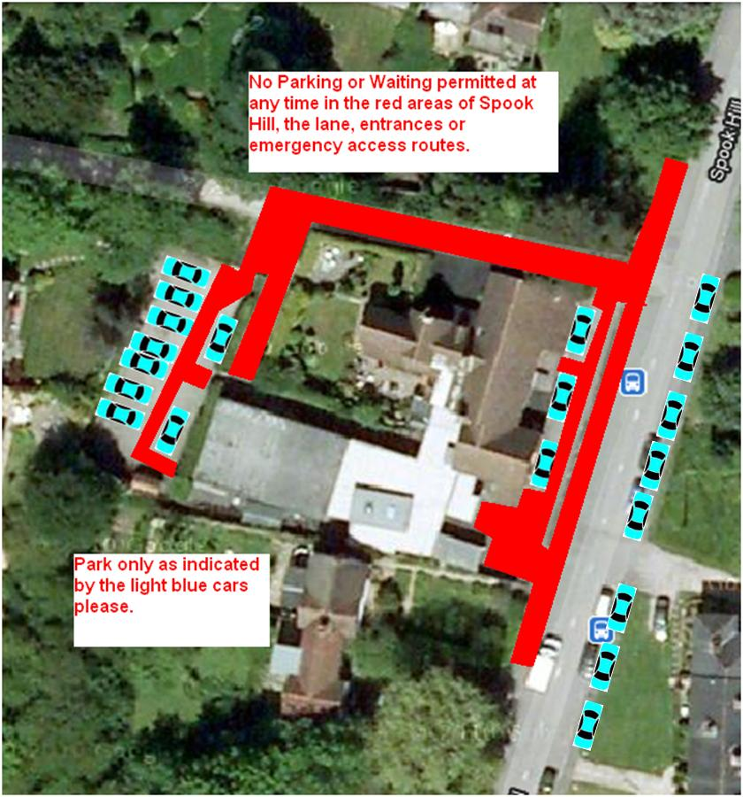

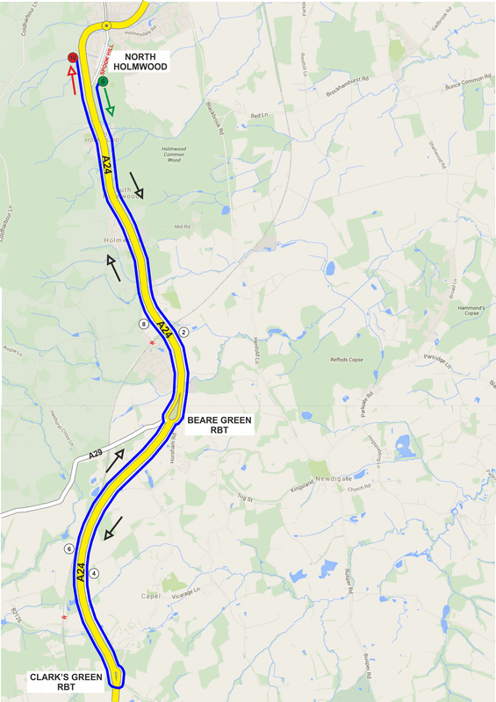
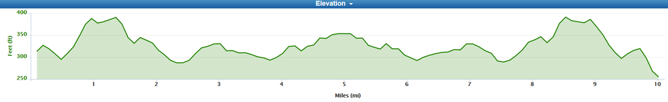

NUMBERS MUST BE FIXED BELOW WAIST

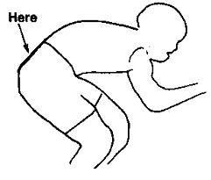

NO TIME MAY BE RECORDED IF NUMBER IS NOT CORRECTLY POSITIONED.

