Presents

The North Downs Hilly 22 Mile Time Trial

Start sheet

Medway Velo Club – Open 22 Mile Hilly Time Trial

To be held on Sunday 22nd July, 2018 starting at 06:30 hrs

On Course QS/7 (Challock- Charing – Challock - Boughton Lees - Chilham - Molash)

Men’s course record: 50:08 Pete Tadros
Women’s course record: 56:04 Louise Mason

Promoted for and on behalf of Cycling Time Trials under their Rules & Regulations

Awards
1st Fastest £30 1st Woman £30 1st Vet £20
2nd Fastest £25 2nd Woman £25 2nd Vet £10
3rd Fastest £20 3rd Woman £20 3rd Vet £5

All awards will be send out to winners in the post after the event.

Event Secretary/Promoter
Steve Smith
76 Prince Charles Avenue, Chatham, KENT, ME5 8EY
Mobile: 07734 651590
Email: stevesmit140177@yahoo.co.uk

Timekeepers/Recorder – Ernie Mackey, Dave Mackey, Vic Williams
Start holder/Marshals/Sign on - Medway Velo Club members & family

Course Details QS/7
Challock- Charing – Challock - Boughton Lees - Chilham - Molash

Start in bus lay-by on a251 approximately 50 metres from Challock rab (halfway house ph)

Proceed to Challock rab and take the first exit to join the A252 towards Charing

Proceed to Charing rab (4.12 miles)
**** Take care on the descent/fast approach to the roundabout ****

Go all the way around the rab – so take the 4th exit to rejoin the A252 to climb Charing hill

Proceed to Challock rab (8.2 miles) and take the 3rd exit onto the A251 to Boughton Lees **** Take care on the sweeping descent ****

At Boughton Lees turn left to kemps corner (11.93 miles).

Turn left at the T-junction to join the A28 to Chilham fork (17.25 miles)
**** Take care – beware of traffic approaching from your right as you turn left at the T-junction ****

Proceed towards Chilham then turn left onto the A252 up Molash hill
**** Take care – beware of traffic approaching from your right as you turn left at the T-junction ****

Proceed towards Challock to finish at the road sign approximately 80 metres short of Challock rab (21.9 miles).

Please take care when turning left at Challock rab (just after starting) and remember when approaching Challock rab each time and when returning to the HQ that other competitors may still be on the course.

Event Headquarters: will be open from 05:30 hrs
Kent Gliding Club
Squids Gate
Challock
Ashford
TN25 4DR

It is approximately 2.6 miles from the HQ to the start.

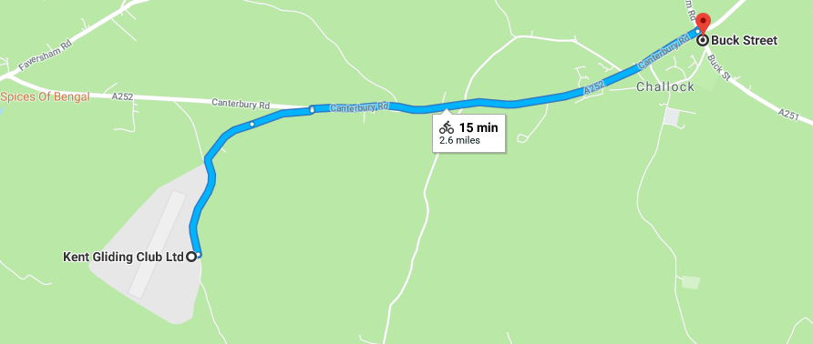

Route to the start – from Squids Gate Lane proceed to the T-junction with the A252. Turn right towards Challock. Proceed to Challock rab taking the third exit. The start is in the bus layby after approximately 50 meters, on the other side of the road – Please no U-turns in the vicinity of the start area.

Notes to riders:
- Start: It is approximately 2 miles from the HQ to the start – please allow enough time for this and be aware that other riders may be racing on the course. Please avoid warming up on the course once the race has started.
- NOTE: there are two fast descents on the course (see course details). PLEASE BE CAREFUL especially if it damp.
- Numbers will be in the event headquarters hall and will be issued to each rider after they have signed on.
- Please remember the new (introduced in 2017) regulation 17(b) requirement to sign off when returning your race number. A rider who fails to sign the official signing out sheet shall be recorded as DNF.
- Riders should refer to Regulation 16 - which states that ‘the number should be centrally positioned below the waist so as to be clearly visible from the rear when in the normal riding position’.
- Numbers may be exchanged for a drink on completion of the ride
- Please keep noise to a minimum to avoid unnecessary disturbance of local residents.
- Please remove racing shoes before entering the hall.
- Do Not perform U turns in the start and finishing areas and do not use these areas as a public toilet. Offenders risk disqualification.
- It is recommended that riders have a working rear light, either flashing or constant, fitted to the machine in a position visible to following road users and is active while the machine is in use, and where possible a front light to enhance safety.

Rider Feedback Forms - Riders should note that these forms are available at the hall by the signing on, and can be used by riders/marshals with comments and suggestions that could significantly improve safety.

All riders under the age of 18 years MUST wear recognised standard protective headgear. In the interests of safety it is recommended that all riders should wear a hard shell helmet that meets an internationally accepted safety standard. Reference to inhalers is no longer required.

Accidents. If a competitor or official is involved in an accident/incident during or in the vicinity of the event, details must be reported as soon as practicable to the Event Secretary who will complete an Accident Report Form. Please assist/cooperate to ensure all required information is captured.

This event is based on the event excellently organised (over many years) by Paul Mepham/VC Elan. The last events results can be found on the Spinwheels website here:

http://spinwheelsresults.org/index.php/open-time-trials-2016/41-results/open-2016/641-vc-elan-hilly-22-mile-time-trial

Thank you for entering our event, I hope you have a safe and fun ride.

Please see the attached flyer for Medway Velo Clubs other open TT events in 2018. A 10 and a 50, both on courses which produce strong fields and fast times.

For any Zwift users out there I've also included information on the SCTT series (including Vets standards based events) Zwift TT events which I co-manage with Steven Melia-Chamberlain.

Ride on!

Steve Smith
Event Secretary

Order of Start
Bib | Start Time | Firstname | Lastname | Club | Gender | Category
1 | 06:31:00 | Neil | Ord | Medway Velo Club | Male | Veteran
2 | 06:32:00 | Craig | Joy | BowlPhish Racing | Male | Senior
3 | 06:33:00 | Tracey | Daniel | Medway Velo Club | Female | Veteran
4 | 06:34:00 | Andrew | Block | Team TFC | Male | Senior
5 | 06:35:00 | Alexander | Cook | Medway Velo Club | Male | Senior
6 | 06:36:00 | Mark | Whittaker | GS Invicta - Eye Level Optical- Herbert Cycles | Male | Veteran
7 | 06:37:00 | Karen | Florey | Medway Velo Club | Female | Veteran
8 | 06:38:00 | Ben | Hilliar | Ashford Road CC | Male | Senior
9 | 06:39:00 | Jacob | Kennison | Medway Velo Club | Male | Senior
10 | 06:40:00 | Neil | Lewis | North Road CC | Male | Veteran
11 | 06:41:00 | Steven | Waite | Medway Velo Club | Male | Veteran
12 | 06:42:00 | Reg | Smith | Gravesend CC | Male | Veteran
13 | 06:43:00 | Kieran | Lawlor | Medway Velo Club | Male | Junior
14 | 06:44:00 | Jill | Cliff | GS Invicta - Eye Level Optical- Herbert Cycles | Female | Veteran
15 | 06:45:00 | Tom | Knight | Medway Velo Club | Male | Veteran
16 | 06:46:00 | Cameron | Kemp | Quick Release Cycling Club | Male | Junior
17 | 06:47:00 | Sally | Smith | Medway Velo Club | Female | Senior
18 | 06:48:00 | David | Greenwood | Rye & District Wheelers CC | Male | Veteran
19 | 06:49:00 | Mark | Amon | Rye & District Wheelers CC | Male | Veteran
20 | 06:50:00 | Daniel | Waite | Medway Velo Club | Male | Veteran
21 | 06:51:00 | Daniel | Gooding | Ashford Road CC | Male | Senior
22 | 06:52:00 | Malcolm | Day | Medway Velo Club | Male | Veteran
23 | 06:53:00 | Danny | Frost | Folkestone Velo Club | Male | Veteran
24 | 06:54:00 | Rob | Kennison | Medway Velo Club | Male | Veteran
25 | 06:55:00 | Sebastian | Dickson | Thanet RC | Male | Senior
26 | 06:56:00 | Phillip | Knell | Ashford Road CC | Male | Senior
27 | 06:57:00 | Keith | Walker | Wigmore CC | Male | Veteran
28 | 06:58:00 | Neil | Harrigan | Gravesend CC | Male | Veteran
29 | 06:59:00 | Emma | Lewis | The Independent Pedaler | Female | Senior
30 | 07:00:00 | Nicholas | Fennell | Thanet RC | Male | Senior
31 | 07:01:00 | Paul | Smith | VeloRefined.com Aerosmiths | Male | Veteran
32 | 07:02:00 | John | Osborn | Folkestone Velo Club | Male | Veteran
33 | 07:03:00 | Pete | Elms | VeloRefined.com Aerosmiths | Male | Veteran
34 | 07:04:00 | John | Cockrill | Abellio - SFA Racing Team | Male | Senior
35 | 07:05:00 | Christopher | Fennell | The Independent Pedaler | Male | Senior
36 | 07:06:00 | Paul | Daniel | Medway Velo Club | Male | Veteran
37 | 07:07:00 | Tom | Rowing | Abellio - SFA Racing Team | Male | Espoir
38 | 07:08:00 | Antony | Bee | Wigmore CC | Male | Veteran
39 | 07:09:00 | Andrew | Meilak | VeloRefined.com Aerosmiths | Male | Veteran

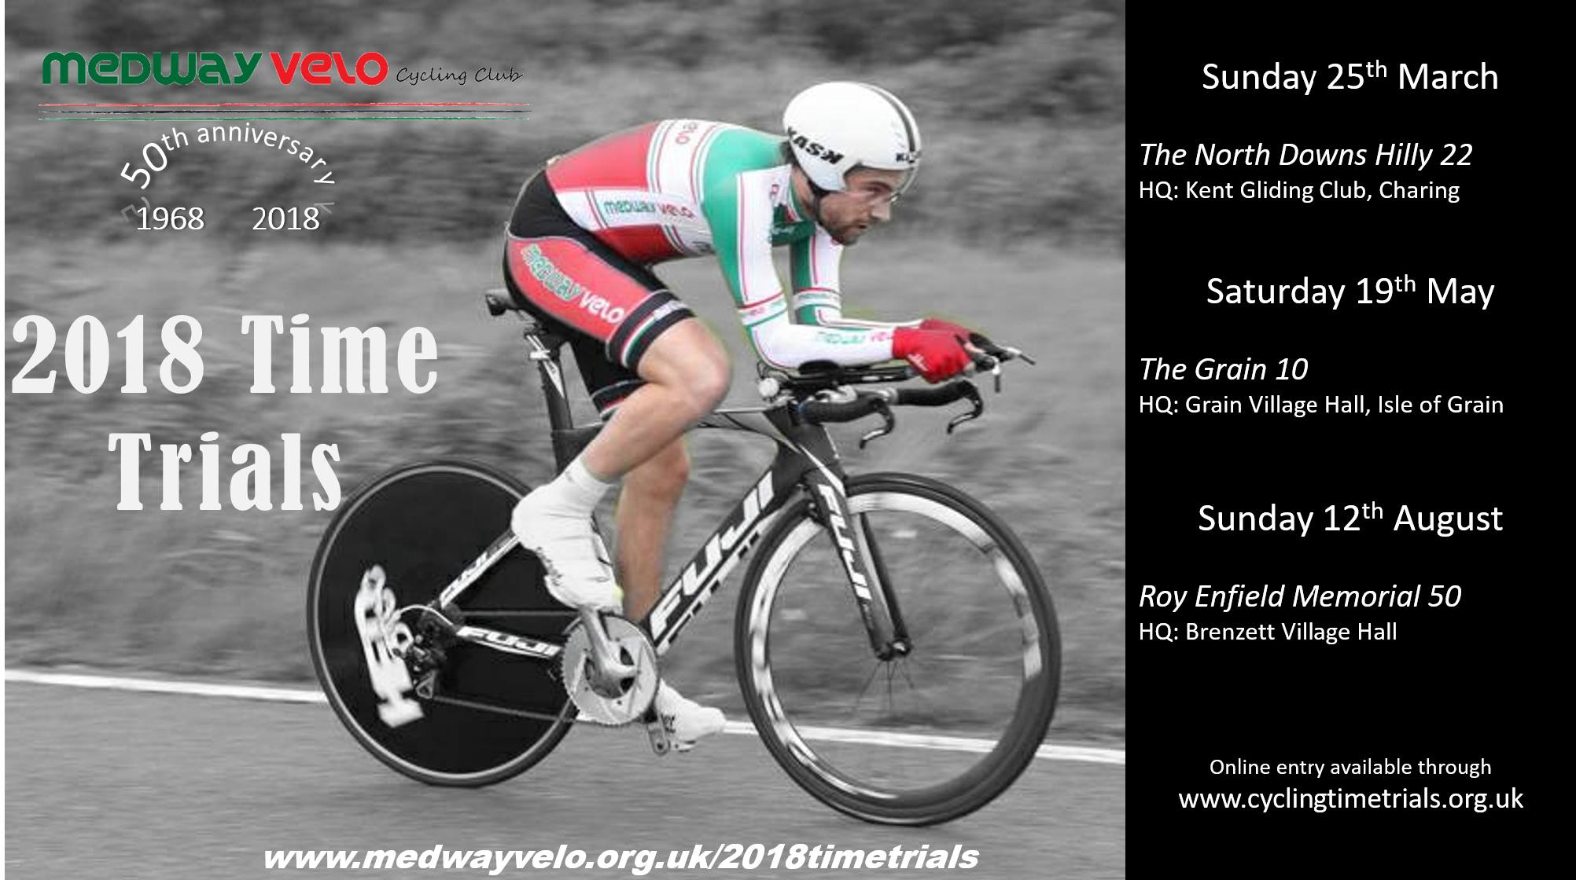
The Sporting Course Time Trial series and Veteran Standard League on Zwift, run in association with BRT (Bolt Race Team) are a series designed to challenge the best all-round time-trial testers. Facebook group: https://www.facebook.com/groups/SCTTonZ/ Website: https://www.brteam.co.uk/sctt

