Law Wheelers Cycling Club

OPEN 25 MILE TIME TRIAL (INCORPORATING SVTTA Ben Smith Trophy) Sunday 1st of July, 2018.

Event HQ:

HQ for the race is Cambusbarron Village Hall, St. Ninians Road. Cambusbarron. STIRLING. FK7 9NU.

Parking:

There is a small car park at the centre. Some limited on-street parking on St Ninians Road and some side streets available but please park considerately.

Please DO NOT park in the housing estate behind the hall.

Please DO NOT park in the lay-by at Touch Road junction (approximately 1.6 miles onto the course from the start)

Sign on: Hall should be open from 07:00 hours and sign on should start shortly after this once we are set up.

Start:

The start is on the A811 immediately to the west of the Kersebonny Road end, Cambusbarron. It is one mile from the event HQ.

The start is accessed from Cambusbarron village by turning right from the HQ entrance, proceeding into the village, turning right down Mill Brae after about a quarter of a mile and left onto Mill Road, which leads to Kersebonny Road. The route to the start is downhill.

Please wait at the foot of Kersebonny Road before being called to the start area.

DO NOT enter the course before your start time.

Start area at the junction with Kersebonny Road.

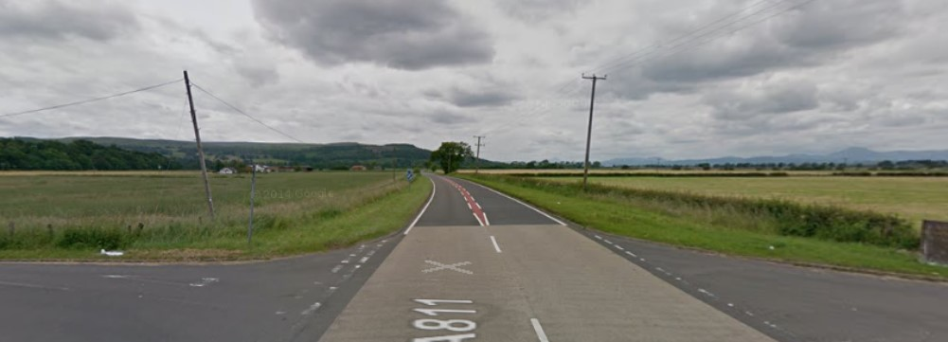

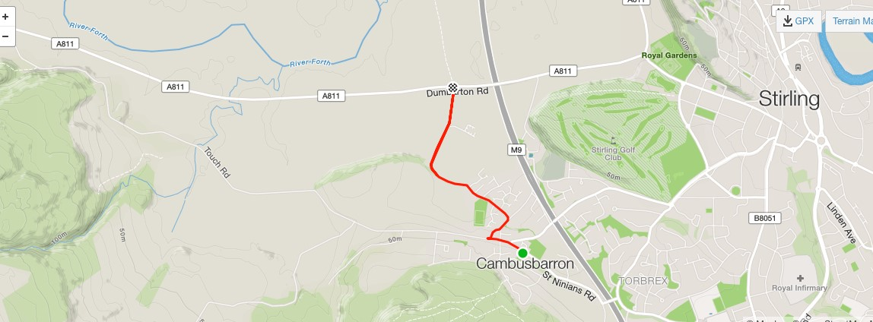

The course:

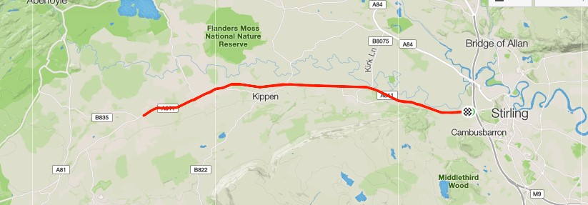

The course is an out and back along the A811. From the start it heads west through the Kippen roundabout. There will be Marshals at this point. They are not allowed to stop traffic so riders must adhere to highway code when negotiating the roundabout. You will traverse this roundabout on the way back also.

On the next stretch to the turn at the entrance to Buchlyvie riders will encounter some incline until they pass through Arnprior. Marshals will be present at the turn which is immediately before the island at the entrance to Buchlyvie. As this is a “dead turn” you will need to watch your speed and be aware of traffic both behind you and approaching from Buchlyvie itself. You must give way if necessary and, again, Marshals cannot stop traffic. Be careful of the road surface in this area.

The approach to the turn:

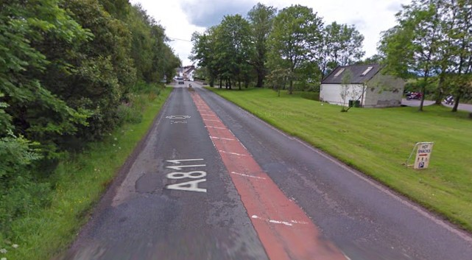

The Finish area.

The finish is on the A811 approximately 400m short of the original start. In the photograph it is just at the large oak tree visible on the left.

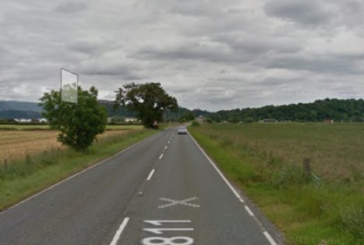

Once finished there will be catering available at the at the HQ. We hope you have an enjoyable and safe ride. If you have any feedback after the event that you feel would be useful for us in organising the event in future, please get in touch.

(robertclements55@gmail.com tel 07722013855)

The SVTTA are running 1 event in tandem with the Law Wheelers CC. For interest,here is some history on the Ben Smith Trophy.

Ben was initiated into cycling by his father prior to his serving in the Italian Campaign in world war two. Shortly after demob Ben took up cycling once more and during the year 1954, and on reaching the age of 42, rode his first SVTTA event. This was the start of an illustrious career in that, he held 11 British Records and during 1966 was second in the British VTTA B.A.R., and along with John Park won the Team Award. Unfortunately, this was Ben’s last year of quality cycling, as during the early part of 1967 he was struck from behind by a car and sustained severe head injuries as well as body. After a prolonged confinement he strived hard to get back to his love of cycling after which, and with the aid of several of his friends, he took part in his first event with one friend steadying him on the start line and other to assist him at the turn. Unfortunately, after several years the rigours of his injuries caught up with Ben.

Start sheet for Law Wheelers 25TT. Sunday 1st July, 2018.

Bib | Start Time | Firstname | Lastname | Club
1 | 08:01:00 | George | Adam | SVTTA
2 | 08:02:00 | Angela | Dixon | Dunfermline CC
3 | 08:03:00 | james | smith | Glasgow Nightingale CC
4 | 08:04:00 | Gary | Longhurst | Stirling Bike Club
5 | 08:05:00 | sean | quinn | Law Wheelers
6 | 08:06:00 | Alan | Jardine | VC Glasgow South
7 | 08:07:00 | William | McMillan | Glasgow United CC
8 | 08:08:00 | John | Russell | Law Wheelers
9 | 08:09:00 | Stephen | Makin | Falkirk B C
10 | 08:10:00 | Mark | Skilling | Carrick CC
11 | 08:11:00 | Angus | Swanson | Stirling Bike Club
12 | 08:12:00 | John | McCrory | Glasgow United CC
13 | 08:13:00 | alex | mcphee | Dooleys RT
14 | 08:14:00 | Isobel | Fletcher | VC Glasgow South
15 | 08:15:00 | Ian | Dobbie | West Lothian Clarion
16 | 08:16:00 | Alan | McAulay | St Christopher's CC
17 | 08:17:00 | Findlay | Watt | Dunfermline CC
18 | 08:18:00 | Stephen | Dickson | Falkirk B C
19 | 08:19:00 | George | Skinner | Royal Albert CC
20 | 08:20:00 | Neil | Pendrich | SVTTA
21 | 08:21:00 | Christina | Mackenzie | Stirling Bike Club
22 | 08:22:00 | Graham | Jones | Edinburgh Road Club
23 | 08:23:00 | Alan | Macintyre | Coatbridge Clarion CC
24 | 08:24:00 | Thomas | McNeish | Royal Albert CC
25 | 08:25:00 | Jamie | Kennedy | GTR - Return To Life
26 | 08:26:00 | Charles | Adams | VC Glasgow South
27 | 08:27:00 | Jim | Sutherland | Loudoun Road Club
28 | 08:28:00 | Daniel | Kirk | Ronde Cycling Club
29 | 08:29:00 | Richard | McCulloch | West Lothian Clarion
30 | 08:30:00 | Lewis | Duff | GTR - Return To Life
31 | 08:31:00 | Iain | Drummond | West Lothian Clarion
32 | 08:32:00 | Allen | Watson | Perth United CC
33 | 08:33:00 | Frederick | Connor | VC Glasgow South
34 | 08:34:00 | alexander | munro | SVTTA
35 | 08:35:00 | derek | mcmillan | SVTTA
36 | 08:36:00 | John | Gormlie | Coatbridge Clarion CC
37 | 08:37:00 | Dougal | Allan | Edinburgh Road Club
38 | 08:38:00 | Steven | Horne | Airdrie cycle club
39 | 08:39:00 | Neil | Lawson | Musselburgh RCC
40 | 08:40:00 | Jimmy | Storrar | Velocity 44
41 | 08:41:00 | Catherine | Logan | Fullarton Wheelers
42 | 08:42:00 | Derek | Skinner | Fullarton Wheelers
43 | 08:43:00 | Robert | Brown | EH Star Cycling
44 | 08:44:00 | Daniel | Ewing | Aberdeen Wheelers
45 | 08:45:00 | Frank | anderson | SVTTA
46 | 08:46:00 | Alan | Thomson | Johnstone Wheelers
47 | 08:47:00 | Allan | Duncan | Fullarton Wheelers
48 | 08:48:00 | Stevie | Watters | Fullarton Wheelers
49 | 08:49:00 | Chris | ONeill | Glasgow Nightingale CC
50 | 08:50:00 | Arthur | Doyle | GTR - Return To Life
51 | 08:51:00 | Frazer | Bell | Fullarton Wheelers
52 | 08:52:00 | Brian | Nicol | Velo Club Vitesse
53 | 08:53:00 | Martin | Shields | Fullarton Wheelers
54 | 08:54:00 | Darren | Ridout | Walkers Cycling Club
55 | 08:55:00 | Gordon | Graham | Fullarton Wheelers
56 | 08:56:00 | James | Snodgrass | Johnstone Wheelers
57 | 08:57:00 | hugh | wardrope | Arria Wheelers Cycling Club
58 | 08:58:00 | Richard | MacPherson | Glasgow United CC
59 | 08:59:00 | Mike | Ferguson | Johnstone Wheelers
60 | 09:00:00 | James | Cusick | Dooleys RT
61 | 09:01:00 | laura | nicolson | Dooleys RT
62 | 09:02:00 | Ian | King | Velocity 44
63 | 09:03:00 | Richard | Thurlow-Begg | Glasgow United CC
64 | 09:04:00 | Ruairidh | Brown | St Christopher's CC
65 | 09:05:00 | Gordon | Murdoch | GTR - Return To Life
66 | 09:06:00 | Andrew | Stewart | Dunfermline CC
67 | 09:07:00 | neil | anderson | Deeside Thistle CC
68 | 09:08:00 | john | leonard | Velopreda
69 | 09:09:00 | Nico | Anelli | Bioracer-Project GO
70 | 09:10:00 | Ross | Thomson | Dunfermline CC
71 | 09:11:00 | Alasdair | Macmillan | Musselburgh RCC
72 | 09:12:00 | Calum | MacDonald | Ayr Roads CC
73 | 09:13:00 | Martin | Kane | SVTTA
74 | 09:14:00 | Esther | Hamill | Dumfries CC
75 | 09:15:00 | Graham | Smith | Law Wheelers
76 | 09:16:00 | George | Donnelly | Johnstone Wheelers
77 | 09:17:00 | Jim | Petrie | Dundee Wheelers CC
78 | 09:18:00 | james | truswell | Fruin Road Club
79 | 09:19:00 | Hector | Nicolson | Moray Firth CC
80 | 09:20:00 | Douglas | Watson | GTR - Return To Life
81 | 09:21:00 | JAMES | MUIR | SVTTA
82 | 09:22:00 | Cameron | Scade | Dumfries CC
83 | 09:23:00 | Owen | Ross | Carrick CC
84 | 09:24:00 | Kevin | Smith | Moray Firth CC
85 | 09:25:00 | David | Griffiths | Bioracer-Project GO
86 | 09:26:00 | David | Fulton | Carrick CC

