
Manchester and District
Ladies’ Cycling Association

30th June 2018

Ladies Open Handicapped and Men’s Invitation

10 mile Time Trial

Promoted for and on behalf of Cycling Time Trials under their Rules & Regulations.
Handicapped using standard tables.

Event Organiser: K. Jackson, 7 Burford Crescent, Wilmslow, Cheshire, SK9 6BL. 01625 537401
Timekeepers: Mr M Jackson & Mrs J Green First rider off at 2:01 pm
Headquarters: Cranage Village Hall on the A50 Post code CW4 8EQ, Grid Ref SJ753685 On A50 ¾ miles north of Holmes Chapel & ¾ miles south of Twemlow Lane. Open from 12:45
Please travel to the HQ via the A50, please do not try to come through Goostrey village, it is their Rose Festival and roads will be closed. Please take care when cycling to the start and back from the finish, when turning right off the A50, it is a very busy and fast road.

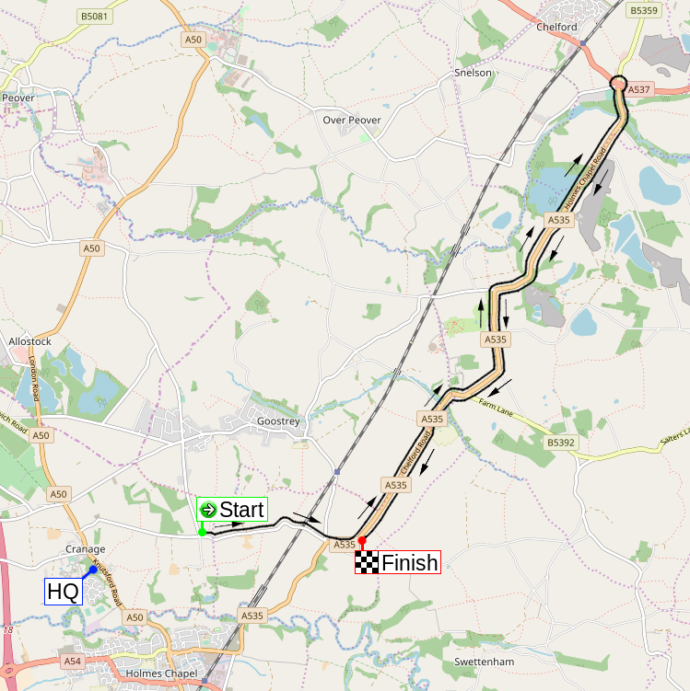
Course: J2/3 10 miles
START In Twemlow Lane at a "JS4" mark just east of Hermitage Lane in line with the hedge on Hermitage Lane.. Proceed eastwards to the A535 at
TWEMLOW GREEN 1.047 miles, left along the A535 to:
CHELFORD ISLAND 5.661 miles, encircle the island and retrace along the A535 to:
FINISH 10.000 miles at a “JF4” mark by the far post of the last field gate on the left of A535 at Twemlow Green before the Yellow Broom Restaurant

Prizes
Ladies |  |  |  |  | Men |  |  | Combined
1st | £20.00 | 1st handicap | £15.00 |  | 1st | £20.00 |  | 1st | £15.00 each
2nd | £15.00 | 2nd handicap | £12.00 |  | 2nd | £15.00 |  | 2nd | £12.00 each
3rd | £10.00 | 3rd handicap | £10.00 |  | 3rd | £10.00 |  | 3rd | £10.00 each

Fastest team of two Ladies: £10.00 each
Fastest team of two Men: £10.00 each

Certificate to be awarded to fastest M&DLCA Vet
on standard, fastest Junior girl and fastest Juvenile girl at Annual Dinner.

One rider one prize, except Combination and Team.

Numbers will be at the headquarters. Please return numbers to the headquarters, where there will be the results board and refreshments. Please note that each rider must SIGN-ON when collecting their number, and SIGN-OFF when returning it. Failure to do so will result in that rider being classified as DNF.

Warnings:
Warming Up: Riders must not warm up past the start and finish areas.
Care at road junctions: Riders must exercise caution at all junctions. Any competitor whose riding line causes her/him to cross the white line when approaching or leaving a junction will be liable to disqualification from the event and may be reported to the District Committee for further disciplinary action.
U turns: Any rider making a U turn in the vicinity of the start or finish will be disqualified. Observers will be used in this event.
Chelford Island: Riders must negotiate Chelford Island in a safe and sensible manner in accordance with CTT Reg.20 and the rules of the road. Riders must be able to brake and stop at the island if traffic conditions require this. Riders MUST NOT approach and encircle the island using tri-bars. Remember – traffic on the island has priority over traffic (including riders) entering it. Any rider seen to be in breach of this regulation will be disqualified from the event and may be reported for further disciplinary action.
IN THE INTERESTS OF YOUR OWN SAFETY Cycling Time Trials and the event promoters strongly advise you to wear a HARD SHELL HELMET that meets an internationally accepted safety standard.

Ladies

Num | Name | Cat | Club | H/Cap | Std | Start
1 | Jill Fielding |  | North Cheshire Clarion | 7:48 |  | 2:01
2 | Jeanette Barber | V | Seamons CC | 9:14 | 29:51 | 2:02
3 | Gillian Doolan | V | Stockport Tri Club(2017) | 11:25 | 28:53 | 2:03
4 | Jo Coombes | V | Evolve |  | 28:53 | 2:04
5 | Jayne Dickens | V | Vision Racing /Delamere Dairy/GRM Property Consultants/Swinnerton Cycles | 5:26 | 28:48 | 2:05
6 | Alisa Healy |  | The Racing Chance Foundation | 7:15 |  | 2:06
7 | Michelle Fairclough | V | Salford Cycling Club | 8:34 | 28:13 | 2:07
8 | Alexa Dawson | V | Cheshire Maverick Cycle Club |  | 28:19 | 2:08
9 | Carol Robson | V | Weaver Valley CC |  | 28:58 | 2:09
10 | Anna Weaver |  | NJC-Biemme-Echelon | 4:42 |  | 2:10
11 | Sarah Grant |  | Vision Racing /Delamere Dairy/GRM Property Consultants/Swinnerton Cycles | 6:02 |  | 2:11
12 | Rhianna Parkinson |  | Salford Cycling Club | 7:58 |  | 2:12
13 | Lynsey Astles | V | Weaver Valley CC | 10:53 | 28:13 | 2:13
14 | Jo Podolanski | V | Stockport Tri Club(2017) |  | 28:43 | 2:14
15 | Keri Parton |  | Stone Wheelers CC | 4:43 |  | 2:15
16 | Emily Martin |  | Weaver Valley CC | 7:10 |  | 2:16
17 | Janet Grint | V | Stockport Tri Club(2017) | 8:49 | 28:13 | 2:17
18 | Charlotte Wellsbury | V | Evolve | 15:24 | 28:48 | 2:18
19 | Christine Dewsbury | V | Stockport Tri Club(2017) |  | 28:19 | 2:19
20 | Deborah Moss | V | Team Merlin | 4:19 | 28:43 | 2:20
21 | Claire Harrison | V | Vision Racing /Delamere Dairy/GRM Property Consultants/Swinnerton Cycles | 5:53 | 28:24 | 2:21
22 | Anna Docherty | Jun | Liv CC Halo Cycles | 7:06 |  | 2:22
23 | Eleanor Turton |  | Seamons CC | 9:02 |  | 2:23
24 | Sian Segar | V | Stockport Tri Club(2017) |  | 29:03 | 2:24

M&DLCA
Each year, the M&DLCA awards several prizes and trophies to members of the M&DLCA and affiliated clubs, which are presented at our annual dinner dance in November. Any event on a 25 or 50 mile J course counts for these trophies, as long as copies of the results sheet and entry form are sent to the M&DLCA BAR secretary (Katherine Jackson), but the only counting 10 mile events are those organised by the M&DLCA. The onus is on the rider to submit, where required, copies of the entry form and results sheet to the M&DLCA BAR secretary before 1st October of the current season.

Visit our website at http://www.mdlca.org.uk for the latest news, results and photos
The Annual M&DLCA Dinner Dance and Prize Presentation will be held at the Alma Lodge, Stockport on Friday November 16th 2018. Certificates are presented at the Dinner.
For the latest news, results and photos please visit our website on http://www.mdlca.org.uk
We also have a Facebook page for photos and posts.

Men

Num | Name | Club | Invited by | Start
30 | Stephen Turner | Westmead Team 88 | Christine Dewsbury | 2:30
31 | Christian Fox | Manchester Wheelers | Charlotte Wellsbury | 2:31
32 | William Howarth | East Lancashire RC | Janet Grint | 2:32
33 | Paul Barber | Seamons CC | Jeanette Barber | 2:33
34 | George Coombes | Evolve | Jo Coombes | 2:34
35 | Simon Phillips | Stockport Tri Club(2017) | Gillian Doolan | 2:35
36 | Mark Fielding | North Cheshire Clarion | Jill Fielding | 2:36
37 | Gavin Lynch | Glossop Kinder Velo Cycling Club | Anna Weaver | 2:37
38 | Barry Armstrong | Seamons CC | Eleanor Turton | 2:38
39 | Damian Ellis | Leek Cyclists' Club | Deborah Moss | 2:39
40 | Tony Haley | Vision Racing | Sarah Grant | 2:40
41 | Robbie Harcourt | Salford Cycling Club | Rhianna Parkinson | 2:41
42 | Ian Roberts | The Racing Chance Foundation | Alisa Healy | 2:42
43 | Lachlan Hacker | North Cheshire Clarion | Anna Docherty | 2:43
44 | Julian Ainsworth | Salford Cycling Club | Michelle Fairclough | 2:44
45 | Simon Watson | Buxton CC/Sett Valley Cycles | Jo Podolanski | 2:45
46 | Martin Wiggan | Seamons CC | Lynsey Astles | 2:46
47 | Paul Connor | Weaver Valley CC | Emily Martin | 2:47
48 | Tony Perrin | Stone Wheelers CC | Keri Parton | 2:48
49 | Martin Ince | Salford Cycling Club | M&DLCA | 2:49
50 | Colin Lynch | Manchester Wheelers | Sian Segar | 2:50
51 | Matt Hacker | North Cheshire Clarion | Alexa Dawson | 2:51
52 | Mark Fenton | Stone Wheelers CC | Jayne Dickens | 2:52
53 | Andy Robinson | Vision Racing | Claire Harrison | 2:53
54 | Dan Robson | Weaver Valley CC | Carol Robson | 2:54

Sponsored Clubs: Vision Racing - Delamere Dairy/GRM Property Consultants/Swinnerton

