Founded 1928
Pomoted on behalf of Cycling Time Trials under their rules and regulations
Sunday 8TH July 2018
Mens &Ladies National 100 mile Time Trial - L10010
N.L.T.T.A Championship 2018
Start Sheet
Event Secretary: Nigel Clementson: 80 Shevington Moor, Standish, Wigan. WN60SE. 07862289430.
Time Keepers: Richard Taylor, Tracey Moore, Richard Abram, Keith Bickley
Pusher off: Colin Baldwin
Cheif Marshall: Jamie Carson
CTT: Obsereves will be on the course
Headquarters: Braithwaite Institute, Keswick CA12 5RY. (On the A66) It is perfectly located on the course.
There will be a HQ sign indicating the entrance to the car park.
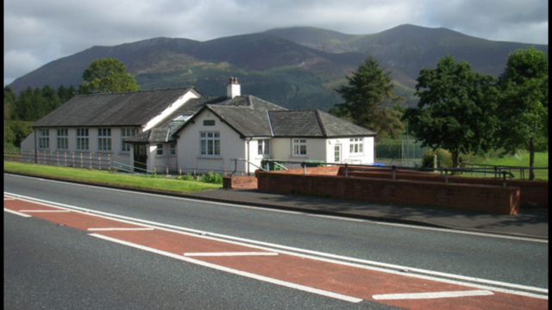
HQ opens from 6am.
Results will be displayed at the HQ.
There will be a prize presentation after the last rider as finished aprox 13-00
Please allow 10 minutes to ride to the start. From the HQ out of the gate and turn left onto the A66 for approx. 1 mile.
There is a large car park at HQ which holds 70 vehicles.
There will be a feed station which will be situated in the lay by on the west carriage of the A66.Each rider will pass this a total of 3 times at aprox 22m, 47m and 72m anyone wishing to use this facility please bring your own bottles and mark then accordingly. Please hand them in when you sign on.
CTT Regulation 17: Signing-on & signing-out sheet
a) The competitors in all types of events must make themselves aware of any special instructions for the event and sign the official signing on sheet when collecting their number.
b) In type A events a competitor must return to the HQ either during the event or within a reasonable time after the last rider has finished the event and must (i) return their number and (ii) sign the official signing out sheet.
First rider off 7:01am
Course L10010
Start at the eastern side of the junction of the old road with the northern side of the A66, 0.36 miles east of Braithwaite Village Hall. Proceed in an easterly direction along A66 to encircle the RAB at the junction of A591/A66 Keswick/Bothel road (1.95 miles). Retrace along A66 in a westerly direction to encircle the RAB at the junction with the A5086 near Cockermouth (14.80 miles). Proceed in an easterly direction through the start point to the RAB near Keswick (27.65 miles) and retrace to the Cockermouth RAB (40.50 miles). Retrace through start to Keswick RAB (53.35 mls) and on to Cockermouth RAB (66..20 mls). Retrace through start to Keswick RAB (79.05 mls) and on to Cockermouth RAB (91.90 mls). On this occasion retrace along A66 to FINISH at the entrance to Hursthole Point which is directly opposite a footpath with wooden stairway from car park on south west side of the A66 (100 miles) Riders must continue along A66 to HQ (clearway).
Remember to keep count as its 4 laps (almost)
Also please be aware when completing your first lap a rider may be just about to start, I would not like any incidents at this point many thanks.
If you intend to feed a rider on the course, you MUST complete a riders support vehicle form and hand it in upon signing on.
Riders support vehicle form can be found on the CTT web site under forms (Strangely).

PRIZES:
Fastest Gentleman: 1st£100 2nd£60 3rd£50 4th£40 5th£30 6th£20
Fastest Lady: 1st£80 2nd£40 3rd£30 4th£20
Team of 3: Mixed or men £20 each
(One rider one prize apart from team prize)
Association members only:
To the fastest man who can break Richard Bideau course record set in 2017- 3:29:40 will receive £100 from the NLTTA.
To the fastest lady who breaks the NLTTA record which stands at 4:19:00 from 2007 set by 4:19:00
Current ladies course record 4:07:40 2017 Steph Mottram

The following Local Regulations have been approved by the National Committee in accordance with
Regulation 38. Any breaches may lead to disciplinary action being taken.
Local Reg No. 5 In all events, competitors prior to starting are not permitted to ride past the finishing timekeeper during the duration of the event.
Local Reg No.6 Any competitors making a U turn in the vicinity of the start or finish will be disqualified from the event.
Local Reg No.9 No parking on the A66 except in a designated layby.
Local Reg No.15 Riders must keep to the left hand side of the road except when overtaking. Failure to comply with the above may lead to disqualification. Riders must give their number at the finish and elsewhere on the course where requested.
Riders MUST NOT STAND in the road at the start or finish. (This constitutes obstruction and is a breach of regulations.)
Riders must NOT ride with their heads down.
Rider Safety Helmets:
All competitors under the age of 18 and/or juniors must wear a HELMET of HARD/SOFT SHELL construction that conforms to a recognised Standard (See Regulation 15). Cycling Time Trials strongly recommends ALL competitors to wear such a helmet.
Competitor Machines - Lights:
CTT recommends that a working rear light, either flashing or constant, is fitted to the machine in a position clearly visible to following road users and is active whilst the machine is in use.
This event may be subject to a Doping Control
It is your responsibility to check As soon as you have finished you should return to the event HQ as it is your responsibility to check if you are required for Doping Control Race numbers required for Doping Control will be displayed at the HQ adjacent to the result board If your number is displayed you should report immediately to Doping Control which will be nearby Remember, it is up to you to check and ensure that you comply If required you must report to Doping Control after finishing without delay
Free cup of tea when you SIGN OFF. REFRESHEMENTS available.
Big THANK YOU to today’s sponsors Truline of Wigan
Big THANK YOU to ALL the marshals. It’s a long day out there. Thank you to the admin/kitchen helpers too.
Have a great day and a safe ride. Remember to keep your HEAD UP and all the best from the NLTTA.
Organiser on the day: Nigel - Mobile: 07862 289430

