Fareham Wheelers CC
25 Mile TT 17 June 2018

Course: P884/25

(Promoted for and on behalf of Cycling Time Trials under their Rules and Regulations)
Sign-on from 06:00 First Rider: 07:00
Prizes

1st Overall | £40.00 |  | 1st Vet on std | £40.00
2nd Overall | £20.00 |  | 2nd Vet on std | £20.00
3rd Overall | £10.00 |  | 3rd Vet on std | £10.00
1st Woman | £40.00 |  | 4th Vet on std | £5.00
2nd Woman | £20.00 |  | 5th Vet on Std | £5.00
3rd Woman | £10.00 |  | 1st U/18 | £20.00
1st Team | £45.00
2nd Team | £30.00
3rd Team | £15.00

Prizes not collected on the day will be deemed to have been donated, unless prior arrangements have been made.
Event Organiser

Roger de Vere, Fosse House Lower Chase Road Swanmore, Southampton, SO32 2PB;
email: deverer2@gmail.com

The Crew

Timekeepers: Roger de Vere and Tim Warner
Pusher-Off and Start Line Stewarding: Jon Dale and Matt Pepper
Recorder: Phill Morris
Sign On and Results: Diana Stevens, Sarah Mackley and Mike Stevens
Catering: FWCC Helpers

Headquarters and Parking

Greatham Village Hall Petersfield Road, Greatham, Liss GU33 6EY

The Course and Route to Start

Route From HQ to Start, Description:
From GVH turn left into Petersfield Road continue to the A325 roundabout. Take the 2nd exit onto the A325. Continue to next roundabout just before A3 interchange. Take 2nd exit onto the Longmoor sliproad.

Do not park near the start on the verges, entrance to the ranges, or the depot as this is MOD land, and it is likely that your vehicle will be clamped or Destroyed as well as you being disqualified!

Course Description:
Start on the Hard shoulder on the southbound slip road to the A3 at Longmoor (A325) three metres from the start of the Armco barrier. Proceed onto the slip road and on to the southbound A3 towards Petersfield'
At Ham Barn Roundabout (1.6m) take the second exit towards Petersfield, passing the exit for West Liss at 3.2m, the Midhurst exit (A272) and the Winchester (A272) and take the Buriton exit at 8.1miles.
Follow slip road and take first exit on roundabout (8.04 miles) to rejoin A3 north. Keep left here and take care to rejoin A3 towards London Guildford. Continue along A3 passing exit for Winchester (A272) the Midhurst exit (A272) and the exit for West Liss, to Ham Barn Roundabout (15.1 miles).
Approaching Ham Barn Roundabout stay in the middle lane (new), take 2nd Exit and proceed North on A3 passing the exit slip road at Longmoor Interchange (signposted A325 Farnham), Griggs Green. At the third turning (20.1 miles) take the left turn signposted Haslemere/Liphook B2171, taking the left turn up the slip road, over the flyover and next left onto the slip road to rejoin the A3 in a southerly direction (signposted Petersfield/Portsmouth).
Retrace along A3 southbound towards the Ham Barn Roundabout passing the Griggs Green turning (22 miles) and pass the starting area at Longmoor to finish at the entrance on the lay-by approximately 600 yards north of Ham Barn roundabout (25 miles) where the P881 ten course finishes.

Safety Notes:
IN THE INTERESTS OF YOUR OWN SAFETY, Cycling Time Trials and the event promoters strongly advise you to wear a HARD SHELL HELMET that meets an internationally accepted safety standard. It is recommended that a WORKING REAR LIGHT, either flashing or constant, is fitted to the machine in a position visible to following road users and is active while the machine is in use.

Also riders must:
- Not make U turns in the vicinity of the Start or Finish
- Not stop at the Finish but continue to the event Headquarters.

Any rider observed riding in a manner which may jeopardise his or her own safety, the safety of others and the future of the Sport will be disqualified and reported to the South District Council of Cycling Time Trials.
Map
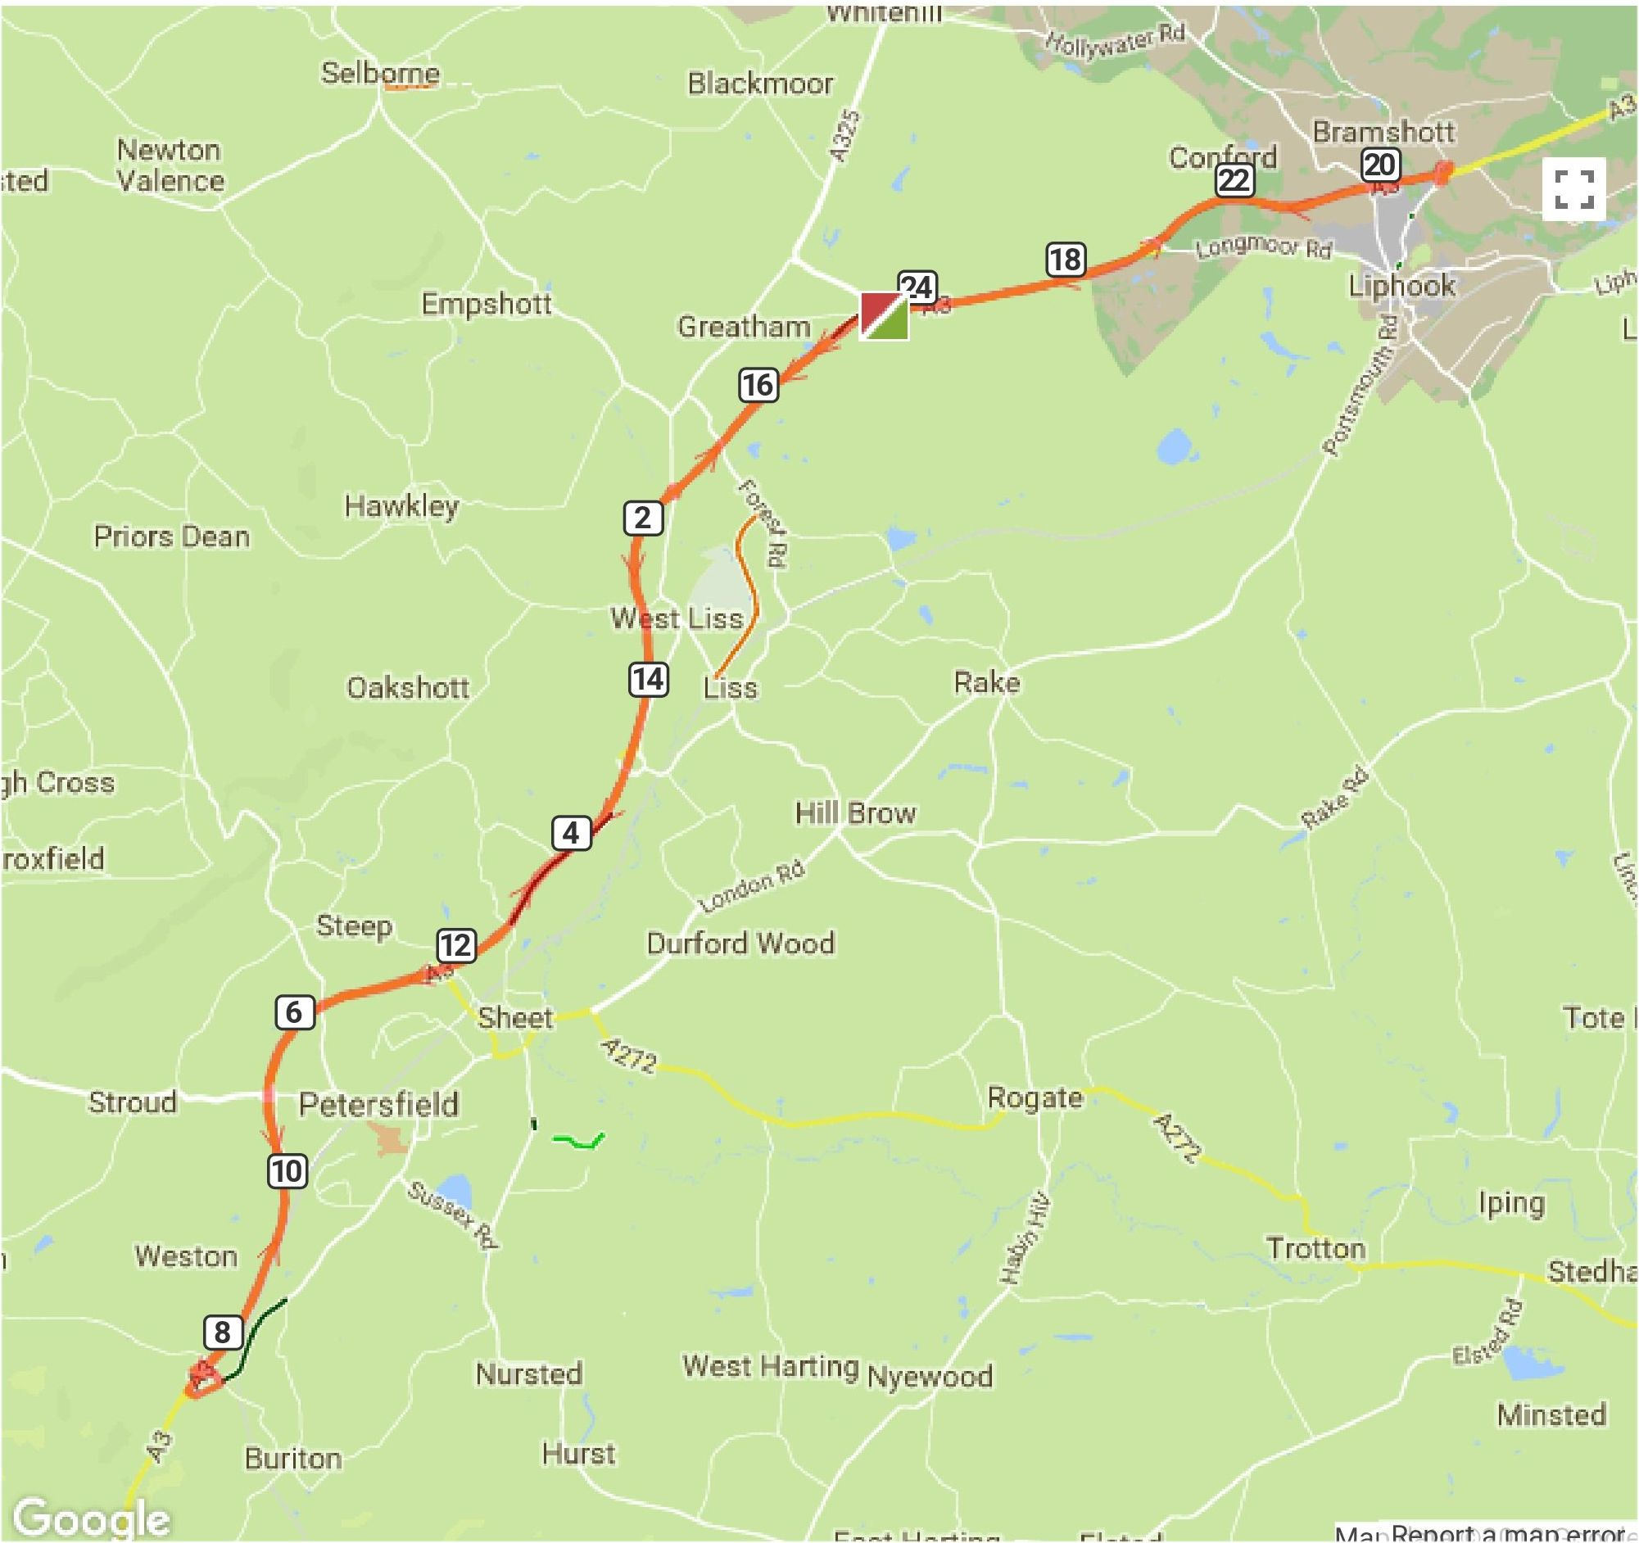

Remember to Sign in & Sign out
Riders who do not sign-out will be deemed DNF.

Start List
No | Start Time | Name | Club/Team | Cat
1 | 07:01 | Michael Stevens | Fareham Wheelers CC | Vet
2 | 07:02 | ken rayson | ...a3crg | Vet
3 | 07:03 | Colin Mooney | Portsdown Hill CC | Vet
4 | 07:04 | Jon Hughes | Velo Club Godalming & Haslemere | Vet
5 | 07:05 | Rob Stephenson | Southborough & Dist. Whs | Vet
6 | 07:06 | Alan Doney | Portsmouth Triathletes | Vet
7 | 07:07 | Iain Duncan | Crawley Wheelers | Vet
8 | 07:08 | Kirsty McSeveney | Fareham Wheelers CC | Sen F
9 | 07:09 | Ben Houston | East Grinstead CC | Vet
10 | 07:10 | Howard Bayley | Blazing Saddles | Vet
11 | 07:11 | Eva Callinan | Hillingdon Slipstreamers | Juv
12 | 07:12 | Pasquale Chionchio | Hillingdon Triathletes | Vet
13 | 07:13 | Evan Jardine-Skinner | Sotonia CC | Vet
14 | 07:14 | Shaun Smart | Southdown Velo | Vet
15 | 07:15 | Matt Kuwertz | Southborough & Dist. Whs | Vet
16 | 07:16 | Paul Beck | Hampshire Road Club | Vet
17 | 07:17 | David French | Weybridge Wheelers | Vet
18 | 07:18 | Robert Charles | Blazing Saddles | Vet
19 | 07:19 | Mike Appleyard | Lancashire RC | Vet
20 | 07:20 | Nick Dwyer | Lewes Wanderers CC | Vet
21 | 07:21 | Lucy Mitchell | Petersfield Triathlon Club | Vet
22 | 07:22 | Philip Clack | Fareham Wheelers CC | Vet
23 | 07:23 | Matthew Butler | Charlotteville Cycling Club | Sen M
24 | 07:24 | Andrew Thomas | ...a3crg | Sen M
25 | 07:25 | Mark Bashford | East Grinstead CC | Sen M
26 | 07:26 | John Isard | Hampshire Road Club | Vet
27 | 07:27 | Paul Greer | Southborough & Dist. Whs | Vet
28 | 07:28 | Katie Crowe | Dulwich Paragon CC | Vet
29 | 07:29 | Neil Mackley | Fareham Wheelers CC | Vet
30 | 07:30 | Paul Jones | Primera-Teamjobs | Vet
31 | 07:31 | Steve Skinner | Bognor Regis CC | Vet
32 | 07:32 | Keith Butler | Bec CC | Vet
33 | 07:33 | Greg Harding | Farnham RC | Vet
34 | 07:34 | Michael Naulls | Velo Club Venta | Vet
35 | 07:35 | James Brickell | Fareham Wheelers CC | Sen M
36 | 07:36 | Colin Harrison | East Grinstead CC | Vet
37 | 07:37 | Perry Lee | Southdown Velo | Vet
38 | 07:38 | Ian Cheesman | Worthing Excelsior CC | Vet
39 | 07:39 | Neil Grunshaw | Kingston Wheelers CC | Sen M
40 | 07:40 | Chris Boddy | Didcot Phoenix CC | Sen M
41 | 07:41 | Shaun Marlor | Bec CC | Vet
42 | 07:42 | Aron Kelly | Southampton Tri Club | Sen M
43 | 07:43 | Barrie Watkinson | Bournemouth Arrow CC | Vet
44 | 07:44 | Paul Haywood | Epsom CC | Vet
45 | 07:45 | Dan Sadler | RT 316 | Vet
46 | 07:46 | Terry Belbin | Poole Whs | Vet
47 | 07:47 | Derrick Thirlwell | Kingston Wheelers CC | Vet
48 | 07:48 | Robert Gilmour | Hounslow & District Whs | Vet
49 | 07:49 | David Dalton | Fareham Wheelers CC | Vet
50 | 07:50 | Jeremy Archer | RT 316 | Vet
51 | 07:51 | David Twin | Sydenham Whs | Vet
52 | 07:52 | Andrew R Green | Bec CC | Vet
53 | 07:53 | Sam Day | CS Grupetto | Vet
54 | 07:54 | Nick andrews | Portsmouth North End CC | Vet
55 | 07:55 | Mark Newton | Elite Cycling | Vet
56 | 07:56 | Marianne Holt | Team Bottrill / Vanguard | Sen F
57 | 07:57 | pete wilson | Bournemouth Arrow CC | Vet
58 | 07:58 | Darryl Barr | ...a3crg | Vet
59 | 07:59 | stuart stow | Twickenham CC | Vet
60 | 08:00 | Gary Chambers | NOPINZ | Sen M
61 | 08:01 | JOHN FROUD | Festival Road Club | Vet
62 | 08:02 | Thomas Goodyer | Portsmouth North End CC | Sen M
63 | 08:03 | Rob Jump | Southampton Tri Club | Sen M
64 | 08:04 | Peter Younghusband | Petersfield Triathlon Club | Vet
65 | 08:05 | mark stafford | Portsmouth North End CC | Vet
66 | 08:06 | Deborah Smith | Southdown Velo | Vet
67 | 08:07 | David Bagge | Southborough & Dist. Whs | Vet
68 | 08:08 | stuart peckham | New Forest CC | Vet
69 | 08:09 | paul byford | Crawley Wheelers | Vet
70 | 08:10 | James Rix | Team Bottrill / Vanguard | Vet
71 | 08:11 | david pothecary | Southdown Velo | Vet
72 | 08:12 | Martin Beale | Velo Club St Raphael | Vet
73 | 08:13 | Julie Chasin | Twickenham CC | Vet
74 | 08:14 | David Rumm | Southborough & Dist. Whs | Vet
75 | 08:15 | Matt Peel | C and N Cycles RT | Sen M
76 | 08:16 | Simon Craig-McFeely | ...a3crg | Vet
77 | 08:17 | Martin Booker | Worthing Excelsior CC | Vet
78 | 08:18 | Paul Morris | Fareham Wheelers CC | Sen M
79 | 08:19 | Richard Weatherstone | C and N Cycles RT | Vet
80 | 08:20 | Liam Maybank | Twickenham CC | Vet
81 | 08:21 | Arthur Waghorn | Bognor Regis CC | Vet
82 | 08:22 | david rich | Fareham Wheelers CC | Vet
83 | 08:23 | Caitlin Peters | i-Team Cyclists Club | Jun
84 | 08:24 | Simon Berogna | Velo Club St Raphael | Vet
85 | 08:25 | Thomas Whatley | Paceline RT | Sen M
86 | 08:26 | Dave Dent | GS Stella | Vet
87 | 08:27 | Chris Jolliffe | Crawley Wheelers | Vet
88 | 08:28 | James Fawcett | Hampshire Road Club | Vet
89 | 08:29 | Ant Gritton | Sotonia CC | Sen M
90 | 08:30 | Chris Bartley | AS Test Team | Sen M
91 | 08:31 | James Ayton | Portsmouth North End CC | Vet

