Team Milton Keynes F5c/20 Open 20 Mile Time Trial
London Millennium Series (Round 8 of 8)
Sunday 27 May 2018
Promoted for and on behalf of Cycling Time Trials under its rules and regulations

Event Secretary: Mrs Linda Dewhurst, opentt@teammk.com, 07866 718356
Event Headquarters: Cranfield Sports Hall, College Road, Cranfield. MK43 0AL
The event HQ will be open from 13:00
Remember to sign back in when finished, as per CTT Regulation 17(b). We must vacate the Hall by 1800h. No parking allowed anywhere on the course.
Timekeepers – Mike Bannister & Tony Farmborough
Course details F5c/20 – (2 laps of the course F5c/10)
Start Point: Start by The Old Swan PH carpark in Astwood Village
0.11Miles Turn left to proceed west on the A244. Give Way.
3.58 Miles Turn left onto unclassified road signposted to N. Crawley
5.47 Miles Turn left at T-junction
7.36 Miles Turn left into unclassified road signposted Astwood
10 Miles Astwood village
10.3 Miles Turn left at T-junction (unclassified road) in Astwood village.
Proceed past start and repeat for second lap
20 Miles Finish Astwood Village at top of hill.

Course F5c/20 – (2 laps of the course F5c/10)
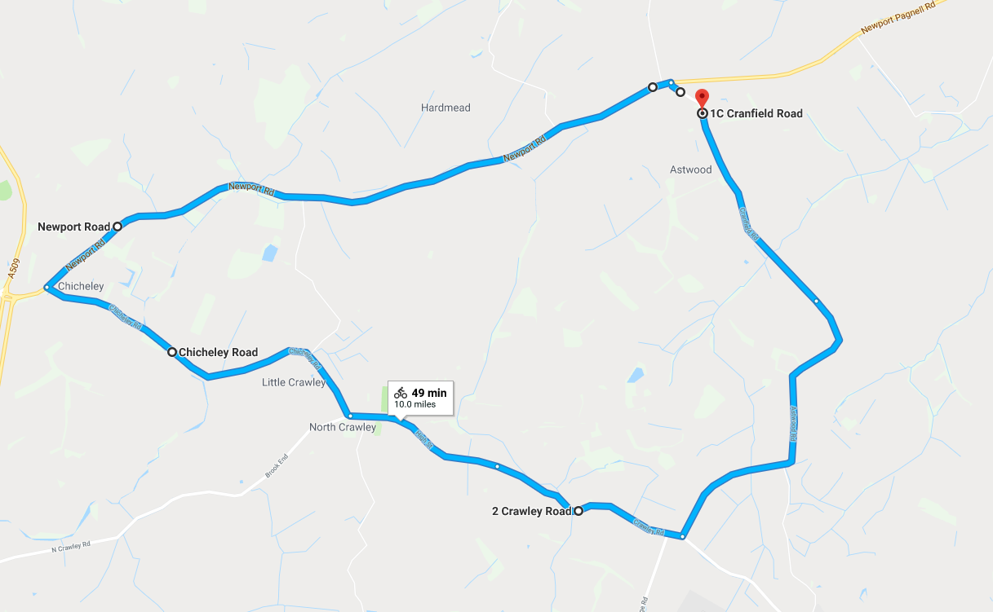

IMPORTANT SAFETY NOTICE - In the interests of your own safety, Cycling Time Trials and the event promoter strongly advise you to wear a hard-shell Helmet that meets an internationally accepted standard. In accordance with Regulation 15 ALL JUNIOR competitors must wear Protective Hard Shell Helmets. It is recommended that a working rear light either flashing or constant, is fitted to the machine in a position visible to following road users and is active whilst the machine is in use. Prizes - one rider, one prize rule.
Prizes – 1st £20 3 seniors, 1st 3 vets, 1st 3 ladies.

HQ To the Start:
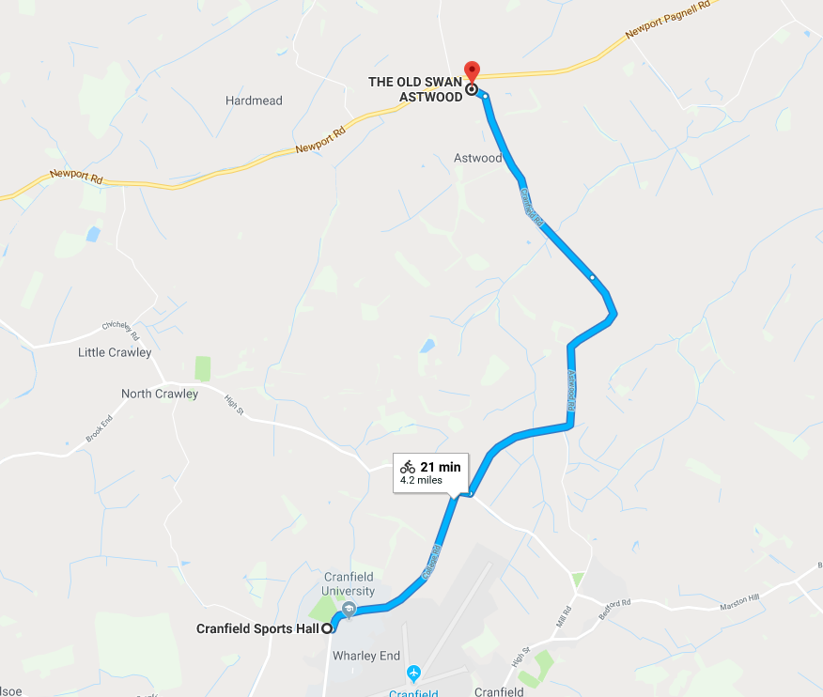

Finish To HQ:
