Bynea CC Open 25TT on R25/4 - 27th May 2018
W.E. Wheeler Memorial 25.
Promoted for and on behalf of Cycling Time Trials under their rules and regulations.
Event Headquarters: Llandovery RFC, Church Bank, Llandovery SA20 0BA.
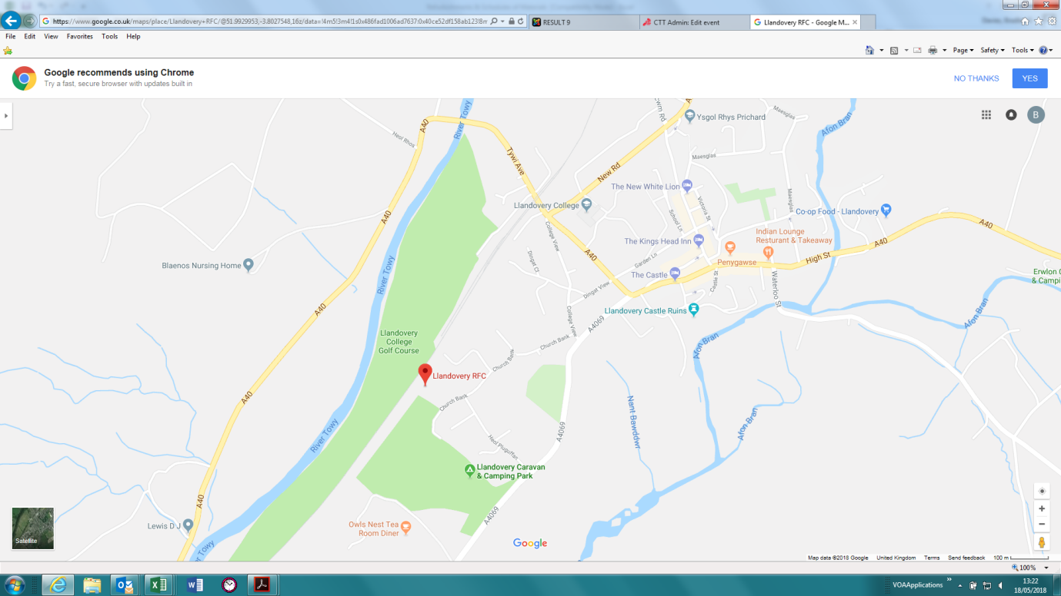

Event HQ will open from 08:00. Ample parking at HQ for all competitors
Sign on and collect numbers at HQ.
Please return numbers to HQ and remember to sign back in after event.
Numbers can be exchanged for a drink at the refreshments counter
Event Organiser: Brad Davies
Timekeepers: Andrew Grist & Tudor Thomas
Refreshments: Alan Owen

Please Note:
There is no parking at the start line, so all competitors are encouraged to ride from event HQ to the start, which is approximately 3 miles.
Please allow ample time to arrive for your start time slot.

Course: r25/4 - description
OS references: sheet 160 start 732311 finish 753334
Start on a4069 at northern edge of field gate on left approximately 3 miles south of Llandovery. Proceed north on a4069 to junction with a40 at Llandovery (3.028 miles). Bear left on a40 over railway crossing, continue on a40 via Llanwrda by-pass (7.197 miles). Continue to Llangadog roundabout (9.50 miles), taking 2nd exit to continue along A40 towards Llandeilo. Pass Rhosmaen village sign (13.897 miles) onto roundabout one mile east of Llandeilo (14.73 miles). Circle roundabout and retrace along A40, to Llangadog roundabout (19.90 miles), taking 1st exit, continuing on A40 to Llanwrda by-pass (22.343 miles). Continue on a40 to finish at telephone pole 12 opposite farm track and 15 yards west of post box in lay-by approximately a mile and a half west of Llandovery town.
https://www.strava.com/segments/14959540

Prizes:
1st Overall: £25
2nd Overall: £20
3rd Overall: £15

1st Lady: £25

1st Veteran on standard: £20
2nd Veteran on standard: £15

Fastest Team of 3 riders: £30

One rider, one prize, except team award

Bynea CC would like to thank all riders for supporting this event and we hope you enjoy riding a traditional single-carriageway course in beautiful Carmarthenshire.

Brad Davies
Event Organiser, Bynea CC

