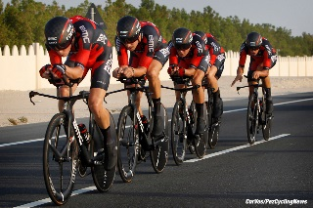

Scottish CTT District Team Time Trial Championship 2018

Sponsored by
Promoted for and on behalf of Cycling Time Trials and their regulations
Saturday 12th May 2018, 1st Team off at 10:01 hours
HQ: At Ballachulish Local Community Centre
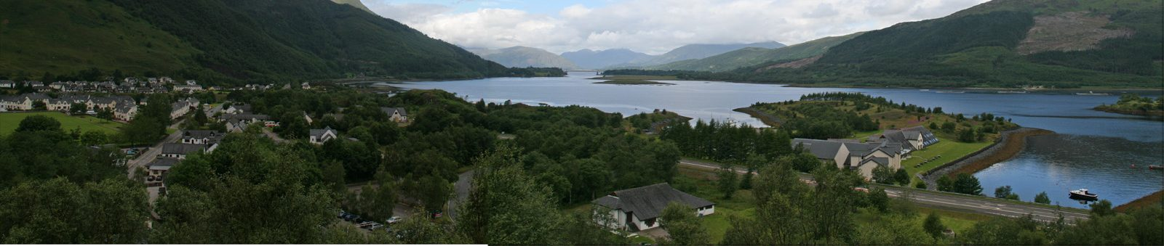
Loan Fern, Ballachulish PH49 4JB

http://balla-hall.co.uk/about-the-hall/
Open at 08:00 am for registration. Printed copies of the start sheet will be available for collection, along with race numbers. There are toilet facilities and tea, coffee and snacks will be available.

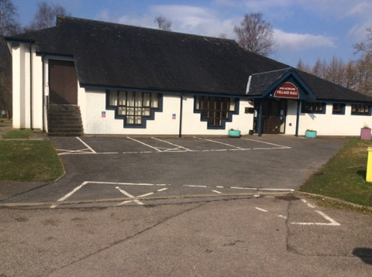
There will be Car parking spaces available, (A82) ‘Sea Xplorer OR Isles of Glencoe Hotel + Leisure Centre.
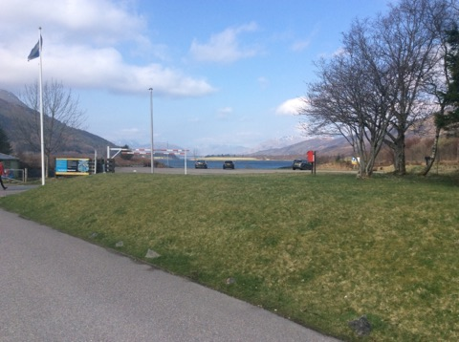

## DO NOT PARK NEAR VILLAGE HALL OR NEAR BY COOPERATIVE CAR PARK##

Organiser: Stevie Blom, 18 Queen St Flat 2/3, Paisley, Renfrewshire, PA1 2TU. Tel: 0141 0141 389 0738. Email: stephenblom@hotmail.com. Mobile number for use on the day: 07423666960 (note that reception will be patchy, so text messages are likely best on the day)
Timekeepers: Jon Entwistle (Start) Jon Entwistle (Finish)
Marshals: Co-ordinator on the day George Skinner along with friends and locals from Lochaber District.
Course: 38 Miles Route
Men and Male Espoirs, Woman, Juniors, Veterans are to complete 38mile Course.
Web link of the Course Map: -
https://www.cyclingtimetrials.org.uk/race-details/16560
Course Description
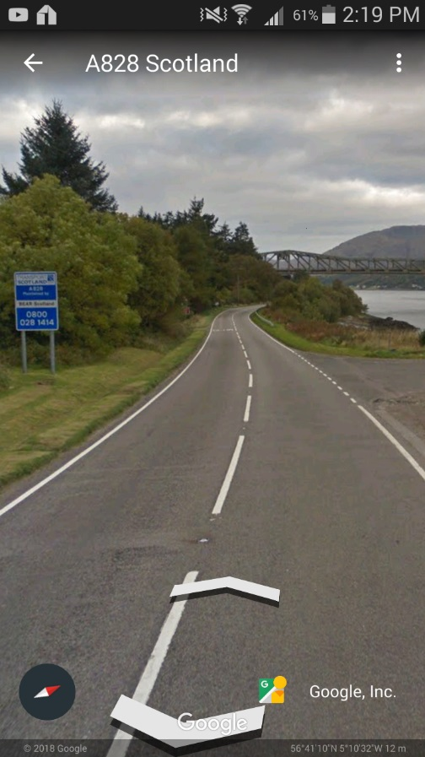
Start on A828,
Next to Blue &
White Transport
Scotland sign post.

(Direction Oban)

Proceed West bound on A828 Heading Direction Oban for 19 miles, turn at the Creagan Roundabout and retrace back to Finish line which is adjacent the Start. Complete Distance 38 Miles.
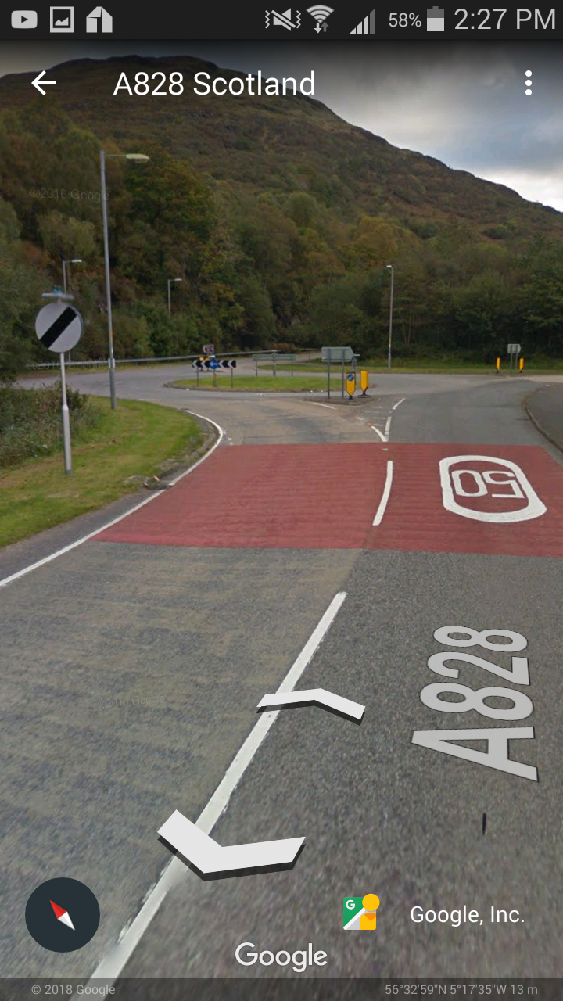

TURN

It’s a Straight forward out and back with only 1 roundabout at the main Turn, There are small junctions off the A828 left and Right hand-sides heading into small on route villages.
Over head shot of the Main Turn Below, please take care and be careful, look out for each other.
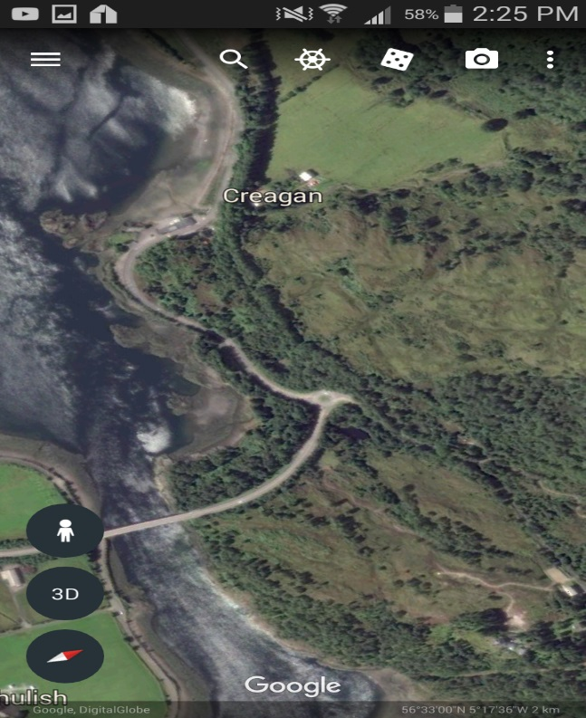

Cautions Going out
1, Please familiarise yourself with this course as this has never been used before.
2, Road is in good condition but After village of Duror there are 3/4 rough patches for 50 yards.
3, Stalker Brae (Descent on main climb) Please take care as roads turn onto a bend which is off camber heading to the Turn.

Cautions on Return leg
1, Potholes are in following areas: -
A, 30 yards after Turn
B, Just by Creagan Village inn
C, Just after Appin Holidays holmes Low drain cover
D, On Appin Straights 3 Pot Holes
E, Just before Appin sign, rough patch for 15 yards
F, At start of Hill down into Kintallon, 1 BAD POTHOLE

Notes: -
1, Please ensure you allow yourself at least 15 minutes to get to the start line
2, Please use the grass verge at Start line for your own safety
3, Course will be well Marshalled, sign posted
4, We may not have enough helpers on the day for any pushers off so expect to Start this event without any
5, Please look out for each other and do a course recce before hand
6, Spotters and neutral observers will be on the course
7, Please ensure your bike is in working order
8, We will not have any mechanical station at the HQ
9, Please stay for the Presentation if you can

Sponsors

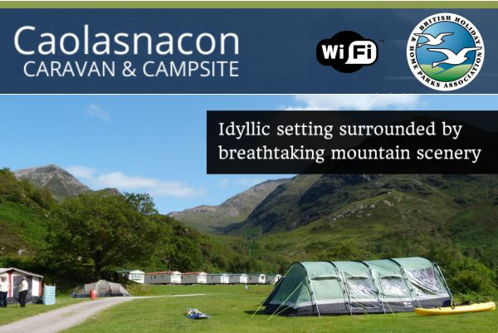

Presentation and Prizes

Fastest Female Team and 1st Team
1, £60.00 Cash
2, Presented with medals

Fastest Male Team
Special prize donated by Hands Gas
1, £150.00
2, Trophy

1st Scottish Male Team
1, £80.00 Cash
2, Presented with medals

2nd Scottish male team
1, £60.00 Cash
2, Presented with medals

3rd Scottish male team
1, £40.00 Cash
2, Presented with medals

4th Scottish Male Team
1, £30.00 Cash

Thank you
From everyone at GTR/Return to life we would like to thank you for entering our event.

