Riders information Pack
Round 4 of 6 Knight Composites Classic TT Series

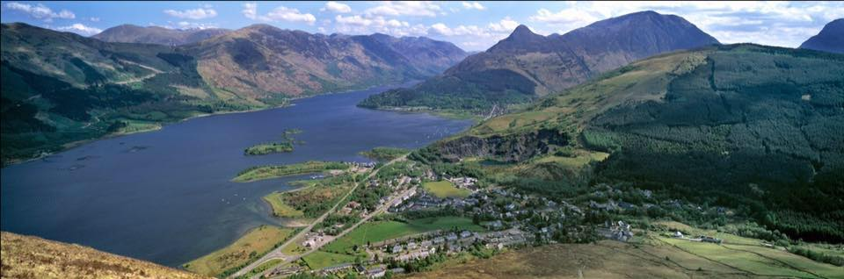
Incorporating the Jason Macintyre Memorial Event 2018

10 Year Anniversary

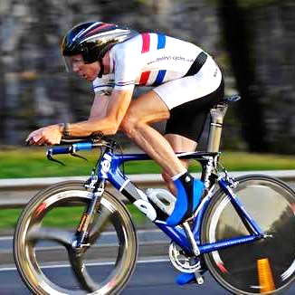

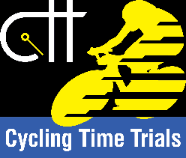

Promoted for and on behalf of Cycling Time Trials and under their regulations
Sunday 13th May 2018, 1st Rider off at 09:01 hours
HQ: At Ballachulish Local Community Centre
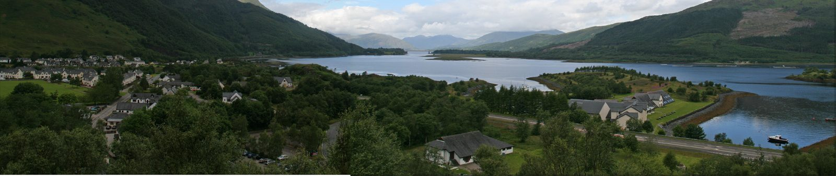
Loan Fern, Ballachulish PH49 4JB
Figure 1
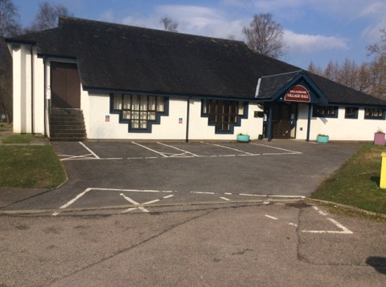

http://balla-hall.co.uk/about-the-hall/
Open at 08:00 am for registration. Printed copies of the start sheet will be available for collection, along with race numbers. There are toilet facilities and tea, coffee and snacks will be available
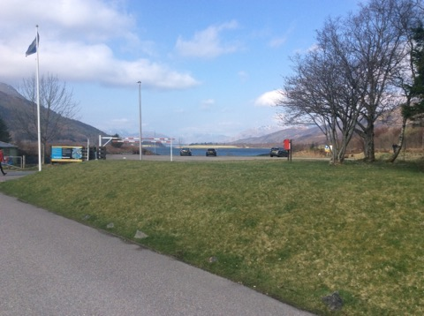
There will be Car parking spaces available, (A82) ‘Sea Xplorer OR Isles of Glencoe Hotel + Leisure Centre.

## DO NOT PARK NEAR VILLAGE HALL OR NEAR BY COOPERATIVE CAR PARK##

Organiser: Stevie Blom, 18 Queen St Flat 2/3, Paisley, Renfrewshire, PA1 2TU. Tel: 0141 0141 389 0738. Email: stephenblom@hotmail.com. Mobile number for use on the day: 07423666960 (note that reception will be patchy, so text messages are likely best on the day)
Timekeepers: Jon Entwistle (Start) Willie Cosh (Finish)
Marshals: Co-ordinator on the day George Skinner along with friends and locals from Lochaber District.
Course: 17.8 Miles Sporting Route
Men and Male Espoirs, Woman, Juniors, Veterans are to complete 17.8mile Course.

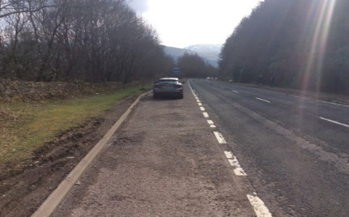
Course Description

Start line is on the A82, 0.5 Miles South of the Ballachulish Bridge Roundabout, Adjacent to a Lay by adjacent to Blue and White Transport Scotland Sign Post.
Coordinates: 56 Degrees 40 North,5 Degrees 09 West,30 Feet Altitude
Proceed South for approximately 2.2 Miles and Turn Left onto B863 Heading Kinlochleven.
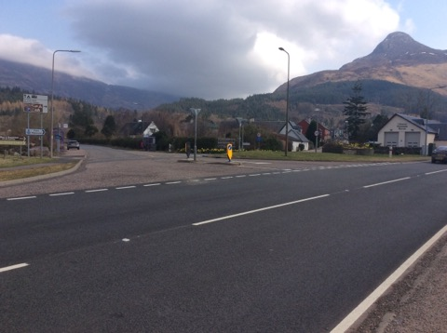Left Hand Turn onto B863

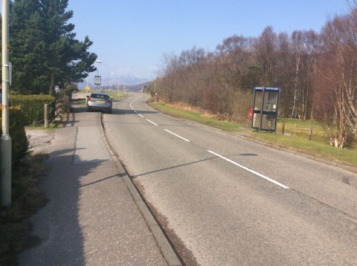Finish line at phone box
Please follow the B863 for the remaining distance of the race until you reach the Finish line at 17.8 Miles.
You will be racing 1x anti clock wise loop of Loch Leven, The Finish line is at the 20mph Sign Post 150 yards from where the B863 Terminates, NORTH BALLACHULISH.
Course Map can be found on the following CTT Link: -
https://www.cyclingtimetrials.org.uk/race-details/16539

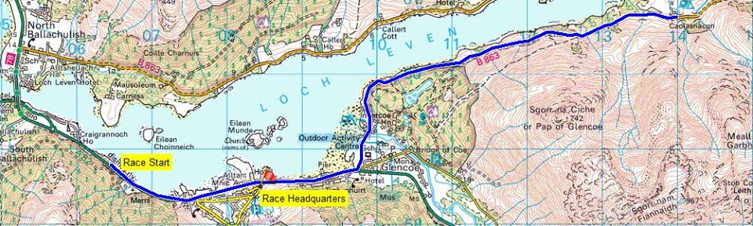
Part 1 of the Course

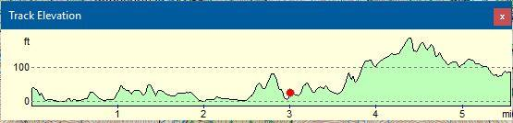

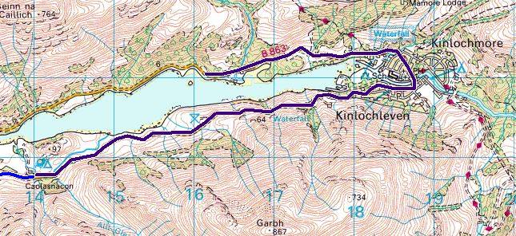
Part 2 of the Course

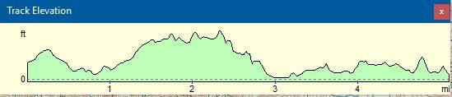

Warnings/Caution
Distance from HQ to Start line is approximately 1.3 Miles, please allow 10 minutes at least to make your Start time.
Lay by at Start is in excellent condition to allow for ample riders queuing and Race Staff.
The course is Flat, Hilly and very Fast in sections.
When you turn left onto the B863 you will immediately see a 1 Road, 2-way bridge. (INVERCOE BRIDGE)

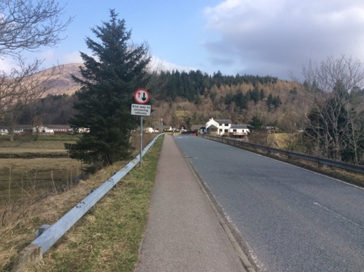
YOU have the right of way and it will be Marshalled accordingly.
Please be aware of Blind Summits + Adverse Camber sections, We, advise you Ride the course before hand to familiarise yourself.
Scenery is Stunning so please be careful and DO NOT FALL /CRASH INTO THE LOCH, The Monster may, Eat you.
You will descend into Kinlochleven Village, Please, take note that this will be a very fast descent and you will need to ride over a Zebra Pedestrian Crossing.
This Pedestrian Crossing in the Village Centre will be Marshalled with Red Flags. The Marshals will do their best to stop Pedestrians from crossing but please be vigilant always.

Please remember this is a Hilly time trial, so bring some low gears, good tyres and brakes, and take care on the descents. Please ensure your bike is in working order. Please avoid parking on the course, particularly on the Lay by at the Start. Do not congregate at the finish. Times will be available at the HQ.

Regulations
Riders must exercise caution at all junctions. Any competitor who crosses the white line when approaching or leaving a junction will be liable to disqualification from the event and may be reported to the District Committee for further disciplinary action. No "U" turns in the vicinity of the start and finish. Observers will be watching. Head up and observe local regulations at all times. Pace must not be given or received, and the onus is on the caught riders to adhere to this rule

Mechanical Station
We will not have a mechanical station, We not be able to provide any tools to assist any repair work required. Please ensure your bike is in working order.
Riding back from Finish Line to HQ

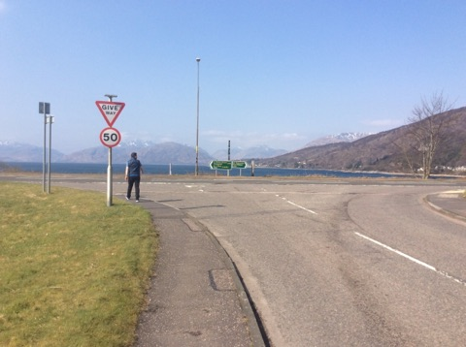Junction ,turn left back to A82
This is important, When, you finish Turn Left back onto the A82 North Ballachulish, Proceed Over the Ballachulish Bridge.
Once you come out of the Bridge please turn left at the Roundabout, BUT YOU MUST JOIN THE ADJACENT BIKE PATH! Marshal will point you in right direction
This is to avoid any riders crossing the Start line again causing any interference/confusion.

The Bike Path Runs Parallel to the A82 and Will take you back to the Race HQ.

Prize Presentation
If you can, please stay for the prize presentation, which takes place as soon possible after the finish at the HQ.
Mark Atkinson, Carolyne Macintyre Will be part of the Prize Giving.
Media
Local Media will be there on the day to cover the event and prize Giving.
Lochaber local paper Oban times Will cover the Story and aim to put in an article on the Internet this week Coming and a Race Report Week After the Event.
CTT Media will be there as well as Cycling Weekly
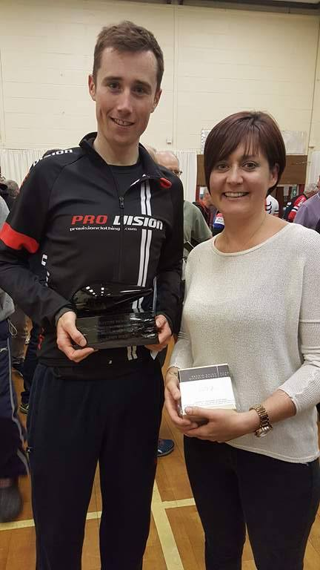Last years Winner and course Record Holder, John Archibald with Carolyne Macintyre.
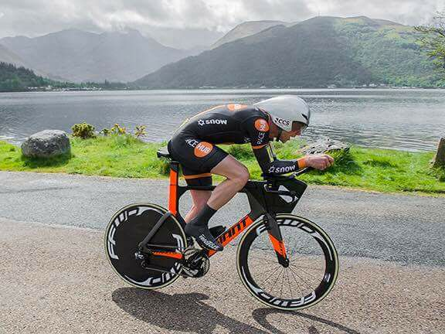Peter Nicholls, 2017

Event Sponsorship
We have been fortunate to have received sponsorship from the following companies: -
Dooleys Cycles, Paisley

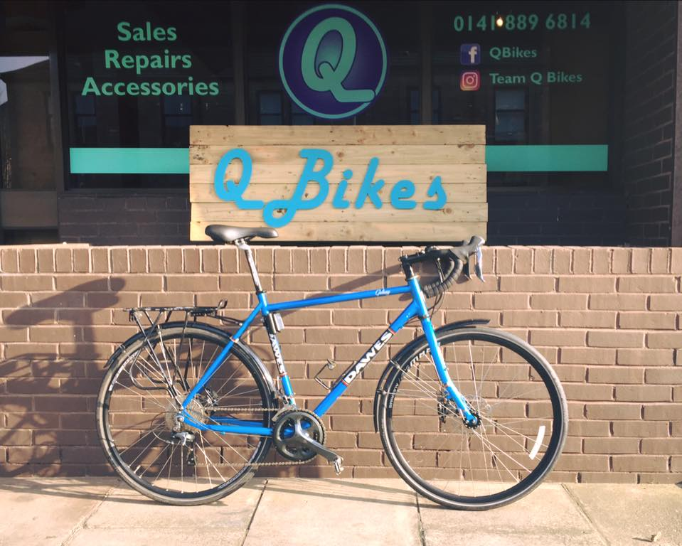

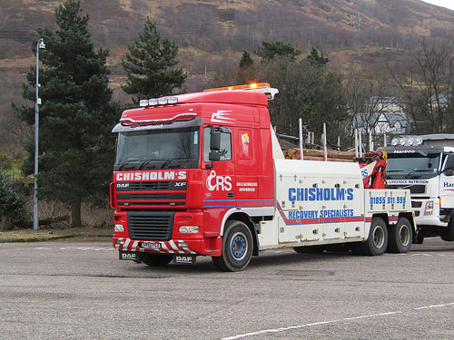
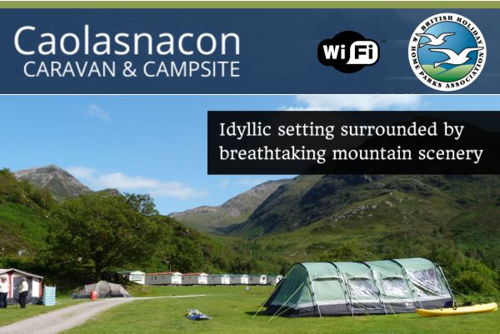

Prize List

1st Local
Dooleys Voucher £10.00 + Trophy

1st Men’s event
- £25 Cycling Time Trials Cheque
-£15.00 Cash
- Dooleys Voucher £50.00
-Wining Race Jersey
-Jason Macintyre Trophy
-Fastest Male Trophy
2nd Men’s event
-£15.00 Cycling Time Trials Cheque
-£10.00 Cash
-£20.00 Dooleys Voucher

3rd Men’s event
-£10 Cycling Time Trials Cheque
-£5.00 Cash
-£10.00 Dooleys Voucher

1st Veteran (Scratch)
-£25 Cycling Time Trials Cheque

2nd Veteran (Scratch)
-£15 Cycling Time Trials Cheque

3rd Veteran (Scratch)
-£10 Cycling Time Trials Cheque

1st Vet Target
-£25.00 Cycling Time Trial Cheque
2nd Vet Target
-£15.00 Cycling Time Trials Cheque
3rd Vet Target
-£10.00 Cycling Time Trials Cheque

1st Over 60
-£15.00 Cash
1st Over 50
-£15.00 Cash
1st Over 40
-£15.00 Cash

1st Female
-£25.00 Cycling time trials cheque
-£10.00 Cash
-£50.00 Dooleys Voucher
-Q Bikes Trophy
2nd Female
-£15.00 Cycling time trials cheque
-£10.00 Cash
3rd Female
-£10.00 Cycling time trials cheque
-£10.00 Cash

1st Para cyclist
-£25.00 Cycling time trials trophy
-£10.00 Aldis Voucher
-Trophy

1st Junior event
-£25 Cycling Time Trials Cheque
-£10.00 Aldi Voucher
- Trophy
2nd Junior event
-£15 Cycling Time Trials Cheque
-£10.00 Aldi Voucher

Trophies to take home
1 x Fastest Para Cyclist
1 x Fastest Female
1 x Fastest Local
1 x Fastest Junior
1 x Fastest Male
Other Prizes
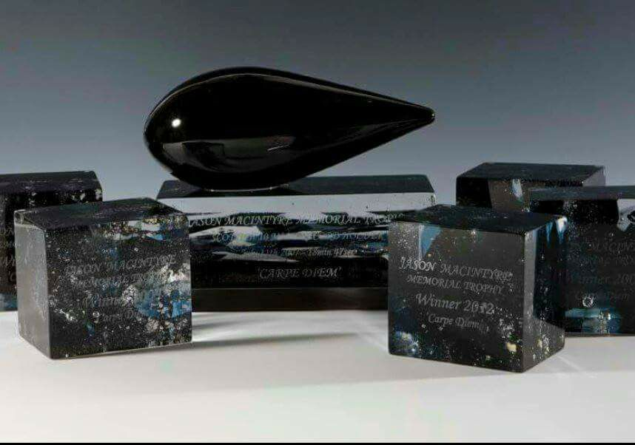
Jason Macintyre Memorial Trophy for Fastest Rider

Spot Prizes Will be awarded also.

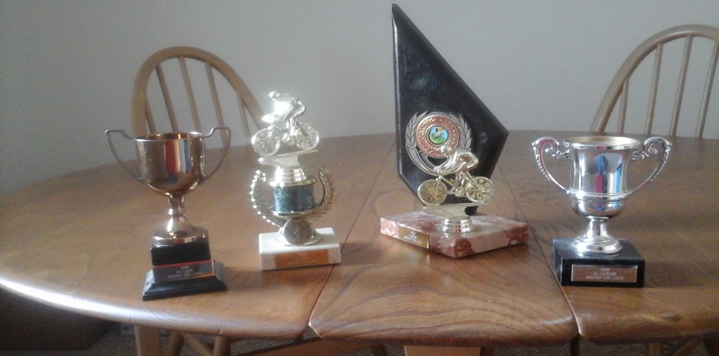Trophies to presented, all engraved.
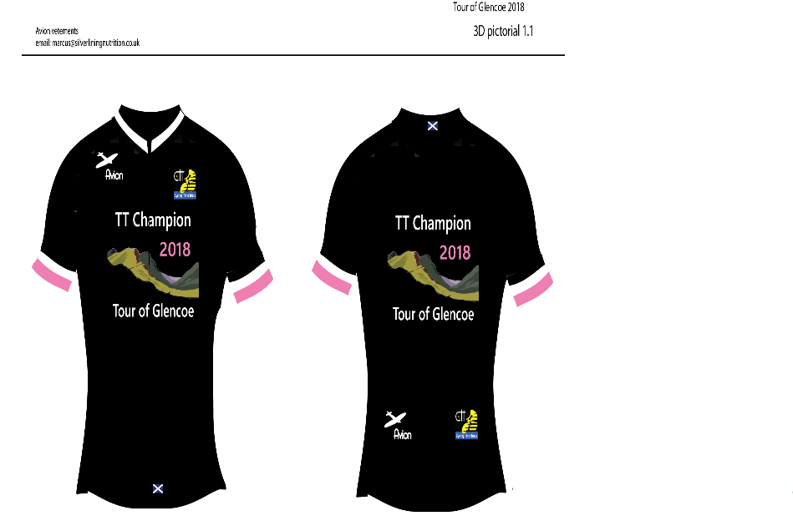 Winners Jersey - Donated by Avion
Huge thanks to all who donated money and awards to make this event a Classic that it deserves. We hope you enjoy the event and complete the Course Safely, hopefully this will be the Start of bigger things to come.
Cheers,
Stevie and the Team.

