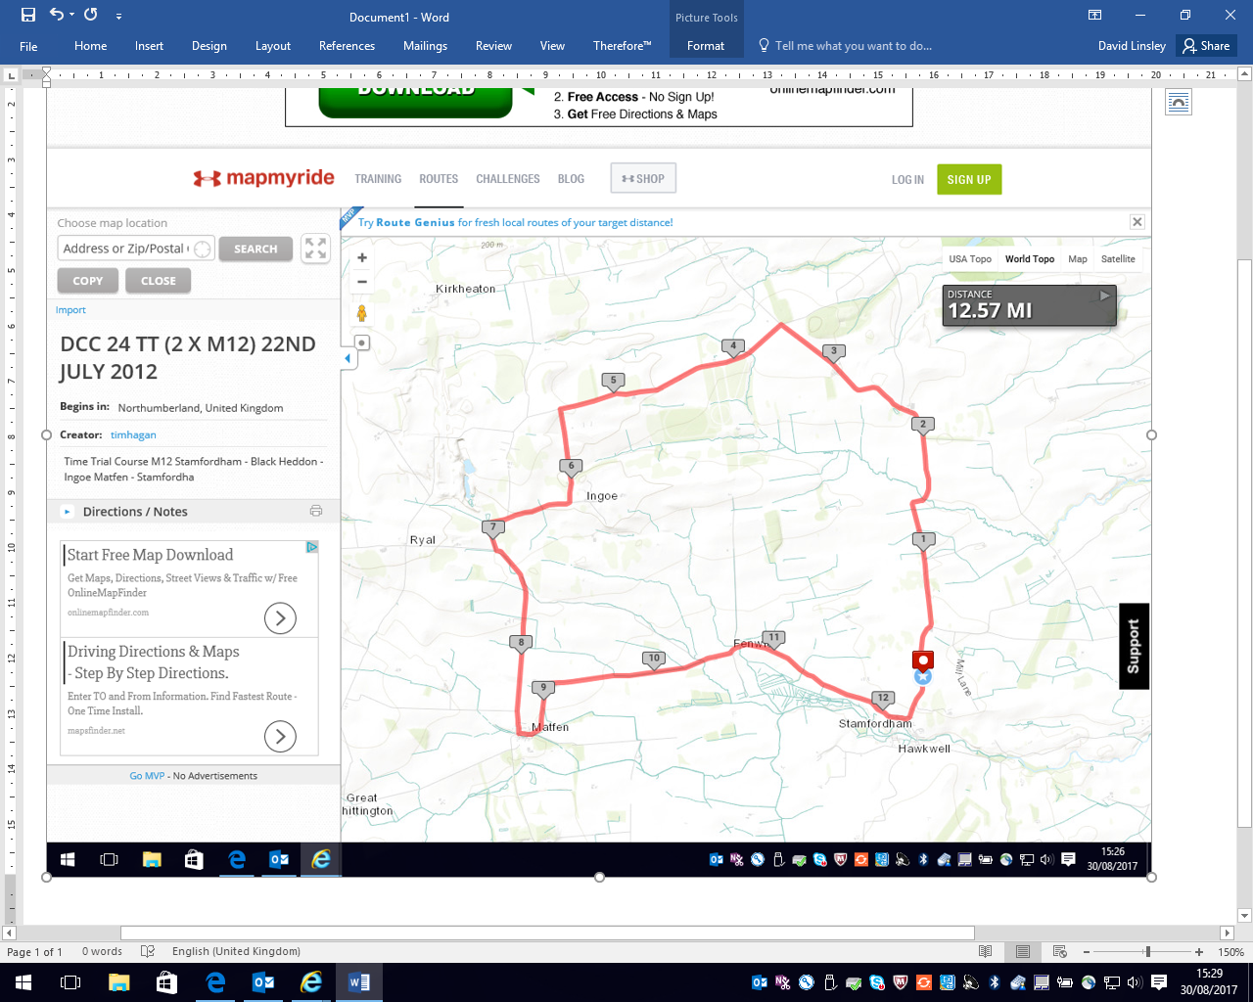

Good road surface

Steep fast descent followed by tight right hand corner

**S**

Rough road surface between 7 & 8 mile

Gravel on road at Main Banks Farm

Give way to traffic from right

Tight Right Bend

Red flag

Tight left hand corner at the Quarry

Rough road surface

Red flag

Tigh