F11/10 HQ to start

Turn Left out of Aylesbury RF Club
Head North-East on Weston Rd for @1mile
At the roundabout, take the 2nd exit onto London Rd for @1mile
Continue over the mini RAB on to and up Tring Hill/B4009 for @1mile
At the roundabout, take the 2nd exit onto B4009 and cross over the Dual Carriageway
At the roundabout, take the 3rd exit onto A41 Slip Road
The Start is on the slip road

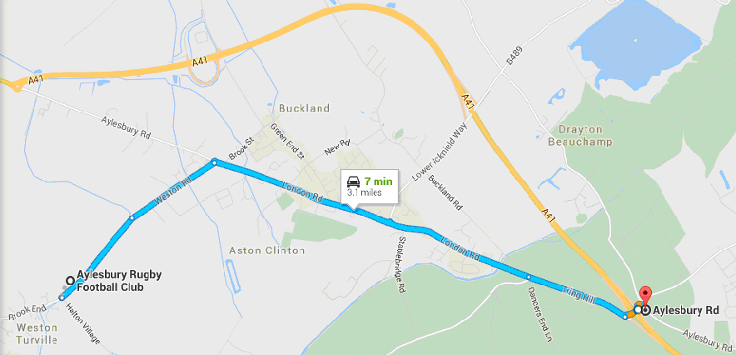
Finish to HQ
Continue up the Slip Road to the T-Junction
Turn right onto Lower Icknield Way for @1mile
At the roundabout, take the 2nd exit onto London Rd for @1mile
At the roundabout, take the 1st exit onto Weston Rd for @1 mile
The HQ is on the right

