CHIPPENHAM & DISTRICT WHEELERS

This event is being promoted for and on behalf of Cycling Time Trials under their Rules and Regulations.

OPEN 10 MILE TIME TRIAL - U41 SPINE ROAD - LATTON

Saturday 05th May 2018. Time of start – 08:00 hours

In the interests of your own safety, Cycling Time Trials and the event promoters strongly advise you to wear a HARD SHELL HELMET that meets an internationally accepted safety standard. Riders signing the entry form state their conversance with Cycling Time Trials Rules and Regulations and agree to observe them.

EVENT OFFICIALS
Event Secretary
Paul Winchcombe Chippenham & District Wheelers
4 Farmhouse Court
Melksham
SN12 6FG
07792 372309 (mobile)

Timekeepers
Start: Mr D Gale West DC
Finish: Mrs S Edwards Chippenham & District Wheelers

Officials
Start: Mr A Spearman Chippenham & District Wheelers
Finish: Mr M Edwards Chippenham & District Wheelers

EVENT HQ: Organiser: Ms Emma Angove
Ashton Keynes Village Hall, Park Place, Ashton Keynes, Swindon, Wiltshire, SN6 6NT
- Refreshments
- Toilets
- Numbers and Signing On
- Prize Presentation
- There are no changing facilities at the Event HQ, so please change considerately
- Event HQ should be open from 0700 hrs

There is limited parking at the HQ so please park considerately in the village. Please do not obstruct the road outside the headquarters entrance.
NO SHOEPLATES IN CLUB HOUSE, PLEASE.

NOTICES:

- This is a new course and a map is below. Please familiarise yourself with the course and do not exit onto the dual carriageway on the roundabouts!
- The Spine Road has suffered badly over the winter and has a number of significant potholes. There are clear racing lines but please be observant and look ahead. We are keeping the early start time to reduce the traffic count to allow riders to ride a bit wider when needed.
- CTT requires all riders to sign out of events when finished. Failure to complete the signing out sheet will result in the rider being disqualified. Other riders or individuals must not sign out for other people.
- Please hand your number in when signing out. We have had several go missing recently and they are expensive to replace.
- Please respect the volunteers from Chippenham and District Wheelers and the timekeepers who are giving up their time to help out.
- Position your main number so that it is visible from the rear when in the racing position.
- This event may be subject to a Doping Control - It is your responsibility to check by returning to the HQ and signing in as soon as possible after you finish.
- Please allow at least 10 minutes to get to the start.
- Head-down riding kills – if dangerous riding is witnessed it will be investigated and reported.
- No vehicles, except those of the timekeepers, shall be parked at the start or finish
- IN THE INTERESTS OF YOUR OWN SAFETY Cycling Time Trials and the event promoters strongly advise you to wear a HARD SHELL HELMET that meets an internationally accepted safety standard. In accordance with Regulation 15 ALL JUNIOR competitors must wear Protective Hard Shell Helmets. It is recommended that a working rear light, either flashing or constant, is fitted to the machine in a position visible to following road users and is active whilst the machine is in use

COURSE DETAILS

To reach start from event HQ follow the High Road to Cox’s Hill Road. At junction with B4696 turn right and follow road to start. Total distance is 1.2 miles. You will be riding towards riders who are racing, so please do not turn onto Spine Road E while warming up. (You may use Spine Road W.)

- LIMIT U TURNS TO AN ABSOLUTE MINIMUM AND QUEUE TO START IN SINGLE FILE IN DRIVE WAY TO FARM. DO NOT QUEUE ON THE ROAD.
- PLEASE DO NOT WARM UP PAST THE START AREA.

START: Start in layby on unclassified road 0.3 mile north of Aggregate Industries entrance.

Head south to junction of Spine Rd West and Spine Rd East (B4696) and turn left. Ride East along Spine Road East towards Cotswold Water Park and A419. Cross the double RAB over the A419 (straight on at first RAB) and turn right at second RAB (second exit) towards Latton (DO NOT TAKE A419 EXITS). Ride South East along Cirencester Road through village of Latton (note traffic calming road narrows) to RAB for A419 and circle RAB to return along Cirencester Road through Latton to the double RAB with A419. At first RAB take second exit (straight across) to second RAB and take second exit along Spine Rd East past Cotswold Water Park (DO NOT TAKE A419 EXITS). Ride West along Spine Rd East to finish 0.5 mile short of junction at West end of small gated layby before Clayhill Car Park

Please take note road surface is rough from area of bridge towards RAB and on return.

https://ridewithgps.com/routes/25084348
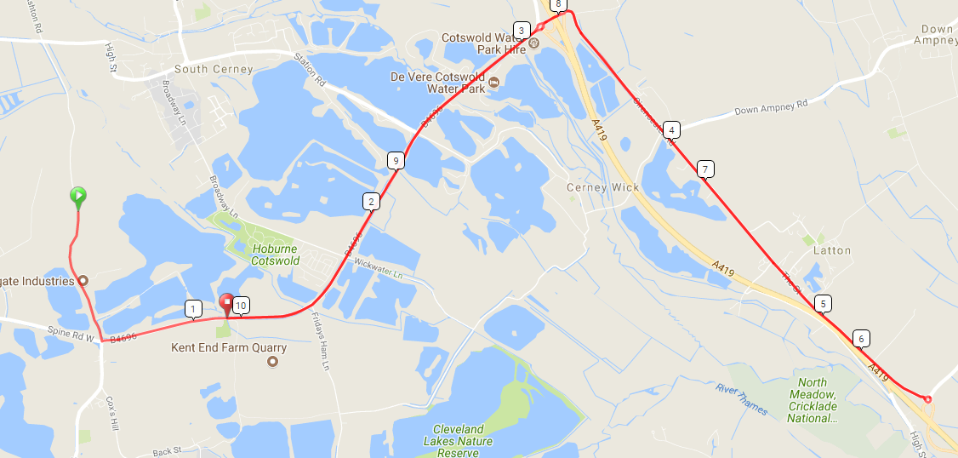

DO NOT STOP on finishing, but warm down and return to HQ.

PRIZE VALUES
Overall |  | Vets |  | Others
1st Place | £20.00 | 1st Place Vet Overall | £15.00 | 1st Place Lady | £20.00
2nd Place | £15.00 | 2nd Place Vet Overall | £10.00 | 1st Team (of 3) | £30.00
3rd Place | £10.00 | 1st Place V40 | £10.00 | Tandem | £20
 |  | 1st Place V50 | £10.00
 |  | 1st Place V60 | £10.00
One prize per rider (except team). In the event of a multiple claim the greater value prize will be awarded.

Prizes will be presented at the Event HQ immediately following the event.

The Chippenham and District Wheelers Sheila Wiseman Memorial Trophy has been returned to the club after several years of absence. It is awarded to the fastest lady in the club open 10 mile time trial and will be awarded to the fastest lady, to be held for one year.
ORDER OF START
Start Time | Rider Number |  | Rider | Club | Cat
 | 10 | Mark | Bradley | Bristol South Cycling Club | V5
08:11 | 11 | Kim | Smale | Bristol South Cycling Club | V5
 | 12 | Joanna | Knight | Bristol South Cycling Club | V5
08:13 | 13 | Andrew | Legge | Bristol South Cycling Club | V4
08:14 | 14 | Paul | Winchcombe | Chippenham & District Wheelers | V5
08:15 | 15 | Luke | Smith | Bristol South Cycling Club | V4
08:16 | 16 | Peter | Lynk | Bournemouth Jubilee Whs | V5
08:17 | 17 | james | sharratt | Swindon Road Club | V6
08:18 | 18 | Robert | Latchem | Somer Valley Cycling Club | V7
08:19 | 19 | Chris | Summers | Sotonia CC | V6
08:20 | 20 | Phil | Brown | trainSharp | V4
08:21 | 21 | Christopher | Davis | Giant CC Halo Films | V6
08:22 | 22 | Mike | Anderson | Velo Club Venta | V6
08:23 | 23 | Sarah | Gunn | Minuteman CC | Lady
08:24 | 24 | Robert | Brush | Winchcombe Cycling Club | Senior
08:25 | 25 | Niel | Dunnage | Cotswold Veldrijden | V4
08:26 | 26 | MIke | Cox | Chippenham & District Wheelers | V6
08:27 | 27 | Paul | O'Driscoll | Team Swindon Cycles | V4
08:28 | 28 | Bryan | Telford | Team Swindon Cycles | V5
08:29 | 29 | PAUL | STANDEN | 73Degrees CC, WestSide Coaching | V4
08:30 | 30 | Dan | Martin | University of Bath Cycling Club | Espoir
08:31 | 31 | Lee | Francis | Velo Club Bristol - Webbs Cycles | Senior
08:32 | 32 | Jenny | Simmonds | Look Mum No Hands! | Lady
08:33 | 33 | Stephen | White | Dursley Road Club | V5
08:34 | 34 | simon | davis | VTTA (Midlands) | V4
08:35 | 35 | graeme | davis | Dursley Road Club | V4
08:36 | 36 | Daniel | Kempe | Bristol South Cycling Club | V5
08:37 | 37 | Carlo | Toledo | Gloucester City Cycling Club | V5
08:38 | 38 | Jamie | Richardson paige | Chippenham & District Wheelers | Senior
08:39 | 39 | Mary-Jane | Hutchinson | Bristol South Cycling Club | Lady
08:40 | 40 | Peter | Garnett | Swindon Road Club | V4
08:41 | 41 | Robin | Short | Performance Cycles CC | V4
08:42 | 42 | Roger | Taylor | Frome and District Wheelers | V7
08:43 | 43 | Maris | Brugis | Bristol Road Club | Senior
08:44 | 44 | Phoebe | Davis | VeloVitesse/ALLCAP/James Barry/Johnson Controls – Hitachi/SiS | Senior
08:45 | 45 | Jim | Beales | Dursley Road Club | Lady
08:46 | 46 | Robert | Jones | Performance Cycles CC | V4
08:47 | 47 | Paul | Freegard | Chippenham & District Wheelers | V6
08:48 | 48 | Roy | Carless | Swindon Road Club | V5
08:49 | 49 | Susan | Crane | Chippenham & District Wheelers | Lady
08:50 | 50 | Josh | Griffiths | Bristol South Cycling Club | Espoir
08:51 | 51 | Tristan | Davenne | Newbury RC | V4
08:52 | 52 | andy | kelly | Bristol South Cycling Club | V5
08:53 | 53 | Chris | Broad-Drake | Swindon Road Club | V6
08:54 | 54 | Robert | Hutchinson | Bristol South Cycling Club | V6
08:55 | 55 | Jim | Curry | Minuteman CC | V4
08:56 | 56 | Lee | Davis | VeloVitesse/ALLCAP/James Barry/Johnson Controls – Hitachi/SiS | V4
08:57 | 57 | Ieuan | Frowen | Cardiff Jif | Senior
08:58 | 58 | Darren | Pitman | Sodbury Cycle Sport | V4
08:59 | 59 | jim | tickner | Velo Club Bristol - Webbs Cycles | V5
09:00 | 60 | Nick | English | AeroCoach | Senior

Please note your name is on the start sheet as it appears in the CTT Database. You can edit your name to make in upper and lower case.

