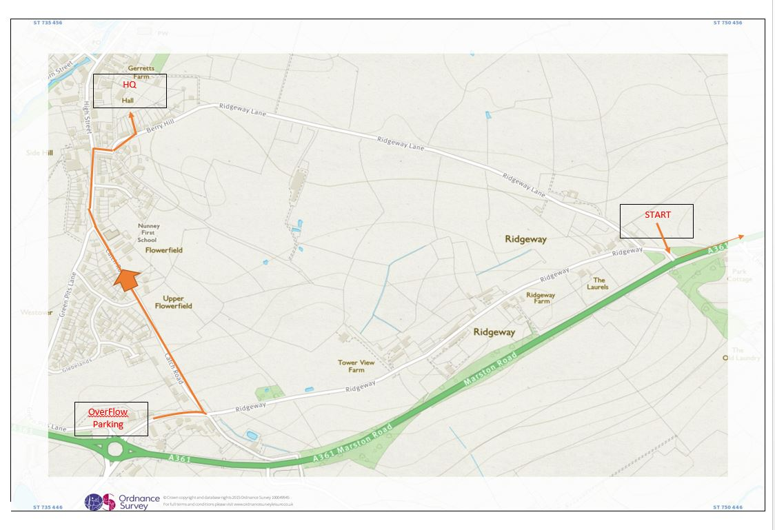
Please see the attached map detailing the HQ overflow parking arrangement. We’ve managed to secure parking next to the Café in the Nunney Catch Round-a-bout truck park.
This is a lorry / services car park so there should be plenty of room. The owners have asked that we park well away from and do not block the fuel pumps, leaving enough room for a lorry to turn, so please park sensibly. The owners have kindly allowed us to use the toilets.
The HQ is about 5-10 minutes ride (downhill) through the village via Catch Lane and the start another 10 minutes from the HQ when riding up Ridgeway Lane. The start from the Overflow Car Park via the A361 is approx. 5 minutes. Please note that Race Numbers will only be available at the HQ so please allow plenty of time to sign-on and collect your number. Please remember to sign off after the race and return your number.
Many thanks,
Jon.

