Open Hill Climb ‘Jennycliff 0.7 miles’
Incorporating ‘Edward Haddon Memorial Trophy’
Sunday 15th October 2017
First Rider off: 10:01am
Event Secretary: Mr. Rob Scott, City Cycle Couriers, The Business Centre, 2 Cattedown Road, Plymouth PL4 0EG M: 07875 760 254 E: citycyclecouriers@live.co.uk
Timekeepers: Mike Brewer & Rob Scott Marshals: Members of City Cycle Couriers RT
Event Headquarters: Jennycliff car park, toilets available in the car park, signing on and numbers will be available on the grass verge.
Course Record Holder: Adrian Sluman – 2mins 31secs - 2015
Course Details:
S3/JennyCliff - Start at the car park entrance / Finish just passed the golf club. (0.7 miles)
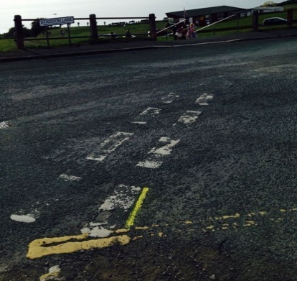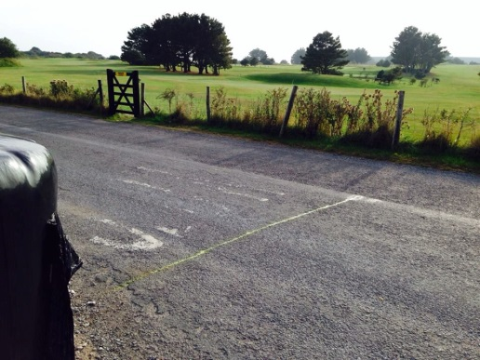
DO NOT RIDE DOWN THE HILL AFTER FINISHING……TAKE A LEFT TURN DOWN ‘HOOE HILL’ AND RETRACE BACK TO JENNYCLIFF CAR PARK (1.8 MILES)
RIDERS PLEASE BE WARNED:
Dangerous riding causes accidents and could endanger the future of the sport. Remain on the correct, left hand side, at junctions. Riders crossing the white line will be given a ’30 sec penalty’.
Please ride with your head up at all times - observe the Highway Code – do not 'WHITE LINE'. Avoid unnecessary U-turns in the road, even when warming up and especially after finishing your ride.
Prizes (Open Event) (One prize, per rider):
1st Overall - Edward Haddon Memorial Trophy (Sponsored by City Cycle Couriers)
£100 (Sponsored by Peter Haddon Property Management Services)
Pair of Schwalbe Tyres (Sponsored by Schwalbe UK)
2md Overall - £25
3rd Overall - £15
1st Lady - £100 (Sponsored by Roper James Solicitors)
Pair of Schwalbe Tyres (Sponsored by Schwalbe UK)
2nd Lady - £20
1st Veteran - £20
1st Juvenile / Junior - £20
Lantern Rouge - Pair of Schwalbe Tyres (Sponsored by Schwalbe UK)
Thanks to our sponsors:
Peter Haddon Property Management Services
Refreshments:
Will be available in the car park provided by Stuart & Karen West.

Open Event Start list:
Race No. |  | Name |  | Club | Cat. | Start
1 |  | Kari Eilertsen |  | City Cycle Couriers RT | Lady | 1001
2 |  | Nikki Gray |  | Yogi Cycling | Lady Vet | 1002
3 |  | Jasmine Gray |  | VCUK VeloChampion | Lady Junior | 1003
4 |  | Martina Geragthy |  | Penzance Wheelers | Lady Vet | 1004
5 |  | Jenny Corser |  | Team RGB Building Supplies | Lady Vet | 1005
6 |  | Marvin Laing |  | City Cycle Couriers RT | Vet | 1006
7 |  | Simon Wharton |  | Plymouth Corinthian CC | Senior | 1007
8 |  | Nick Crawley |  | RutrainingToday CC | Vet | 1008
9 |  | Ivor Pooke |  | City Cycle Couriers RT | Vet | 1009
10 |  | James Cartlidge |  | Plymouth Corinthian CC | Senior | 1010
11 |  | Andrew Parnowski |  | Alltrax | Vet | 1011
12 |  | Graham Florey |  | RNRMCA | Vet | 1012
13 |  | Keith Satchwell |  | Plymouth Corinthian CC | Vet | 1013
14 |  | John Morgan |  | City Cycle Couriers RT | Senior | 1014
15 |  | Ben Kerwin |  | Tavistock Wheelers | Espoir | 1015
16 |  | Dean Wickett |  | Launceston Velo | Senior | 1016
17 |  | Mark Mullen |  | RNRMCA | Senior | 1017
18 |  | Martin Griffith |  | Plymouth Corinthian CC | Senior | 1018
19 |  | David Spreadbridge |  | RutrainingToday CC | Junior | 1019
20 |  | Harrison Wood |  | Mid Devon CC | Junior | 1020
21 |  | Bobby Cowsill |  | CS South Hams | Senior | 1021
22 |  | Stephen Jones |  | Plymouth Corinthian CC | Senior | 1022
23 |  | Chris Puertas |  | Alltrax | Vet | 1023
24 |  | Matt Fish |  | Plymouth Corinthian CC | Senior | 1024
25 |  | James Hywel-Davies |  | Gillingham & District Wheelers | Espoir | 1025
26 |  | Andrew Gray |  | VCUK VeloChampion | Vet | 1026
27 |  | Owen Puckey |  | RutrainingToday CC | Juvenile | 1027
28 |  | John Benney |  | Alltrax | Vet | 1028
29 |  | Dave Lea |  | Plymouth Corinthian CC | Vet | 1029
30 |  | Andrew Feather |  | Bike Chain Ricci | Senior | 1030
31 |  | Josh Coyne |  | Okehampton CC | Espoir | 1031
32 |  | Stuart Hall |  | Devon & Somerset FRSCC | Vet | 1032
 | N/A
 | N/A
 | 2-37
Club Event Start list:
Entry on the day available £5, signing on closes at 9:30am for riders entering on the line.
Race No. | Name | Club | Cat | Start
33 | Marvin Laing | City Cycle Couriers RT | Vet | 1032
34
35
36
37
38
39
40

Jennycliff Hill Climb – All time fastest
Leaderboard (Results from 2014/15/16)
Top 10:
1 Adrian Sluman 2:31
2 Josh Greet 2:35
3 Adrian Sluman 2:37
4 Dexter Hurlock 2:38
5 Harry Luxton 2:39
6 Harry Luxton 2:41
7 James Cartlidge 2:43
8= Josh Coyne 2:45
8= Jordan Channon 2:45
10 James Cartlidge 2:46

