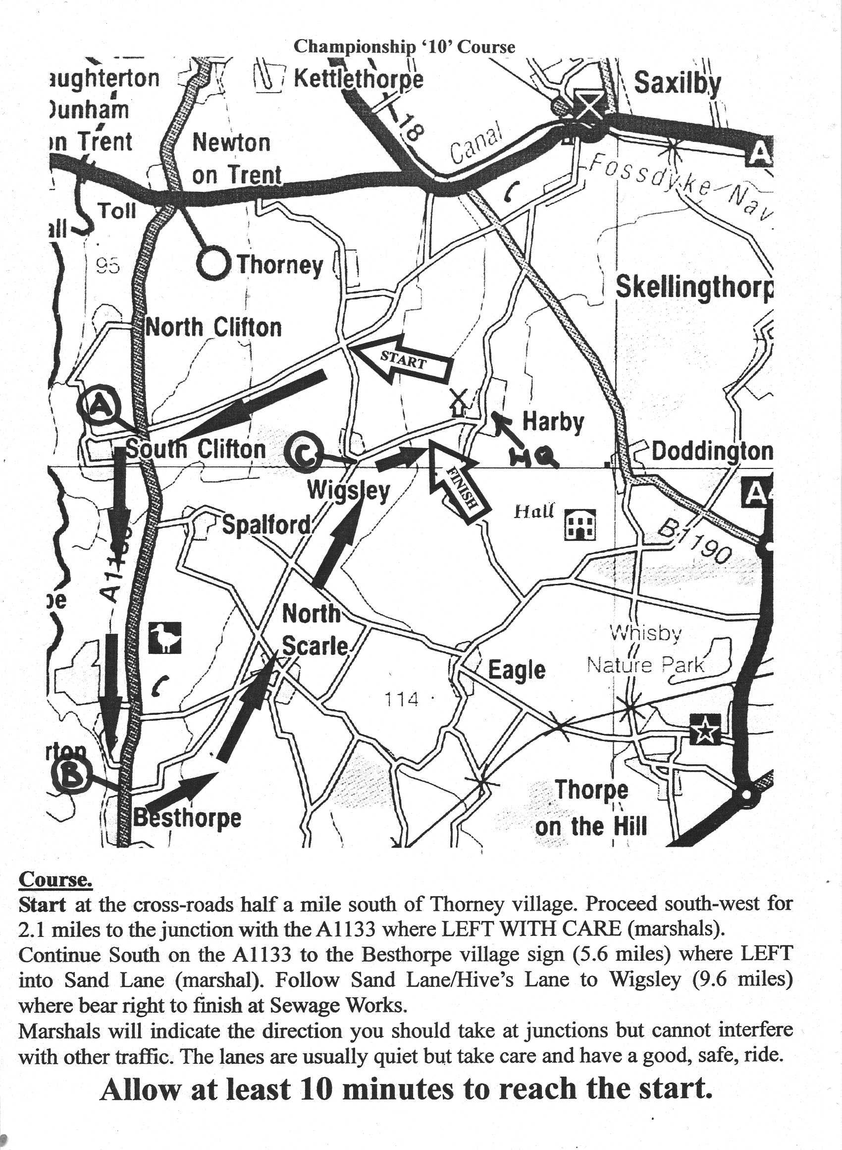

Lincoln Wheelers Tandem and Tricycle 10 Mile Events
promoted for and on behalf of CTT under their Rules and Regulations
date Saturday 7th October 2017 from 1.00pm

Course C10/17 Thorney 10 miles

Start on minor road from Thorney to South Clifton at junction with road to Wigsley. Proceed to South Clifton crossroads where left onto A1133 (care M). Continue south on A1133 to Besthorpe where left (care M) onto minor road to Harby to finish at mark in road on approach to Harby village. Please see map

Event Headquarters
Harby Village Hall situated in the middle of Harby Village (see map for location). The hall will be open from 11.30am. Parking is available in the car park and on one side of road outside of Village Hall only. Please be quiet and be careful to park so as not to inconvenience any residents. (For sat nav use nearby Postcode NG23 7EQ)
NB Notes including up-to-the-minute information will be available at the signing on table. Please read them carefully and take notice for your own safety.
Event Secretary Peter Holland, Stepping Stones, Dunston LN4 2EZ. 01526 322633.
Time Keepers Steve Walker, Keith Carlton Lincoln Wheelers
Time Keeper’s Clerk Keith Barnard, Lincoln Wheelers
Handicapper Neil Winter
Result Board Heidi De Wolf
Marshals Members and supporters of the Lincoln Wheelers & the T.A.
Numbers and Signing on Will be at the event HQ. Exchange numbers for a cup of tea after your ride. YOU MUST SIGN OUT AT THIS EVENT
ALL RIDERS PLEASE NOTE
No U turns are allowed in the vicinity of the start and finish. No warming up is allowed on the course once the event has started.
The Lincolnshire Road Safety Partnership remind you that competitors should observe the Highway Code. The duty of marshals is to indicate which direction you should take. They cannot interfere with other traffic. You are responsible for your own safety. Keep your head up and take care.
A CTT Observer will be present. CTT strongly advise the wearing of a hard shell helmet that meets International Safety standards and to use a rear LED light.
Please allow enough time to reach the start which is approximately 2 miles away from the event headquarters.
10 MILE TRIKE EVENT
on Saturday 7^{h} October 2017 from 1.01 pm

No | Name | Club | Start | h’cap | Notes
1 | Greta Spiers | TA East | 1.01 | 20.30
2 | Ian Matthews | Team For 2000 | 1.02 | 10.30
3 | David Hardy | Leicester Forest | 1.03 | 13.00
4 | Dave Capps | Lincoln Wheelers | 1.04 | 5.30
5 | Geoff Booker | Oxonian CC | 1.05 | 4.00
6 | Jane Moore | Willesden CC | 1.06 | 7.00
7 | Wayne Baker | Avon & Som Police | 1.07 | 7.30
8 | Ian Mackenzie | Southend Wheelers | 1.08 | 8.30
9 | Paul Potter | Lincoln Wheelers | 1.09 | 9.00
10 | Lez Young | Lincoln Wheelers | 1.10 | 3.00
11
12 | Ian Pike | Fenland RC | 1.12 | Scr

AWARDS (one prize per machine)
Fastest trike £15.00
Second fastest trike £ 8.00
1st handicap £15.00
2nd handicap £ 8.00

10 MILE TANDEM EVENT
on Saturday 7th October 2017 from 1.14 pm

No | Name | Club | Start | Notes
14 | Jim Edwards | Lincoln Wheelers | 1.14
 | Brenda Edwards | Lincoln Wheelers
16 | Nicola Casburn | Lincoln Wheelers | 1.16
 | Joanne Johnson | Lincoln Wheelers

AWARDS (one prize per machine)

Fastest tandem £20.00

PLEASE NOTE

We need bookings for the Bernard Rosen Memorial Skittles Evening taking place at the Grey Horse Collingham by 6pm on 30th September – please tel Peter Holland on 01526 322633 with your requirements.

